Page **1** of **12**

Chemistry by Dr.Satyendra S.

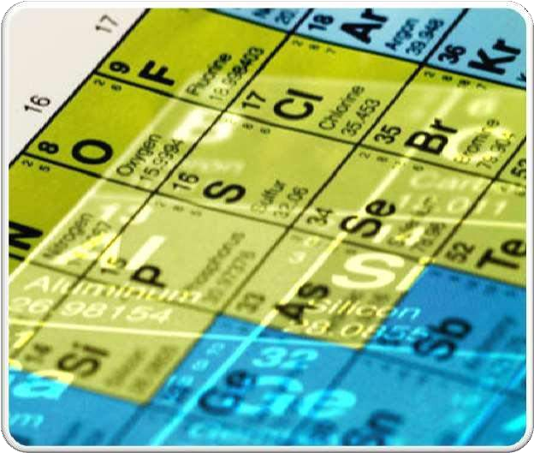

**JESUS AND MARY SCHOOL AND COLLEGE**

**CHEMISTRY MODULE-3 1ST JUNE, 2020 PREPARED BY**

**DR.SATYENDRA SINGH**

**CH.PERIODIC PROPERTIES OF ELEMENTS CLASS 10**

## PERIODIC PROPERTIES

#### **PERIODIC LAW :** ELEMENTS ARRANGED BY ATOMIC NUMBER GIVES PHYSICAL AND CHEMICAL PROPERTIES VARYINGPERIODICALLY.

* WE WILL STUDY THE FOLLOWING PERIODIC TRENDS:
  + ATOMIC RADII
  + METALLIC AND NON METALLIC CHARACTER
  + IONIZATION ENERGY
  + ELECTRON AFFINITY
  + ELECTRONEGATIVITY
  + MELTING POINT

ATOMIC RADIUS

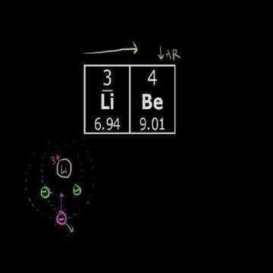

•

* Atomic radii actually decrease across a row in the periodic table. Due to an increase in the effective nuclear charge.
* Within each group (vertical column), the atomic radius tends to increase with the period number.

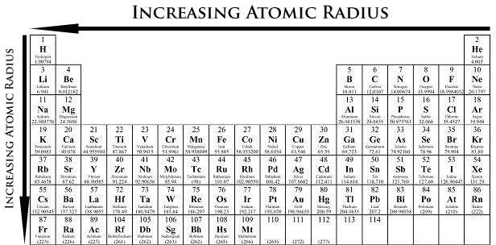

METALLIC AND NON METALLIC CHARACTER

### Metallic characteristics decrease from left to right across a period. This is caused by the decrease in radius of the atom that allows the outer electrons to ionize more readily.

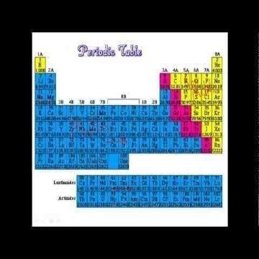

* + Metallic characteristics increase down a group.

Electron shielding causes the atomic radius to increase thus the outer electrons ionizes more readily than electrons in smaller atoms.

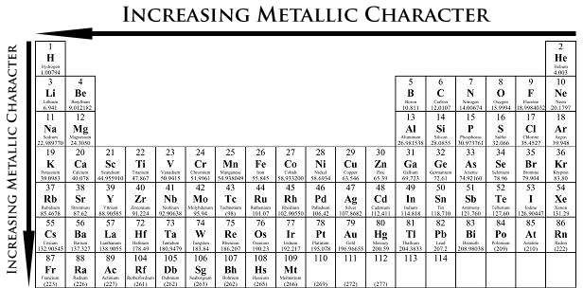

* + Metallic character relates to the ability to lose

electrons, and nonmetallic character relates to the ability to gain electrons.

IONIZATION ENERGY

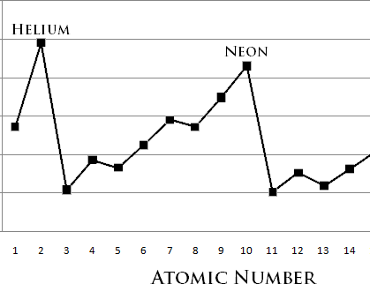

* IONIZATION ENERGY REQUIRED TO REMOVE AN ELECTRON FROM A NEUTRAL ATOM IN ITS GASEOUS PHASE.
* CONCEPTUALLY, IONIZATION ENERGY IS THE OPPOSITE OF ELECTRONEGATIVITY.
* THE LOWER THIS ENERGY IS, THE MORE READILY THE ATOM BECOMES A CATION. THEREFORE, THE HIGHER THIS ENERGY IS, THE MORE UNLIKELY IT IS THE ATOM BECOMES A CATION.
* GENERALLY, ELEMENTS ON THE RIGHT SIDE OF THE PERIODIC TABLE HAVE A HIGHER IONIZATION ENERGY BECAUSE THEIR VALENCE SHELL IS NEARLY FILLED.
* ELEMENTS ON THE LEFT SIDE OF THE PERIODIC TABLE HAVE LOW IONIZATION ENERGIES BECAUSE OF THEIR WILLINGNESS TO LOSE ELECTRONS AND BECOME CATIONS. HENCE,IONIZATION ENERGY INCREASES FROM LEFT TO RIGHT ON THE PERIODIC TABLE.

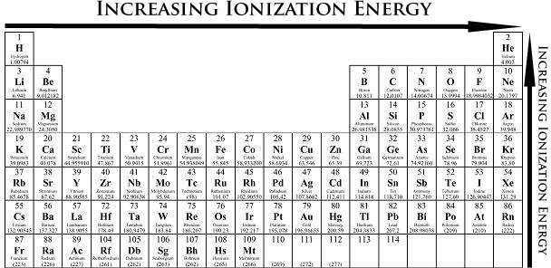

* THE IONIZATION ENERGY OF THE ELEMENTS WITHIN A PERIOD

GENERALLY INCREASES FROM LEFT TO RIGHT. THIS IS DUE TO VALENCE SHELL STABILITY.

* THE IONIZATION ENERGY OF THE ELEMENTS WITHIN A GROUP GENERALLY DECREASES FROM TOP TO BOTTOM. THIS IS DUE TO

ELECTRONSHIELDING.

* THE NOBLE GASES POSSESS VERY HIGH IONIZATION ENERGIES BECAUSE OF THEIR FULL VALENCE

SHELLS AS INDICATED IN THE GRAPH. NOTE THAT HELIUM HAS THE HIGHEST IONIZATION ENERGY OF ALL THE ELEMENTS.

# ELECTRON **A**FFINITY

#### ELECTRON AFFINITY IS THE ABILITY OF AN ATOM TO ACCEPT AN ELECTRON.

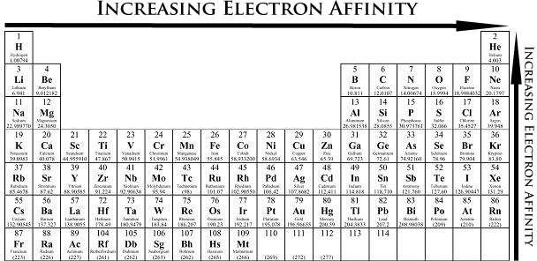

* ELECTRON AFFINITY IS A QUANTITATIVE MEASUREMENT OF THE ENERGY CHANGE THAT OCCURS WHEN AN ELECTRON IS ADDED TO A NEUTRAL GASEOUS ATOM.
* THE MORE NEGATIVE THE ELECTRON AFFINITY VALUE, THE HIGHER AN ATOM'S AFFINITY FOR ELECTRONS.

ELECTRONEGATIVITY

* + ELECTRONEGATIVITY CAN BE UNDERSTOOD AS A CHEMICAL PROPERTY DESCRIBING AN ATOM'S ABILITY TO ATTRACT AND BIND WITH ELECTRONS

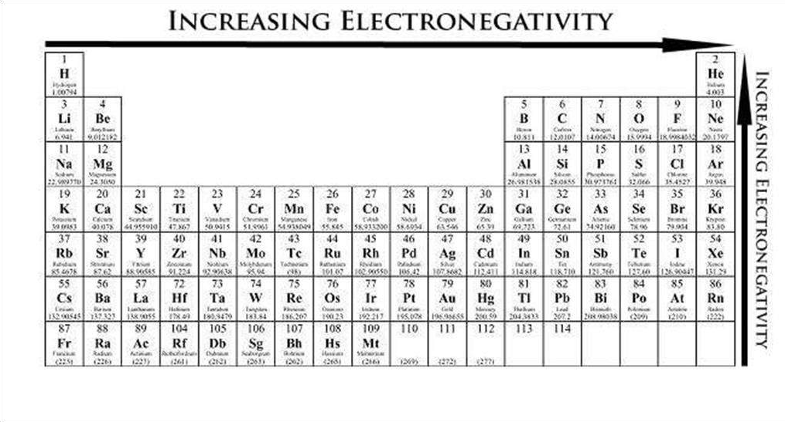

* + ELECTRONEGATIVITY IS A QUALITATIVE PROPERTY, THERE IS NO STANDARDIZED METHOD FOR CALCULATING ELECTRONEGATIVITY.
  + ELECTRONEGATIVITY VALUES FOR EACH ELEMENT CAN BE FOUND ON CERTAIN PERIODIC TABLES.

MELTING POINT

* THE MELTING POINTS IS THE AMOUNT OF ENERGY REQUIRED TO BREAK A BOND(S) TO CHANGE THE SOLID PHASE OF A SUBSTANCE TO ITS LIQUID STATE.

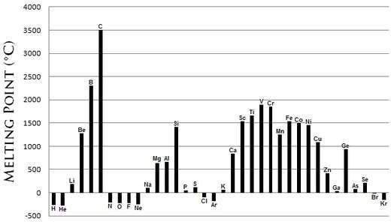

I

* THE STRONGER THE BOND BETWEEN THE ATOMS OF AN ELEMENT, THE MORE ENERGY REQUIRED TO BREAK THAT BOND. AS TEMPERATURE IS DIRECTLY PROPORTIONAL TO ENERGY, A HIGH BOND DISSOCIATION ENERGY CORRELATES TO A HIGH TEMPERATURE.
* MELTING POINTS ARE VARIED AND DO NOT GENERALLY FORM A DISTINGUISHABLE TREND ACROSS THE PERIODIC TABLE. HOWEVER, CERTAIN CONCLUSIONS CAN BE DRAWN FROM THE GRAPH BELOW.
* METALS GENERALLY POSSESS A HIGH MELTING POINT.
* MOST NON-METALS POSSESS LOW MELTING POINTS.
* THE NON-METAL CARBON AND BORON ALSO POSSESSES A HIGH MELTING & THE HIGHEST BOILING POINT OF ALL THE ELEMENTS.

.Multiple choice questions:

**ASSIGNMENT**

1. Multiple Choice questions:
2. 14 elements after actinium is called
   1. Lanthanides
   2. Actinides
   3. D-block elements
   4. P block elements
3. An element has an atomic number of 15, with which of the following elements will it show similar chemical properties.
   1. Be (4)
   2. Ne (10)
   3. N (7)
   4. O (8)
4. The group number and period number respectively of an element with atomic number 8 is. a. 6, 2

b. 16, 2

c. 6, 8

d. 16, 4

1. An element belongs to period 2 and group 2. The number of valence electrons in the atoms of this element is.
   1. 2
   2. 4
   3. 3
   4. 1
2. In the third period of the periodic table, the element having smallest size is_
   1. Na
   2. Ar
   3. Cl
   4. Si
3. Electronic configuration of Al+3 is_ a. 2,8,3

b. 2,8,8

c. 2,8

d. 2,8,8,3

1. Identify among the following sets, which is not a Dobereiner’s triad_
   1. Li, Na, K
   2. Be, Mg, Cr
   3. Ca, Sr, Ba
   4. Cl, Br, I
2. Which is not true about the noble gases?
   1. They exist in atomic form
   2. They are radioactive in nature
   3. Xenon is the most reactive among these
3. Identify the wrong sequence of the elements in a group
   1. Ca, Br, Ba
   2. Cu, Au, Ag
   3. N, P, As
   4. Cl, Br, I
4. Which of the following atomic number element, will form a basic oxide a. 7, b. 17, c. 14, d. 11
5. Short answer type questions:
   1. The three elements A, B and C with similar properties have atomic masses X, Y and Z respectively. The mass of Y is approximately equal to the average mass of X and Z. What is such an arrangement of elements called as? Give one example of such a set of elements.
   2. Elements have been arranged in the following sequence on the basis of their increasing atomic masses.

F, Na, Mg, Al, Si, P, S, Cl, Ar, K

1. Pick two sets of elements which have similar properties.
2. The given sequence represents which law of classification of elements?
   1. Can the following groups of elements be classified as Dobereiner’s triad ?
3. Na, Si, Cl
4. Be, Mg, Ca

Atomic mass of Be 9; Na 23; Mg 24; Si 28; Cl 35; Ca 40

* 1. Explain by giving reason.

In Mendeleev’s Periodic Table, the elements were arranged in the increasing order of their atomic masses. However, cobalt

with atomic mass of 58.93 amu was placed before nickel having an atomic mass of 58.71 amu. Give reason for the same.

* 1. Hydrogen occupies a unique position in Modern Periodic Table”. Justify the statement.
  2. Write the formulae of chlorides of Eka-silicon and Eka-aluminium, the elements predicted by Mendeleev.
  3. Three elements A, B and C have 3, 4 and 2 electrons respectively in their outermost shell. Give the group number to which they belong in the Modern Periodic Table. Also, give their valencies.
  4. If an element X is placed in group 14, what will be the formula and the nature of bonding of its chloride?
  5. Compare the radii of two species X and Y. Give reasons for your answer.
     1. X has 12 protons and 12 electrons
     2. Y has 12 protons and 10 electrons
  6. Arrange the following elements in increasing order of their atomic radii.
     1. Li, Be, F, N
     2. Cl, At, Br I

***Note: Please do all this work in your “Chemistry Notebook” which will be checked when college resumes. Please consider this important.***

**\*\*\*\*\*\*\*\*\*\*\***