**1st June, 2020 JESUS AND MARY SCHOOL AND COLLEGE MODULE 3**

**CLASS X**

**ENGLISH LITERATURE**

**MERCHANT OF VENICE**

**Act III Scene 2 (Contd.)**

**NOTE:** Dear Students, in the previous two modules, we started and continued with Act III Scene 2 of the drama section of your syllabus. We are going to continue the same and finish the explanation of the scene in this module. In the last module we studied till the point Gratiano expresses his love for Nerissa and his desire to marry her. We’ll continue from thereon and see what happens next in the scene.

**TEXT:**

**GRATIANO: But who comes here……............**

**Enter Lorenzo, Jessica and Salerio**

**BASSANIO: Lorenzo and Salerio ……….**

**PORTIA: So do I ……………**

**(Lines 217-225)**

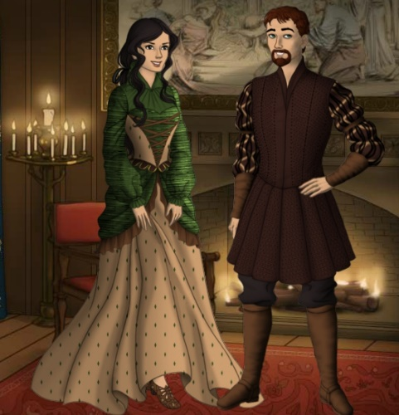

**GRATIANO AND NERISSA**

**EXPLANATION:**

**Lines 217-218 -** Moments after love between Gratiano and Nerissa is revealed, Lorenzo, Jessica and Salerio enter the scene with a breaking news. Gratiano sees them coming and exclaims that Lorenzo and his Jewess (Jessica) have come, also coming with them was his old Venetian friend Salerio. And with this Lorenzo, Jessica and Salerio enter the scene.

**Lines 219-223 –** In these lines, Bassanio welcomes Lorenzo and Salerio there in Belmont, provided his newly acquired rights permit him to do so. He further adds that with Portia’s permission, he welcomes his friends and countrymen.

**Lines 224-225 –** Portia also says that she also welcomes them and that they are most welcome there.

**TEXT:**

**LORENZO: I thank your honour……………….**

**SALERIO: I did, my lord……………..**

**BASSANIO: Ere I ope ………………**

**SALERIO: Not sick, my lord…………………**

**(Lines 226-238)**

**EXPLANATION:**

**Lines 226-230 –** Lorenzo thanks Bassanio for the welcome and tells him that as far as he is considered, his intention was not to meet him there, but he met Salerio on the way and he persuaded him to accompany him,ignoring his refusal to go.

**Lines 231-233 –** Salerio agrees with Lorenzo and accepts that he did that but for a reason. He tells Bassanio that gentleman Antonio had sent him his greetings. (Then Salerio gives a letter to Bassanio).

**Lines 234-235 –** Bassanio asks Salerio to tell him how his good friend Antonio was doing, before he opens his letter and reads the contents.

**Lines 236-238 –** Salerio replies to Bassanio telling about Antonio that he was neither sick nor well, unless it was in his mind. He further tells that the letter would tell Bassanio of Antonio’s financial status. (and then Bassanio opens the letter).

**TEXT:**

**GRATIANO: Nerissa, cheer yon ………………….**

**SALERIO: I would you …………….**

**PORTIA: There are some shrewd …………………**

**(Lines 239-252)**

**EXPLANATION:**

**Lines 239-243 –** Meanwhile Gratiano asks Nerissa to cheerfully welcome the guest lady (Jessica). He further shakes hand with Salerio and asks him what news he had brought from Venice and how was the noble merchant Antonio. He tells Salerio that Antonio would be glad to know about their success (talking about him and Bassanio winning their respective ladies). He adds that they are like adventurous suitors who have won the Gold.

**Line 244 –** Salerio replies that he wishes that Gratiano could have won the fortune that Antonio has lost.

**Lines 245-252 –** Portia now speaks and says that there was some bad news in that letter that had made Bassanio turn pale, some dear friend must had died because nothing else in the world would change the condition of a normal man so much. She further says that Bassanio’s condition is worsening as he is reading the letter. She adds that with Bassanio’s permission, since she was now half of himself, so she must freely have the half of anything that that letter brings to him.

**TEXT:**

**BASSANIO: O sweet Portia,……………………………… of merchant- marring rocks?**

**(Lines 253-274)**

**EXPLANATION:**

Bassanio tells Portia that that letter had some of the most unwelcome words that were ever written on paper! He tells her that when he first made his affection for her, he told her that his only wealth was his noble blood and the fact that he was a gentleman. He adds that what he said was true, yet, when he claimed his wealth as nothing, he was exaggerating his position. He further says that when he told her that he owned nothing; he should have told her that he was less than nothing and he had bound himself to a dear friend and made him pledge himself to his worst enemy to get the money he needed. He adds that the paper on which the letter was written could be compared to the body of his friend and every word on it, to an open wound from which his blood is gushing out. Bassanio then asks Salerio if it was true that all business ventures of Antonio had failed and not one had survived. He tells that his ships were sailing from Tripolis, Mexico, England, Lisbon, Barbary and India. He asks him whether not even one ship was spared from being wrecked on the dangerous rocks that often ruin merchants.

**TEXT:**

**SALERIO: Not one, my lord………………………….**

**JESSICA: When I was with him……………………….**

**PORTIA: Is it your dear ………………………………..**

**BASSANIO: The dearest friend…………………………**

**(Lines 275-300)**

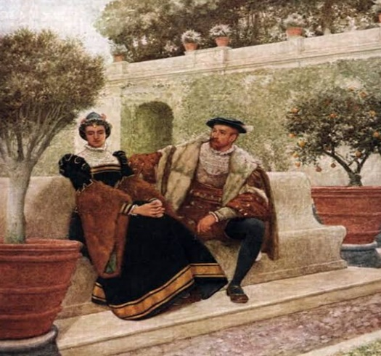

**LORENZO AND JESSICA**

**EXPLANATION:**

**Lines 275-287 –** Salerio says that not a single one of Antonio’s ships survived and further it seems that even if he had the money to repay the Jew, Shylock would not take it from him the. Salerio says that never had he come across a creature in the form of a man so eager and greedy to destroy another man. He tells that Shylock appeals to the Duke, morning and evening, and threatens legal action against the country’s system of justice if they deny it to him. He adds that twenty merchants, the Duke himself and the noblemen of highest rank, had advised Shylock, but no one could prevent him from his revengeful claim for giving up the conditions of the bond and fulfilment of his legal demand.

**Lines 288-294 –** Jessica tells that when she was with Shylock, she heard him tell Tubal, Chus and other Jews that he would rather have a pound of Antonio’s flesh than twenty times the value of the debt. She further adds that she knows well that unless the law and the higher powers intervene, it would be very difficult for poor Antonio.

**Line 295 –** Portia asks Bassanio if it is his dear friend who is in trouble.

**Lines 296-300 –**Bassanio answers Portia and says that Antonio is the dearest friend to him, the kindest man, the best-intentioned man, never tired in showing kindness to others and that he displays the old Roman spirit of honour more than any other person living in Italy then.

**TEXT:**

**PORTIA: What sum…………..**

**BASSANIO: For me………….....**

**PORTIA: What, no more……………..**

**BASSANIO: [Reads] “Sweet Bassanio,……………………..**

**PORTIA: O love………………….**

**BASSANIO: Since I have …………………………. ‘twixt us twain. [*Exeunt*]**

**(Lines 301-330)**

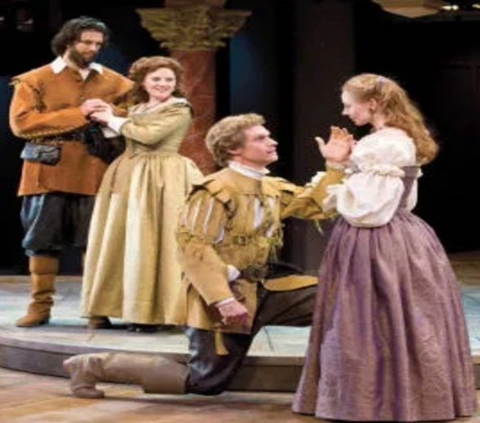

**BASSANIO AND PORTIA WITH GRATIANO AND NERISSA**

**EXPLANATION:**

**Line 301 –** Portia asks Bassanio how much money Antonio did owe to the Jew.

**Line 302 –** Bassanio answers that Antonio owed three thousand ducats, on his behalf.

**Line 303-319 –** Portia exclaims on hearing the loan amount if that’s it. She further tells Bassanio to pay Shylock six thousand ducats and cancel the bond and even double the six thousand, and then multiply that by three, rather than let such a friend suffer the slightest harm through a fault of his. She then asks Bassanio to go with her to the church and get married immediately (so that Bassanio would rightfully become the owner of Portia’s wealth and assets) and then hasten to Venice to his friend. She tells him that he should never live with her as her husband with such a troubled mind and that he would have enough money to pay that small debt twenty times over and when he had paid it, he can bring back his friend with him. She further adds that her maid and she herself would live as spinsters or widows. She then asks him to come with her because he would travel from there even if it was his wedding day. She also asks him to welcome his friends and show a cheerful face. She tells him that since she had won him dearly, she would love him dearly. She then requests him to let her know what the contents of the letter were.

**Lines 320-326 –** Bassanio then reads the letter and its contents were as follows:

“Dear Bassanio, my ships have perished, my creditors are growing impatient, my finances have fallen very low and the due date of my bond to the Jew has expired. Paying the penalty to him means surely losing my life. Please regard all debts between you and me as settled. I only wish to see you as I die. In spite of my desire to see you, please be free to act as you wish. If your love for me does not make you come to me, let not my letter compel you to do so.

**Line 327 –** Portia asks Bassanio to finish all his business there and be gone to Venice.

**Lines 328-330 –** Bassanio says that since he has her kind permission to go, he would hurry up but till he comes back, he would not go to bed and no rest shall keep him separated from her. With this, we come to the end of the scene.

**ASSIGNMENT**

**Answer the following questions in brief:**

1. Who enters the scene after the love between Gratiano and Nerissa is revealed?
2. What does Salerio say when Bassanio asks him how was his good friend doing?
3. Explain: “I would you had won the fleece that he hath lost!” (Line 244)
4. Why does Portia say that there are some shrewd contents in the letter?
5. Explain: “yet, dear lady, rating myself at nothing, you shall see how much I was a braggart.” (Lines 259-261)
6. What does Bassanio compare the letter to?
7. What does Salerio tell about Shylock’s actions happening in Venice?
8. How does Bassanio praise Antonio in front of Portia?
9. What did Portia say to Bassanio about paying the debt? Why does Portia tell Bassanio to marry her immediately before going to Venice?
10. Briefly explain the contents of the letter.

**NOTE: Please do this work in your copies which will be checked once the school reopens.**

**\*\*\*\*\*\*\*\*\*\*\*\*\***