**1st June, 2020 JESUS AND MARY SCHOOL AND COLLEGE MODULE-3**

**CLASS XII**

**CHEMISTRY**

**CHAPTER: SOLID STATE**

**NOTE:**

My loving Students, today I’m going to tell you a very simple and lucid way of understanding ‘Imperfections in Solids’ with the help of colourful pictures and simple explanation. This is an integral part of the Physical chemistry topics you get in the Board Examinations. Study the following notes carefully and then test yourself by attempting the given assignment in the last of this module. Please note that this work must be done in chemistry note book which will be checked when College resumes.

**Imperfections or Defects in Solids**

*  In a crystalline solid, the atoms, ions and molecules are arranged in a definite repeating pattern, but some defects may occur in the pattern due to departure of an atom from perfectly ordered arrangement of atoms in crystals.
* It may occur due to rapid cooling or presence of additional particles.
* The defects are mainly of two types, namely_

1. Point or atomic defects,
2. Line defects.

**I. Point Defects**

When some constituent particles are missing from their lattice site, it is known as point defects. It can be classified into four types_

i.Stoichiometric defects,

ii.Non-stoichiometric defects,

iii.Impurity defects.

**i.** **Stoichiometric Defect:**

The ratio between the cation and anions remains the same as represented by the molecular formula. This stoichiometric defect is also called intrinsic or thermodynamic defect. This defect is further classified into four categories_

|  |  |  |  |  |
| --- | --- | --- | --- | --- |
| **Defect** | **Definition** | **Types of solid** | **Density** | **Crystal structure after defect** |
| a. Vacancy  b. Interstitial  c. Schottky  d. Frenkel | When in ionic solids, some of the lattice sites are vacant.  When some of constituent atoms occupy the interstitial sites in lattice  When equal no. of cation and anion removed from crystal lattice  When a cation is missing from the lattice site & occupies an interstitial space | Non-Ionic comp.  Non-Ionic comp.  Ionic comp.  Ionic comp. | Decrease  Remain same  Decrease  Remain same | tbl.1.png  tbl.2.png  tbl.3.png  tbl.4.png |

**Note below:**

* In schottky defects, ionic compounds have high co-ordination number and size of cations & anions are nearly same. eg. NaCl,Cs Cl.
* In Frenkel defect, ionic compounds have low co-ordination number because smaller sized cations are surrounded by very less number of larger sized anions.
* AgBr has both Schottky and Frenkel defects.

**ii.** **Non-Stoichiometric Defects:**

Non-stoichiometric crystals are those which do not obey the law of constant proportions. The

numbers of positive and negative ions present in such compounds are different from those expected from their ideal chemical formulae. However, the crystal as a whole is neutral.

Types of n-stoichiometric defects are as follows:

**A)** **Metal excess defects:** It may arise due to**_**

**a. Anionic vacancies:** When a negative ion is missing from its lattice site and its vacancy is occupied by an electron to maintain electrical neutrality, the defect is called metal excess defect due to anion vacancies. The electrons trapped in anion vacancies are called F-centres. F-centres contribute colour and paramagnetic nature of the crystal. [F is taken from german word Farbe meaning colour).This type of defect generally occurs in those crystals where schottky defect takes place.

eg. Alkyl halides like NaC1and KCl show this type of defect. NaCl appears yellow when heated with sodium vapours.

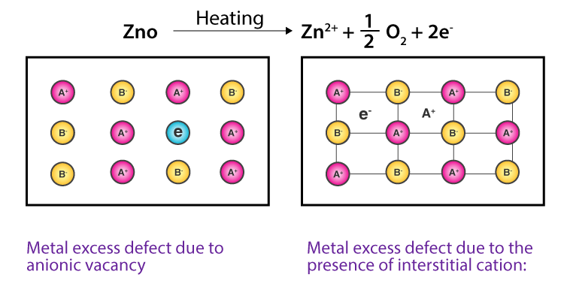

**Fig. (a) Fig. (b)**

**b. Extra cations at interstitial sites**: This defect arises when an extra cation is present in an interstitial site, and to maintain electrical neutrality, an e- is present in the adjacent void.

e.g., Zinc oxide is white in colour at room temperature. On heating, it loses oxygen and turns yellow.



White Yellow

The excess Zn2+ ions are entrapped in interstitial sites and equal no. of electrons are trapped in the neighbourhood to maintain electrical neutrality. These electrons absorb light from the visible region and radiate yellow colour.

**Consequences of metal excess defect:** Crystals having metal excess defect possess free electron and conduct electricity. These crystals are coloured due to F-centre. These are also called n- type semiconductor as the flow of electricity is due to free electrons.

**B) Metal deficiency defects:** This defect can arises_

a. When a cation is missing from its lattice site and the adjacent metal ion acquires some higher oxidation state to maintain electrical neutrality, is known as metal deficiency defect. Transition metals exhibit this type of defect.

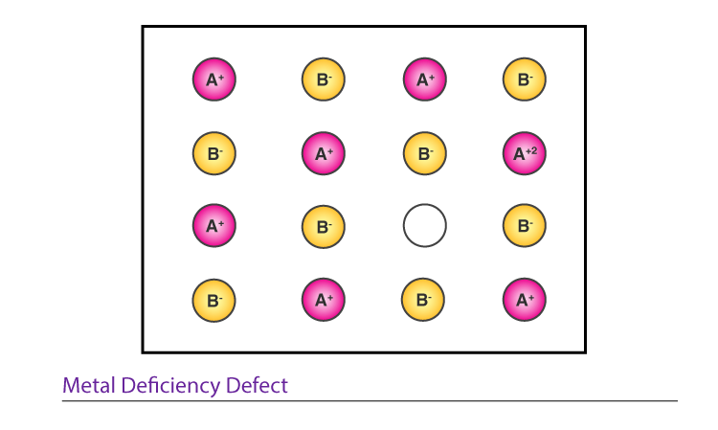

**Metal deficiency defects**

For eg. Fe0.95O in which some Fe2+ ions are missing and the loss of Fe2+ is balanced by the presence of required number of Fe3+ ions.

b. When an extra anion occupies in an interstitial void and to maintain electrical neutrality, some nearby cations acquire higher oxidation state as shown in the following figure_

**Consequences of metal deficiency defect:** Crystals having metal deficiency defect possess cation vacancies or holes which can conduct electricity. These are also called p-type semiconductor.

**iii**. **Impurity Defects:**

It arises when foreign atom or ion as impurity occupies a lattice site in place of host atom or ion, is called impurity defect. The process of adding impurities to a crystalline substance so as to change its properties is called ‘doping’. It may take place in ionic as well as covalent solids**.**

**A)Doping in ionic solids:** In case of ionic solids, the impurities are introduced in the form of ions. If the impurity ions are in different oxidation state from that of the host ions, vacancies are created which result in higher electrical conductivity of the solid. For eg. Addition of little SrCl2 as added to molten NaCl and then cooled.

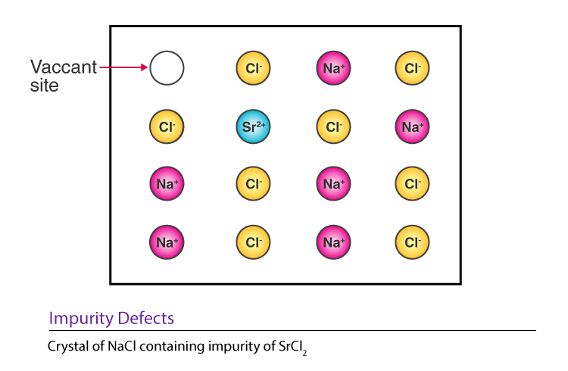

Vacant Site

**Impurity defect introduced by substituting Na+ ions by Sr2+ ions**

**B) Doping in covalent solids:** It is also called electronic defects. It may be of two types on the basis of impurity added_

|  |  |
| --- | --- |
| **a) Doping with Electron Rich Impurities** | **b) Doping with Electron Deficit Impurities** |
| **figa.jpg**  Doping of Si with gr.15 elements to produce n-type semiconductors  When group 14 elements like silicon or germanium having four electrons in the valence shell is doped with group 15 elements like P or As having five electrons in their valence shell. This excess electron increases its conductivity and are called n-type (negative) semi-conductors. | **figb.jpg**  Doping of Si with gr.13 elements to produce p-type semiconductors  When group 14 elements like Si or Ge is doped with group 13 elements like B, Al or Ga. In this case, hole is created due to less no. of electron containing impurities and thus forms p-type (positive) semi-conductors. |

**II.Line defects**

Line defects are the imperfections in crystalline substance which arise due to deviations from ideal arrangement in the entire rows of lattice points.

**ASSIGNMENT**

**A. Multiple choice questions:**

1. Vacancy defects in solids is a sub type of _

a) Point imperfections

b) Line imperfections

c) Volume imperfections

d) Surface imperfections

2. Substitution of a foreign atom in the site of parent atom in the crystal is a?

a) Vacancy defect

b) Substitution impurity

c) Volume imperfection

d) Vacancy defect

3. Edge dislocation imperfection is a sub type of_

a) Point imperfections

b) Line imperfections

c) Volume imperfections

d) Surface imperfections

4. Displacement of an ion from regular location to interstitial location is known as ____

a) Vacancy defect

b) Line imperfection

c) Schottky defect

d) Frenkel defect

5. When a pair of cation and anion are missing in a crystal, it is called ____

a) Vacancy defect

b) Line imperfection

c) Schottky defect

d) Frenkel defect

6. Which one of the following is not a zero-dimensional defect?

a) Vacancy defect

b) Substitution imperfection

c) Schottky’s defect

d) Screw dislocation

7. Twin or Twinning is a category of ____

a) Point imperfections

b) Line imperfections

c) Volume imperfections

d) Surface imperfections

8. As the grain size of a metal increases, its strength ____

a) Decreases

b) Increases

c) Remains constant

d) No effect of grain size on strength

9. As the grain size of a meal increases, its ductility ____

a) Decreases

b) Increases

c) Remains constant

d) No effect of grain size on ductility

10. Phenomenon of cross slip occurs in ____

a) Point imperfections

b) Line imperfections

c) Volume imperfections

d) Surface imperfections

**B. Short answer type questions:**

1.It can be seen now that both fcc and Hexagonal Primitive Structure have the same packing fraction. Moreover this is also the highest packing fraction of all the possible unit cells with one type of atom with empty voids. Can you explain this?

2.The radius of a calcium ion is 94 pm and of an oxide ion is 146 pm. Predict the crystal structure of calcium oxide.

3.The unit cell of silver iodide (AgI) has 4 iodine atoms in it. How many silver atoms must be there in the unit cell?

4.The co-ordination number of the barium ions, Ba2+, in barium chloride (BaF2) is 8. What must be the co-ordination number of the fluoride ions?

5. A solid between A and B has the following arrangement of atoms

Atoms A are arranged in ccp array

Atoms B occupy all the octahedral voids and half the tetrahedral voids.

What is the formula of the compound?

6.In corundum, oxide ions are arranged in hcp array and the aluminium ions occupy two thirds of octahedral voids. What is the formula of corundum?

7.Calculate the ratio of the alkali metal bromides on the basis of the data given below and predict the form of the crystal structure in each case. Ionic radii (in pm) are given below

Li+ = 74, Na+ = 102, K+ = 138

Rb+ = 148, Cs+ = 170, Br- = 195

8.In the close packed cation in an AB type solid have a radius of 75 pm, what would be the maximum and minimum sizes of the anions filling the voids?

9.NH4Cl crystallizes in a body centered cubic lattice, with a unit cell distance of 387 pm. Calculate (a) the distance between the oppositely charged ions in the lattice, and (b) the radius of the NH4+ ion if the radius of the Cl- ion is 181 pm.

10.Copper has the fcc crystal structure. Assuming an atomic radius of 130pm for copper atom (Cu = 63.54):

(a) What is the length of unit cell of Cu?

(b) What is the volume of the unit cell?

(c) How many atoms belong to the unit cell?

(d) Find the density of Cu.

***Note:* *Please do all this work in your “Chemistry Notebook” which will be checked when college resumes. Please consider this important.***

**\*\*\*\*\*\*\*\*\*\*\***