**1ST JUNE, 2020 JESUS AND MARY SCHOOL AND COLLEGE MODULE 3**

**CLASS XII ENGLISH LITERATURE**

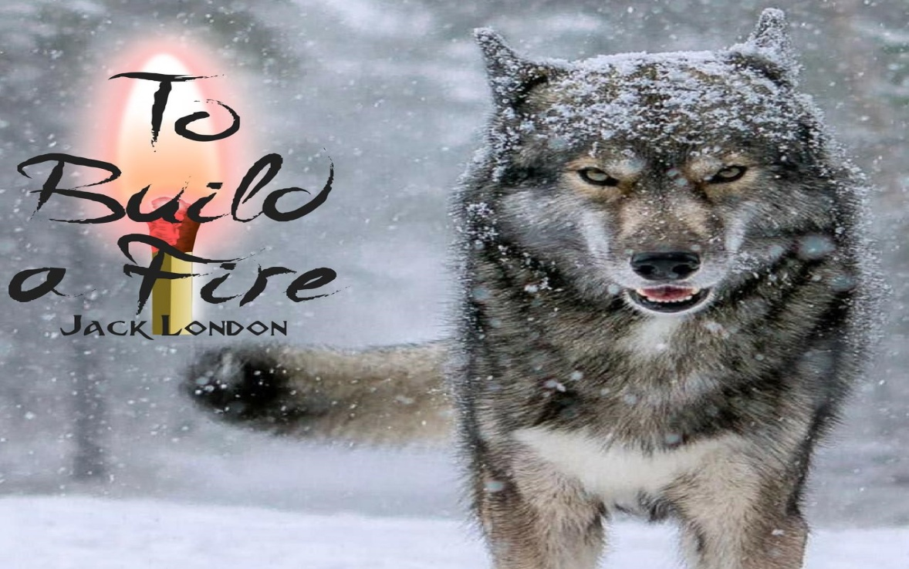

**TO BUILD A FIRE**

**By JACK LONDON**

***Dear Students,***

***THE SOLUTION TO THE PREVIOUS TWO UPLOADS HAVE BEEN GIVEN AT THE END OF THIS DOCUMENT. PLEASE ENSURE TO DO IT IN YOUR NOTEBOOKS.***

***Today we are going to study in as much detail as possible this story which is the longest story of your book. I have tried to summarize the story with the analysis of the summary for easy understanding. Please take your time and read this story carefully so that it may be understood in the best way possible.***

***The story tells us of an unnamed man and his dog who tries to cross the frozen Yukon region in north - western Canada. The temperatures are dropping to below minus seventy five degrees, but against all advice not to travel in such extreme conditions, the man is confident that he will cross the Yukon trail successfully, only to finally fail and meet his death at the hands of ruthless nature.***

**SUMMARY**

At dawn, [the man](https://www.litcharts.com/lit/to-build-a-fire/characters/the-man) turns aside from [the main Yukon trail](https://www.litcharts.com/lit/to-build-a-fire/symbols/the-main-yukon-trail). He is a solitary hiker. There is no sun in the clear sky, as this northern part of Canada has not seen daylight in several days at this time of year. The whiteness of the land, covered in ice and snow, is broken only by the trail which leads 500 miles south and 1,500 north all the way to the Bering Sea. The landscape has no effect on the man, despite the fact that it is new to him. This is the man’s first winter in this area.

**ANALYSIS**

The setting of the story in the extreme cold of the largely uninhabited Yukon establishes the thematic role nature will play from the beginning. Nature is awe-inspiring—extremely cold and stark—and also terrible in its indifference to individual human life. “The Man” has been given no name. His fatal flaw is, his unawareness of the power of nature, which is established immediately.

**SUMMARY**

[The man](https://www.litcharts.com/lit/to-build-a-fire/characters/the-man)’s lack of interest is due to his lack of imagination. The man is competent and resourceful, but practical, uninterested in the meanings behind things. ***A temperature of fifty degrees below zero*** does not encourage the man to imagine his own weakness, the possibilities of life after death, or the meaning of life. Cold simply means discomfort to him.

**ANALYSIS**

The man’s limited imagination repeatedly causes him to underestimate the power of nature. He is also confident in his survival skills, which rely on man-made resources, and not natural abilities.

**THE MAN IS TRAVELLING TO MEET HIS COMPANIONS.**

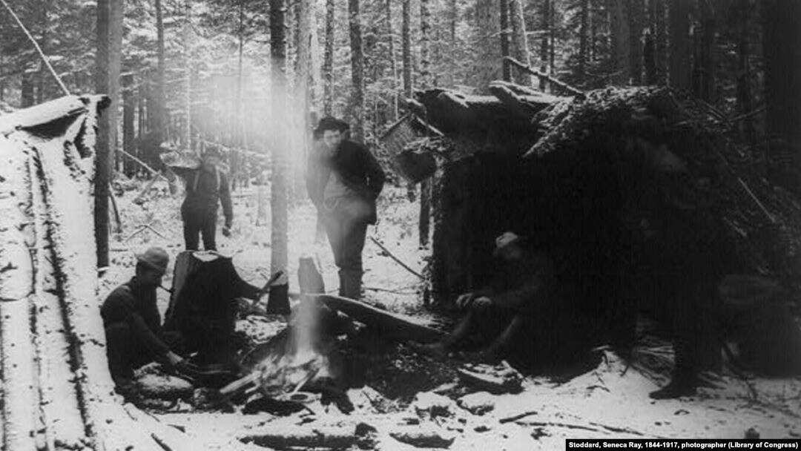

**SUMMARY**

As [the man](https://www.litcharts.com/lit/to-build-a-fire/characters/the-man) walks, he spits, only to discover that the liquid from his mouth freezes in the air as it falls. He assumes from this that the temperature is colder than fifty degrees below zero. The man is hiking alone toward Henderson Camp to meet [the boys](https://www.litcharts.com/lit/to-build-a-fire/symbols/the-boys), his travelling companions. He plans to arrive by six o’clock, when it’ll be dark, but the boys will already be there ready to greet him with a fire and a hot supper.

**ANALYSIS**

The boys represent civilization and protection from nature. The man is alone in nature, which is dangerous. His freezing spit should reinforce this danger, but the man, because of his limited imagination, overlooks the risks and consequences of such extreme cold.

**THE MAN TRIES TO EAT HIS LUNCH**

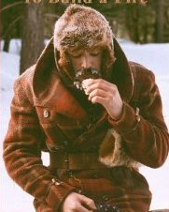

**SUMMARY**

[The man](https://www.litcharts.com/lit/to-build-a-fire/characters/the-man) carries his lunch inside his jacket against his skin, so that it won’t freeze. The side trail he travels on is not well-marked. He acknowledges as he walks that it is truly cold. His beard does not protect his nose or the upper part of his face sufficiently.

**ANALYSIS**

These details bring the situation to life. The man is a generic figure and many of the details in the story invite the reader to imagine him or herself in these conditions.

**ACCOMPANIED BY HIS DOG**

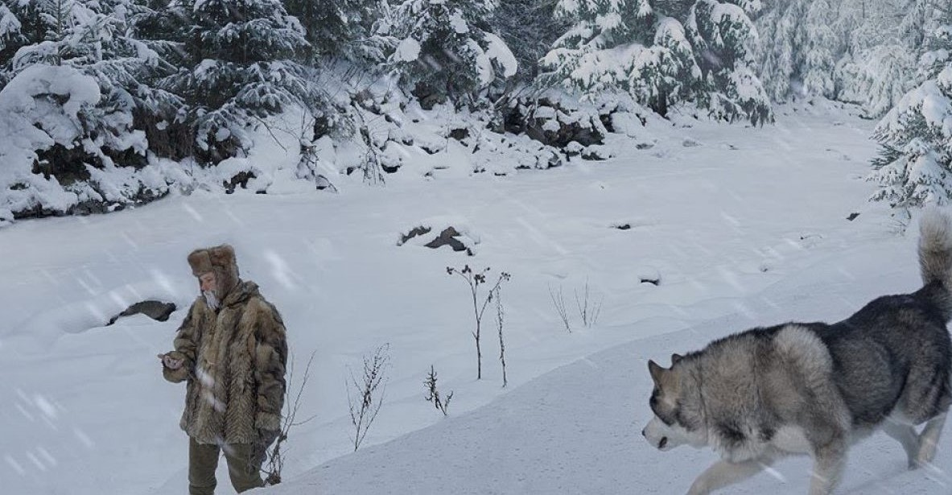

**SUMMARY**

A large wolf dog accompanies the man. [The dog](https://www.litcharts.com/lit/to-build-a-fire/characters/the-dog) is made anxious by the cold, knowing instinctively that in such weather it is safer to hide and wait out the cold. Although neither man nor dog is aware, the temperature of the day is ***seventy-five degrees below zero.*** The dog watches the man carefully, expecting him to go into camp or seek shelter and build a [fire](https://www.litcharts.com/lit/to-build-a-fire/symbols/fire). The dog looks to the man as the source of fire, and it desires that protective warmth.

**ANALYSIS**

The dog is a key figure because it represents everything that the man is not: natural, instinctual, and aware of the power of the natural world. The dog is “in touch” with the weather conditions because of its similarities to its wild cousin, the wolf. The dog’s instinctual knowledge is more helpful than the man’s rationality, and its unmet expectations suggests the mistakes the man is making.

**THE MAN’S FROZEN BEARD, WHATEVER HE SPITS OUT FREEZES**

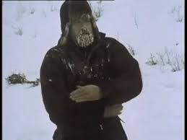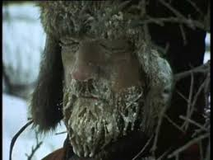

**SUMMARY**

Both, the fur of [the dog](https://www.litcharts.com/lit/to-build-a-fire/characters/the-dog) and the facial hair of [the man](https://www.litcharts.com/lit/to-build-a-fire/characters/the-man) are frosted from their warm breath freezing. The man’s chewing tobacco freezes in an icicle hanging from his mouth because the freezing material prevents from spitting effectively. The path follows Henderson Creek. The man is walking at four miles per hour and predicts his arrival at a place to eat lunch at half-past twelve.

**ANALYSIS**

The man and the dog, although different, are both impacted by the extreme conditions. The man’s focus remains on the rational aspects of his situation: calculating his rate of travel and planning his lunch. He is as disinterested in nature as it is in him.

**SUMMARY**

[The man](https://www.litcharts.com/lit/to-build-a-fire/characters/the-man) and [the dog](https://www.litcharts.com/lit/to-build-a-fire/characters/the-dog) walk along the frozen creek. The man is not a thinker and so he walks with few thoughts and reflections. He thinks only of his plan for lunch and of his arrival at the camp in the evening. Occasionally, he reflects on the cold, realizing that he has never experienced such extreme temperatures before. He rubs his face as he walks, but the skin instantly returns to its numb state once he stops. He wishes for a guard to more fully cover his nose and face from the cold. But, he reflects, a little frost is, at most, painful, never dangerous.

**ANALYSIS**

The man’s imagination is limited because all of his thinking is limited. The man is not intelligent, despite being practical and resourceful. His quickly freezing face shows that he is not prepared for these extreme conditions, and yet he overlooks this warning sign, yet again. This is an example of an error that the man makes which contributes to his demise. (Death)

**SUMMARY**

[The man](https://www.litcharts.com/lit/to-build-a-fire/characters/the-man) observes the changes in the creek and the safest places to put his weight. Once, he startles away from a place as he feels the ice move. The creek is fully frozen, but streams of water run from the hillsides under the snow. These concealed streams never freeze, and the depth of these waters might be three inches or three feet. These unexpected places of moving water present a very serious danger because breaking through the snow and ice to one of these streams could cause the man to get very wet. Getting his feet and legs wet at the very least means a delay. He’d need to build a [fire](https://www.litcharts.com/lit/to-build-a-fire/symbols/fire) and dry his clothes.

**ANALYSIS**

The mention of these concealed streams is a clear example of foreshadowing (What is about to happen). Once this threat is presented in the story, it is apparent that they will manifest (increase) in some way later on. The danger that this risk presents is established before the event occurs. This literary technique allows the reader to understand the dangers of the situation as it unfolds. It also introduces the idea of chance: the man is prepared for these risks, yet he is still not impacted by them.

**SUMMARY**

During his two hours of walking before lunch, [the man](https://www.litcharts.com/lit/to-build-a-fire/characters/the-man) happens to step upon several dangerous places in the ice. Usually the hidden water is indicated by a sunken area, but not always. At once patch, he sends [the dog](https://www.litcharts.com/lit/to-build-a-fire/characters/the-dog) across first. The dog falls through the ice, but quickly crawls out on the other side. The water on its feet and legs freezes immediately and the dog lays down in the snow to bite away the chunks of ice. The dog does this instinctively, not because it understands the consequences of frozen feet. The man helps the dog, but his fingers grow numb within a minute of removing his glove.

**ANALYSIS**

The man’s decision to send the dog across a dangerous patch of ice first reveals the lack of empathy or love between the dog and his master. The man would happily risk the dog’s life. But the dog is also better prepared to deal with the risks of extreme cold as his act of biting away the ice on his paws shows. The dog is protected by his instincts, which the man lacks.

**NEED TO BUILD AFIRE**

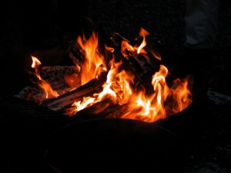

**SUMMARY**

[The man](https://www.litcharts.com/lit/to-build-a-fire/characters/the-man) arrives at the creek divide where he planned to eat lunch. He is pleased with his pace (speed of travelling) and settles down to eat. He strikes his numb, bare fingers against his leg to warm them. He tries to take a bite, only to find the ice around his mouth impenetrable (cannot be broken through). He laughs, realizing he should have immediately made a [fire](https://www.litcharts.com/lit/to-build-a-fire/symbols/fire). The feeling in his toes when he first sat down has gone. His toes are frozen. He questions whether his toes are numb or warm. He leaps up and stamps his feet until the feeling returns.

**ANALYSIS**

The man’s initial failure to build a fire demonstrates how much he needs one. That the man is unable to eat without a fire despite keeping his lunch against his body again attests to the way his preparations are not enough to face this degree of cold. This first successful fire establishes fire as a source of life and protection, vitally important to the man’s survival in the story.

**THE MAN’S FIRST ATTEMPT TO BUILD A FIRE**

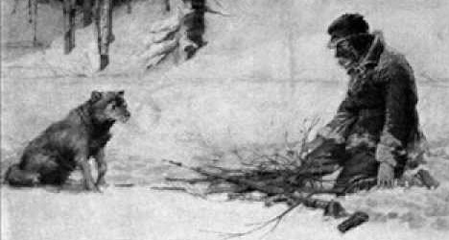

**SUMMARY**

The [man](https://www.litcharts.com/lit/to-build-a-fire/characters/the-man) remembers an [old man at Sulphur Creek](https://www.litcharts.com/lit/to-build-a-fire/symbols/the-old-man-at-sulphur-creek) who told him how cold it could get in this area this time of year. He remembers how he laughed at the old man, but now he realizes the truth in the old man’s words. It is very cold. He gathers wood and lights a fire with a match. Once the fire is ready, he leans near to melt the ice from his face. He eats his lunch. [The dog](https://www.litcharts.com/lit/to-build-a-fire/characters/the-dog) lies near the fire. The man smokes his pipe, enjoying the brief break.

**ANALYSIS**

The old man at Sulphur Creek presents a different possibility for the relationship between humans and nature: one based on healthy fear and respect of the natural world. The old man understands the natural world because he does not underestimate it, as the man does. Meanwhile, the man is able to enjoy life even in such cold with the comfort of a fire.

**THE MAN AND THE DOG ARE INDIFFERENT TO EACH OTHER**

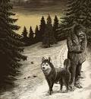

**SUMMARY**

As [the man](https://www.litcharts.com/lit/to-build-a-fire/characters/the-man) continues his walk, [the dog](https://www.litcharts.com/lit/to-build-a-fire/characters/the-dog) does not want to leave the fire behind. The dog knows this type of cold, as its ancestors did. The dog and the man are not companions or friends. The dog is the man’s slave, and the dog does not care about the man’s well being. Therefore, it does not attempt to help the man or express its misgivings about leaving the [fire](https://www.litcharts.com/lit/to-build-a-fire/symbols/fire) behind other than for its own survival. But the dog must obey the man’s whistle to follow him.

**ANALYSIS**

The dog’s attachment to the fire shows that its instinctual knowledge is more effective in this situation than the man’s scientific knowledge. The lack of care between dog and man is further established: both are only focused on their own survival and well being. A human companion would have been a different type of support for the man.

**SUMMARY**

For the next half hour, [the man](https://www.litcharts.com/lit/to-build-a-fire/characters/the-man) does not observe any signs of water under the snow. Then, without warning, the ice breaks and the man falls through into a shallow pool. His pants and boots are wet to the knees. He curses aloud at the delay. He knows enough to understand that he must stop and build a [fire](https://www.litcharts.com/lit/to-build-a-fire/symbols/fire). It is too dangerous to be wet at this temperature.

**ANALYSIS**

The man’s accident is a dramatic moment in the story, as both man and reader seem to fully realize the consequences: the stakes of building a fire are now much higher. The fire is literally the only chance he has at survival.

**THE MAN’S SECOND ATTEMPT TO BUILD A FIRE**

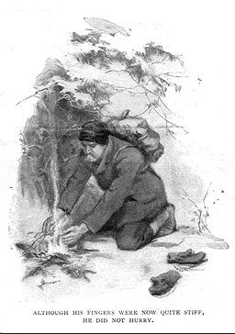

**SUMMARY**

Under some pine trees at the top of the bank, [the man](https://www.litcharts.com/lit/to-build-a-fire/characters/the-man) discovers some dry wood and grasses. He builds his [fire](https://www.litcharts.com/lit/to-build-a-fire/symbols/fire) carefully because he understands that he will have one chance to successfully build a fire. With wet feet, his time in such a cold temperature is precious. If his feet were dry, he could run to keep his blood circulating, but even running could not keep wet feet from freezing. The man is aware of the importance of building a fire if he’s wet because of more advice from the [old man at Sulphur Creek](https://www.litcharts.com/lit/to-build-a-fire/symbols/the-old-man-at-sulphur-creek). He’s grateful for the advice.

**ANALYSIS**

The man is cautious and careful in his fire building, and, yet, he overlooks the thing that will destroy him: the location of his fire under the pine trees. The man’s care shows his practicality and awareness of the relevance of the advice of the old man at Sulphur Creek. The man is not foolish. This is important because it shows that even a resourceful human may not survive a chance accident in nature.

**SUMMARY**

[The man](https://www.litcharts.com/lit/to-build-a-fire/characters/the-man) removes his mittens to pile the sticks and light the [fire](https://www.litcharts.com/lit/to-build-a-fire/symbols/fire) and his fingers quickly grow numb. His quick hiking helped keep his blood flowing, but as soon as he stops walking to build a fire, his extremities grow cold quickly. Like [the dog](https://www.litcharts.com/lit/to-build-a-fire/characters/the-dog), his blood wants to hide away from the cold, sinking to the central parts of his body, away from the surface. His nose, face, feet and hands grow numb first.

**ANALYSIS**

In describing the man’s blood as “living” and comparing his blood and its reaction to the cold to the dog’s similar reaction to the cold, the story shows that the man is, physically, still part of nature. His blood works instinctively, even if he overpowers this instinctual knowledge with his confident mind.

**SUMMARY**

The freezing does not matter, [the man](https://www.litcharts.com/lit/to-build-a-fire/characters/the-man) tells himself, as the [fire](https://www.litcharts.com/lit/to-build-a-fire/symbols/fire) roars to life. The [old man at Sulpur Creek](https://www.litcharts.com/lit/to-build-a-fire/symbols/the-old-man-at-sulphur-creek) had told him that no man should travel alone if it was colder than fifty degrees below zero. The man congratulates himself on proving the old man wrong. He’d had an accident and yet he’d saved himself without assistance. Any rational man, who is not old and womanish, should be able to do so, the man reflects.

**ANALYSIS**

The man’s success in building the fire seems a testament to his resourcefulness and the power of man in nature. Yet the man’s self-congratulation also lacks any respect for nature, and is full of a kind of pride before a fall…

**BUILDING THE FIRE UNDER THE PINE TREES WAS A TERRIBLE MISTAKE**

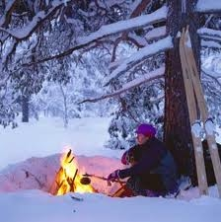

**SUMMARY**

[The man](https://www.litcharts.com/lit/to-build-a-fire/characters/the-man) starts to remove his moccasins (shoes), but the strings are frozen. His fingers are numb. Then he reaches for his knife to cut the strings. But, at that instant, snow falls from the pine trees above onto the man and [fire](https://www.litcharts.com/lit/to-build-a-fire/symbols/fire). This was the man’s mistake. ***He built his fire underneath the trees because it was easier to gather the wood.*** The tree above held a large amount of snow on its branches, and, as the man pulled sticks from the lower branches, he jostled (shook) the tree. Eventually, this movement created a landslide of snow from above,

… which then destroys his fire.

**ANALYSIS**

The collapse of the snow from the trees is the best example of the broader theme of chance and human error. The collapse of the snow occurs both through the man’s failure to understand the consequences of the position of his fire, as well as by the chance of where the snow falls and when. But it also shows his failure of imagination, his failure to be interested in and see the broader possibilities and risks of the world around him.

**SUMMARY**

The fire is smothered (destroyed) under a pile of snow. [The man](https://www.litcharts.com/lit/to-build-a-fire/characters/the-man) is shocked, as if he has heard his own death knell (a bell ringing to mark his death). He thinks of the advice of the [old man at Sulphur Creek](https://www.litcharts.com/lit/to-build-a-fire/symbols/the-old-man-at-sulphur-creek). A companion on the trail could make all the difference at that moment: he could have built the fire. The man knows he’s likely to lose some toes at this point, because of frostbite, even if he builds a second fire. He moves quickly and calmly, preparing a new foundation for a fire out in the open. [The dog](https://www.litcharts.com/lit/to-build-a-fire/characters/the-dog) watches his activities.

**ANALYSIS**

In the moment of his fire’s collapse, the man is humbled. He begins to admit that the old man was right and that the situation is extremely serious. However, he still refuses to consider the possibility of his own death and he still focuses on the practical steps toward survival. The watching dog again suggests the man’s lack of instinctual response to his situation (as opposed to his rational, practical response).

**SUMMARY**

[The man](https://www.litcharts.com/lit/to-build-a-fire/characters/the-man) reaches into his pocket to get a piece of tree bark that will easily catch fire and help him start his [fire](https://www.litcharts.com/lit/to-build-a-fire/symbols/fire). But his fingers are so numb that he cannot tell if he has grabbed onto the bark or where it is in his pocket. He fights his growing alarm that each second spent trying to grab the bark is another second in which his feet freeze more fully. He puts on his mittens and beats his hands. He looks at [the dog](https://www.litcharts.com/lit/to-build-a-fire/characters/the-dog), which is secure and safe because its natural body provides the protection it needs against the cold.

**ANALYSIS**

The detailed and painstaking description of the man’s struggle to complete simple tasks with frozen fingers demonstrates the realism of London’s writing. The man’s jealousy of the dog shows a shift in his thinking: he is no longer confident in his man-made resources, and recognizes that the dog is better prepared than he because of its natural abilities.

**THE MAN’S THIRD AND LAST ATTEMPT TO BUILD A FIRE**

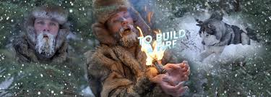

**SUMMARY**

Some feeling returns painfully to his fingers and [the man](https://www.litcharts.com/lit/to-build-a-fire/characters/the-man) manages to remove the tree bark from his pocket. He retrieves his pack of matches, but his fingers are re-freezing and he drops the pack in the snow. He cannot pick up the pack. He tries to move deliberately; driving fear from his mind, he focuses entirely on picking up the matches, looking at his fingers closing because he cannot feel. He puts on his mitten (gloves) and beat his hand against his knee again.

**ANALYSIS**

The man’s attempt to light the matches is painful to read and to imagine because of its nightmare-like experience of being unable to do the one thing that will make a difference in saving his life. At this point, the ending of the story starts to become inevitable. The terror of the man, the stark indifference of nature, and the man’s smallness within nature, are clear.

**SUMMARY**

Eventually, [the man](https://www.litcharts.com/lit/to-build-a-fire/characters/the-man) gets the pack of matches between his mitten-clad hands and then into his mouth, breaking the ice as he wrenches his jaw open. He removes one match with his teeth, but drops it. He gets one match in his teeth and strikes it on his leg, but the smoke in his nose causes him to spit out the burning match into the snow. In despair, he admits that the [old man at Sulpur Creek](https://www.litcharts.com/lit/to-build-a-fire/symbols/the-old-man-at-sulphur-creek) was right: he should never have travelled alone.

**ANALYSIS**

The man is betrayed by his own body: his hands fail him and he cannot control his natural reaction to the smoke which chokes him and which causes him to drop the lit match. The man is unable to overpower his body’s limitations with his mind. In this way, nature (the part of the man that is natural) continues to be stronger than human reason.

**SUMMARY**

In sudden desperation, [the man](https://www.litcharts.com/lit/to-build-a-fire/characters/the-man) removes both gloves and strikes the whole pack of matches. There is no wind and so the man holds the pack to the tree bark. He cannot feel it, but he realizes ***his hand is burning from the smell of burning flesh.*** Then he feels pain, but still holds the matches. He drops them into the snow once the tree bark is lit. This small flame means life and he carefully adds grasses and wood pieces.

**ANALYSIS**

The man’s actions of lighting all the matches and of letting his flesh burn until the tree bark is lit show the extent of his desperation. The simple narration of the story avoids overstatement or descriptions of the inner-workings of the man’s mind. The reader sees and feels his fear through his actions.

**SUMMARY**

[The man](https://www.litcharts.com/lit/to-build-a-fire/characters/the-man)’s body is shaking from the cold. He cannot successfully control his hands as he adds sticks to the [fire](https://www.litcharts.com/lit/to-build-a-fire/symbols/fire). He tries to push a wet piece out of the flames, but he scatters the coals he has been cultivating. Each piece is smothered and dies. His fire has failed.

**ANALYSIS**

This lack of bodily control reinforces the idea that the man’s body has betrayed him. His lack of control of his hands is such that he accidentally puts out the fire he is trying to create. His practical, rational knowledge is worthless when he can’t control his own body. But he never perceived of this danger as he couldn’t imagine not having control of his body, and couldn’t imagine the consequences of the cold.

**THE MAN DECIDES TO KILL THE DOG TO WARM HIS HANDS INSIDE ITS BODY**

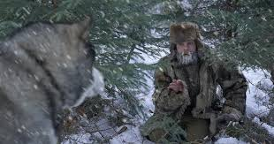

**SUMMARY**

[The dog](https://www.litcharts.com/lit/to-build-a-fire/characters/the-dog) is sitting across from [the man](https://www.litcharts.com/lit/to-build-a-fire/characters/the-man) and the sight of the dog inspires an idea. The man once heard a story about a man who survived a winter storm by killing an animal and crawling inside the corpse. The man thinks that he could kill the dog and put his hands inside the body to warm them. Then he could attempt to build another [fire](https://www.litcharts.com/lit/to-build-a-fire/symbols/fire). He calls the dog, but his voice reveals his fear and his intentions. The dog shies away from whatever he senses in the man’s voice. The man tries to crawl toward the dog, but this is unusual, so the dog is scared.

**ANALYSIS**

The man’s decision to kill the dog represents both his desperation and the absence of emotional bond between human and animal. The man is thinking like an animal, putting survival above all other considerations. Neither man nor dog considers the life of the other. Both only see the other as a means to their own survival. The man is not sentimental about the dog.

**SUMMARY**

[The man](https://www.litcharts.com/lit/to-build-a-fire/characters/the-man) puts on his mittens and stands. He cannot feel his feet and looks down to make sure he is truly standing. He calls [the dog](https://www.litcharts.com/lit/to-build-a-fire/characters/the-dog) again. When the dog comes, the man tries to grab it and is surprised again to find that his hands cannot grasp. He is able, however, to wrap his arms around the dog and hold it. The dog barks and tries to break free. The man realizes that he physically cannot kill the dog. He cannot hold his knife. He cannot strangle the dog with his frozen hands. He lets go and the dog runs off only forty feet before stopping and continuing to watch him.

**ANALYSIS**

The man’s capture and then release of the dog is another mental and emotional turning point. The man is used to having a plan and is surprised when he cannot grasp the dog or kill it, especially because he starts to carry out his plan and then is forced to abandon the idea. This shows more fully the betrayal of his body, which cannot carry out the commands of his mind or use the man-made resources, like a knife, that he has relied on.

**SUMMARY**

[The man](https://www.litcharts.com/lit/to-build-a-fire/characters/the-man) discovers that he needs to look down to see where his hands and arms are because he cannot feel anything. He beats his arms and hands for five minutes when he is suddenly overwhelmed by fear of his own death. The situation is no longer one in which he could lose fingers or toes, but his life. Panicking, he starts to run along the trail. He is blinded by fear greater than anything he has ever experienced.

**ANALYSIS**

The man is trying to be practical when he is overwhelmed for the first time by fear of his own death. His instinctual need to live overpowers his rational thought, and for the rest of the story, the man’s thinking fluctuates between desperate desire for survival and certainty of death. This introduces the theme of fighting versus accepting death.

**SUMMARY**

Running helps [the man](https://www.litcharts.com/lit/to-build-a-fire/characters/the-man) stop shaking. He regains some hope of being able to run far enough to keep his feet from freezing, to reach the camp. If only he could get there, then [the boys](https://www.litcharts.com/lit/to-build-a-fire/symbols/the-boys) would take care of him. But he also starts to think that he’ll never reach the camp, and that he’ll die in the wilderness. He tries to smother this thought, to overpower it when it comes to the front of his mind. He feels he is flying over the surface of the earth because he cannot feel his feet.

**ANALYSIS**

The man regains false hope as he runs. At the same time, he realizes new despair. The two extremes of hope for life and certainty of death are both in his mind. For the first time, the man is imagining possible outcomes of his situation. He had no such thoughts before when he was neither thinking nor imagining, when he was focused on rational practicality.

**SUMMARY**

[The man](https://www.litcharts.com/lit/to-build-a-fire/characters/the-man) runs and stumbles. Then he falls. He cannot get up and decides he must rest before he continues. He lacks endurance (stamina) for long-distance running. As he sits, he feels warm, but he realizes that actually more and more of his body is freezing. He pictures his body completely frozen, and this sets off a new panic. He runs again. He walks. He runs again.

**ANALYSIS**

The man’s body is failing partly because he did not prepare fully for the conditions he would experience in Yukon. This is an example of human error combined with the chance need to run for survival. He is now driven not by practical considerations but the desperate hope of life.

**SUMMARY**

Throughout [the man](https://www.litcharts.com/lit/to-build-a-fire/characters/the-man)’s running and falling, [the dog](https://www.litcharts.com/lit/to-build-a-fire/characters/the-dog) keeps pace with him. The man looks at the dog’s warm coat that provides safety from the weather. He curses it aloud. He runs only one hundred feet before he falls. This time, he sits and feels calm. He thinks about dying with dignity after he realizes that he has been foolishly running around when his death is inevitable. He begins to grow sleepy. Freezing is not too bad, he thinks. Sleep is peaceful compared to other deaths.

**ANALYSIS**

The dog’s lack of understanding of the man’s situation, and its own continued normal behaviour, represent the indifference of all nature to the man’s fate. Eventually, the man begins to accept death. The stages of his acceptance and exhaustion mirror real near-death accounts, demonstrating London’s realism.

**SUMMARY**

[The man](https://www.litcharts.com/lit/to-build-a-fire/characters/the-man) imagines [the boys](https://www.litcharts.com/lit/to-build-a-fire/symbols/the-boys) finding his frozen body after searching for him the next day. He pictures them on the trail and himself with them. In this vision, the group finds his body lying in the snow and the man feels that his is outside himself, looking at his body. He thinks again of the [old man at Sulphur Creek](https://www.litcharts.com/lit/to-build-a-fire/symbols/the-old-man-at-sulphur-creek). He murmurs aloud to the man that he was right in his advice about travelling alone.

**ANALYSIS**

The man’s out-of-body experience is representative of many real near-death accounts. His vision of the boys finding him shows his desire for the unattainable: other humans and civilization. As he falls into his death-visions (talking to a man who isn’t there in a way that he never would have done when he was his earlier practical self) he displays a fuller understanding of nature. Of course, this knowledge came at the cost of his own death.

**THE MAN FALLS ASLEEP NEVER TO WAKE UP AGAIN**

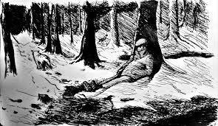

**SUMMARY**

Finally, [the man](https://www.litcharts.com/lit/to-build-a-fire/characters/the-man) falls into a sleep that seems more restful than any other sleep he has experienced. [The dog](https://www.litcharts.com/lit/to-build-a-fire/characters/the-dog) sits waiting. Evening arrives. The dog is surprised that the man sits in the snow and does not make a [fire](https://www.litcharts.com/lit/to-build-a-fire/symbols/fire). The dog cries out, longing for a fire. It expects the man to curse, but there is only silence. Later, the dog moves near to the man, but it smells death. It waits longer, howling, while the stars shine in the sky. Eventually, the dog leaves, running along the trail to the camp, seeking the other people who can make fires and provide food.

**ANALYSIS**

The final passage of the story contrasts the man’s death with the stunningly beautiful natural world, which is also cold and indifferent. The dog’s eventual departure from the man’s body shows that humans are interchangeable in its mind, another example of the indifference of nature. The dog survives and the man does not, showing the triumph of instinct over rationality.

**THIS FIRE WAS SO ESSENTIAL FOR THE MAN’S SURVIVAL**



**WORKSHEET 3**

**Answer the following questions to test your ability of comprehending the story:**

1. Where was the man travelling? What was his purpose of travel?
2. Describe the severe conditions that the man was travelling through.
3. What was the man’s attitude towards his surroundings?
4. What were the man and the dog’s attitude towards each other?
5. With reference to the text, describe the dangers that lurked beneath the snow.
6. Describe the man’s first attempt to build the file. Was he successful?
7. The theme of the story is ‘Man versus Nature’. Do you agree with this? Give reasons.
8. Describe the man’s second attempt to build the fire. What caused him to fail?
9. Narrate briefly the third attempt to build the fire. Why did he not succeed?
10. The man finally resigned himself to his fate. Discuss with reference to the ending of the story.

**DESCRIPTIVE TYPE QUESTIONS.**

1. **Describe the man’s repeated attempts to keep himself warm.**
2. **Contrast the attitude of the man and the dog towards the weather.**
3. **What does the man finally learn from his experience?**

**NOTE: Please ensure that all the answers are done in your old note books which will be checked when the school reopens.**

**SOLUTION TO WORKSHEET 1 UPLOADED ON 04.05.2020.**

**FROM TEXT 1:**

1. Prospero is standing in front of his cell. Ferdinand and Miranda are also with him.
2. Prospero had made Ferdinand pile up logs in front of his cell. It was physically and psychologically severe because Ferdinand was a prince and he was not used to manual labour and it was also below his dignity to do such menial work.
3. Prospero compensates him by giving him an integral part of his life. He offers him a priceless gift, his daughter Miranda’s hand in marriage.
4. An Oracle is the voice of God. Even if the Oracle had to tell him differently about Miranda, he would not believe it. He would not hear anything against Miranda.
5. The acquisition is the winning of Miranda. Prospero had warned Ferdinand to maintain the chastity of his daughter and had subjected him to menial labour to test the purity of his love for Miranda. Now Ferdinand had passed the test and had ‘purchased’ his prize.

**FROM TEXT 2:**

1. Ariel was summoned suddenly because Prospero was suddenly reminded of the evil Caliban and his companions and their attempt to kill him. The rabble is the crowd of other spirits. The rabble is to carry out an illusion worked out by Prospero’s magic to entertain Ferdinand and Miranda.
2. The illusion of Prospero’s magic that is presented through the masque performed by Iris, Ceres and Juno.
3. Ariel is now obedient to Prospero’s orders and does not want to incite him to anger, so he carries out all his orders without any delay.
4. He calls Ariel industrious because Ariel carries out all his orders to perfection.
5. Ariel has successfully performed the Tempest and has caused all his enemies to be brought down to their knees and at his mercy.

**FROM TEXT 3:**

1. Iris is the goddess of the rainbow. She is believed to be the messenger of the gods, especially Juno. She invokes Ceres, the goddess of Agriculture.
2. She describes them as rich fields of wheat, rye, barley, vetches, oats and peas. She describes the mountains as turf covered, where the sheep feed, where flat meadows are covered with fodder for the cattle. She describes the river banks overgrown with marsh marigolds and reeds.
3. Juno is the name of the wife of the chief God, Jupiter, in Roman mythology. Her messenger is Iris, the goddess of the rainbow. She tells Ceres that Juno has commanded her to leave everything and come to that grassy lawn to play with Juno. She tells her to prepare to entertain Juno.
4. With her wings of orange colour, Iris drops honey on her flowers in the form of refreshing showers and with each end of her blue rainbow, she covers her green fields and her bare plains like a rich scarf covering proud Mother Earth.
5. Iris tells Ceres that she has been invited to celebrate a solemn pledge of true love and to freely bestow some gift on the happy lovers.

**FROM TEXT 4:**

1. Ceres is afraid of the company of Venus and her son because they had plotted against her by using those means by which Pluto, the dark God of the underworld had abducted her daughter Prosperpina from the earth to his own kingdom. Ceres therefore has strong grievance against Venus and her son.
2. Venus and her son Cupid had used their magic charms to try and incite the lovers Ferdinand and Miranda so that Miranda’s virginity would be defiled before their union. But they had failed in their attempts.
3. Hymen is the god of marriages and he is supposed to be carrying a lamp which is lighted when the marriage is solemnized. Mars is the god of war and his minion is his darling, the goddess Venus.
4. Cupid is said to be the irritable son of Venus who causes people to fall in love. Since he has failed in his mission to cause mischief between Ferdinand and Miranda, he has now broken all his arrows and says he will shoot no more, but will now play with sparrows.
5. Ceres recognizes Juno by her manner of walking and knows now that she is coming.

**FROM TEXT 5:**

1. This scene takes place in front of the cell of Prospero on the island. The spirits are involved for the purpose of entertaining and celebrating the betrothal of Ferdinand and Miranda.
2. Juno blesses them with honour, riches, a happy marriage, long life and much happiness and many hours of joy.
3. Ceres blesses them with the abundance of crops on earth, may their barns and stores never be empty, may their vines always be clustered with grapes, may spring come to them at the last and may scarcity and want never come to them.
4. This majestic vision has been arranged by Prospero to celebrate the betrothal of Ferdinand with Miranda.
5. Continuance means long life and Foison means plentiful.

**FROM TEXT 6:**

1. Naiads are the spirits of the streams. Their garlands are woven from reeds and they have very innocent looks.
2. This means marriage of true lovers being solemnized. Ferdinand and Miranda have to enter this contract of true love.
3. She tells the nymphs to come and help celebrate the marriage of the true lovers.
4. The wedding is attended by the goddesses, Iris, Ceres and Juno and the entertainment is provided by the nymphs and reapers. This in itself is proof enough that the celebration must be grand. They were celebrating the wedding of Ferdinand and Miranda.
5. Prospero suddenly becomes serious as he is reminded of the villainy of Caliban and his confederates. As he speaks, with a strange and confused noise, all the spirits and goddesses depart.

**SOLUTION TO WORKSHEET 2 UPLOADED ON 18.05.2020**

1. Ferdinand sees the sudden change in Prospero and gets dismayed, upset and scared. Prospero had abruptly ended the celebration because he was suddenly reminded of the foul conspiracy of the beast Caliban and his helpers plotting against his life.
2. Prospero makes an apt comparison by saying that all the actors performing the masque were spirits and have vanished into thin air just like the unreal vision, the great towers rising to touch the clouds, all the grand palaces and the holy temples and the great world itself nwith all its people will vanish, fading out like the unreal vision of the spirits that just performed the masque.
3. Being drunk, they became so brave that they were aiming their blows in the air that blew in their faces. They stamped the ground that dared to touch their feet, but yet they were determined to pursue their plot to kill Prospero.
4. Ariel made them follow him through thorny bushes that pierced their legs and finally left them in the dirt covered cell beyond Prospero’s cell with the dirty water up to their chins.
5. He tells Ariel to go and bring the flashy garments from his house to set up as an attraction for the thieves (Caliban and group) to catch them.
6. Caliban is referred as a born devil because no amount of goodness or education can have any impact on him. All the troubles and noble motives that Prospero had taken to make him a better person have been wasted. His body becomes more ugly with age and his mind grows more foul.
7. The villains have lost their precious bottle of wine in the pool. This is a disgrace and an infinite loss. They lost it in the dirty pool where they were standing up to their chins.
8. The good mischief is the plan to murder Prospero. If the plan would be successful, Stephano would become the king of the island, Trinculo would become his minister and Caliban would become their subject and free from the tyranny of Prospero.
9. Dropsy is a disease which causes swelling of the soft tissues of the body. Caliban is cursing Trinculo that he may be affected with dropsy. He is annoyed with Trinculo because Trinculo is being attracted towards the flashy garments that have been hung there to serve as bait for them by Prospero.
10. Fury and Tyrant are the names of the dogs and hounds that have been let loose on the three villains. They have been asked to chase the villains.
11. They are punished for plotting against the life of Prospero.
12. Prospero intends to tell his spirits to afflict their joints with painful spasms and to make their muscles contract with cramps that affect the old people and pinch them till more scars are left on their bodies.
13. All the three culprits are driven out from there. This shows that Prospero is relentless and merciless in his quest for revenge.
14. Prospero is a very wise and careful magician who waits patiently for his enemies to be at his mercy and then take action on them so that they may all be at his mercy.
15. The main purpose of Prospero for uniting Ferdinand and Miranda is that he wants Miranda to become the queen of Naples. His dukedom was taken away by Antonio with the help the king of Naples. So what better revenge if ultimately his own daughter becomes the queen of Naples and rules over them all.

**Students, please note that the above given solution to Module 1 and 2 will have to be done in your old note books. Please be informed that all this work being done online will not be repeated in school due to time constraints. This is the reason I have made the language as simple as possible and have also introduced illustrations (pictures) in the text for easy understanding. It has taken me many hours of painstaking work to complete this module, so please pay careful attention to what is being explained and complete all the solutions in your note books.**

**JOE SIR.**

**\*\*\*\*\*\*\*\*\*\*\*\*\*\*\*\*\*\*\*\*\*\*\*\*\*\*\*\*\*\*\*\*\*\*\*\*\*\*\*\*\*\*\*\*\*\*\*\*\*\*\*\*\*\*\*\*\*\*\*\*\*\*\*\*\*\***