**1st June 2020 Jesus and Mary School MODULE – 3**

**Class 2**

**Science**

**Wild Animals**

In the last topic we learned about Plants and their uses. In this topic we will learn about animals.

Forests are home to many animals. Animals which live in dense forest all over the world are called wild animals. Animals like lions, giraffes, tigers, and crocodile are wild animals. Forests or jungles are home to these animals where they can live safely in their natural environment.

We cannot keep wild animals at homes or farms as they can be dangerous for us. We can watch them in a zoo where they are kept safe in a confined space for public to see.

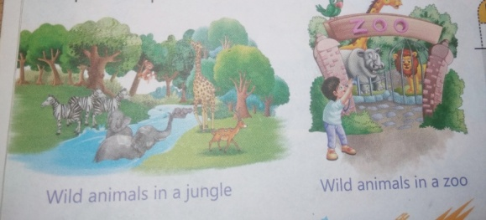

Where do Animals Live?

Some wild animals make home to live in, while some do not.

Animals need shelter to protect themselves from extreme weather conditions and from other animals.

1. Animals like deer, elephant, giraffe, zebra etc. do not build their homes. They wander from one place to another in search of food and water. They live in big groups called Herd.

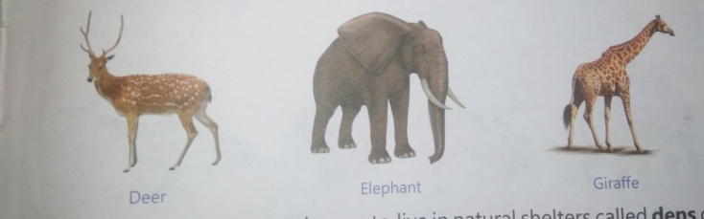

1. Some animals like lions, bears etc. live in natural shelters called Dens or Caves.

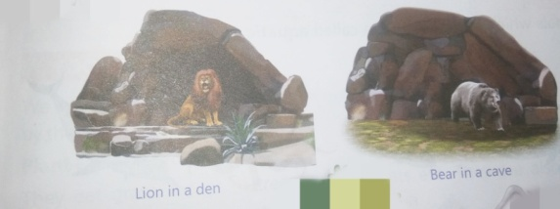

Animals like birds, monkeys, squirrels etc. live on trees. Rabbits, rats and snake live underground or in holes.

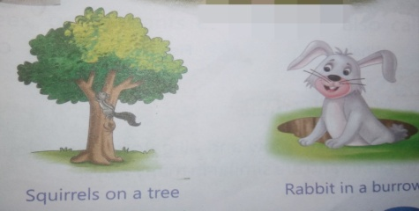

Animals which live in water are called Aquatic animals.

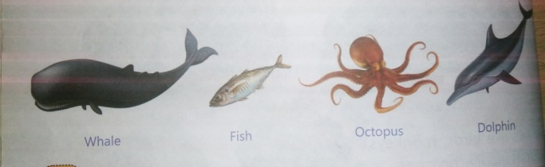

Animals who can survive on both land and water are called Amphibians.

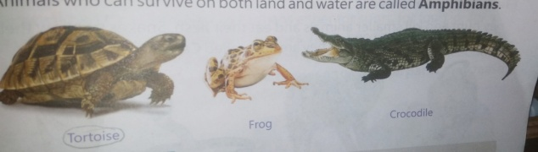

Food of Animals

We can divide animals into different groups on the basis of the food eaten by them.

Plant Eating Animals

They eat grass, leaves, of trees, green plants etc. They are also called Herbivores.

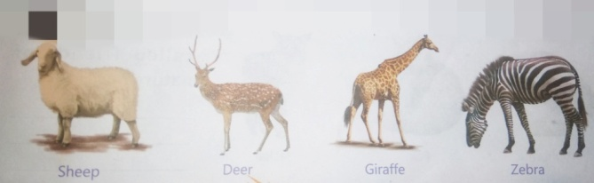

Flesh Eating Animals

They hunt and kill smaller animals and eat their flesh. Snakes swallow their prey whole without chewing. They also called Carnivores.

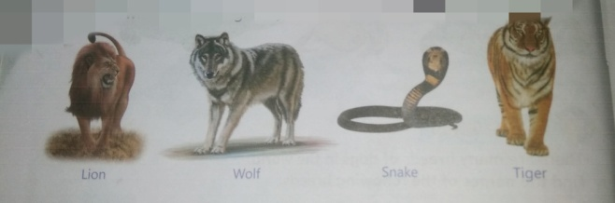

Animals Eating Both Plant and Animals

They eat plant parts as well as flesh of animals. They are also called Omnivores.

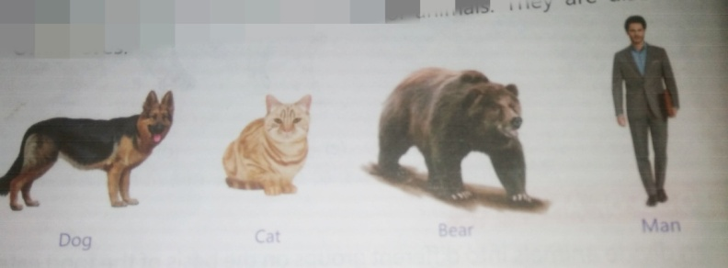

Animals Eating Flesh of dead Animals

They eat flesh of dead animals. They are also called Scavengers. Such animals help to keep the jungle clean.

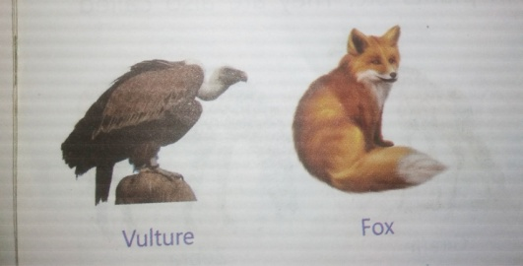

Endangered Animals

Many wild animals are killed by humans either for sport, for food, or for just fun. As a result, many animals species have become endangered. The number of animals in our world is becoming less. These animals need to be protected. They are protected in sanctuaries and national parks to increase their number and to save the natural environment.

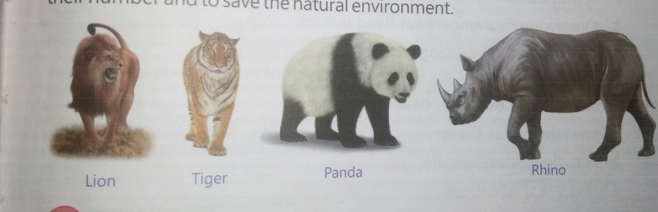

WORK SHEET – 3

NOTE:- DO ALL THE FOLLOWING EXERCISE IN COPY.

**Exercise 1 Write True or False:**

1. Animals living in a forest are wild animals. (True)
2. A frog only lives in water. (False)
3. Omnivores eat dead matter. (False)
4. Tigers are endangered animals. (True)
5. Lion is the king of jungle. (True)

**Exercise 2 Fill in the blank:**

1. Animals live in forest are wild animals.
2. Herbivores eat plants.
3. Monkeys live on trees.
4. Snake smells with their tongues.

**Exercise 3 Question and Answer:**

**Question 1: Which animals are called wild animals?**

Answer: The animals living in jungle are wild animals.

**Question 2: What do Omnivores eat?**

Answer: Omnivores eat both animals and plants.

**Question 3: What do Herbivores eat?**

Answer: They eat grass, leaves and green plants.

**Question 4: What do Scavengers eat?**

Answer: They eat flesh of dead animals.

**Exercise 4 Draw a diagram fish and snake.**

___________________________________________________________________________