**18th May 2020 JESUS AND MARY SCHOOL MODULE – 2**

**CLASS 3**

**SCIENCE**

**Eating habits of animals**

**EXPLANATION**

Food is the basic necessity of life. We need food for life. It gives us energy to work and play. Plants can prepare their food by the process of photosynthesis. Animals cannot prepare their own food. They depend on plants or other animals for their food requirements.

**Feeding habits of animals:**

Different animals have different types of feeding habits. Herbivores are the animals which eat only plants, fruits and vegetables. Example -Cow, goat. Carnivores are the animals which eat flesh of other animals. Example –Lion, tiger. Omnivores are the animals which eat both plant and flesh of other animals. Example –Bear, crow.

Scavengers are the animals which eat the flesh of dead and decaying animals. Example –Vulture, fox. They keep our environment clean by eating up the dead remains of other animals.

**How animals eat food:**

Animals eating habits depends on the type of food they eats. Plant eating animals have sharp and broad biting front teeth which help them to bite grass and leaves easily.Cud chewing animals or ruminants first swallow the plant parts quickly. Later on, they bring the food back into their mouth to chew it properly and swallow it again. This is called chewing the cud. Cows, buffaloes and camel are ruminants. Gnawing animals like rats, rabbits have very sharp, long front teeth to bite into seeds, fruits etc. Elephant have large trunks which help them to eat plants and drink water.

Flesh eating animals or carnivores have very sharp and pointed teeth which help in tearing flesh of their prey. Some flesh eating animals like frogs, snakes, lizards have no teeth. They swallow their food as a whole.

**Animals eating liquid food:**

Some insects like honeybees, mosquitoes, and butterflies survive on liquid diet. They do not have teeth to chew food. Instead, they have long tube like tongue to suck nectar from flowers.

**FOOD CHAIN** – A food chain shows that all living things are dependent on each other for their food requirement. It shows that all living things get their food by eating other living things. This is like a chain that plants and animals form. It is called food chain.

A plant is always at the beginning of a food chain. Thus, all animals depend on plants.

**Worksheet -2**

**Note: Do all the given exercises in your note copy.**

**Exercise:1**

Word Meanings

1. Decay Process of rotting.
2. Swallow Allow food to pass down the throat.
3. Nectar Sugary fluid of flower.
4. Hollow Having an empty space inside.

**Exercise:2 Fill in the blanks.**

1. An animal which sucks nectar honey bee.
2. An omnivore bear.
3. An animal which laps us milk cat.
4. An animal with a trunk elephant.

**Exercise:3 True/False**

1. Bear is omnivore. (True)
2. Mosquito sucks its food. (True)
3. Animals start food chain. (False)
4. Camel has a long sticky tongue. (False)

**Exercise:4 Match the following.**

1. Leaves cow
2. Nuts monkey
3. Gnaw rat
4. Flesh lion
5. Long neck giraffe

**Exercise: 5 Question and answers Short type:**

**Question 1.From where animals get their food?**

Answer: Animals get there food from plants or other animals.

**Question 2.Why do butterflies and honey bees have tube like tongue?**

Answer: Butterflies and honey bees have tube like tongue so that they can suck nectars from flowers.

**Question 3.Why do animals need food?**

Answer: Animals need food to live and grow.

**Question 4.Write two plant eating animals.**

Answer: The two plant eating animals are deer and zebra.

**Question5. Name two animals which lap up milk and water?**

Answer: The two animals which lap up milk and water are cat and dog.

**Long type:**

**Question 1.What is the food chain? Explain with diagram.**

Answer: All living things get their food by eating other living things. This is like a chain that plants and animals form. It is called food chain. Food chain is essential to transfer energy from one living being to another.

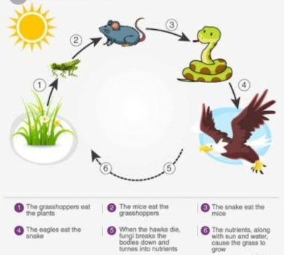

**Question 2.What is the difference between herbivores, carnivores and omnivores?**

Answer: Herbivores are the animals which eat only plants. Example - cow, goat etc. Carnivores are the animals which eat flesh of other animals. Example – lion, tiger etc. Omnivores are the animals which eat both plants and flesh of other animals. Example – bear, crow etc.

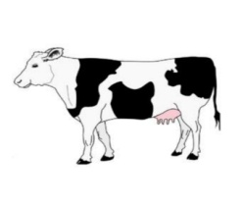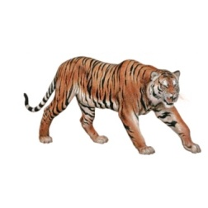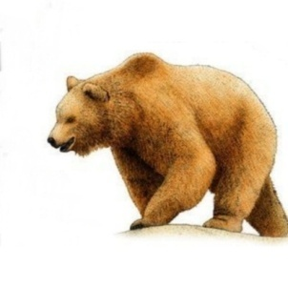

**Exercise: 6** Draw and color the diagram of food chain.

__________________________________________________________________________