**1st June 2020 JESUS AND MARY SCHOOL MODULE - 3**

**CLASS – 5**

**SCIENCE**

**SIMPLE MACHINES**

**EXPLANATION**

**Machine -**

A machine is a thing that is created bypeople to make work easier. It is a tool orinvention which multiplies the effect of humaneffort. Simple machines increase on change thedirection of force.

**Simple machines make our work easier-**

**1-** By increasing the amount of force applied.

**2-** By changing the direction of work.

**3-**Increasing the speed of work.

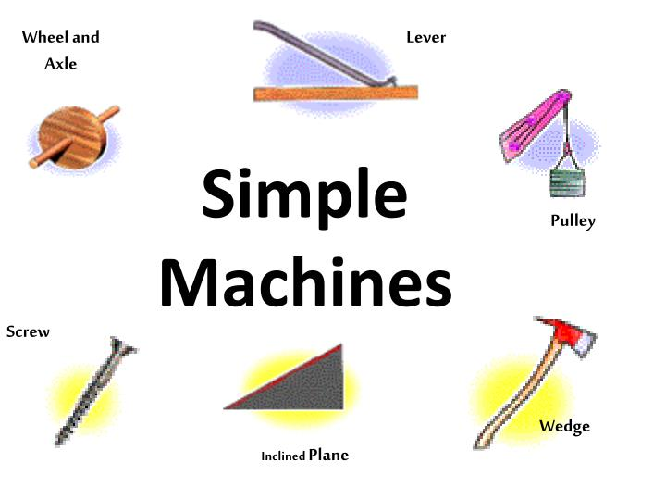**There are basically six types of simple machine –**

**Lever-** A handle that you pull or push in order tomakea machine, etc.

**A Lever is made of Three parts**

**1) Fulcrum-** It is the fixed point about which therod moves.

**2) Load -**It is the object that has to be moved,rotated or cut.

**3) Effort-** It is the force we have to apply on therod to do a work.

**• Based on position of effort , load and fulcrum,levers are classified into threetypes.**

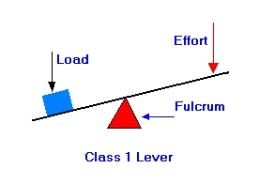**Class one lever-** Here the fulcrum is in the middlewith load and effort on either side.

Ex- See-Saw, scissors, crow bar.

**Class two lever-** Here, the load lies between the effort and the fulcrum. Ex- Nut cracker, wheel barrow, bottle opener etc.

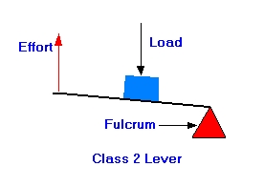

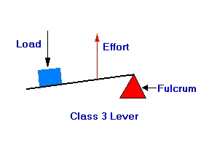**Class three lever-** Here the effort lies between the load and the fulcrum. Ex- A pair of Tongs, stapler etc

**Inclined plane -** It is a simple sloping surface with one end higher than the other. It is used for pushing or rolling objects up a slope rather than lifting them up.

Ex- Flyovers, Stair cases , Hospital ramps etc.

**Screw-** It is an inclined plane wrapped around a cylinder in the form of a spiral. It has a winding edge with threads.

Screws are used for holding things together so that they have a better grip while moving through long distances.

**Wedge -** It is a simple machine, which has two inclined planes joined together back-to-back, with a sharp edge in the shape of a 'v'. It is used for cutting or splitting.

**Pulley -** A pulley is a small wheel with a grove around its outer edge. The groove can hold a rope in its position. A pulley can turn about a fixed rod that passes through its Centre. The rod is called axle.

**There are two types of pulleys-**

**Fixed pulley**

**1.** It is used for drawing water from deep wells.

**2.** It is fixed at one position with the help of some support.

**3.** Here, one end of the rope is tied to the object to be pulled, and the effort is applied on the other end.

**Moveable pulley**

1. It is used for lifting heavy loads.
2. It has more than one pulley, without being fixed to a support.
3. Here the effort applied is less because the weight is supported by more than one pulley.

**Wheel and axle-**

The wheel and axle together forms a simple machine. A wheel is connected to a rod, called axle. The axle makes the wheel turn on it. It is used for covering distance or magnifying the applied force .Ex- Steering wheel of a car, spinning wheel and bicycle wheels.

**WORK SHEET – 3**

**Note:- DO ALL THE FOLLOWING EXERCISES IN YOUR COPY.**

**EXERCISE – 1** **Word- Meanings**

1. **Rigid –** Stiff or fixed.
2. **Steep –** Rising or falling sharply.
3. **Groove –** A long and narrow cut.

**EXERCISE 2 Tick (√) the correct option .**

**1. In class one lever,_____ is in the centre.**

(a) Effort (b) load (c) fulcrum **√** (d) energy

**2. It is an example of wedge.**

(a) Blade (b) knife (c) axe (d) all of these √

**3. A hospital ramp is an example of a/an _________ .**

(a) Pulley (b) inclined plane **√** (c) wedge (d) screw

**4. It is a complex machine.**

(a) Washing machine (b) truck (c) sewing machine (d) all of these **√**

**EXERCISE – 3 True – false**

**1.** Screw is not an inclined plane. **(F)**

**2.** Fulcrum is the fixed point about which the rod moves .**(T)**

**3.** A Wedge is a simple complex machine. **(F)**

**4.** Machines may be simple or Complex.

**5.** A complex machine is made up of many small machines. **(T)**

**EXERCISE – 4 Short type question- answer**

**Q1. What do you mean by machine and write the types of machine?**

**Ans-** A Tool or device that helps to make a task easier is called a machine. There are two type of machine.

**1.** Simple machine **2.** Complex machine

**Q2. What do you mean by Wedge?**

**Ans-** The machines that used for splitting or cutting the things are called wedge. A wedge is also an inclined plane. Ex- Knife, Axe etc.

**Q3. What do you mean by inclined plane?**

**Ans-** A gradual sloping surface connecting a lower level to a higher level is called an inclined plane .

**Q4. What do you mean by Complex machine?**

**Ans-** A machine made up of two or more simple machine is called a complex machine.

**Q5. Write a short note on:-**

1. **Fixed pulley. (B) Moveable pulley**

**Ans – (A) Fixed pulley-**

* 1. It is used for drawing water from deep wells.
  2. It is fixed at one position with the help of some support.

1. **Movable pulley-** 
   1. It is used for lifting heavy loads.
   2. It has more than one pulley, without being fixed to a support.

**Q6:- Give an example of lever?**

**Ans-** A Bottle Opener is the best example of lever .

**EXERCISE – 5 Long type question- answer**

**Q1. What is a lever? Explain all kind of lever with diagrams.**

**Ans-** Lever is a simple machine which helps us to do work with less effort and less energy.

**Kinds of levers -**

**(A) Lever of first class -** The lever in which the load and effort are on either side of the fulcrum.

Ex- See-saw, scissors etc.

**(B) Lever of second class -** The lever in which the fulcrum and effort are on either side of load.

Ex- Bottle opener, Nutcracker etc.

**(C) Lever of third class -** The lever in which the effort is between the fulcrum and the load.

Ex-fishing rods, A pair of tongs etc.

**Q2. What is difference between a lever and a pulley?**

**Ans-Lever -** A lever is a simple machine used to:-

**1)** Cut things - Example - Scissors

**2)** Lift weights - Example - Seesaw

**3)** Open lids – Example - bottle opener.

**Pulley -** A pulley is a simple machine used to draw water from the well.

**Q3. Explain the parts of a lever.**

**Ans- A Lever is made of three parts: -**

1. **Fulcrum –** It is the fixed point about which the rod moves.
2. **Load –** It is the object that has to be moved, rotated or cut.
3. **Effort –** It is the force we have to apply on the rod to do work .