# JESUS AND MARY SCHOOL

**11 May 2020 CLASS**- 3 **MODULE - 1**

**SOCIAL STUDIES**

**SYLLABUS**

**INTRODUCTION**

**CHAPTER 1-** LET’S USE DIRECTIONS

**CHAPTER 2** – OUR UNIVERSE

**CHAPTER 3** – PLANET EARTH

**CHAPTER 4** – WEATHER, CLIMATE AND SEASONS

**CHAPTER 6** – PHYSICAL DIVISIONS OF INDIA

Word meaning, fill in the blanks, match the following, true/false, question/answer short type, long type, diagrams and map work.

**INTRODUCTION**

**QUESTION/ANSWER**

**QUESTION-1) What is globe?**

**ANSWER-** A globe is a model of earth spherical in shape showing ocean, seas, continents, countries and cities.

**Question-2) What is history?**

**ANSWER-** History is the subject in which we study about our past.

**Question-3)What is geography?**

**ANSWER-** Geography is the subject in which we study about the solar system, planets, stars, and our earth.

**Question-4)What does the word B.C. stand for?**

**ANSWER-** The word B.C. stands for “Before Christ”.

**Question-5)What does the word A.D. stand for?**

**ANSWER-** The word A.D. stands for “Anno Domini”.

**Question-6)What is the full form of C.E.?**

**ANSWER-** The full form of C.E. is “Common Era”.

**Question-7)What do you mean by social studies?**

**ANSWER-** The study of history, geography and civics is known as social studies.

**LET’S USE DIRECTIONS**

**SUMMARY**

Directions help us to read maps. We can locate any place with the help of directions. There are four main directions North, South, East and West. These are called the cardinal points. You can tell directions by observing the rising and setting of the sun.

Your right hand should be pointing towards the rising sun, so your right hand is towards the east, your left hand is pointing towards the west. In front of you is north and behind you is south.

There are sub-directions. The directions between the north and east are called the northeast (NE). The direction between south and east is called the southeast (SE). The direction between south and west is called the southwest (SW). The direction between north and west is called the southeast (NW).

A sundial is an instrument which shows time and direction. A magnetic compass is an instrument used by sailors to know direction. Sundial and magnetic compass are two instruments used for finding directions.

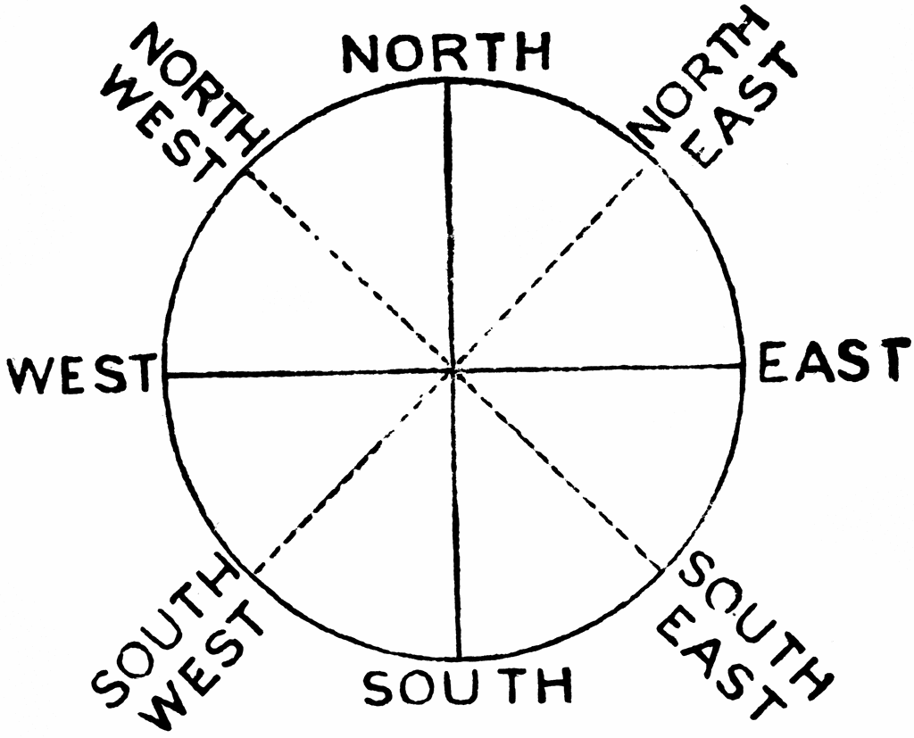

**The Sub-Directions**

**EXPLANATION -** A sketch is a rough drawing without any measurements. A map is a flat drawing of any part of the earth’s surface. Early humans planned their hunting expeditions by drawing maps on the ground.

**WORK SHEET**

**( NOTE : DO THE FOLLOWING EXERCISES OF THE WORK SHEET IN YOUR COPY )**

**EXERCISE – 1 Fill in the blanks.**

1. A sketch is a rough drawing without any measurement. (sketch/map).
2. Early men planned their hunting expedition by drawing maps on the ground . (ground/sea)
3. The four main directions – North, South, East and West are called the cardinal points. (direction/cardinal)
4. Direction is a path along which someone or something is moving or pointing. (compass/direction)
5. When you look at any map, the top of the map is the north . (north/east)

**EXERCISE – 2 Give the names.**

1. An important place that can be seen easily - Landmark
2. The four main directions - North, South, East and West
3. A flat drawing of the Earth’s surface showing the shape of the land - Map
4. A book of maps - Atlas
5. An instrument used by sailors to know directions - Sundial/Magnetic compass

**EXERCISE – 3** **Answer the following questions briefly.(Short Type)**

Q.1 What are landmarks?

Ans- Any large fixed object or important place that can be seen easily from a distance is called a landmark.

Q 2. Name the cardinal points.

Ans- The four cardinal points are North, South, East and West.

Q.3 What is the direction at the top of a map?

Ans- The North direction is at the top of the map.

Q.4 Name the instrument used for telling the time.

Ans- A sundial is an instrument which shows time and direction.

**EXERCISE – 4** **Long type Question/Answer**

Ques- What is a map?

Ans – A map is a flat drawing of any part of the earth’s surface. It shows states, cities, countries, rivers, mountains, rainfall, forests, crops, roads and railways, wheather report, tourist map for any city, distribution of different things like minerals, industries etc.

**EXERCISE - 5. Tick the correct answer.**

1. A sketch is also called
2. a rough map b. a compass c. a landmark
3. The oldest maps were made on
4. ground b. stones c. paper
5. If your right hand is pointing towards the rising Sun in the East, your left hand is pointing to the
6. South b. North c. West
7. The direction between North and East is the
8. Northwest b. Northeast c. North
9. When there were no clocks or watches, people could tell the time with the help of
10. Stars b. shadows c. winds

**Draw and colour the diagram of globe.**