**11th May, 2020 JESUS AND MARY SCHOOL AND COLLEGE MODULE-1**

**CLASS 4**

**COMPUTER SCIENCE**

**Syllabus :** 1. ERA’s and classification of computer

2. Computer Peripherals

3. Desktop Management

4. Working with Windows 10 (Part -1 File Management)

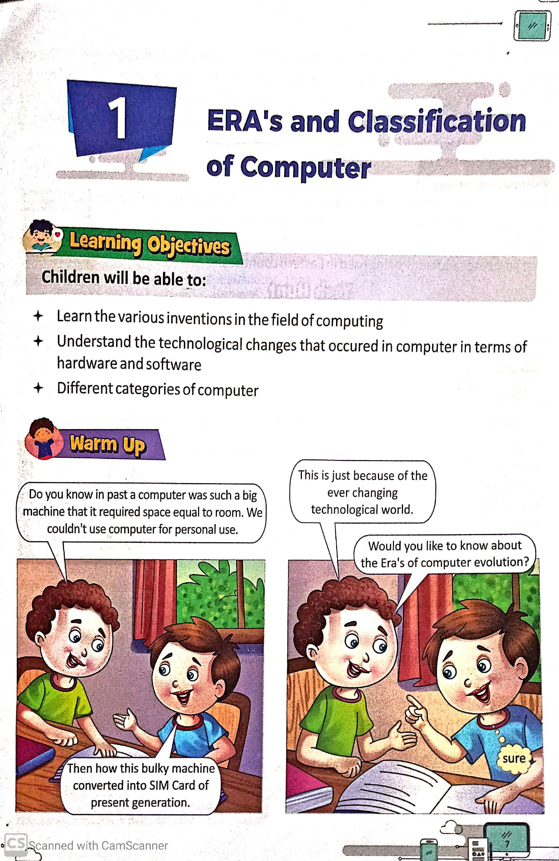

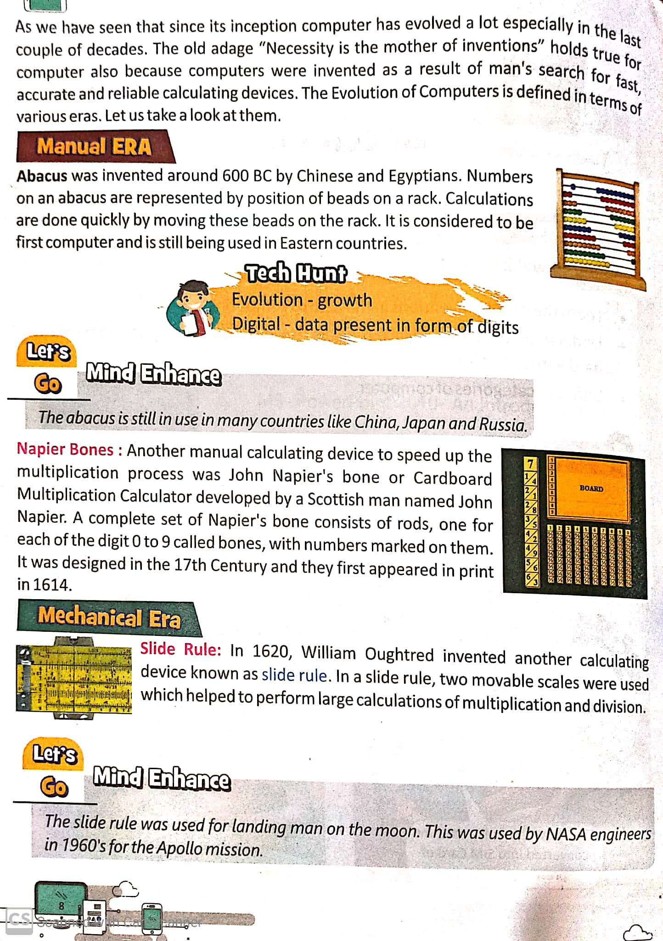

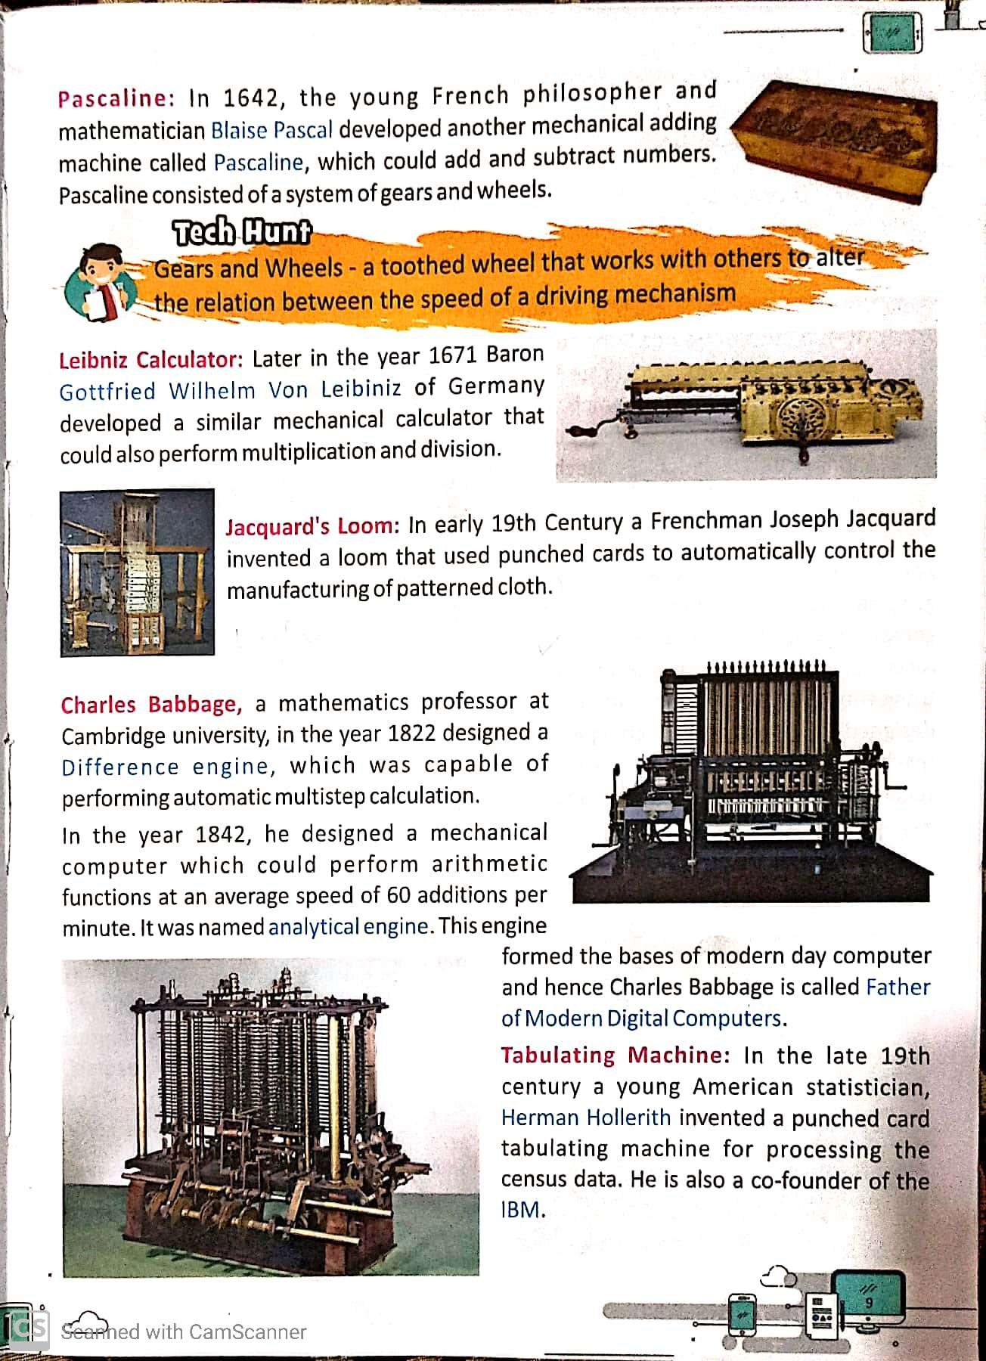

**EXPLANATION**

1. **Abacus**

* Abacus was the earliest calculating device.
* Abacus was invented in China around 2000 years ago.
* Abacus has a wooden frame with several rods.
* There are movable beads which can be used for counting.
* Abacus had two section heaven and earth.
* There are two beads on the rod in heaven section and five beads in earth section.

1. **Napier bones**

* In 1617, John Napier invented a calculating device called Napier bones.
* These were multiplication table written on stripes of wood or bones.
* They were use for multiplying, dividing, taking square roots or cube roots.

1. **Pascaline Calculator**

* In 1642, Blaise Pascal invented the first calculating device called Pascaline.
* It had a box with eight movable wheels called dials.
* The numbers for calculations were entered with dials.
* It could add, subtract, multiply and divide big number.

1. **Leibniz Calculator**

* In 1671, German mathematician Gottfried invented a calculating device called Leibniz Calculator.
* It could add, subtract, multiply and divide.

1. **Jacquard’s Loom**

* In 1801, J.M. Jacquard invented a powered loom.
* It used punched wooden card.
* It could be as being the first “read only memory” device.

1. **Charles Babbage**

* Charles Babbage is known as the father of modern computer.
* He designed a machine called Difference engine in 1822. It aimed at calculating mathematical tables.
* In 1834 he designed another machine and named it Analytical Engine.

1. **Tabulating Machine**

* Herman Hollerith invented a fast counting machine and named it the tabulating machine.
* It was aimed at taking census in USA in 1880.

**WORKSHEET 1**

* **Question/ Answer**

**Q1.** Who is known as the father of computer?

**Ans.** Charles Babbage is known as the father of computer.

**Q2.** Who invented Pascaline?

**Ans.** Blaise Pascal invented a calculating machine called Pascaline.

**Q3.** Name the machine that was designed for taking census in USA in 1880.

**Ans.** Tabulating machine that was designed for taking census in USA in 1880.

**Q4.** What is Abacus?

**Ans.** Abacus was the earliest calculating device. It was invented in China around 2000 years ago.

**Q5.** Who invented analytical engine and when?

**Ans.** Charles Babbage invented analytical engine in 1834.

* **Fill in the blanks.**

1. Abacus was invented in **China**.
2. **John Napier** invented a Napier Bones.
3. Blaise Pascal invented a calculating machine called **Pascaline**.
4. **Charles Babbage** is known as the father of computer.
5. **Tabulating Machine** was aimed at taking census in USA in 1880.

* **True and False.**

1. Abacus was the first calculating device developed by the Chinese. ( T )
2. John Napier invented Napier’s bones in 1617. ( T )
3. Analytical Engine was invented by Blaise Pascal in 1641. ( F )
4. Herman Hollerith invented the Tabulating machine. ( T )
5. ENIAC was invented by John Presper Eckert and John Mauchly. ( T )

**Note-**

**Please do all this work in old copies which will be checked when school reopens. Please consider this important.**