**JESUS AND MARY SCHOOL**

**11 May 2020 CLASS-IV MODULE – 1**

**SUB- SOCIAL STUDIES**

**Syllabus**

1. Globes and Maps
2. Knowing more about India
3. Natural Resource- Water Resource of India
4. Our Mineral resources and Industries
5. Shivaji – The Great Maratha Warrior

**Globes and maps**

**Text book**

The shapes of the Earth is round, but slightly flat at the top and bottom, and bulging in the middle. Ferdinand Magellan’s famous ocean voyage around the world provides. That the Earth is not flat but round.

**Globe-** A globe is a very small model of the Earth. It is round in shapes. It is supported by a tilted rod and a metal arc. This is fixed to a stand. The rod represents the tilted axis of the Earth. The globe spins along this rod. With the help of a globe, we can understand what the Earth looks like. We can also understand the spinning movement of the Earth. We can see the location of different continents, countries, oceans, and seas. Remember- *the* ***axis*** *of the Earth is an imaginary line that passes through the centre of the Earth.* The axis of rotation of the globe is the same as that of the Earth.

**Limitations of a Globe**

The globe is useful, but it also has some limitations.

1. We cannot see all the places at one time. We have to rotate or gently spin the globe to see the places lying on the other side.
2. Very minute details cannot be shown on a globe.
3. It is difficult to carry big globes from one place to another.

**Map –** *A* ***map*** *is a drawing of the whole or part of the Earth’s surface on a flat paper.* A map gives us more detailed information about the places on the surface of the Earth than a globe. We can easily roll or fold a map and carry it anywhere. *Maps are put together in the form of a book which is known as an* **atlas.**

**Types of Maps**

There are two major types of Maps- **Physical** and **Political.** Each type of maps shows a particular kind of information.

**Physical Map-** shows physical features like plains, mountains Valleys, Plateaus, deserts, seas, rivers, lakes, etc.

**Political Map-** shows countries, state, capital, cities, important towns, national, and international boundaries.

**Important features of a Map**

A map has some important features. With the help of the following feature, we can understand any map- **title, direction, scale, colours, symbols, and key or legend.**

**Explanation-**

**Globe** –

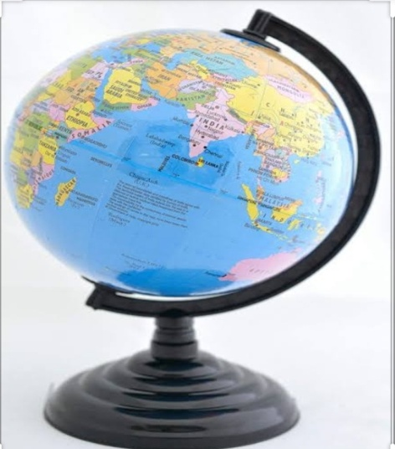

A globe is a spherical model of Earth, of some other celestial body or of the celestial sphere. With which we can study about the earth. A model globe of Earth is called a terrestrial globe. A globe of the celestial sphere is called a celestial globe. It is round in shape and supported by a tilted rod and a metal arc. This is fixed to stand. The rod represents the tilted axis of earth. A globe shows details of its subject. A globe shows different continents, countries, oceans and seas. With the help of a globe we can understand the shapes and spinning movement of the Earth. The axis of the earth is an imaginary line that passes through the centre of the earth. The word globe comes from the Latin word globes means “sphere”.

**Uses of globe**- 1. A globe is only accurate way to study the whole earth.

2. A globe is more accurate than a flat map

**Limitations of a Globe-** 1.It is difficult to carry big globes from one place to another place.

2. We cannot see all the places at the same time. We have to spin the globe to see the other places.

**Map-** A map is a visual representation of an entire area or part of an area, typically represented on a flat surface. A map gives us a more detail information about the places on the surface of the earth than a globe. We can easily roll or fold a map. We can carry it anywhere but not globe. Maps are put together in form of a book which is known as atlas. The network of lines on a map is known as grids.

**Types of Maps-** There are two types of maps- physical and political

**Physical Map-** It shows plains mountains Valleys, Plateaus, deserts, seas, rivers, lakes, etc.

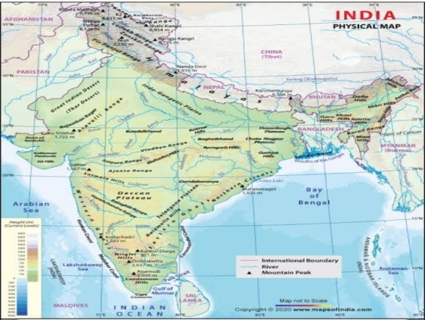EXAMPLE-

**Political Map-** It shows countries, state, capital, cities, important towns, national, and international boundaries. EXAMPLE

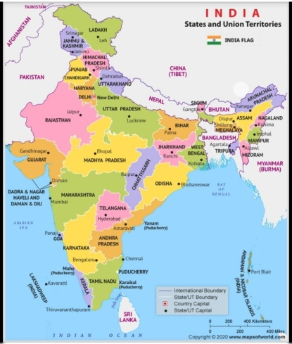

**Important feature of a Map-** A map has some important features. They are as follows-

**Title-** The title of a map indicates the information that is shown in the map.

**Direction**- It is a very important feature of a map. With the help of direction we can locate any place. You know that there are four main directions – North, South, East, and West. These four directions are known as the cardinal points.

**Scale-** We use a map scale to reduce large distance into small one. The scale shows the relationship of the distance between two places on a map and the actual distance between those two places on the ground.

**Colours-** Colours help in identifying many features on map such as-

Blue- water bodies, Green- plains forest and vegetation, Yellow- desert, Brown-mountain and plateau

White-snow covered regions.

**Symbols-** A map does not have enough space to represent features like hospital, airport, post offices, building etc. Signs with fixed meaning are used for showing certain feature on a map.

**Key or Legend-** It explains the meaning of colours, symbols and pattern used in the map.

**WORKSHEET - 1**

**Do the following exercises in your copy/ Note book**

**EXERCISE – 1 Word/Meaning**

1. Spherical - round
2. Axis - central
3. Pattern - design
4. Indicate - hint
5. Plateaus - An area of fairly level high ground
6. Bulging - swelling
7. Voyage - ocean traveller

**EXERCISE – 2 Short type Ques/ans**

**Q1. *Define Map*.**

Ans. A Map is a drawing of the whole or part of the Earth’s surface on a flat sheet of paper.

**Q2. *How is a Map more useful than a globe?***

Ans. A Map is more useful than a globe because it gives us more detailed information about the places on the surface of the Earth than a globe.

**Q3. *What are the different colours used in a map?***

Ans. The different colours used in a map are blue, green, yellow, brown and white.

**Q4. *What do the different colours show in Map?***

Ans. The different colours shows water bodies, plains, forests, vegetation, desert, mountain, plateaus and snow covered regions.

**Q5. *What are the six important features of a Map?***

Ans. The six important features of a map are title, direction, scale, colours, symbols, key or legend

**EXERCISE – 3 Long type Ques/Ans**

**Q1. *What is globe? What are its limitations?***

Ans. A globe is a small model of the Earth, spherical in shape showing ocean, seas, Continent, countries and cities.

***Its limitations are-***

1. We cannot see all the places at one time. We have to spin or rotate the globe to see the places.
2. Very minute details cannot be shown on a globe.
3. It is difficult to carry big globe from one place to another.

**Q2. *Define scale. Why is scale important for a Map?***

Ans. Scale is the relationship of the distance between two points on the map to the corresponding distance on the ground. Scale is important for a map because it reduces a large distance into a small one.

**EXERCISE- 4 Fill in the blanks.**

1. To study the Earth, we use a model of the Earth which is called **a globe.**
2. The **axis** of the Earth is an imaginary line that passes through the centre of the the Earth.
3. **Title** indicates the information that is shown in a map.
4. The four main directions are known as the **cardinal points**

**EXERCISE – 5 Tick(√) the correct answer.**

1. With the help of a globe, we can understand the

(a) shape of the Earth (b) rotation of the Earth (c) both of these [√]

1. Maps are put together in the form of a book known as

(a) globe (b) atlas [√] (c) plans

1. The colours used to show mountain and plateaus on the map is

(a) green (b) brown [√] (c) blue

1. The key or legend explains the meaning of

(a) direction (b) scale (c) colours and symbols[√]

**Draw and colour the diagram of A GLOBE**