**11th May, 2020 JESUS AND MARY SCHOOL AND COLLEGE MODULE 1**

**CLASS 5**

**COMPUTER SCIENCE**

**Syllabus :** 1. Generation of computer

2. Types of Software

3. Computer Memory

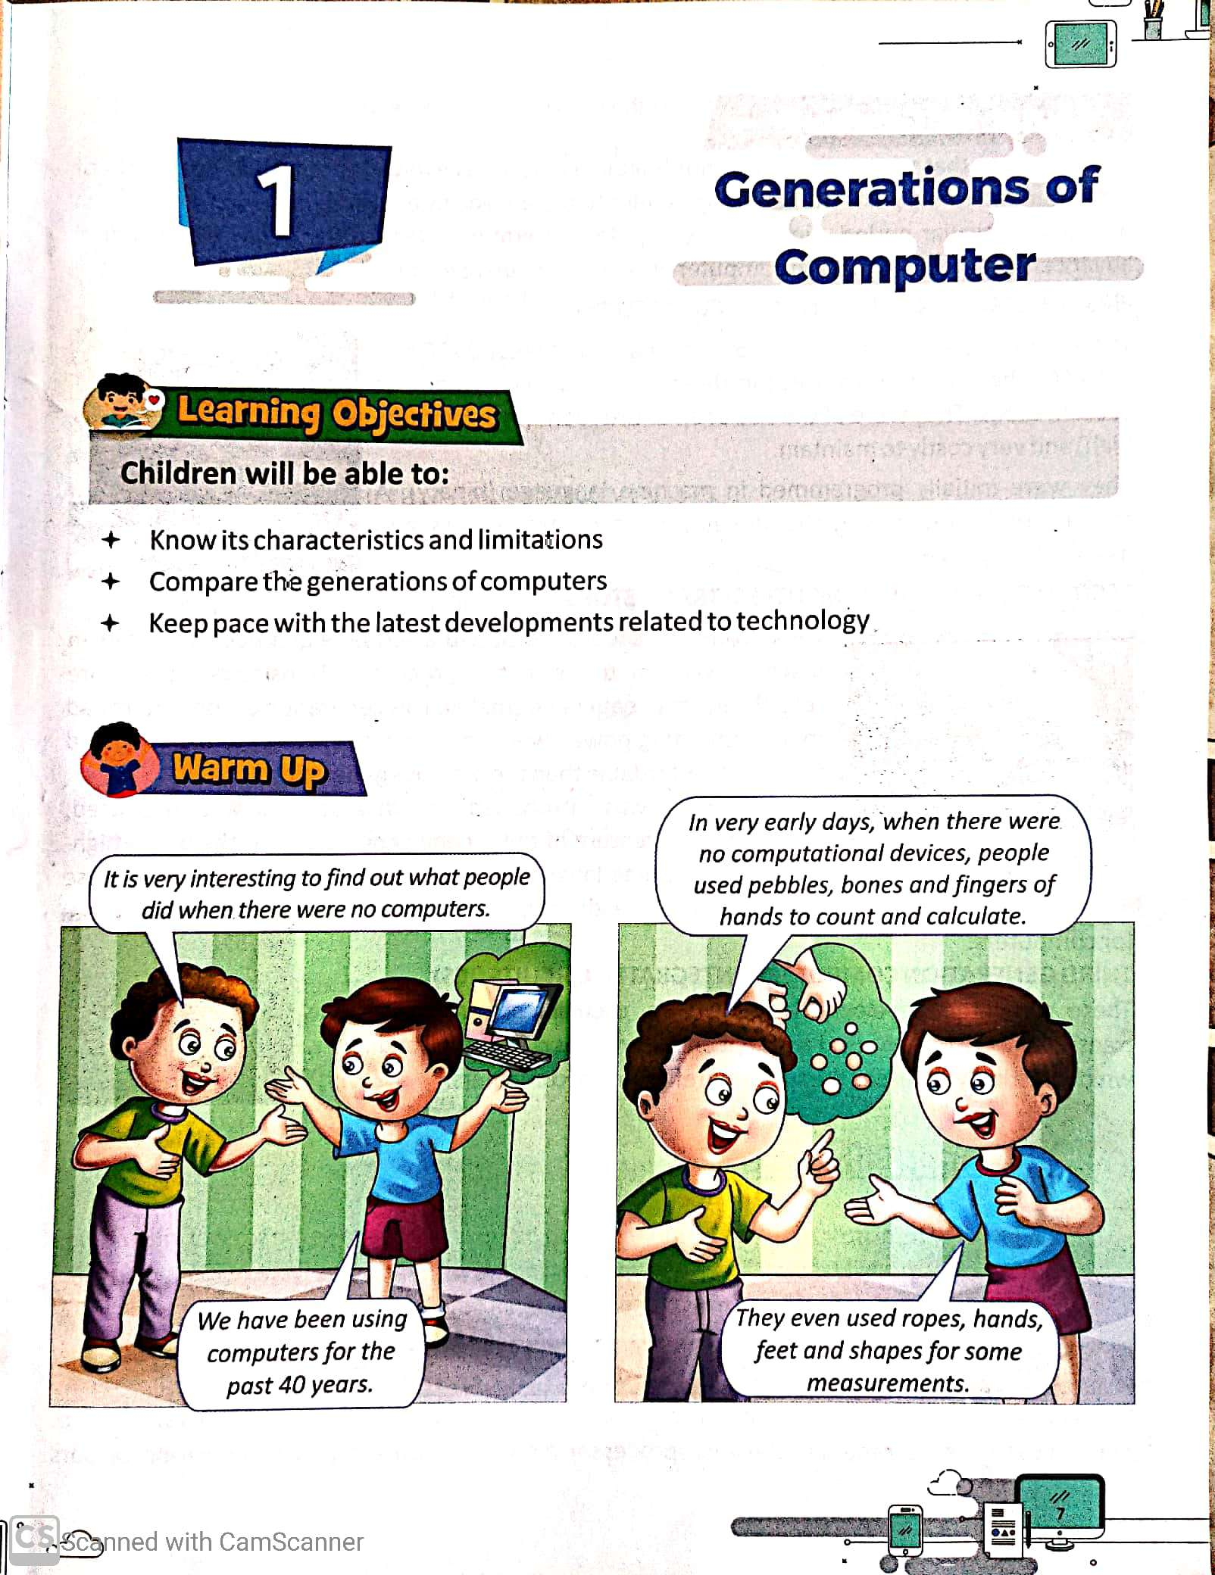 4. Advance feature of M.S. Word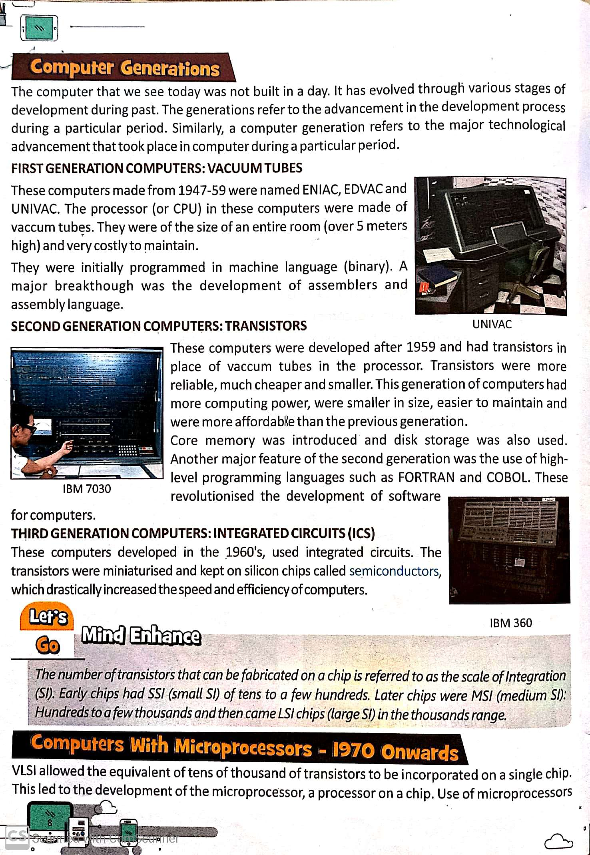

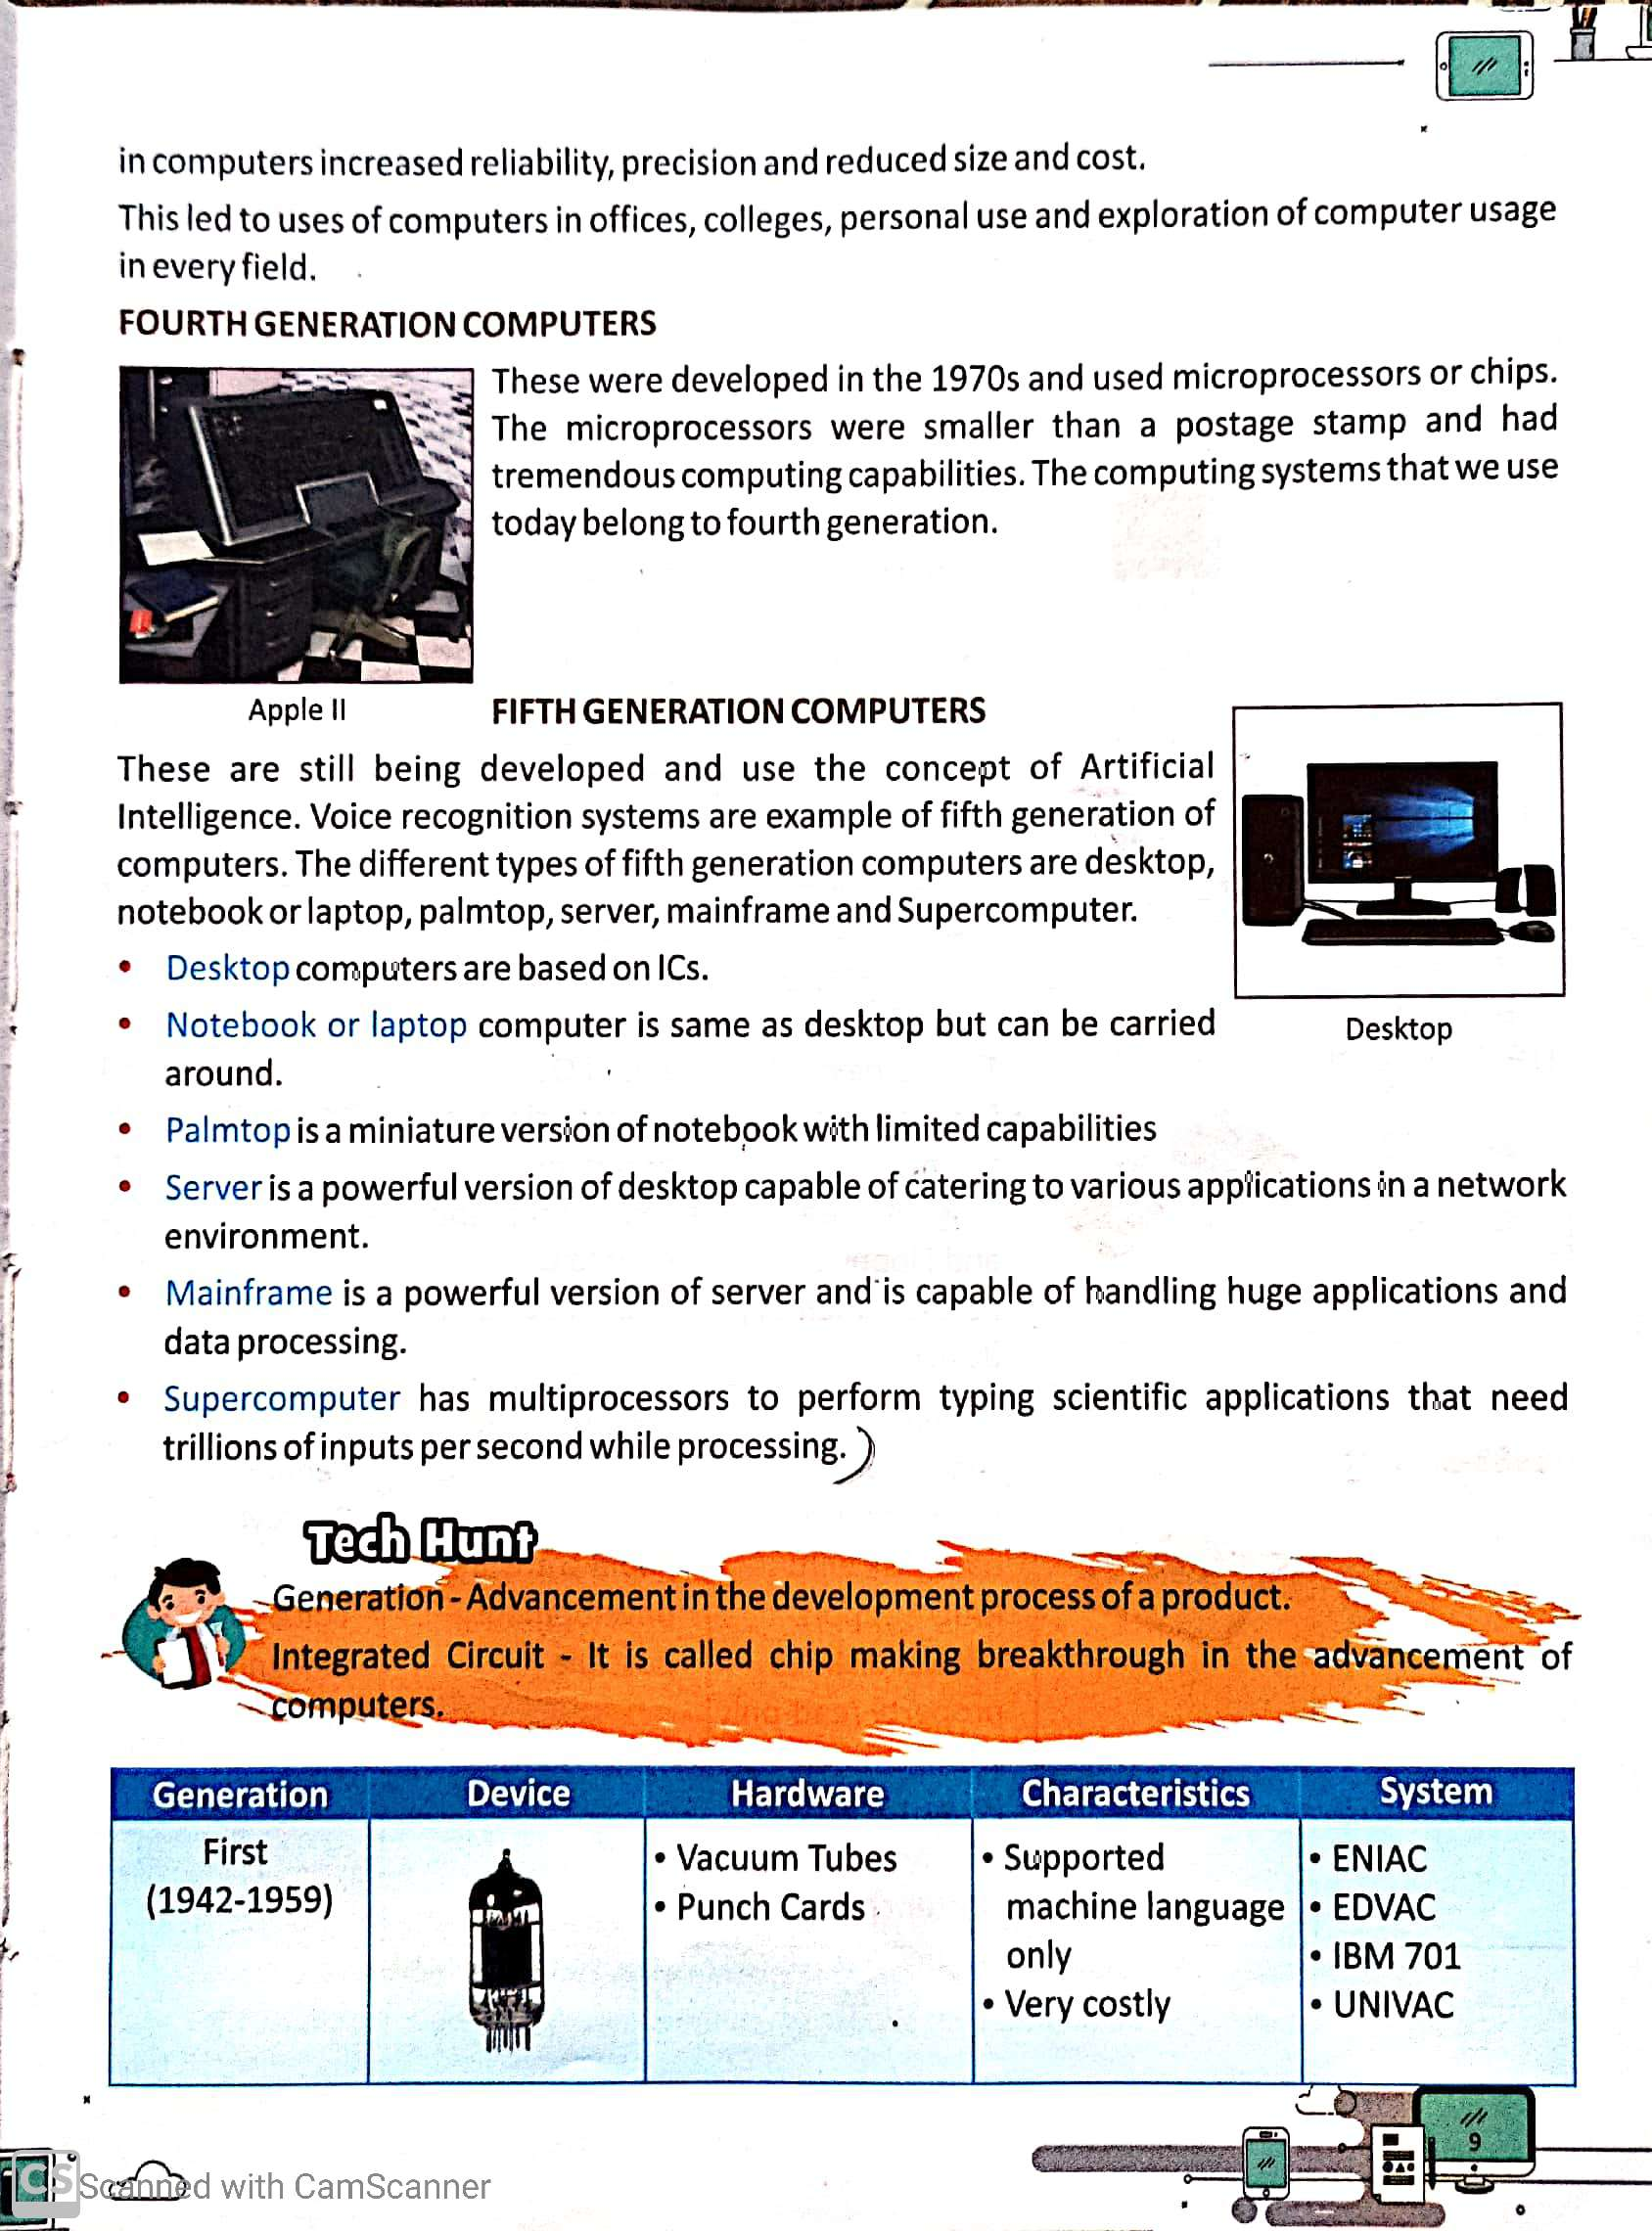

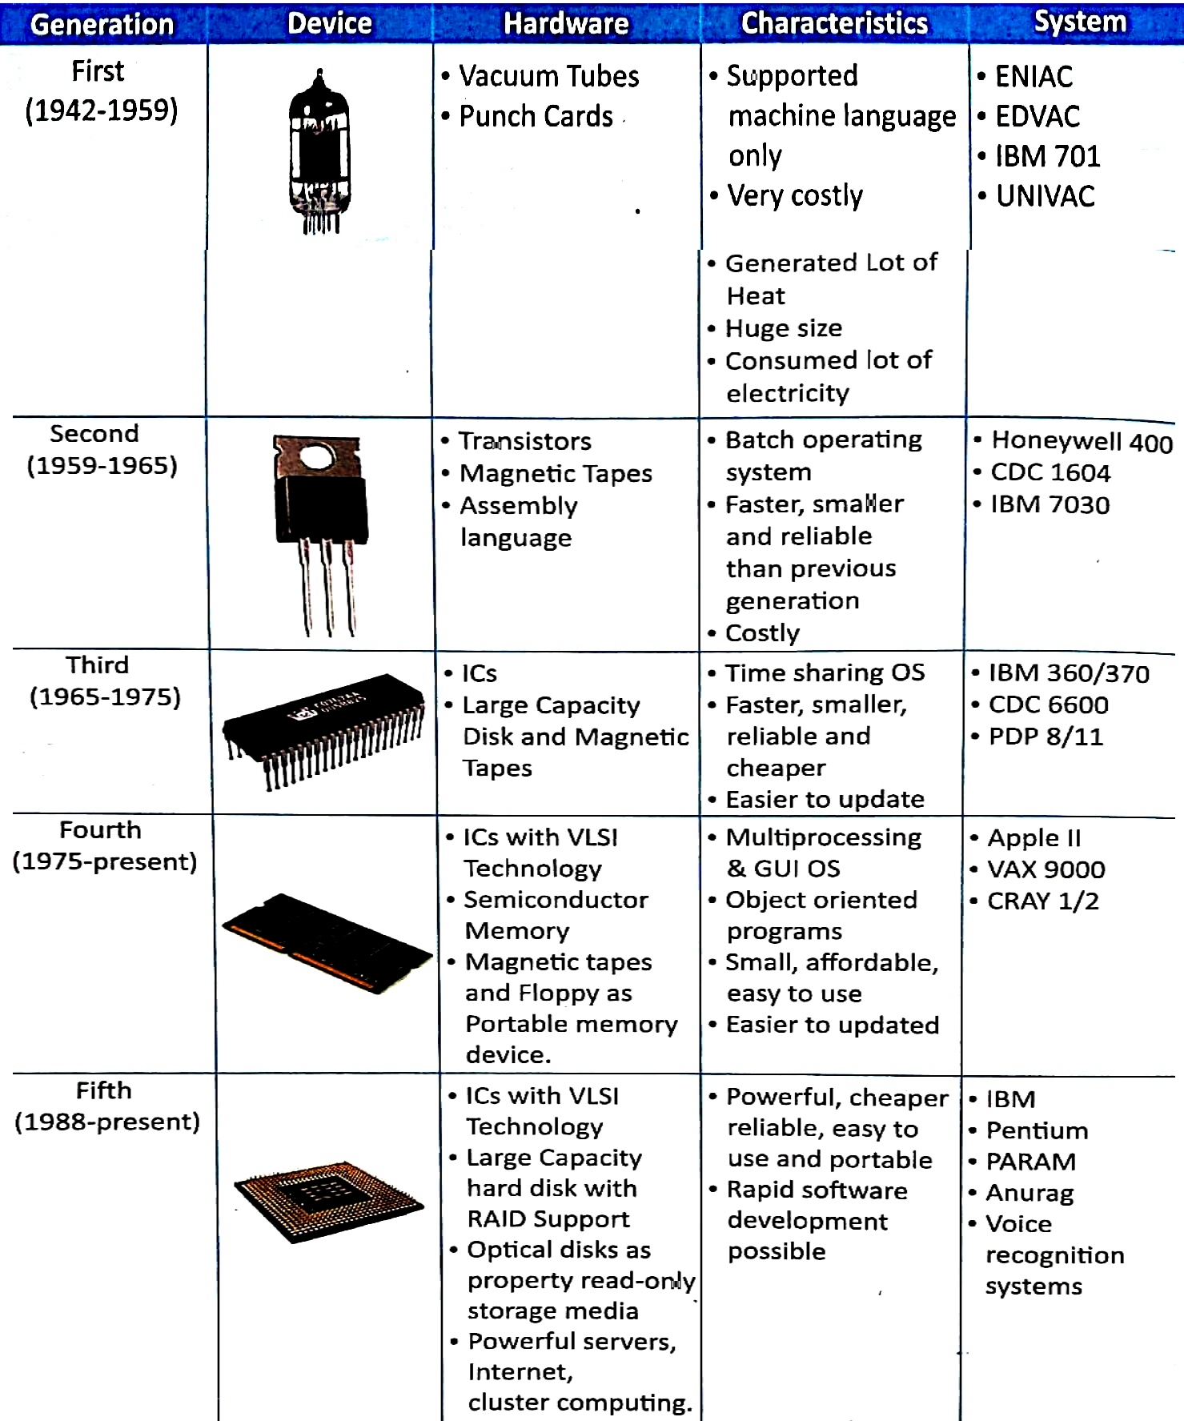

**EXPLANATION**

**COMPUTER GENERATION :**

* Computer technology in terms of the development of computer is called Computer Generations. There are totally 5 computer generations known till today.

**FIRST GENERATION COMPUTER :**

* Those computers which use vacuum tubes where known as First Generation Computer.
* These computers were very large in size.
* These computers were slow in speed and had low accuracy.
* Example of First Generation computers are:- ENIAC, EDVAC, EDSAC.

**SECOND GENERATION COMPUTER :**

* Transistors were invented in 1948.
* Transistors were used in the second generation computers.
* Comparing to the first generations these computers were faster, smaller and powerful but they were very expensive.

**THIRD GENERATION COMPUTER :**

* In 1964 the electronic technology formulated integrated circuits.
* Third generation computers are based on IC Technology.
* Hundreds of transistors are put together to form a chip.
* Third generation computers were smaller, faster and more reliable than the second generation computers.

**FOURTH GENERATION COMPUTER :**

* In 1975, with a development of technology microprocessor were introduced.
* Integrated Circuits with the entire computer circuit fixed on a single silicon chip is known as microprocessor.
* Fourth generation computers are smallest in size and cheapest among all generations.

**FIFTH GENERATION COMPUTER :**

* Fifth generation computers are in used today.
* There are many super computers in the world today.
* Scientist are at work to develop computers with artificial intelligence.

**WORKSHEET 1**

* **Question and Answer-**

**Q1.** Which was considered the first true programmable digital computers?

**Ans.** ENIAC was considered the first true programmable digital computers.

**Q2**. Which invention enabled developers to create micro computers?

**Ans.** Integrated circuit invention enabled developers to create micro computers.

**Q3.** Which generation of computer used Integrated Circuits?

**Ans.** Third generation of computer used Integrated Circuits.

**Q4**. Give any two example of the third generation computers.

**Ans.** 1. IBM 370 2. CDC 6600.

**Q5.** In which generation of computers micro processor were used?

**Ans.** Fourth generation of computers micro processor were used.

* **Match the following**

1. Second Generation **a.** Transistor
2. Third Generation **b.** Integrated Circuits
3. Fourth Generation **c.** Microprocessor
4. Fifth Generation **d.** Artificial Intelligence
5. First Generation **e.** Vacuum tubes

* **True or False**

1. Third generation computers used integrated circuits. ( T )
2. PARAM computers are Mini circuit computers. ( F )
3. Micro-processors were used in computer of fourth generation. ( T )
4. A mini computer is also known as midrange computer. ( T )
5. Second generation computers used vacuum tubes as the main component. ( F )

**Note-**

**Please do all this work in old copies which will be checked when school reopens. Please consider this important.**

**\*\*\*\*\*\*\*\*\*\*\*\*\*\*\*\*\*\*\*\*\*\*\*\*\*\*\*\*\*\*\*\*\*\*\*\*\*\*\*\*\*\*\*\*\*\*\*\*\*\*\*\*\*\*\***