**11th May, 2020 JESUS AND MARY SCHOOL AND COLLEGE MODULE 1**

**CLASS 7**

**COMPUTER SCIENCE**

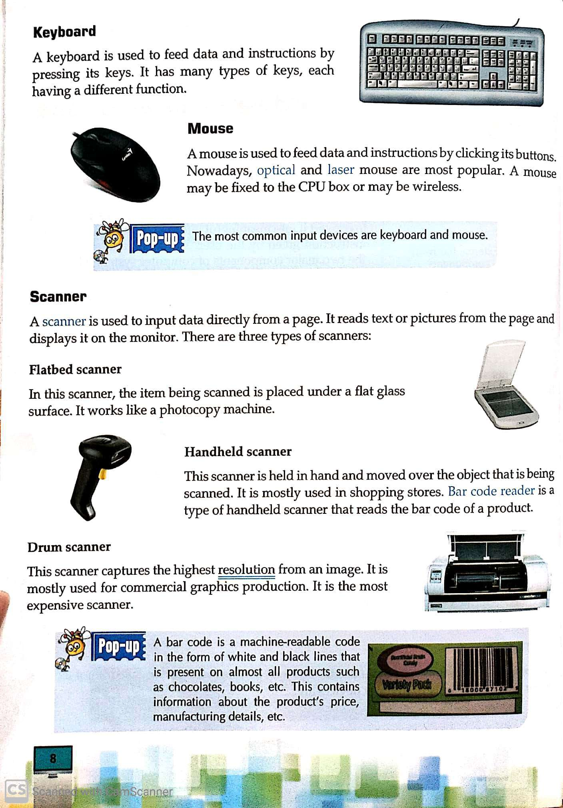

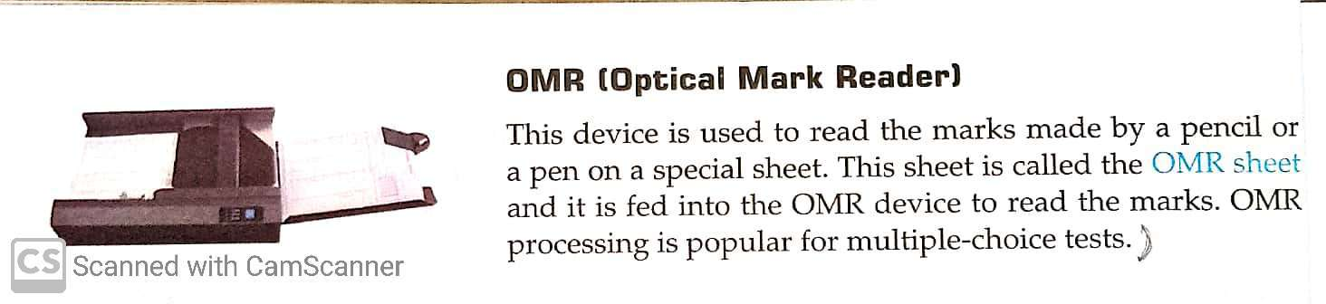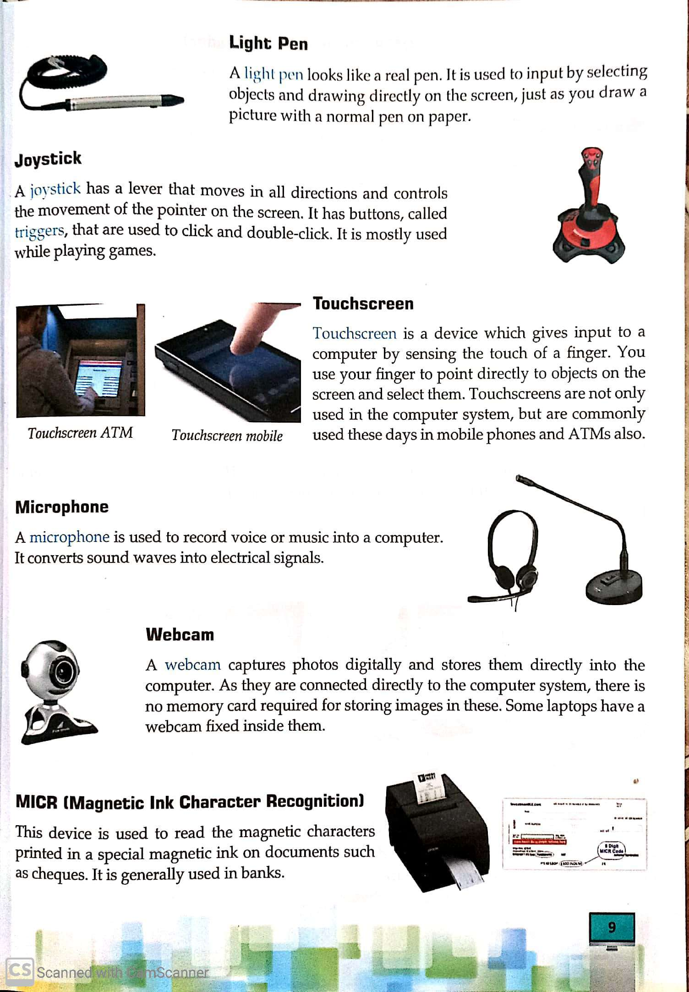

**EXPLANATION**

* Hardware and software are two major components of computer system. Which help the user to solve their problems

**HARDWARE :**

* The parts of computer which we can see and touch are hardware.
* As like -
* **Input Device**- Keyboard, Mouse, Scanner, Microphone, MICR, OMR.
* **Output Device-** Monitor, Printer, Plotter, Speaker and headphones, Plotter.
* **Storage Device-** Hard disk, Blue ray, Floppy disk, Pen Drive, DVD.

**EXTERNAL HARDWARE COMPONENTS :**

* The components which are visible from outside and help the user to work on computer system are called external components.

**INPUT DEVICE :**

* Devices through which we feed data or instructions are called input devices.
* Input devices are used to enter data or instructions into the memory of the computer.
* The word input means whatever is put into something.

**KEYBOARD :**

* Keyboard is most important and most commonly used in a computer system.
* The keyboard of a computer is quite similar to that of an electronic typewriter.
* The push buttons on the keyboard are called keys.

**MOUSE :**

* Mouse is used as a operator to move the cursor or select certain items from a menu.
* There are three buttons in the mouse.

**SCANNER :**

* A scanner is used for scan documents.
* There are three types of scanners.
* Flatbed Scanner
* Handheld Scanner
* Drum Scanner

**LIGHT PEN:**

* Light pen is used to input any graphics design to the computer.
* It is a pen like photo sensitive instrument.

**THOUCH SCREEN :**

* A touch screen is a computer display screen.
* The screen is sensitive.
* Touch screen used by touching it with a finger or a stylus pen.

**MICROPHONE :**

* Microphone converts [sound](https://en.wikipedia.org/wiki/Sound) into an [electrical signal](https://en.wikipedia.org/wiki/Electrical_signal).
* It used for record voice or sounds.

**JOYSTICK :**

* Joystick is used for controlling the movement of the cursor or a pointer in a computer device.
* Joystick mostly used for gaming applications and, sometimes, in graphics applications.

**WEBCAM:**

* Webcam is web camera in computer.
* It can be used for real time chatting and video calling.

**MICR:**

* MICR stands for Magnetic Ink Character Recognition.
* MICR mainly used in the banking industry to ease the processing and clearance of cheques and other documents.

**OCR:**

* OCR stands for Optical Character Recognition.
* OCR technology can be used to convert a [hard copy](https://techterms.com/definition/hardcopy) of a document into soft copy.

**Worksheet 1**

* **QUESTION ANSWER**

**Q1.** Which scanner is mostly used in shopping store?

**Q2.** What are external component?

**Q3.** What is a touch screen?

**Q4.** Write any four input devices.

**Q5.** What are input devices?

* **Fill in the blanks.**

1. **……………..** deviceis used to read magnetic characters printed on cheques.
2. **……………** scanner is mostly used for commercial graphics production.
3. A **……………..** is connected to all other hardware components, internal or external, of the computer directly or indirectly.
4. A **……………** is used to record voice or music into a computer.
5. A **………………** is used to input data directly from a page.

* **True and False.**

1. Both touch pad and touch screen work on touch of the finger. ( )
2. A webcam captures photos and stores directly on the computer. ( )
3. Flatbed scanner captures the highest resolution from an image. ( )
4. A mouse may be fixed to the CPU box or may be wireless. ( )
5. A light pen is an input device. ( )

**Note- Please do all this work in old copies which will be checked when school reopens. Please consider this important.**