**11th May, 2020 JESUS AND MARY SCHOOL AND COLLEGE MODULE 1**

**BIOLOGY**

**CLASS – VIII**

**CHAPTER – TRANSPORT OF FOOD AND MINERALS IN PLANTS**

**INTRODUCTION:**

The transport system of plants is also called as ***vascular system*** or ***conducting system.*** Plants require a transport system to deliver raw materials for photosynthesis to the leaves and to deliver the sugar made to other parts of the plants for use and storage. Plants have two transport systems:

1. Xylem
2. Phloem

**EXPLANATION OF XYLEM:**

Xylem is found in the centre of the vascular bundle deep in the plants. The xylem transports water and minerals from the roots up the plant stem and into the leaves. It is compose of four types of cells:

1. **Xylem vessels:**

Xylem vessels are thick walled, non-living, long, tubular cells. Water rises in the vessels against the force of gravity.

1. **Xylem tracheids:**

Along with xylem vessels, tracheids also conduct water and minerals.

1. **Xylem fibres:**

Xylem fibres are thick walled cells and provide mechanical support to the plant.

1. **Xylem parenchyma:**

Xylem parenchymas are the only living cells. They perform storage functions.

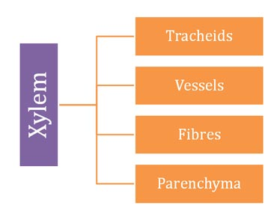

**EXPLANATION OF PHLOEM:**

Phloem is found on the outer side of the vascular bundle phloem is the living tissue in vascular plants that transports the soluble organic compounds made during photosynthesis, which are known as photosynthates, in particular the sucrose, to the parts of the plants where needed. This transport process is called translocation. In trees phloem is the innermost layer of the bark, hence the name, derived from the Greek word *phloios* meaning “bark”. The term was introduced by **Carl Nageli** in 1858.

Usually Phloem is situated external to xylem. In, leaves phloem is located on the abaxial side (lower side). It is composed of four types of cells:

1. **Sieve elements:**

Sieve elements are the fundamental cell type in the phloem. They are living cells with protoplasm, but without any nucleus and are used for conducting food. Two types of sieve elements are found in phloem: Sieve cells and sieve tubes. Sieve cells are less specialized and primitive type, usually found in Pteridophytes and Gymnosperms. Sieve tubes are advanced sieve elements and are found in Angiosperms.

1. **Companion cells:**

Companion cells are specialized parenchymatous cells associated with the sieve tubes of Angiosperms. These cells provide energy to sieve elements for phloem transport. These are also called albuminous cells.

1. **Phloem parenchyma:**

These are thin walled cells with protoplasm and nucleus. Phloem parenchyma is used to store food.

1. **Phloem fibres and sclereids:**

These are dead cells, which possess lignified secondary cell wall. These are supportive cells and provide mechanical strength.

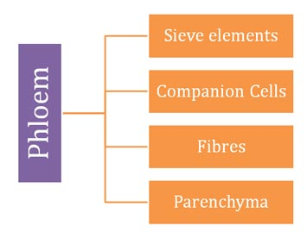

**FUNCTION OF TRANSPORT SYSTEM IN PLANTS:**

The main function of xylem is to transport water and dissolved minerals from the roots to the rest of the plant body, while the phloem transports the food manufactured in the leaves to all parts of the plants.

**WORKSHEET – 1**

**EXERCISES:**

1. **Answer the following questions:**
2. What is the transport system in plants?
3. What is the function of xylem?
4. What is photosynthesis?
5. What is the function of phloem?
6. Write the names of the cells found in phloem.
7. What is the function of the companion cells?
8. Write the name of cells found in xylem.
9. Who introduced the term phloem?
10. What are the works of phloem fibres and phloem parenchyma?
11. **Tick the correct option:**
12. What does xylem carry up the stem?
13. Water
14. Nutrients
15. Water and nutrients
16. None of the above
17. What does phloem transport in the plants?
18. Sugar
19. Water
20. Oxygen
21. All of the above
22. Xylem tissue is made up of dead cells.
23. True
24. False
25. Tracheids are xylem cells.
26. True
27. False
28. Phloem is thicker than xylem.
29. True
30. False
31. Which of the tissues are involved in water conduction?
32. Xylem and phloem
33. Tracheids and vessels
34. Parenchyma and sclerenchyma
35. Xylem fibres and bast fibres
36. Xylem consists of –
37. Tracheids, vessels, fibres and parenchyma
38. Tracheids, vessels and companions cells
39. Tracheids, vessels, sieve cells and companion cells
40. Tracheids, vessels, fibres and parenchyma

**NOTE:**

**Please do this work in your old copies which will be checked when the school reopens. Please consider this important.**