**15th June, 2020 JESUS AND MARY SCHOOL AND COLLEGE MODULE-4**

**CLASS X**

**CHEMISTRY**

**CHAPTER: CHEMICAL BONDING**

**NOTE:**

My dear Students, today I’m going to give you a very simple and lucid way of understanding ‘Chemical bonding along with the complete details of Ionic compounds’ with the help of colourful structures and tables. This is an integral part of the Physical chemistry topics you get in the Board Examinations. Study the following notes carefully and then test yourself by attempting the given assignment in the last of this module. Please note that this work must be done in chemistry note book which will be checked when College resumes.

**......................................................................................................................................................**

## What is Chemical Bonding?

* Chemical Bonding refers to the formation of a chemical bond between two or more atoms, molecules, or ions to give rise to a chemical compound.
* When two atoms combine together, they try to acquire stable electronic configuration by giving, taking or sharing their valence electrons and **stabilizes them by the overall loss of energy is known as chemical bonding.** Therefore, it can be understood that [chemical compounds](https://byjus.com/chemical-compound-formulas/) are reliant on the strength of the chemical bonds between its constituents. Stronger the bonding between the constituents, the more stable the resulting compound would be.
* A chemical bond is actually interatomic attraction which holds the two atoms together in a molecule.
* The chemical bond may be ionic, covalent, coordinate or metallic in nature.

**Cause of Chemical Combination**

From the very beginning, it has been a pertinent question in the mind of chemists that why atoms combine together and what types of forces hold atoms together. The detailed study of electronic configuration of atoms, the discovery of noble gases and the study of their behaviour helped chemists a lot in this direction.

The main causes of chemical combination are as follows:

1. **Tendency to acquire stability:** It is the law of nature that an unstable system has a tendency to acquire stability. The most stable state of a system corresponds to the state of minimum energy. Therefore every system in this universe tends to behave in such a way that it can attain minimum energy and the maximum stability.

For example: Water always flows from a higher level to a lower level. This is because the potential energy corresponding to a lower level is less as compared to that in the higher level. The theory of chemical combination also reveals that the formation of a chemical bond involves a decrease in the potential energy of the system.

1. **Tendency to Acquire Noble Gas Configuration:** The noble gases possess practically no tendency to form chemical bonds and to enter into chemical combination. This implies that these gases are stable. Their electronic configurations should therefore be stable electronic configuration which is shown in the following table:

**Electronic Configuration of Noble Gases**

|  |  |  |  |  |
| --- | --- | --- | --- | --- |
| Noble gas | Symbol | Atomic Number | Electronic Conf. | Valence shell Conf. |
| Helium  Neon  Argon  Krypton  Xenon  Radon | He  Ne  Ar  Kr  Xe  Rn | 2  10  18  36  54  86 | 2  2,8  2,8,8  2,8,18,8  2,8,18,18,8  2,8,18,32,18,8 | 2  8  8  8  8  8 |

Since, an atomic system is also a part of the universe and has a basic tendency to acquire stability i.e. a state of minimum energy, it takes part in chemical reactions to acquire a stable electronic configuration similar to that of its nearest noble gas.

**Kossel-Lewis Approach to Chemical Bonding**

In 1916 Kossel and Lewis succeeded in giving a successful explanation based upon the concept of an electronic configuration of noble gases about why atoms combine to form molecules. Atoms of [noble gases](https://byjus.com/chemistry/noble-gases-physical-chemical-properties/) have little or no tendency to combine with each other or with atoms of other elements. This means that these atoms must be having stable electronic configurations.

Due to the stable configuration, the noble gas atoms neither have any tendency to gain or lose electrons and, therefore, their combining capacity or valency is zero.

According to Kossel and Lewis, **“during the formation of a chemical bond, atoms combine together by gaining, losing or sharing electrons in such a way that they acquire stable noble gas configuration”.**

**Octet Rule:** This rule was developed by Lewis, which can be stated as follows:

“During the formation of a molecule, an atom of a particular element gains, loses or shares electrons until it acquires a stable configuration of eight electrons in its valence shell.”

The octet rule is found to be very useful in explaining the normal valency of elements and in the study of the chemical combinations of atoms leading to the formation of molecules.

***Note:***

* Octet rule is not valid for H and Li atoms. These atoms tend to acquire only two electrons, i.e. a duplet in their valence shells similar to that in helium.
* In some of the cases, octet rule is not obeyed like_

**i.**In BeF2, BF3, AlCl3, the central atoms Be, B and Al have incomplete octet with 4, 6 and 6 electrons respectively (Octet is reduced).

**ii.**In PCl5, SF6, IF7, the central atoms P, S and I have expanded octet with10, 12 and 14 electrons respectively (Octet is exceeded).

**Types of Chemical Bonds**

During the formation of a chemical bond, the combining atoms gain, lose or share electrons, to attain stable noble gas configuration. Depending upon the mode of attainment of stable noble gas configuration, the important types of chemical bonds, which are prescribed in the latest class 10 syllabus, are as follows_

1. Electrovalent or ionic bond,

2. Covalent bond,

3. Coordinate or Dative bond.

**Ionic** **Bond and Electrovalent Bond**

The electrostatic force of attraction which holds the two oppositely charged ions together is called the ionic bond.

A chemical bond is formed between two atoms by the complete transfer of one or more electrons from metal atom to the non metal atom as a result of which both the atoms attain their nearest [inert gas](https://byjus.com/chemistry/group-18-elements-characteristics/) configuration.

There are primarily three ways in which two atoms combine together to lose energy and to become stable. One of the ways is by donating or accepting electrons so as to complete their stable configuration. The bond formed by this kind of combination is known as an ***ionic bond*** or ***electrovalent bond***. This kind of bond is formed when one atom gains electrons while the other atom loses electrons from its outermost orbit.

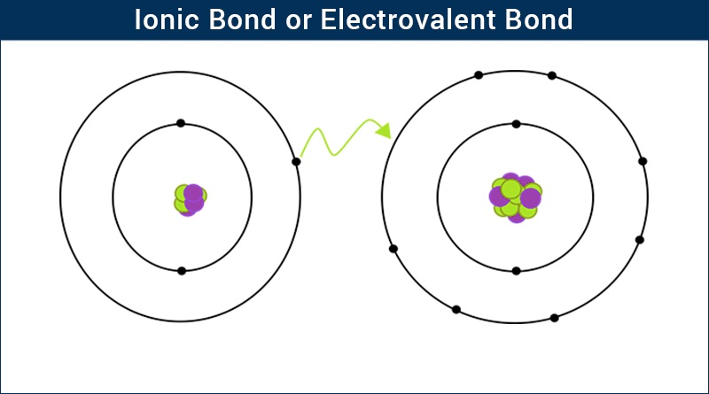

***Ionic Bond (Electrovalent Bond) – Electrostatic Attraction between Oppositely Charged Ions***

## Electronegativity and Ionic Bonding

* An Ionic bond is the bond formed by the complete transfer of valence electron so as to attain stability.
* This type of bonding leads to the formation of two oppositely charged ions – positive ion known as **cations (+)** and negative ions are known as **anions (-)**.
* The presence of two oppositely charged ions results in a strong attractive force between them. This force is an ionic or electrovalent bond.
* Ionic bonds form between atoms with large differences in [electronegativity](https://byjus.com/chemistry/electronegativity/), whereas covalent bonds formed between atoms with smaller differences in electronegativity.
* The compound formed by the electrostatic attraction of positive and negative ions is called an ionic compound.

## Examples of Ionic Bonds

The following table shows the elements and the ions formed by them when they lose or gain e‑_

|  |  |  |  |
| --- | --- | --- | --- |
| **Elements** | **Electronic config.** | **Reaction** | **Formed ions** |
| Na(11) | 2,8,1 | Na → Na+ + e–   ………………….. Reaction 1 | Na+ |
| Ca(20) | 2,8,8,2 | Ca → Ca2+ + 2e–……………….. Reaction 2 | Ca2+ |
| Cl(17) | 2,8,7 | Cl + e–→ Cl– ………………….……. Reaction 3 | Cl– |
| O(8) | 2,6 | O + 2e–→ O2-…………………… Reaction 4 | O2- |

* Now when Na reacts with Cl, reaction 1 and reaction 3 will take place and the resultant compound will be NaCl.
* When Na reacts with O, reaction 1 and reaction 4 will take place and the resultant compound will be Na2O.
* When Ca reacts with O, reaction 2 and reaction 4 will take place and the resultant compound will be CaO.
* When Ca reacts with Cl, reaction 2 and reaction 3 will take place and the resultant compound will be [CaCl2](https://byjus.com/chemistry/cacl2/).

Structure of Ionic Compounds:

Structures of some ionic compounds are as follows:

1. **Structure of Sodium Chloride**

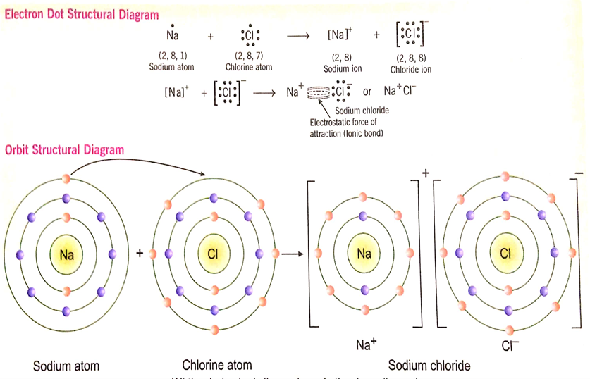

***Fig. represents the formation of Sodium Chloride molecule by the transfer of 1 e- from Sodium to Chlorine***

1. **Structure of Calcium Oxide**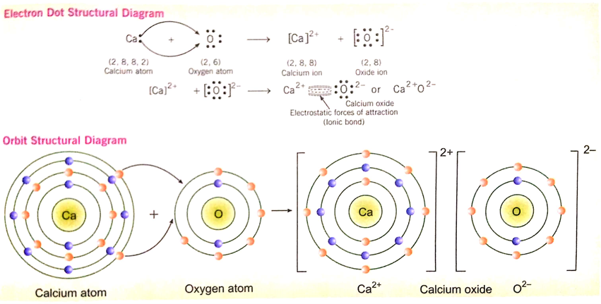

***Fig. represents the formation of Calcium Oxide molecule by the transfer of 2 e- from Calcium to Oxygen***

**Conditions for ionic bonding**

* 1. Low ionisation energy (IE) values of metal atoms forming cation.
  2. High electron affinity (EA) values of non metal atoms forming anion.
  3. Higher lattice energy (EL) of ionic compound.

## Properties of Ionic Compounds:

Due to the presence of a strong force of attraction between cations and anions in ionic bonded molecules, the following properties are observed_

1. These compounds usually exist in the form of crystalline solids at room temperature.
2. These are hard and brittle solids.
3. Usually soluble in water.
4. The ionic bonds are the strongest of all the bonds.
5. The ionic bond has charge separation and so they are the most reactive of all the bonds in the proper medium.
6. The ionic bonded molecules have high [melting and boiling point.](https://byjus.com/chemistry/melting-and-boiling-point/)
7. The ionic bonded molecules in their aqueous solutions or in the molten state are good conductors of electricity due to the presence of free ions.
8. Ionic compounds are neither rigid nor directional due to which they do not exhibit any type of stereoisomerism.
9. Reactions of ionic compounds are very fast or instantaneous.

**Electrovalency:** The number of electrons transferred from metals to non metals in ionic bond formation is called its electrovalency. For example:

1. Electrovalency of NaCl is 1 due to the shifting of one electron from sodium to chlorine.
2. Electrovalency of MgCl2 is 2 due to the shifting of two electrons from magnesium to chlorine.
3. Electrovalency of AlCl3 is 3 due to the shifting of three electrons from aluminium to chlorine.

**WORKSHEE – 4**

**Short answer type questions:**

1. How is an ionic bond formed?

2. Draw the electron dot and orbit structure of sodium chloride molecule by depicting electrons of both the elements differently?

3. What type of bonding exists between electropositive and electronegative elements?

4. Which compound contains both ionic as well as covalent bonds?

5. Define the term electrovalency with example?

6. Does a cation gain protons to form a positive charge or does it lose electrons?

7. Give reason why electrovalent compounds are bad conductor of electricity in solid state?

8. What type of compounds may show stereoisomerism and why?

9. Write three ionic compounds which are insoluble in water?

10. Why ionic compounds are having high B.P. and M.P.?

***Note:* *Please do all this work in your “Chemistry Notebook” which will be checked when college resumes. Please consider this important.***

**\*\*\*\*\*\*\*\*\*\*\***