**15th June, 2020 JESUS AND MARY SCHOOL AND COLLEGE MODULE 4**

**CLASS X**

**ENGLISH LITERATURE**

**THE LITTLE MATCH GIRL**

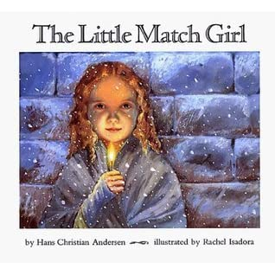

**INTRODUCTION**

Dear Students, in the previous three modules, we finished the study of Act III Scene 2 of Merchant of Venice. In this module, we are going to study the story **The Little Match Girl** written by Hans Christian Andersen. H.C. Andersen was a Danish writer best known for his fairy tales. However his stories are not restricted to children alone and have themes of universal appeal that transcend age and culture. Andersen had a very unhappy childhood and much of his stories reflect this sadness, dealing with loss and death. **The Little Match Girl** is one such. Set around Christmas, the story tells of a little girl who, unable to sell her match sticks dies of cold and hunger on the street even as, people are celebrating the birth of the Christ Child inside their warm cosy homes. The tale is rich in irony, imagery and symbols, emphasising the need for compassion for those who have so much less than we do.

**SUMMARY**

**Pathetic story**

The story **The Little Match Girl** is a pathetic story. It revolves around a poor little girl who sold matches on a cold wintry night. The weather was rough and the snow was falling.

**The Match girl and her slippers**

It was New Year’s eve and dreadfully cold. In this cold and darkness, there went along the street a poor little girl, bareheaded and with naked feet. When she left home she had slippers on, it is true, but they were too large for her feet. Her mother had used those slippers till then, but the poor little girl lost them running across the street when two carriages were quickly passing by. When she looked for them, one was not to be found, and a boy grabbed the other and ran off saying that it would come in very handy as a cradle some day when he had children of his own. So the little girl walked on with her tiny naked feet that were quite red and blue from the bitter cold.

**THE MATCH GIRL LOSES HER SLIPPERS**

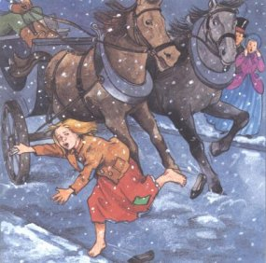

**The Match girl selling matches**

She carried a quantity of matches in an old apron and she held a bundle of them in her hand. No one had brought so much as a bunch all long day and no one had given her a penny. She crept along trembling with cold and hunger. She felt miserable.

**THE MATCH GIRL SELLING MATCHES IN HEAVY SNOWFALL**

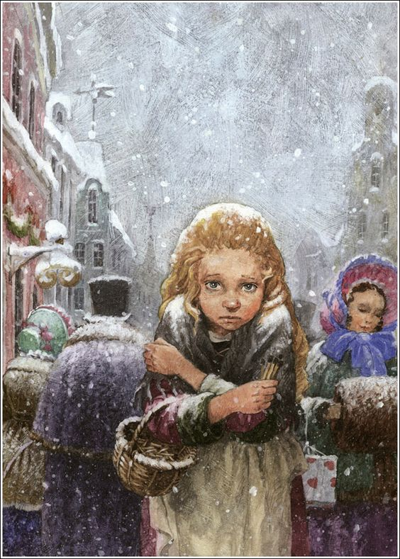

**Heavy snowfall**

The flakes of snow covered her long fair hair, which fell in beautiful curls around her neck, but she did not think of her beauty or of the cold. Lights shone from every window, and she could feel the delicious smell of roast goose being cooked for New Year’s Eve in all the houses. She could not stop thinking about it.

In a corner between two houses, she sat down. She tucked her little feet underneath herself, but still she grew colder and colder. She did not dare to go home, as she had not sold any matches and could not bring any money. Her father would certainly beat her. Besides, it was cold enough at home, as they had only a roof above them that was full of holes and cold wind blew through them.

**VISION OF AN IRON STOVE**

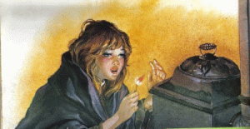

Her little hands were almost numb with cold. She thought that a match might warm her fingers if she lit it. She drew out one and struck it. It blazed and burnt and gave out a warm, bright flame like a little candle as she held her hands over it. It was a wonderful light. It really seemed to the girl as if she sat in front of a great iron stove having polished brass knobs, with a lovely fire inside it. It burned so nicely that the little girl stretched out her feet to warm them. She felt very comfortable. But then the flame went out, the stove vanished, and nothing remained. She had only the remains of the burnt-out match in her hand.

**VISION OF A ROAST GOOSE**



She rubbed another match against the wall. It burnt brightly and where the light fell on the wall she could suddenly see into the room. A snow-white cloth was spread on the table, on which laid beautiful china plates, while a stuffed roast goose cooked away and made the most delicious smell. And what was more delightful and wonderful, the goose jumped from the dish, with knife and fork still in its breast, and waddled along the floor straight towards the little girl. But the match went out then and nothing was left to her but the thick damp wall.

**VISION OF A CHRISTMAS TREE**

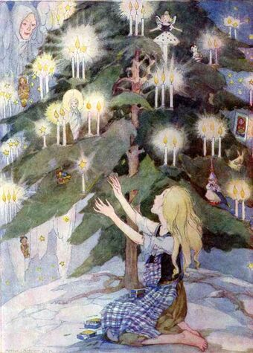

She lit another match and found herself sitting under the most magnificent Christmas tree. Thousands of candles were burning on the green branches and little painted figures, like she had seen in shop windows, looked down on her. She stretched out her hands to them, but then the match went out. Still the lights of the Christmas tree burned higher and higher into the sky until she saw one fall, forming a trail of fire.

“Now someone is dying!” said the little girl; for her old grandmother, the only one who had ever been good to her but who was now dead, had said, “Whenever a star falls, a soul goes up to God.”

**VISION OF HER GRANDMOTHER**

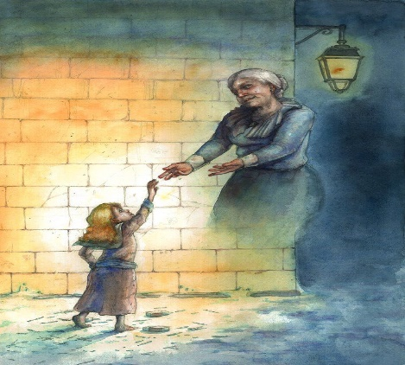

She struck another match against the wall. It lit and its brightness, her dear old grandmother appeared before her, beaming love and kindness. “Granny!” cried the little girl. “Oh, take me with you! I know you will disappear when the match is burnt out; you will vanish like the warm stove, the lovely roast goose and the great glorious Christmas tree!” And she rubbed the whole bundle of matches quickly against the wall, for she wanted to keep her grandmother near her.

**THE MATCH GIRL DIES**

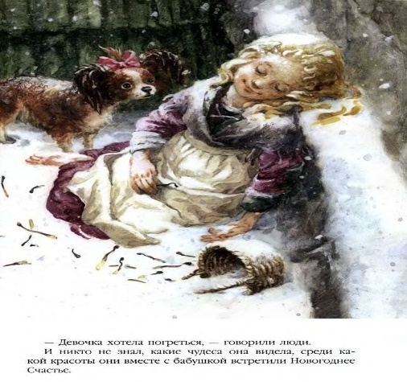

They burned with such brilliant light that it became brighter than the midday sun. Her grandmother had never looked so grand and beautiful. She took the little girl in her arms and both flew joyfully together, climbing higher far above the earth, away from cold and hunger, to heaven.

The next morning she was found frozen with a smile on her face. She had died on the last evening of the old year. No one imagined what beautiful things she had seen or how happily she had gone with her grandmother into the New Year.

**THEME**

In this story, the writer depicts the poor, miserable and hard life of a little girl who undergoes untold suffering in her life. It is a pathetic story that touches the hearts of the readers. It revolves around a small poor girl who is trying to sell matches and earn money because she is ordered to do so by her strict father.

The story begins on a cold winter night in which the snow never stopped. It was New Year’s Eve and dreadfully cold. In the cold and darkness, there went along the street a poor little girl bareheaded and with naked feet. She was out to sell matches but failed to do so. She crept along trembling with cold and hunger. She felt miserable, sad and uncomfortable.

Lights shone from every window and she could smell the glorious smell of roast goose being cooked for New Year’s Eve in all houses. In a corner between two houses, she sat down. Her little hands were almost numb with cold. She thought that a match might warm her fingers if she lit it. She lit the match and felt comfortable. Lighting the matches, she had visions of an iron stove, a roast goose, a Christmas tree and her grandmother. The little girl suffered from cold and hunger. Her life was full of pain, agony and suffering. So she asked her grandmother to take her along with her. Her grandmother took the child in her arms and both flew joyfully together, climbing higher far above the earth, away from cold and hunger, to heaven. The next morning she was found frozen and dead. At last, death came to her rescue and saved her from cold, hunger and misery.

**WORD MEANINGS**

1. Cradle - a small bed for a baby
2. Huddled - held her arms and legs together
3. Spluttered - matching soft sounds
4. Stretched - spread
5. Vanished - disappeared
6. Gauze - transparent cloth
7. Hopped - jumped
8. Waddled - walked with short steps
9. Streaking - moving fast
10. Blaze - burn brightly

**WORKSHEET NO. 4**

**Answer the following question in brief:**

1. Describe the miserable condition of the little girl. What effect did the cold weather have on her?
2. What did the poor girl carry with her? Why did she walk about the streets?
3. How did the little girl lose the slippers that she was wearing when she left her home?
4. Why didn’t she dare to go home? How did her hands become numb?
5. What did the little girl do to escape the cold?
6. How did the little girl feel in the bright flame of the burning match?
7. What did she visualize when she lit the second match?
8. What did she visualize on the Christmas tree?
9. What had the little girl’s grandmother told her about the star when it fell?
10. What did the little girl tell her grandmother? Why did she quickly strike all the matches she had in the packet?

**************

**SOLUTION TO WORKSHEET NO. 3**

**(UPLOADED ON 1ST JUNE, 2020)**

**Answer the following questions in brief:**

1. Who enters the scene after the love between Gratiano and Nerissa is revealed?
2. What does Salerio say when Bassanio asks him how was his good friend doing?
3. Explain: “I would you had won the fleece that he hath lost!” (Line 244)
4. Why does Portia say that there are some shrewd contents in the letter?
5. Explain: “yet, dear lady, rating myself at nothing, you shall see how much I was a braggart.” (Lines 259-261)
6. What does Bassanio compare the letter to?
7. What does Salerio tell about Shylock’s actions happening in Venice?
8. How does Bassanio praise Antonio in front of Portia?
9. What did Portia say to Bassanio about paying the debt? Why does Portia tell Bassanio to marry her immediately before going to Venice?
10. Briefly explain the contents of the letter.

**Answers:**

1. Lorenzo, Jessica and Salerio enter the scene after the love between Gratiano and Nerissa is revealed.
2. To Bassanio’s question, Salerio answers that Antonio is neither sick nor well, unless it is in his mind but his letter would tell him of his financial status.
3. Salerio says these words in response to Gratiano’s remark that Antonio would be glad to hear of their success and that they are like modern Jasons who have won the Golden Fleece. To this, Salerio says that he wishes that he (Gratiano) could have won the fortune that Antonio has lost.
4. Portia says that there are some shrewd contents in the letter because she saw Bassanio turn pale on reading the letter. She adds that some dear friend must have died, for nothing else in the world would change the condition of any normal man.
5. In these lines, Bassanio is explaining to Portia that when he told her that he owned nothing, he was exaggerating his position because he should have told her that he was less than nothing as he had made his dear friend pledge himself to his worst enemy to get the money he needed.
6. Bassanio compares the letter to the body of his friend Antonio, and every word written on it, to an open wound from which his blood is gushing out.
7. Salerio tells that even if Antonio had the money to repay Shylock, he would not take it from him now. He tells that Shylock appeals to the Duke, morning and evening, and threatens to take legal action against the country’s system of justice if they deny it to him.
8. Bassanio praises Antonio by declaring him his dearest friend, the kindest man, the best-intentioned man, never tired in showing kindness to others. He says that Antonio displays the old Roman spirit of honour more than any other person living in Italy.
9. Portia tells Bassanio to pay Shylock six thousand ducats and cancel the bond. She tells him to double the six thousand, and then multiply that by three, rather than let such a friend suffer the slightest harm through a fault of Bassanio. She asks Bassanio to marry her before leaving for Venice so that Bassanio could rightfully have the access over her wealth and possessions.
10. In his letter to Bassanio, Antonio tells him that his ships had perished, his creditors were growing impatient, his finances had fallen very low and the due date of his bond to the Jew had expired. He further writes that paying the penalty would surely result in his death, so he should regard all debts between him and Antonio cleared and he wishes to see him as he dies. But he also writes that this letter should not compel Bassanio to come to Venice, if his love for him doesn’t.

**NOTE: Please do this work in your copies which will be checked once the school reopens.**

**\*\*\*\*\*\*\*\*\*\*\*\*\*\*\*\*\*\*\*\*\*\***