**15TH JUNE, 2020 JESUS AND MARY SCHOOL AND COLLEGE MODULE 4**

**CLASS XII ENGLISH LITERATURE**

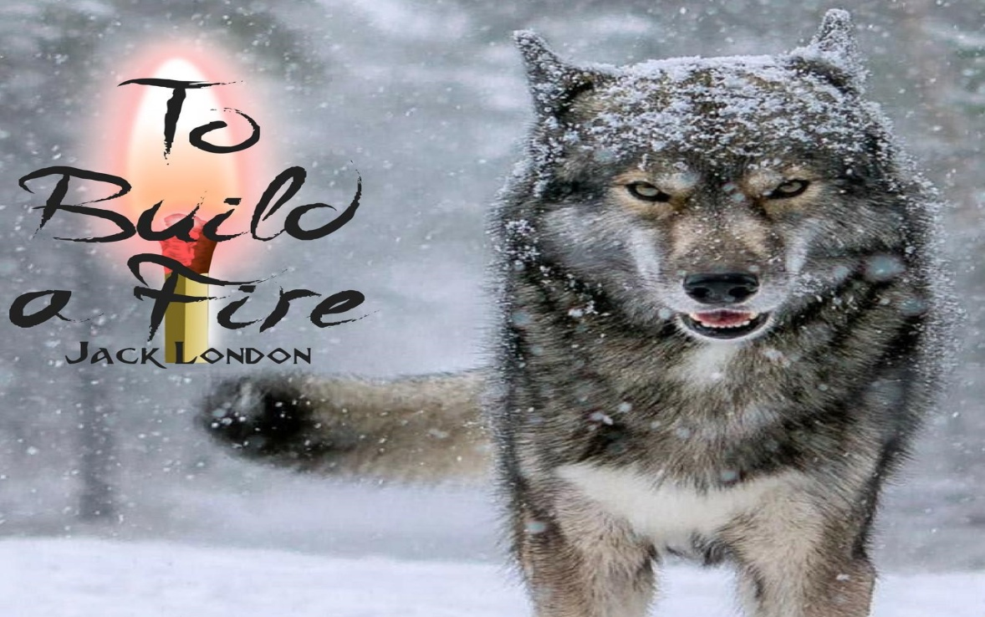

**TO BUILD A FIRE**

**By JACK LONDON**

***Dear Students,***

***Since this chapter is the lengthiest chapter of your book so I have given the solution to the worksheet uploaded on 1st June. Please go through this solution and copy it in your notebooks so that your notes may be complete when school reopens. No new chapter has been started in this module.***

**SOLUTION TO WORKSHEET 3 UPLOADED ON 1ST JUNE, 2020.**

**Answer the following questions to test your ability of comprehending the story:**

1. **Where was the man travelling? What was his purpose of travel?**

The man is travelling through the Klondike region of Canada near Alaska across the frozen Yukon river. He has undertaken a nine hour walk in brutally cold weather to meet his companions at an old wining camp during his first winter in the Klondike.

1. **Describe the severe conditions that the man was travelling through.**

The story opens with the description of the terribly cold and gray day. It is nine O’ Clock in the morning and there is no sun. He estimated that the temperature was fifty degrees below zero but the fact was that the temperature was seventy five degrees below zero. The moisture of the dog’s breath was fast freezing and setting on its fur, its jowls, muzzle and eyelashes. The man’s red beard was likewise frosted and the tobacco he chewed was forming a growing crystal appendage on his chin. As he spat, the spittle cracked with a sharp explosive sound before it hit the ground. This meant that the cold was extreme and intense, the kind of weather where no man should travel alone.

1. **What was the man’s attitude towards his surroundings?**

The man was initially completely indifferent towards the cold and harsh weather. It made no impression on him at all. Fifty degrees below zero impressed him only as being cold and uncomfortable and nothing else. He did not meditate on the fact that man is a creature of temperature, able to live only within certain narrow limits of heat and cold. The minus fifty degrees was only a figure to him and nothing else. All he could concentrate on was that he had to reach his companions.

1. **What were the man and the dog’s attitude towards each other?**

There was no keen intimacy between the man and the dog. This means that they did not care much for each other. The dog was the slave of the man and was only whip lashed by the man or he was threatened of the whip lash. The dog made no effort to communicate to the man the danger that he was in by travelling in this forsaken weather. It was not concerned for the welfare of the man. But it had to follow the orders of the man so it followed him at his heels.

1. **With reference to the text, describe the dangers that lurked beneath the snow.**

The creek was frozen to the bottom but the man knew that there were springs that bubbled out of the hillsides and ran along under the snow and above the ice of the creek. Even the coldest snaps never froze these springs and he knew their danger. They were traps and hid pools of water under the snow that might be three inches or three feet deep. If he had to walk in or sink up to his waist in these pools, it could be fatal.

1. **Describe the man’s first attempt to build the file. Was he successful?**

The man managed to get his firewood from the undergrowth where high water from the previous spring had lodged a supply of seasoned twigs. Working carefully from a small beginning, he soon had a roaring fire over which he thawed the ice from his face and in the protection of the fire, he ate his biscuits.

1. **The theme of the story is ‘Man versus Nature’. Do you agree with this? Give reasons.**

The theme “Man versus Nature” is aptly brought out in the story. The story tells us how the man underestimated nature and attempted to travel alone in the Yukon wilderness in extremely low temperatures with a totally indifferent attitude. During the trek, the man is confronted by his weakness again and again as a lone individual against the formidable power of nature in the form of brutal cold. The story depicts that how nature has the ability to overpower man. Even after realising how cold it was, too much pride in his abilities resulted in the man’s death. Even though he had been warned never to travel in fifty below temperatures without a partner, the man did not pay any attention to this advice and trusted his own abilities. But nature is much more relentless than man can ever think and the treacherous tree blotted out his fire. The flame of his life withered away and he finally resigned himself to the power of nature.

1. **Describe the man’s second attempt to build the fire. What caused him to fail?**

The man found a high water deposit of dry fire wood tangled in the underbrush near the trunks of several small spruce trees. There were sticks and twigs but also larger portions of seasoned branches and dry grasses. He first threw down several large pieces on the snow to serve as a foundation and prevent the young flame from drowning itself in the snow which would melt. Then he took a small piece of birch bark from his pocket and ignited it. He then fed the young flames with wisps of grass and tiny dry twigs. Gradually the flame grew stronger. But he had built the fire under the spruce trees which carried the weight of snow on its boughs. Each time he pulled a twig; it agitated the tree and ended up in the tree shedding its load of snow over the fire and blotted it out.

1. **Narrate briefly the third attempt to build the fire. Why did he not succeed?**

The man made a new foundation for the fire, but this time in the open. Then he gathered dry grasses and tiny twigs. He even collected an armful of larger branches to be used later when the fire gathered strength. He then tried to reach for the birch bark in his pocket but could not clutch hold of it. He tried to beat his fingers into action but it was of no use. He finally took off his mitten and reached for the birch bark. Next, he brought out his bunch of sulphur matches but his fingers were numb and the whole bunch fell in the snow. He tried to pick them up but his fingers could not hold them. He swooped them up and tried to burn them with his teeth. He failed. Then he tried to scratch the matches against his leg and it burst into flames, seventy sulphur matches all at once. His flesh was burning but he managed to burn the birch bark. He tried to get the dry grasses and twigs burning but a large piece of moss fell on the fire and scattered it. Each twig gushed a puff of smoke and went out. The man had failed.

1. **The man finally resigned himself to his fate. Discuss with reference to the ending of the story.**

The man finally resigned himself to his fate. He thought of accepting death with dignity. He thought to sleep his way to death. Drowsiness overtook him and he had visions of walking along with his companions and discovering his own frozen body the next day. Then he also heard himself telling the old timer at sulphur creek that he was right about not travelling alone in the brutal cold. Once the dog sensed that the man was dead, it left him and moved towards the camp, where it knew it would find “other food providers with fire providers”

**DESCRIPTIVE TYPE QUESTIONS.**

1. **Describe the man’s repeated attempts to keep himself warm.**

Then first fire was built easily and the man was able to eat his biscuits. He was forced to make another fire when his feet got wet, when he broke through the surface ice while walking. He pulled twigs off the brush piled around trees to build a fire, but it was extinguished. He built another fire with the help of his matches, but it all gets pulled apart when he tried to take a piece of moss out of the pile of fire. He tries to put the fire together yet he could not do so as he had no life left in his hands. Finally he attempts at running around the area to regulate his circulation but to no avail. He fails in keeping himself warm and dies.

1. **Contrast the attitude of the man and the dog towards the weather.**

It was the instinct that helped the dog to survive. The dog had an inbuilt respect for nature and her power. The dog is very anxious throughout the incidents of the story; he only forges ahead as he is afraid of the man. The dog is cautious and stays afar from the man as he does not trust him. The dog only thinks of the man in two ways, one who provides fire and food. The dog is naturally insulated and therefore well prepared to face the brutality of nature.

The man being emotional is conceited enough to feel he can defeat anything, including what nature sends his way. The old timer at Sulphur Creek had warned him and cautioned him to listen to the warning of nature, but he did not do any such thing and moved out on his expedition and eventually gets frozen to death.

The dog and the man share the same instincts, but the man chooses to ignore his instincts. The dog also stays away from the man’s reach when the man tries to kill him. Ultimately when he dies because of his own foolishness and ignorance, the dog howls for a little while and then leaves the corpse to the elements and moves towards other food and fire providers.

1. **What does the man finally learn from his experience?**

The man’s inadequate imagination frequently causes him to misjudge the supremacy of nature. He is also self assured in his strength of endurance, which depends on artificial resources, and not natural instincts and abilities. The man is indifferent because he is devoid of imagination. The man is capable and practical, but he does not take into account that when nature strikes, no one can escape. He learns that no man can defeat nature. An arrogant man, unmindful of nature’s might, will easily fall victim to nature’s wrath.

He thought of the old timer on Sulphur Creek, imagining him warm and comfortable and smoking a pipe, he said to himself, “You were right, old hoss; you were right.”

**NOTE:**

**Please complete the above solutions in your note books. Every work given will be checked.**