**15th June, 2020 JESUS AND MARY SCHOOL AND COLLEGE MODULE 4**

**CLASS 12**

**PHYSICS**

Concept of Electric field

Electric field can be considered as an electric property associated with each point in the space where a charge is present in any form. An electric field is also described as the electric force per unit charge.

The formula of electric field is given as;

**E**= **F**/**Q**

Where,

E is the electric field.  
F is a force.  
Q is the charge.

Electric fields are usually caused by varying [magnetic field](https://byjus.com/physics/magnetic-field/)s or electric charges. Electric field strength is measured in the SI unit volt per meter (V/m).

The direction of the field is taken as the direction of the force which is exerted on the positive charge. The electric field is radially outwards from positive charge and radially in towards negative point charge.

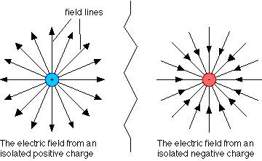

**Example 1**

A force of 5 N is acting on the charge 6 μ C at any point. Determine the electric field intensity at that point.

**Solution**

Given

Force F = 5 N

Charge q = 6 μ C

Electric field formula is given by

E = F / q

= 5N / 6×10−6C

E = 8.33 × 105 N/C.

**Point charge and test charge**

**Point charge:** Any charge whether positive or negative, whose electric field is to be found at a particular distance(point) is called point charge.

**Test charge:**Any charge whose magnitude is very small, in fact negligible, as compared to that of the point charge, and which does not affect the electric field of the point charge, whose magnitude is to be found out, is called test charge.

## **What is Electric Field Intensity?**

The space around an electric charge in which its influence can be felt is known as the electric field. The electric field Intensity at a point is the force experienced by a unit positive charge placed at that point.

1. Electric Field Intensity is a vector quantity.
2. It is denoted by ‘E’.
3. Formula: Electric Field = F/q.
4. Unit of E is NC-1 or Vm-1.

The electric field intensity due to a positive charge is always directed away from the charge and the intensity due to a negative charge is always directed towards the charge.

**Electric Field Intensity due to a Point charge**

An electric field is a vector field that associates the Coulomb force experienced by a test charge at each point in space to the source charge. The strength and the direction of the electric field can be determined from the Coulomb force F on a test charge q. If the field is generated by a positive charge Q, the direction of the electric field will be radially outward. Similarly, for a negative point source charge, the direction is radially inwards. The magnitude of the electric field E can be derived from Coulomb’s law. Let there is a point charge Q placed in the vacuum. We introduce another point charge q (or test charge) at a distance r from the charge Q. The electric field at point P due to the point charge Q is given by

E= $\frac{F}{q}$

Q. P E

r

In the figure above we have shown the direction of the electric field due to a positive point charge. The direction of  is also shown. The magnitude of the electric field is proportional to the length of the  shown. However, if a relatively large test charge q is brought within the vicinity of the source charge Q, it is bound to modify the original electric field due to the source charge. A simple way to avoid this conflict is to use a negligibly small test charge q. Thus our definition of electric field modifies to,

E=lim F/q where q tends to zero

According to the definition given above, the electric field at point P due to the point charge Q is

E=1/4πε0 q1q2r2

S.I. unit of electric field NC-1

In the diagram below, we have shown the electric field due to a positive point charge as a function of distance.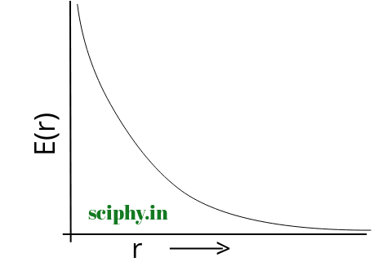



### **Salient Features of Electric field due to Point Charge**

* An electric field due to a point charge is a vector quantity.
* This electric field is the property of the source charge and does not depend on the test charge.
* For a positive source charge, the electric field will point radially outward from the source charge and for a negative one, it will direct radially inwards.
* The magnitude of the electric field due to a point charge also depends on the distance from the source charge.
* Electric field due to point charge has spherical symmetry and does not depend

## **Electric field due to Continuous Charge Distribution**

Here we need to consider that the charges are distributed continuously over a length or a surface or a volume.

1. Linear charge density-in the case of charge distribution along the line segment of length L, the linear charge density is,

*λ*= $\frac{charge\left(q\right)}{length(L)}$

λ is C/m

1. Surface charge density-If the total charge carried by an area element is equal to q, then the charge density of the element is,

*σ*= $\frac{charge\left(q\right)}{area\left(A\right)}$

​ σ is C/m2

1. Volume charege density-in case of charge distributed along with a volume element V, the volume density can be given by,

*ρ*= $\frac{charge\left(q\right)}{volume\left(V\right)}$

ρ is C/m3

## **What is Electric Field Line?**

Electric field lines are an excellent way of visualizing electric fields. They were first introduced by Michael Faraday himself.

A field line is drawn tangential to the net at a point. Thus at any point, the tangent to the electric field line matches the direction of the electric field at that point. Secondly, the [relative density](https://byjus.com/physics/relative-density/) of field lines around a point corresponds to the relative strength (magnitude) of the electric field at that point. In other words, if you see more electric field lines in the vicinity of point A as compared to point B, then the electric field is stronger at point A.

## **Properties of Electric Field Lines**

* The field lines never intersect each other.
* The field lines are perpendicular to the surface of the charge.
* The magnitude of charge and the number of field lines, both are proportional to each other.
* The start point of the field lines is at the positive charge and end at the negative charge.
* For the field lines to either start or end at infinity, a single charge must be used.

### **Electric Field Lines Attraction and Repulsion**

Electric field lines always point away from a positive charge and towards a negative point. In fact, electric fields originate at a positive charge and terminate at a negative charge.

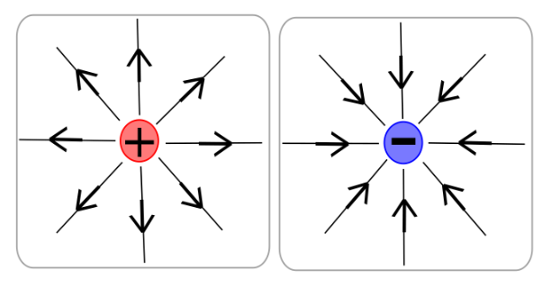

Electric field of point charges

Also, field lines never cross each other. If they do, it implies that there are two directions for the electric field at that point. But this is impossible since electric fields add up vectorially at any point and remember that “A field line is drawn tangential to the net electric field at a point”. Thus, electric field lines can never intersect one another.

As said before field lines are a great way to visualize electric fields. You can almost feel the attraction between unlike charges and the repulsion between like charges as though they are trying to push each other away.

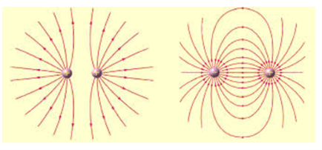

Electric field on the left image explains how like charges repel and right image explains how unlike charges attract

Coming to our initial example of static charge on hair, the direction in which charged hair stands up traces the local electric field lines. The charges on the hair exert forces on the hair strand as they attempt to leak into the surrounding uncharged space. The hair aligns accordingly so that there is no net force acting on it and inadvertently traces the electric field lines.

### **Rules for Drawing Electric Field Lines**

1. The field line begins at the charge and ends either at the charge or at infinity.
2. When the field is stronger, the field lines are closer to each other.
3. The number of field lines depends on the charge.
4. The field lines should never crossover.
5. Electric field and electric field line are tangent at the point where they pass through.
6. Questions related to electric field

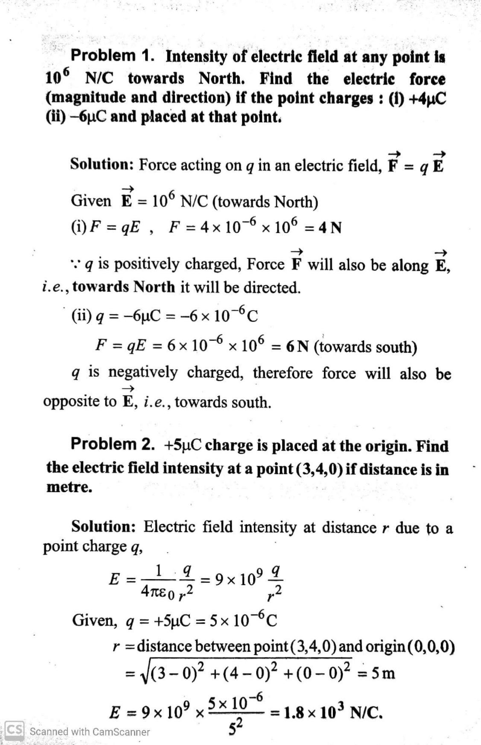

**Problem 3.  The electric field lines never cross each other, why?**

**Sol.** If the electric field lines intersect at any point, then there will be two directions of electric field at that point, which is not possible.

**Problem 4.  An electrostatic field line cannot be discontinuous, why?**

**Sol.**   An electrostatic force extends up to infinity, so the electrostatic field lines cannot be discontinuous.

 P**roblem 5.     The electric field E due to any point charge near it is defined as** E=limq→0Fq**where q is the test charge and F is the force acting on it. What is the physical significance of**limq→0**in this expression?**  
 **Draw the electric lines of point charge Q when**  
 **(i) Q > 0 and (ii) Q < 0.**

**Sol**. significance of limq→0 implies that the test charge is vanishingly small and so does not have its own field which would modify the field of charge q

(i)

[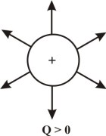](https://www.dronstudy.com/wp-content/uploads/2014/01/510.jpg)

(ii)

[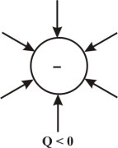](https://www.dronstudy.com/wp-content/uploads/2014/01/313.jpg)

**Problem 6**.

**Two point charges qA = 3 μC and qB = −3 μC are located 20 cm apart in vacuum.**

**(a) What is the electric field at the midpoint O of the line AB joining the two charges?**

**(b) If a negative test charge of magnitude 1.5 × 10−9 C is placed at this point, what is the force**

**experienced by the test charge?**

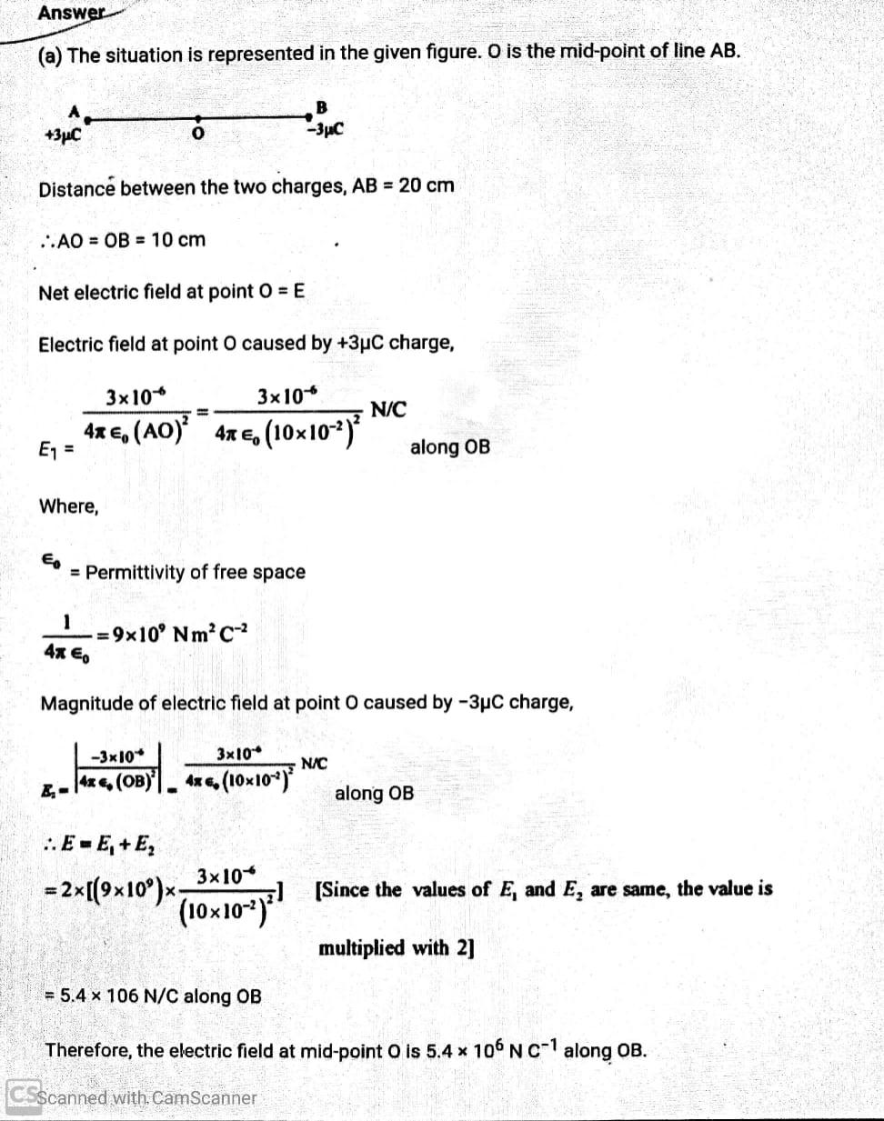

(b) A test charge of amount 1.5 × 10−9 C is placed at mid-point O.

q = 1.5 × 10−9 C

Force experienced by the test charge = F

∴F = qE

= 1.5 × 10−9 × 5.4 × 106

= 8.1 × 10−3 N

The force is directed along line OA. This is because the negative test charge is repelled by the charge placed at point B but attracted towards point A.

Therefore, the force experienced by the test charge is 8.1 × 10−3 N along OA.

**WORKSHEET 4**

Ques1.Define electric field

Ques2. Define electric field intensity at a point.

Ques3. Write the equations for electric field intensity.

Ques4. Define an electric line of force or electric field line.

Ques5. Draw the electric field lines due to

(i) an isolated positive charge

(ii) an isolated negative charge

(iii) an electric dipole

(iv) Two positive charges

Ques6. Write the properties of electric field lines.

Ques7. Two electric field lines never intersect. Why?

Ques8. Two point charge 4×10-9 and -16×10-9 are at 1m distance apart. At which point on line joining two charges, will electric field be zero?

Ques9. ABC is an equilateral triangle with side 10cm.A point charge of 5×10-6 is placed at point A, find the electric field at the mid point of B and C.

Ques10.A point is 10cm on north of a point charge 10-9C.Find the direction and magnitude of electric field at that point.

[[[[

**Note:- Please do this work in your copies which will be checked when the school reopens.**

**Please consider this important.**

*****************************