**15TH JUNE 2020 JESUS AND MARY SCHOOL MODULE 4**

**CLASS 1**

**SCIENCE**

**My Body**

**EXPLANATION**

All of US: Let’s Rhyme.

My hands are for clapping.

My arms can hug tightly.

My fingers can snap.

My lungs are for jumping.

My eyes help me to see.

This is my body

And I love all of me.

**Parts of our body:**

Our body is made up of many parts. Each part of our body has a name and a function. Each part of our body is important for us.

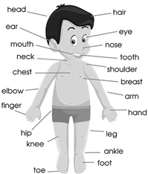

**Functions of body parts:**

Each part of our body does a work which is called its function. We use our mouth for eating, biting, and talking.

**HANDS:** Our hands are very useful to us. We use them for many activities, such as writing, clapping, playing etc.

**LEGS:** We can do many things with our legs too. For ex.- running, walking, dancing,

**Parts of our face:**

Our face also has many parts.

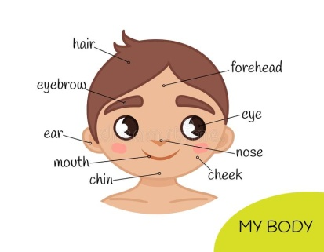

**SENSE ORGANS:** There are some parts of our body which help us to sense the things around us. They are known as our sense organs.

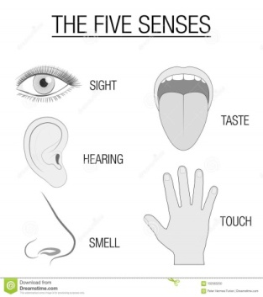

**EYES:** We have two eyes. They help us to see things far and near. We observe shape, size, colours of things with our eyes.

**EARS:** We have two ears. They help us to hear all types of sound around us.

**TONGUE:** We have one tongue in our mouth. It helps us to taste the things we eat. There are many types of tastes- sweet, salty, sour, bitter etc.

**NOSE:** We have one nose. It helps us to smell things.

**SKIN:** Our skin helps us to feel. It helps us to know if a thing is hot, cold, smooth, rough or hard.

**Health is wealth:**

We must take good care of our body to keep it fit and healthy.

1. Take bath daily.
2. Brush our teeth twice a day.
3. Trim our nail every week.
4. Eat healthy food and drink milk twice a day.
5. Exercise daily.
6. Sleep for at least 8 hours daily.

WORK SHEET -4

**Note: Do all the given exercises in your copy**

**Exercise: 1 Fill in the blanks.**

1. We taste with our tongue.
2. We work with our arms.
3. We use skin to feel.
4. We use hands to write.
5. We have five sense organs.

**Exercise: 2 True/False**

1. Taking a bath daily. (True)
2. Cleaning nose with finger. (False)
3. Eating fruits daily. (True)
4. Brushing teeth daily. (True)
5. Biting nails with teeth. (False)

**Exercise: 3 Count and write the number of body parts you have.**

1. Ten fingers.
2. Two lips.
3. One mouth.
4. One neck.
5. Two knees.

**Exercise: 4 Question/Answers.**

Q.1- Name any three things you do with your legs?

A.1- We can play, walk and dance with our legs.

Q.2- Name five sense organs?

A.2- Eyes, ears, nose, tongue, and skin are our sense organs.

Q.3- How is tongue useful to us?

A.3- Tongue help us to taste the food.

Q.4- What is the function of skin?

A.4- Our skin helps us to feel.

Exercise: 5 Draw the diagram of our body parts.