**15TH JUNE 2020 JEUS AND MARY SCHOOL MODULE 4**

**CLASS 2**

**SCIENCE**

**Bones and Muscles**

**EXPLANATION**

**OUR BODY-** Our body is made up of many parts. The body parts are also known as organs. The body parts which can be seen, felt, and touched by us are called external organs. Example- eyes, ear, nose, etc. There are many parts which cannot be seen our touched by us, they are called internal organs. Some important internal organs are:

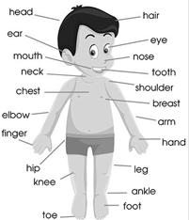

1. Brain- It helps us to read, write, think and remember. It controls all other body parts.
2. Heart- It pumps blood to all the body parts.
3. Lungs- They help us to breathe.
4. Stomach- It help to digest the food.
5. Kidneys- They clean our blood by filtration.

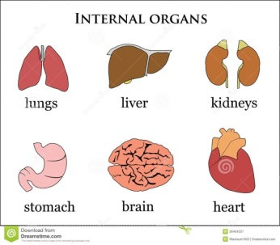

**BONES-** There are 206 bones in our body of different shapes and sizes. All the bones join together to form a framework in our body which is called the skeleton.

**Function of skeleton:**

1. The skeleton gives definite shape to our body.
2. It protects the delicate internal organs such as heart, lungs, brain etc.
3. It helps the movement of body parts.

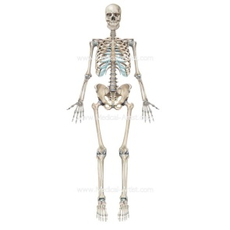

**JOINT-** The place where one bone joins with the other bones is called a joint.

**MUSCLES-** Muscles are the soft parts under the skin. There are about 650 muscles in our body. Bones and muscles work together and help us to move, walk, run, cycle etc.

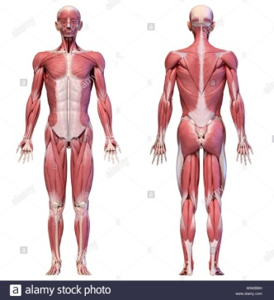

**Taking care of bones and muscles:**

We must take a protein rich diet to build healthy muscles. Exercises tone up the muscles and make them strong. The more we use our muscles, the stronger they become. If we do not use our muscles, we will become fat and lazy. Drink lots of milk and eat foods rich in calcium for stronger bones.

**WORK SHEET – 4**

**NOTE: Do all the given exercises in your copy.**

**EXERCISE: 1 Fill in the blanks:**

1. The largest bone of our body femur.
2. Number of bones in our face 14.
3. Number of bones in our body 206.
4. Number of muscles in our body 650.

**EXERCISE:2 Missing letters**

1. Heart 2. Brain 3.Lungs 4.Stomach 5.Kidneys

**EXERCISE: 3Match the following**

1. Good posture beautiful

2. Milk calcium

3. Pulses protein

4. Eyes external organs

5. Heart internal organs

**EXERCISE:4 QUESTION/ ANSWERS(SHORT TYPE)**

Q1. What is posture?

Ans. Posture is the way we move, sit, or stand.

Q2. What is the skeleton?

Ans. All the bones join together to form a framework in our body is called skeleton.

Q3 Write two functions of skeleton?

Ans. Two functions of skeleton are-

1. The skeleton gives definite shape to our body.
2. It helps in the movement of body parts.

Q4.How can we make our muscles stronger?

Ans. We can make our muscles stronger by doing regular exercise and eating protein rich diet.

Q5 How many bones are present in our body?

Ans. There are 206 bones present in our body.

EXERCISE: 5 Draw the diagram of our body parts.