**15TH JUNE 2020 JESUS AND MARY SCHOOL MODULE . 4**

**CLASS – 4**

**SCIENCE**

**AIR, WATER AND WEATHER**

**EXPLANATION**

Air is a mixture of gases. It is present all around us. We cannot see air but we can feel it. It has weight and occupies space. Air is necessary for breathing andburning.

**COMPOSITION OF AIR**

Air is made up of gases, dust, smoke and water Vapours.

**The composition of gases in air is :-**

**Nitrogen = 78%, Oxygen = 21%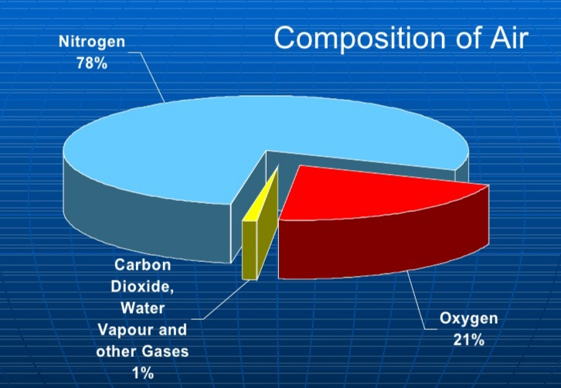 Carbon dioxide = 0.3%, Other gases = 0.7%**

Moving air is called wind. The speed of wind affectsand changes the weather of a place. In nature, the sun heats up the land. So, theair near the land also gets heated up.

**CONVECTION CURRENTS**

The hot air expands and rises up and whenthe hot air moves up, the cold air takes its place. These movements caused by hot and cold air are known as convection currents.

**HUMIDITY**

Humidity is the amount of water vapours present in the air. An instrument called **Hygrometer** is used to determine the humidity of air.

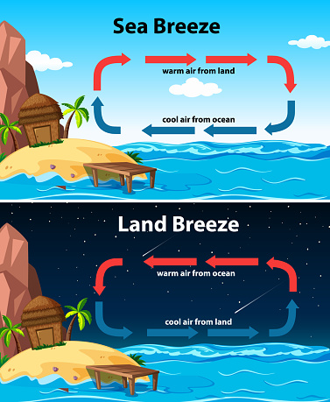**TYPES OF BREEZE**

There are two types of breeze –

1. Sea breeze **2.** Land breeze

**Sea Breeze**

During daytime, the land heats up fasterthan sea water. The hot air from the landrises and the cool air from the sea rushesto take its place. So the wind blows from the sea towards the land. This is calledsea breeze.

**Land Breeze**

At night, the land cools faster than seawater. The air above the seawater iswarmer than the air above the land.Warm air rises and cools air from the landrushes towards the sea. This is called land breeze.

**WEATHER**

Weather is the state of the atmosphere at any given period of time. It may be hot, cold, rainy, windy,cloudy, dry or humid. Weather changes from day to day, time to time and place to place.

The weather of a place depends on the following factors :-

1. Wind 2. Air pressure 3. Clouds 4. Temperature 5. Moisture

**WATER**

Earth is also known as **Blue planet** because three – fourth part of earth is covered with water . It is the most important and abundant compound on the earth.

Water is the only form of matter which is available in solid **(** ice **),** liquid **(** water **)** and gaseous **(** water vapours **)** form .

All the three forms of water are interchangeable on heating or cooling .

**SOURCES OF WATER**

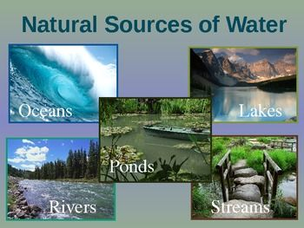

The sources of water for our villages, towns and cities are rivers, lakes, ponds,wells, tubewells and underground water. All these get water from rains.Rain occurs because of evaporation and condensation of water in nature.

**FACTORS WHICH AFFECT EVAPORATION**

When water is heated up, it changes into water vapours. This process is calledevaporation. There are some factors which affect evaporation such as:

**a) High temperature or heat of the sun.**

Clothes spread to dry outside, dry faster than the clothes spread inside .

**b) When the exposed surface is larger .**

The larger the surface area of water, the faster is the evaporation. Water evaporates faster from large shallow lakes as compared to smaller and deeper lakes. Water in ponds evaporates faster than water in deep wells.

**c) Strong wind favours evaporation.**

Take two saucers with equal amount of water. Place one under a fan and the other one away from fan or wind. You will notice after an hour that the water in the saucer under the fan has evaporated faster

This explains why **wet clothes dry faster on a windy day**. We feel cooler under a fan because our sweat evaporates quickly.

**CONDENSATION**

It is the process when water vapours cool down to change into water droplets.

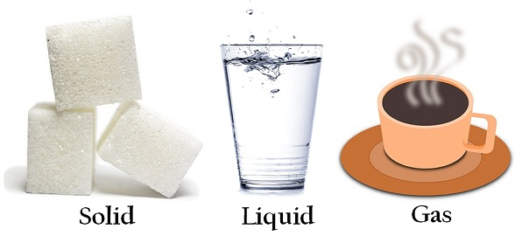We can see condensed water vapours in many different forms in nature .

**FORMS OF CONDENSATION**

**Rain –** It falls because water vapours in the air get condensed and fall from clouds.

**Dew –** Dew drops are found on plants, leaves, window panes on cold winter mornings when water vapours condense.

**Fog-** It is formed in winters when water vapours condense on the dust particles close to the ground.

**Frost–** It is formed when water vapours freeze into ice crystals in winter.

**Snow-** It is formed in very cold places where water droplets freeze and form snow.

**SEDIMENTATION AND DECANTATION**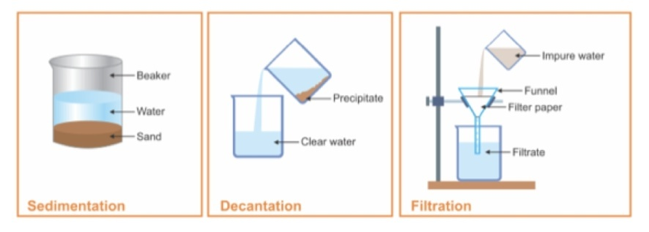

When the heavier component in a mixture settles **(** after leaving it undisturbed for sometime **),** the process is called **sedimentation .**

The process of removal of water above the sediment is called **decantation .**

**Filtration-** It is the process of removing thesuspended solids from water by passing itthrough a filter. The decanted water is passedthrough a filter paper.

**Boiling-** The filtered water is not safe for drinkingas it may contain harmful disease causing germs. Boiling water for 10-15 minutes kills germs thus making water pure.

**Chlorination-** It is the process of adding a chemical calledchlorine in the form of tablets to kill harmful germs.

We can also clean water by using filters such as aquaguard and RO. They kill the germs and remove impurities fromwater.

**Storage of Water:** After purifying the water, it should be stored in cleanand covered vessels. We should wash our hands beforetaking out water from the vessel. The containers shouldbe kept in a neat and clean place away from dustbins.

**WORK SHEET – 4**

**Note:- Do all the given exercises in your copy.**

**EXERCISE - 1 Word- meanings**

1. **Abundant -**  Available in large quantities.
2. **Sauces -** A shallow dish.
3. **Condense -** Cause to change from a gas or vapour to a liquid.
4. **Vessel –** A utensil

**Exercises – 2 Underline the correct option.**

**1.** Three-fourth part of earth is covered with **water**/air

**2.Chlorine**/Iodine kills the germs in water.

**3.Fog**/Frost is formed when water vapours condense on dust particles.

**4.** Strong winds favour **evaporation**/condensation.

**5.** Water is not fit for drinking after **sedimentation**/filtration.

**EXERCISE – 3 Write (E) for evaporation and (C) for condensation.**

**1.** Making of salt from sea water. **(E)**

**2.** Water droplets on a chilled cold drink tin. **(C)**

**3.** Dew drops on windowpanes . **(C)**

**4.** Drying of wet clothes under a fan. **(E)**

**5.** Feeling cool under a fan in summer season. **(E)**

**EXERCIOSE – 4 Complete the sentences.**

**1.** Earth is also called Blue Planet because **earth is covered with water more than 71% .**

**2.** Near the sea are cooler because **of the atmospheric mixing and local winds that are created.**

**3.** spread out dry faster because **the exposed surface area increases . As a result the rate of evaporation' increases .**

**4.** We should not drink water obtained after decantation because **it cannot separate solids or liquids that dissolve in the mixture .**

**EXERCISE – 5 Short type question – answer**

**Q1. What is weather? Which factors affect weather?**

**Ans-**Weather is the condition of the atmosphere at a certain place and time. The Sun, the sea, the earth's rotation, the earth's revolution and the atmosphere around are the factors that affect weather.

**Q2. What is wind? What causes it to blow?**

**Ans-**Moving air is called wind. The wind also blows due to the sun.

**Q3. What do you mean by convention currents?**

**Ans-**The movements caused by hot and cold air are called convention currents.

**Q4. What is condensation?**

**Ans-** The process of changing of water vapour into liquid is called condensation.

**Q5. What do you mean by Dew?**

**Ans-**  After a cold night, water vapour in the air condenses on the grass and leaves of the plants.These droplets of water is called Dew.

**Q6. What do you mean by boiling?**

**Ans-**  A liquid can change into gas when heated so the process in which a liquid changing into gas on heating is called boiling.

**EXERCISE – 6 Long type question – answer**

**Q1. What is sedimentation and decantation ? (Draw the diagram from your notebook)**

**Ans – Sedimentation -** The method of settling down of insoluble impurities present in water is called sedimentation.

**Decantation -** When the mud settles down at the bottom after sedimentation the upper layer can easily be poured into another beaker. This process is called decantation.

**Q2. Write the composition of atmosphere with percentage. Draw the diagram**

**Ans - The Composition of air are -**

**1)** Nitrogen (78%) **2)** Oxygen (21%) **3)** Carbon dioxide (0.004%) **4)** Other ( less than 1%)

**Q3. What is land breeze and sea breeze? Explain with diagrams.**

**Ans- Land breeze -** During the night the land cools down more quickly than the sea. So, the air above the sea is hotter than the land. This hot air, rises up and the cold air above the land flows towards the sea to take the place of the worm air. This causes the land breeze.

**Sea breeze -** During the day, the land heats up more quickly than the sea. As the land is heated, the air above it also heats up. This hot air is lighter than the cold air above the sea. So the hot air above the land rises up and the cold air above the sea flows towards the land to take its place. This causes the sea breeze.**(Draw the diagram from your notebook )**