**15th June, 2020 JESUS AND MARY SCHOOL AND COLLEGE MODULE 4**

**CLASS 6**

**ENGLISH LITERATURE**

**THE DAFFODILS**

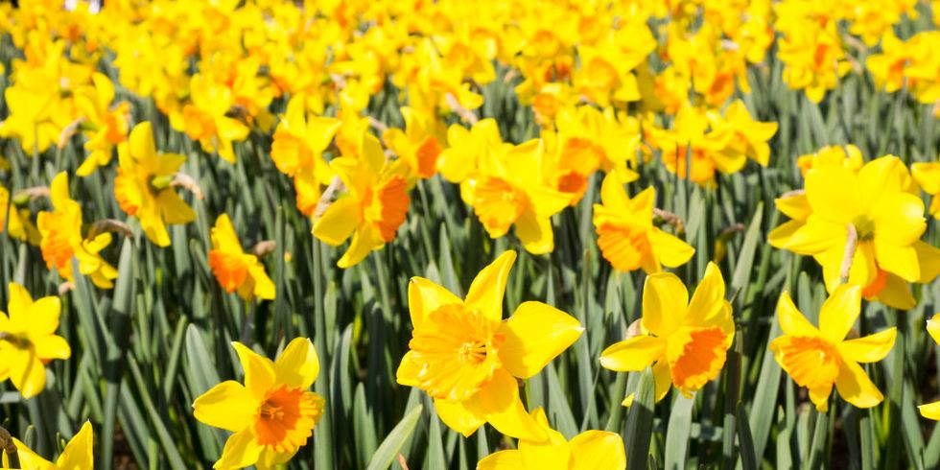

**INTRODUCTION**

Dear Students, in this module, we are going to study the poem **The Daffodils** written by William Wordsworth. William Wordsworth is regarded as the greatest poet of Nature. He is a worshipper of Nature. Nature occupies in his poems independent status and is not treated in a casual or passing manner. The poem **The Daffodils** shows Wordsworth’s love of Nature. It brings home the idea that nature is the source of eternal joy. The beautiful scene of the golden daffodils fills the poet with pleasure and his heart begins to dance with the daffodils.

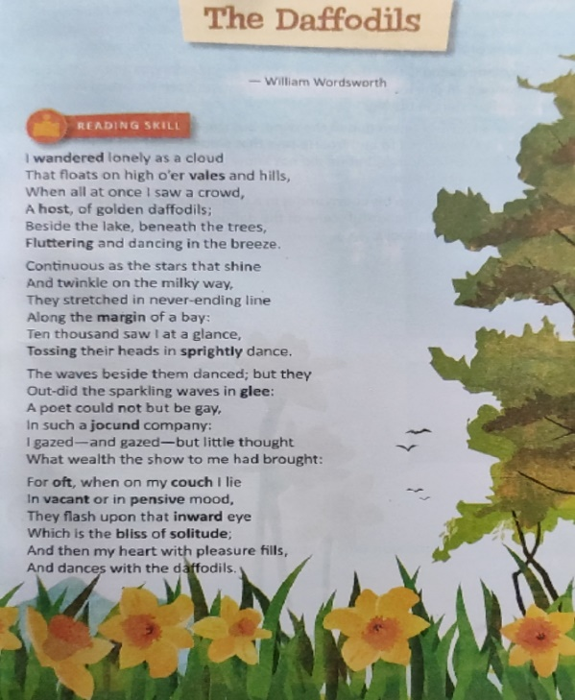

**EXPLANATION**

The poem **The Daffodils** depicts the sight that the poet actually enjoyed in the company of his sister Dorothy while they were in the woods beyond Gowbarrow park.

In the beginning, the poet describes himself roaming lonely as a cloud that floats over the hills and valleys. All of a sudden, his eyes fell upon a large belt of yellow daffodils by the side of the lake. They were sheltered under growing trees. A gentle breeze made these golden-coloured flowers wave and dance.

The poet feels that the daffodils were as numerous as the stars that shine and twinkle in the Milky Way. They were spread in a long line on the bank of the lake. In one look, the poet felt that they were ten thousand in number, moving their heads as if they were dancing and rejoicing.

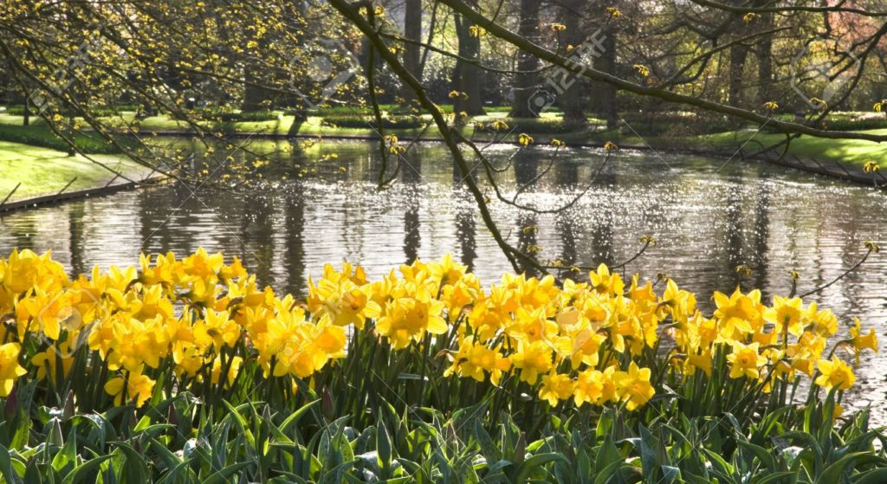

The waves of the lake also rippled due to the wind, but the daffodils seemed to be more lively and joyful as they moved to and fro. He says that a poet could not help being happy in such joyful surroundings. He was so lost in its beauty that he could hardly realize its worth then. He realized its worth only when he was away from the sight.

Often when he is lying alone on his couch and is in a thoughtful mood or even if he has no thoughts, he remembers the beautiful scene of the daffodils and he feels very happy as his heart dances with the daffodils. He forgets his sadness or loneliness.

It is, of course, in solitude that human mind captures the things already seen. The poet wants to emphasise that nature is a source of eternal joy to man.

**WORD MEANINGS**

1. Wandered - roam about
2. Vales - valleys
3. Host - group
4. Fluttering - moving slightly
5. Margin - bank
6. Tossing - moving to and fro
7. Sprightly - lively
8. Glee - joy
9. Jocund - joyful
10. Oft - often
11. Couch - bed
12. Vacant - empty
13. Pensive - lost in thought
14. Inward - inner
15. Bliss - happy state of mind
16. Solitude - loneliness

**WORKSHEET NO. 4**

1. **Answer the following questions:**
2. How are the daffodils described?
3. Where are the daffodils and what are they compared to?
4. What did the poet not realise when he saw them?
5. What does the poet not help doing?
6. What happens when he is alone?
7. **Write the rhyming words (from the poem).**
8. **Fill in the blanks:**
9. That floats on high o’er ______ and hills.
10. _____________ and dancing in the breeze.
11. Tossing their heads in ____________ dance.
12. Out-did the sparkling waves in ________.
13. Which is the bliss of ____________.
14. **Make sentences with the following words:**
15. Tossing
16. Vacant
17. Host
18. Margin
19. Couch

**********

**SOLUTION TO WORKSHEET NO. 3**

**(UPLOADED ON 1ST JUNE, 2020)**

**Answer the following questions**

1. **How did Aladdin’s father die and why was his mother sad?**

Ans: Aladdin’s father died with the grief that his son was idle and did nothing but play all day long in the streets with little idle boys like him. Aladdin’s mother was also sad over his idleness and not changing himself.

1. **Who met Aladdin as he was playing on the streets and what kind of introduction did the man give of himself?**

Ans: A stranger, who was a famous magician met Aladdin when he was playing in the streets and introduced himself as his Uncle.

1. **What did Aladdin’s mother tell him about his uncle?**

Ans: Aladdin’s mother told him about his uncle that his father had a brother but she always thought that he was dead.

1. **How did the magician win the trust of Aladdin’s mother?**

Ans: The magician won the trust of Aladdin’s mother by offering to take a shop for him and stock it with merchandise. He also bought Aladdin a fine suit of clothes and took him all over the city showing him the sights.

1. **Where did the magician lead Aladdin to?**

Ans: The magician led Aladdin into some beautiful gardens a long way outside the city gates.

1. **What kind of magic trick did the man show when the fire was lit and what appeared at that time?**

Ans: When the fire was lit, the magician threw on it a powder he had about him, at the same time saying some magical words. The earth trembled a little and opened in front of them, revealing a square flat stone with a brass ring to raise it by.

1. **What was Aladdin’s reaction to the magic trick happening there? What did the magician do to Aladdin?**

Ans: Seeing the magic trick, Aladdin tried to run away but the magician caught him and gave him a blow that knocked him down.

1. **What made Aladdin forget his fears?**

Ans: The magician told Aladdin that beneath the stone lies a precious treasure which is only meant to be his and none else may touch it. This made Aladdin forget his fears.

1. **What were the instructions given to Aladdin as he descended the steps?**

Ans: The magician instructed Aladdin to go down the stairs and told him that at the foot of those steps, he will find an open door leading into three large halls, he would have to go through them without touching anything or else he would die instantly, he should continue walking till he finds a shelf where stands a lighted lamp, he had to pour out the oil it contains and bring it to him.

1. **How was Aladdin trapped inside the cave?**

Ans: Having got the lamp, Aladdin arrived at the mouth of the cave. The magician cried out in great hurry to make haste and give the lamp to him, which Aladdin refused to do till he was out of the cave. Then the magician got very angry and throwing some more powder on the fire, saying something. The stone rolled back into its place and Aladdin was trapped inside the cave.

**Fill in the blanks**

Next day the magician led Aladdin into some beautiful **gardens** a long way outside the city gates. They sat down a **lovely fountain**, and the magician pulled a cake from his **girdle**, which he divided between them. Then they journeyed onwards till they almost reached the **mountains**. Aladdin was so tired that he begged to go back, but the magician **beguiled** him with pleasant stories.

************

**NOTE: Please do this work in your copies which will be checked once the school reopens.**