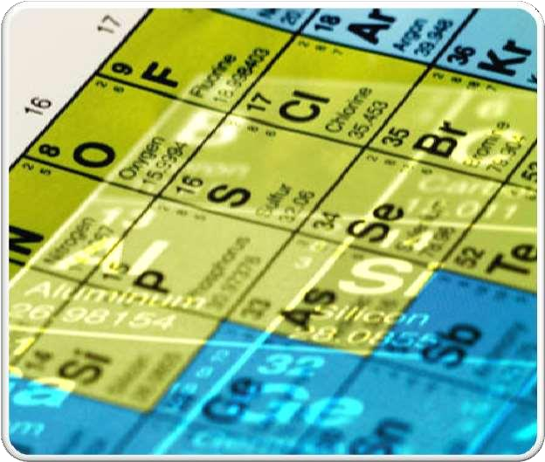

# MODERN PERIODIC

TABLE

* 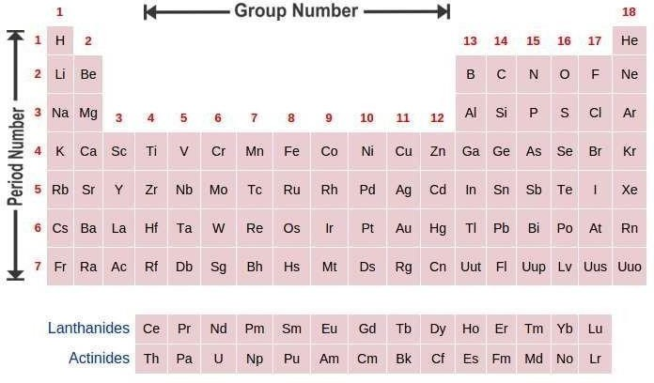**PERIODIC TABLE:** IT IS THE TABLE OF CHEMICAL ELEMENTS ARRANGED IN ORDER OF ATOMIC NUMBER SUCH THAT ELEMENTS

WITH SIMILAR STRUCTURE APPEAR VERTICAL COLUMNS.

ATOMIC IN THE

* **MODERN PERIODIC LAW:** THE MODERN PERIODIC LAW STATES **“THE CHEMICAL AND PHYSICAL PROPERTIES OF ELEMENTS ARE A PERIODIC FUNCTION OF THEIR ATOMIC NUMBERS”.** MODERN PERIODIC TABLE IS BASED ON THE MODERN PERIODIC LAW.

Chemistry by Dr. Satyendra S.

**CLASSIFICATION OF ELEMENTS**

* + GROUP 1 ON EXTREME LEFT POSITION CONTAINS **ALKALI METALS** (LI, NA, K, RB, CS AND FR).
  + THE **ALKALINE EARTH METALS** ARE METALLIC ELEMENTS FOUND IN THE GROUP 2 OF THE PERIODIC TABLE.
  + ELEMENTS PRESENT IN GROUPS 3 TO 12 IN THE MIDDLE OF THE PERIODIC TABLE ARE CALLED **TRANSITION ELEMENTS**. IN THE TRANSITION ELEMENTS, VALENCE ELECTRONS ARE PRESENT IN MORE THAN ONE SHELL. WITH A FEW MINOR EXCEPTIONS, THE ELECTRONIC STRUCTURE OF TRANSITION METAL ATOMS CAN BE WRITTEN AS [ ]NS2(N-1)DM, WHERE THE INNER D ORBITAL HAS MORE ENERGY THAN THE VALENCE-SHELL S ORBITAL.
  + GROUP 18 ON EXTREME RIGHT SIDE POSITION CONTAIN **NOBLE GASES** ( HE, NE, AR, KR, XE AND RN ). THEIR OUTERMOST SHELLS CONTAIN 8 ELECTRONS EXCEPT **HE** AS ITS OUTERMOST SHELL IS **K** SHELL AND IT CAN HOLD

ONLY A MAXIMUM OF 2 ELECTRONS.

* + **INNER TRANSITION ELEMENTS**:
    - 14 ELEMENTS WITH ATOMIC NUMBERS 58 TO 71 (CE TO LU) ARE CALLED **LANTHANIDES** AND THEY ARE PLACED ALONG WITH THE ELEMENT LANTHANUM (LA), ATOMIC NUMBER 57 IN THE SAME POSITION (GROUP 3 IN PERIOD

6) BECAUSE OF VERY CLOSE RESEMBLANCE BETWEEN THEM. HOWEVER, FOR CONVENIENCE SAKE, THEY ARE

SHOWN SEPARATELY BELOW THE MAIN PERIODIC TABLE.

* + - 14 ELEMENTS WITH ATOMIC NUMBERS 90 TO 103 (TH TO LR) ARE CALLED **ACTINIDES** AND THEY ARE PLACED ALONG WITH THE ELEMENT ACTINIUM (AC), ATOMIC NUMBER 89 IN THE SAME POSITION (GROUP 3 IN PERIOD
      1. BECAUSE OF VERY CLOSE RESEMBLANCE BETWEEN THEM. THEY ARE ALSO SHOWN SEPARATELY BELOW THE MAIN PERIODIC TABLE ALONG WITH LANTHANIDES.

**PERIODICITY**

**periodicity of elements means the recurrence of similar properties of the elements after certain regular intervals when they are arranged in the order of increasing atomic numbers.**

**Cause of**

**Periodicity of Elements**

**The cause of periodicity of the properties of elements is the repetition of similar electronic configuration of their atoms in the outermost energy shell (or valence shell) after certain regular intervals.**

## PERIODIC TRENDS IN PERIODIC TABLE

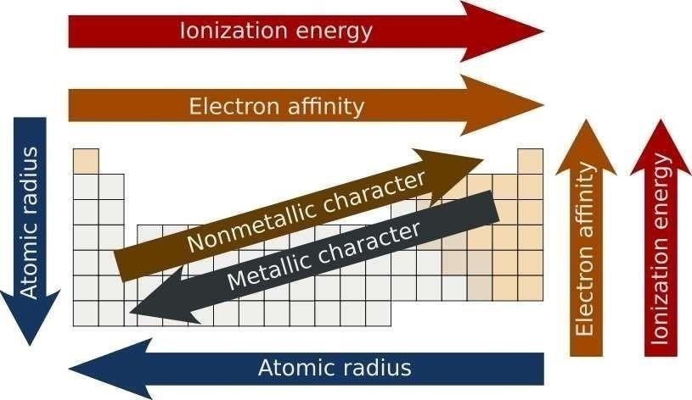

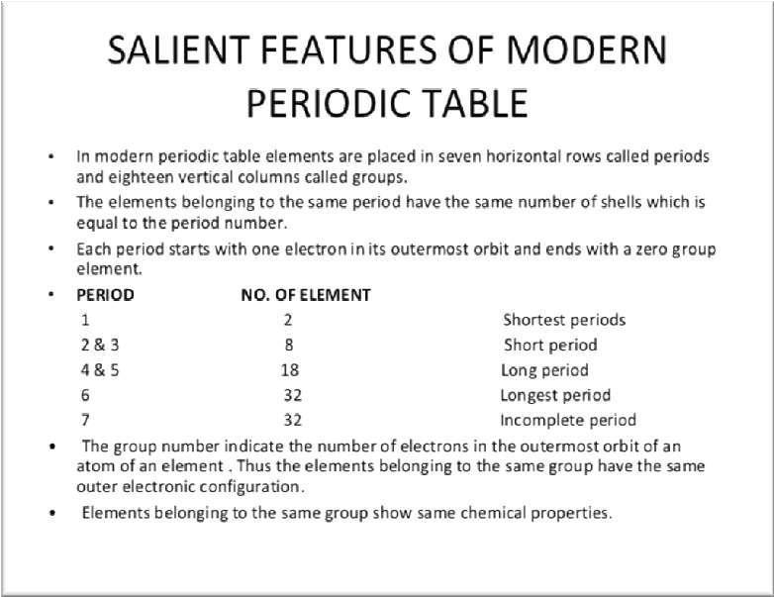

SALIENT

FEATURES

OF MODERN

PERIODIC

TABLE

**GROUPS**

* + - * + G MODERN PERIODIC TABLE HAS 18 VERTICAL COLUMNS.

THEY ARE CALLED GROUPS, ARRANGED FROM LEFT TO RIGHT

GROUP 1 – ELEMENTS OF THIS GROUP ARE KNOWN AS ALKALI METALS AS THEY FORM STRONG ALKALIS WITH WATER

GROUP 2 – ALKALINE EARTH METALS – THEY FORM WEAKER

ALKALIS AS

### COMPARED TO GROUP 1

GROUP 3 -12 – TRANSITION ELEMENTS

GROUP 13 – BORON FAMILY

### GROUP 14 – CARBON

* GROUP 15 – NITROGEN FAMILY
* GROUP 16 – OXYGEN FAMILY ( ALSO KNOWN AS CHALCOGEN)
* GROUP 17 – HALOGEN FAMILY
* GROUP 18 – NOBLE GAS OR INERT GAS
  + - * + PERIODS – THERE ARE 7 HORIZONTAL ROWS IN THE MODERN PERIODIC TABLE. THEY ARE CALLED PERIODS

THE NUMBER OF SHELLS PRESENT IN AN ATOM DETERMINES ITS PERIOD.

Chemistry by Dr. Satyendra S.



SHELLS (ORBITS) AND VALENCY

**ORBITS**: ELECTRONS REVOLVE AROUND THE NUCLEUS IN CERTAIN DEFINITE CIRCULAR PATHS CALLED ORBITS OR SHELLS.

DOWN THE GROUP, THE NUMBER OF SHELLS INCREASES SUCCESSIVELY, SUCH THAT THE NUMBER OF SHELLS EQUALS THE NUMBER OF THE PERIOD TO WHICH THAT ELEMENT BELONGS

ALONG THE PERIOD, THE NUMBER OF SHELLS REMAIN SAME

**VALENCY**: VALENCY DENOTES THE COMBINING CAPACITY OF THE ATOM OF AN ELEMENT. IT IS EQUAL TO THE NUMBER OF ELECTRONS AN ATOM CAN DONATE OR ACCEPT OR SHARE

•

**SALIENT FEATURES OF THE PERIODIC TABLE**

* ELEMENTS OF GROUP 1,2,13,14,15,16 & 17 ARE KNOWN AS THE MAIN GROUP ELEMENTS OR REPRESENTATIVE ELEMENTS OR NORMAL ELEMENTS.
* LANTHANIDES GROUP 3 OF SIXTH PERIOD AND ACTINIDES GROUP 3 OF THE SEVENTH PERIOD HAVE SIMILAR PROPERTIRS AS THEY BELONG TO THE SAME GROUP 3.
* THIRD PERIOD ELEMENTS , SODIUM , MAGNESIUM , ALUMINIUM , SILICON,PHOSPHORUS,SULPHUR AND CHLORINE ARE CALLED TYPICAL ELEMENTS.

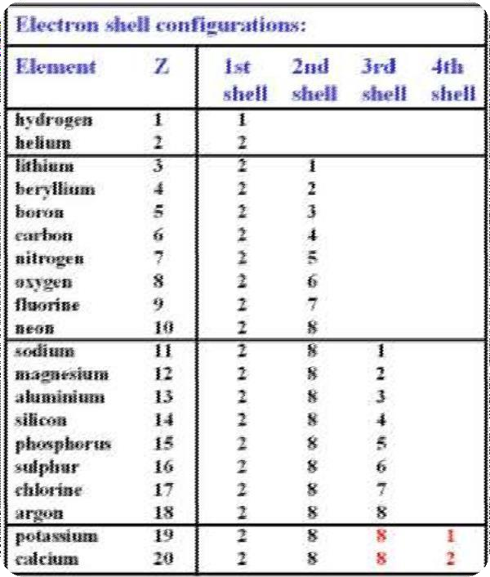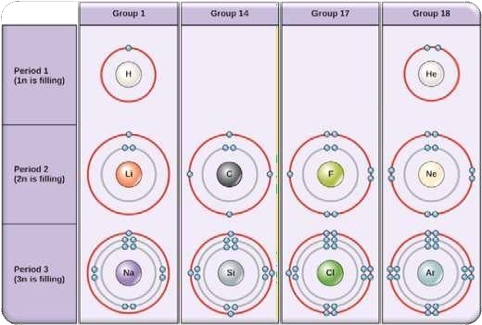

.

10jhj[Type the company name] | PERIODICITY

10

## VALENCY, ORBITS AND THE PERIODIC

**TABLE**

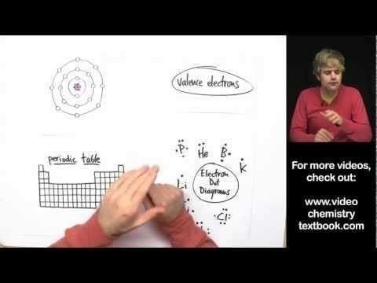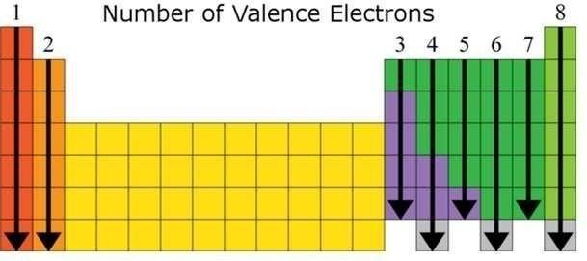

Chemistry by Dr.Satyendra S.

ASSIGNMENT

1. **Fill in each blank with appropriate word_**
   1. ………….. exists as monoatomic molecules at S.T.P.
   2. Alkali metals, alkaline earth metals and halogens are placed in group number …………….

Respectively.

* 1. Elements whose two outermost shell may be involved in a chemical reaction are called……………..
  2. The bonds present in silicon carbide are …………..
  3. All halogens show a common valency of …………..

1. **Short answer type questions_**
   1. Give the name and symbol of a liquid non-metal.
   2. Write an unique element of periodic table.
   3. Name a member of halogen family which is found in solid state.
   4. Give the name of a sublimable solid element.
   5. Name the element having no neutron inside its nucleus.
   6. Give the name of a radioactive halogen.
   7. Write the name and symbol of two light members of alkali metal group.
   8. Name two abnormal noble gases.
   9. Discuss about the zero group element which is absent in nature.
   10. Which element was reported as rogue element and why?

Chemistry by Dr.Satyendra S.