**18th May, 2020 JESUS AND MARY SCHOOL AND COLLEGE MODULE 2**

**CLASS- X**

**PHYSICS**

**TOPIC- CENTRE OF GRAVITY**

**Centre of Gravity:**

The centre of gravity of a body is the point about which the algebraic sum of moments of weights of all the particles constituting the body is zero.

The entire weight of the body can be considered to act at this point, how so ever the body is placed

The position of the centre of gravity of a body of given mass depends on its shape i.e., on the distribution of mass. It is not necessary that the centre of gravity will always be within the material of the body.

**Q1. Figure shows three pieces of card board of uniform thickness cut into three different shapes. On each diagram draw two lines to indicate the position of centre of gravity G.**

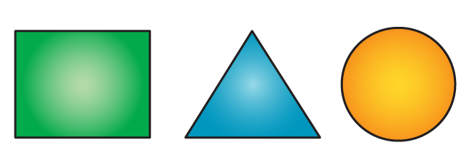

**Solutions:**

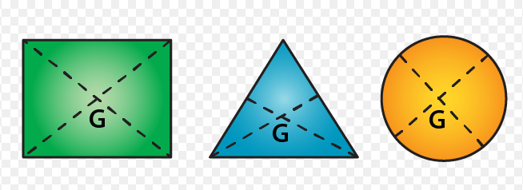

**Q2. Explain how you will determine experimentally the position of centre of gravity for a triangular lamina (or a triangular piece of card board).**

**Solutions:** Take a triangular lamina. Near the edge of triangular lamina make three fine holes at a, b, c. Now along with a plumb line from hole ‘a’ suspend the given lamina. Check that the lamina is free to oscillate about the point of suspension. Draw a straight line ad along the plumb line when lamina has come to rest. We get straight lines ‘be’ and ‘cf’ respectively by repeating the experiment by suspending the lamina through hole ‘b’ and then through hole ‘c’. It is noticed that the common point G is the position of centre of gravity of triangular lamina where the lines ad, be and cf intersect each other ie. the point of intersection of medians.

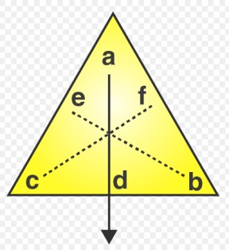

**Q3. A uniform flat circular rim is balanced on a sharp vertical nail by supporting it at point A, as shown in Fig. Mark the position of centre of gravity of the rim in the diagram by the letter G.**

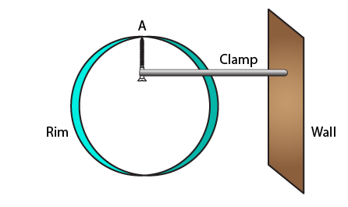

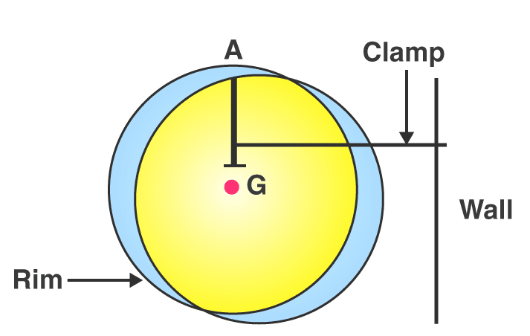

**Solutions:**

**Q4.What is the position of centre of gravity of a:**

**(a) rectangular lamina (b) cylinder**

**Solutions:**

**(a)** The position of centre of gravity of a rectangular lamina is at the point of intersection of its diagonals.

**(b)** The position of centre of gravity of a cylinder is at the midpoint on the axis of cylinder.

**Q5. Which point is the centre of gravity situated in:**

**(a) A triangular lamina and**

**(b) A circular lamina?**

**Solutions:**

**(a)** A triangular lamina’s centre of gravity is situated at the point of intersection of its medians.

**(b)** A circular lamina’s centre of gravity is situated at the centre of circular lamina.

**WORKSHEET 2**

**ASSIGNMENT**

**Q1. Where is the centre of gravity of a uniform ring situated?**

**Q2. Square card board is suspended by passing a pin through a narrow hole at its one corner. Draw a diagram to show its rest position. In the diagram mark the point of suspension by the letter S and centre of gravity by the letter G**

**Q3.Whether the following statements are true or false.**

**(i) ‘The position of centre of gravity of a body remains unchanged even when the body is deformed’.**

**(ii) ‘The centre of gravity of a freely suspended body always lies vertically below the point of suspension’.**

* **MULTIPLE CHOICE TYPE**

**Q1.** The centre of gravity of a uniform ball is.

**(a)** At its geometrical centre

**(b)**At its bottom

**(c)** At its topmost point

**(d)** At any point on its surface

**Q2.** The centre of gravity of a hollow cone of height h is at distance x from its vertex where the value of x is:

**(a)** h/3

**(b)** h/4

**(c)** 2h/3

**(d)** 3h/4

**Note: Please do all work in your old note book which will be checked when School reopens.**