**18th May, 2020 JESUS AND MARY SCHOOL AND COLLEGE MODULE 2**

**CLASS 12**

**PHYSICS**

**COULOMB'S LAW**

## **Q1. What is Coulomb’s Law?**

According to Coulomb’s law, the force of attraction or repulsion between two charged bodies is directly proportional to the product of their charges and inversely proportional to the square of the distance between them. It acts along the line joining the two charges considered to be point charges.

Coulomb’s Law Formula: F ∝ q1q2/d2

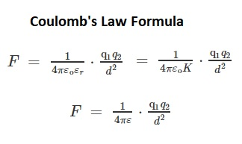

where,

1. ε is absolute permittivity,
2. K or εr is the relative permittivity or specific inductive capacity
3. ε0 is the permittivity of free space.
4. K or εr is also called a [dielectric constant of the medium](https://byjus.com/physics/dielectric-constant/) in which the two charges are placed.

## **Coulomb’s Law in Vector form**

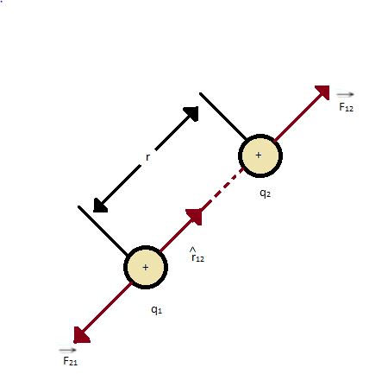



Here F12 is the force exerted by q1 on q2 and F21 is the force exerted by q2 on q1.

Coulomb’s law holds for stationary charges only which are point sized. This law Newton's third law

## **What is 1 Coulomb of Charge?**

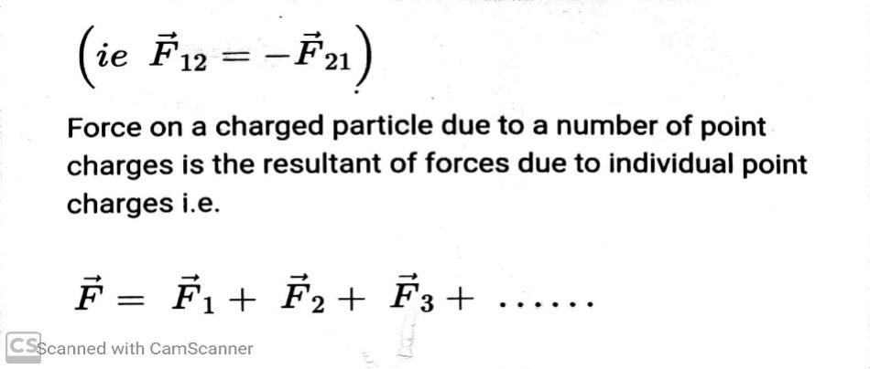A coulomb is that charge which repels an equal charge of the same sign with a force of 9×109 N when the charges are one meter apart in a vacuum. Coulomb force is the conservative mutual and internal force.

The value of εo is 8.86 × 10-12 C2/Nm2 (or) 8.86 × 10-12 Fm–1

Note: Coulomb force is true only for [static charges](https://byjus.com/physics/static-electricity/).

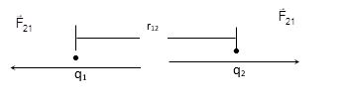

## **Limitations of Coulomb’s Law**

* The law is applicable only for the point charges at rest.
* Coulomb’s Law can be only applied in those cases where the [inverse square law](https://byjus.com/inverse-square-law-formula/) is obeyed.
* It is difficult to implement Coulomb’s law where charges are in arbitrary shape because in such cases we cannot determine the distance’ between the charges.
* The law can’t be used directly to calculate the charge on the big planets.

## **PROBLEMS ON COULOMBS LAW**

**Q1. Charges of magnitude 100 microcoulomb each are located in vacuum at the corners A, B and C of an equilateral triangle measuring 4 meters on each side. If the charge at A and C are positive and the charge B negative, what is the magnitude and direction of the total force on the charge at C?**

**Solution:**

The situation is shown in fig. Let us consider the forces acting on C due to A and B.

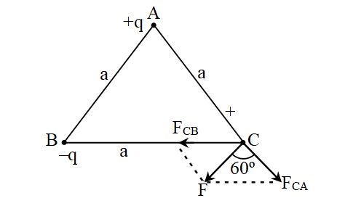Now, from Coulomb’s law, the force of repulsion on C due to A i.e., FCA in direction AC is given by

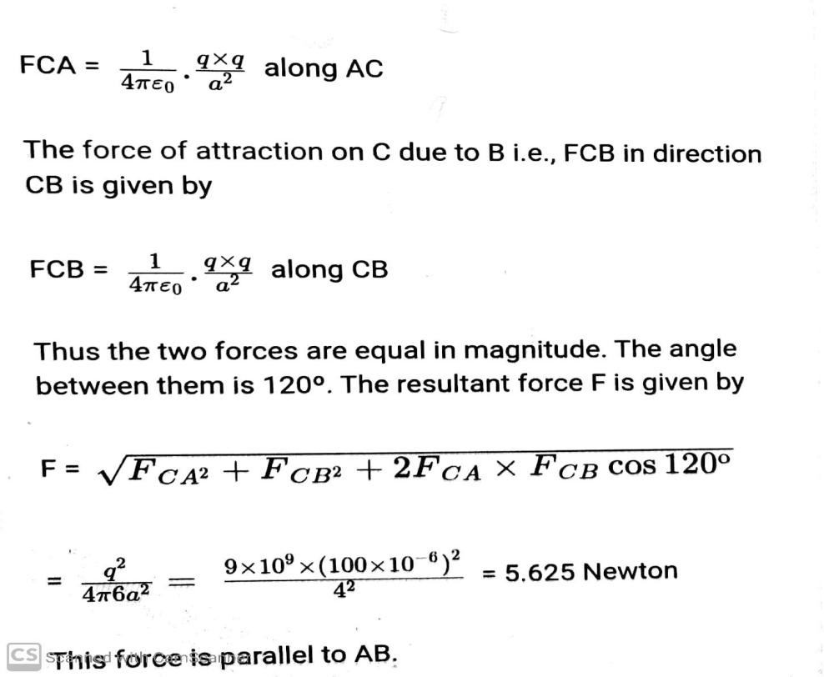

**Q2.** **The negative point charges of unit magnitude and a positive point charge q are placed along the straight line. At what position and for what value of q will the system be in equilibrium? Check whether it is stable, unstable or neutral equilibrium**

**Solution:**

The two negative charges A and B of unit magnitude are shown in fig. Let the positive charge q be at a distance $rA$ from A and at a distance $rB$ from B.

Now, from coulombs law, Force on q due to A

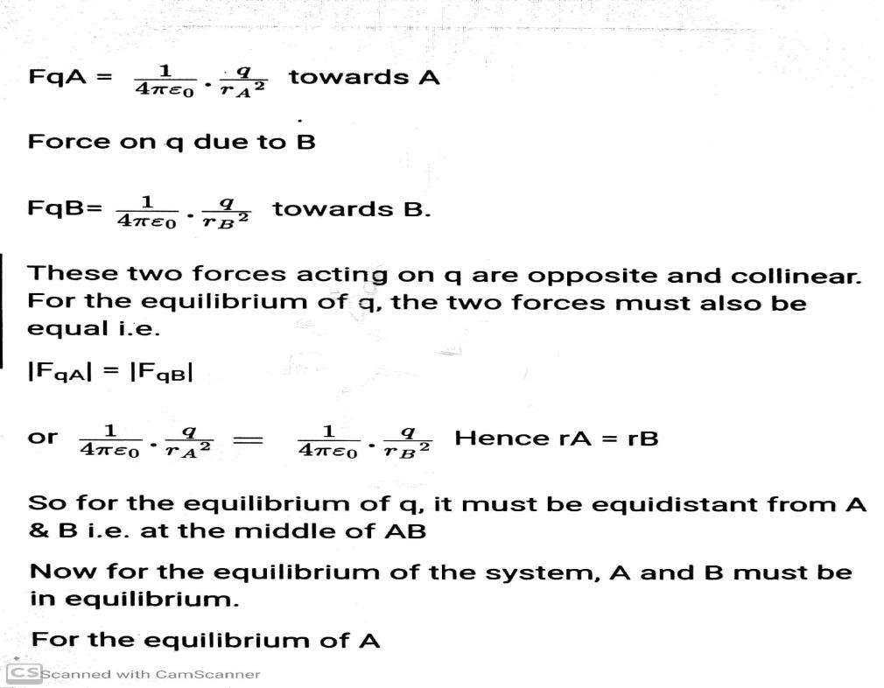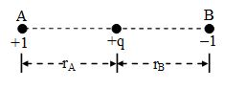

Now,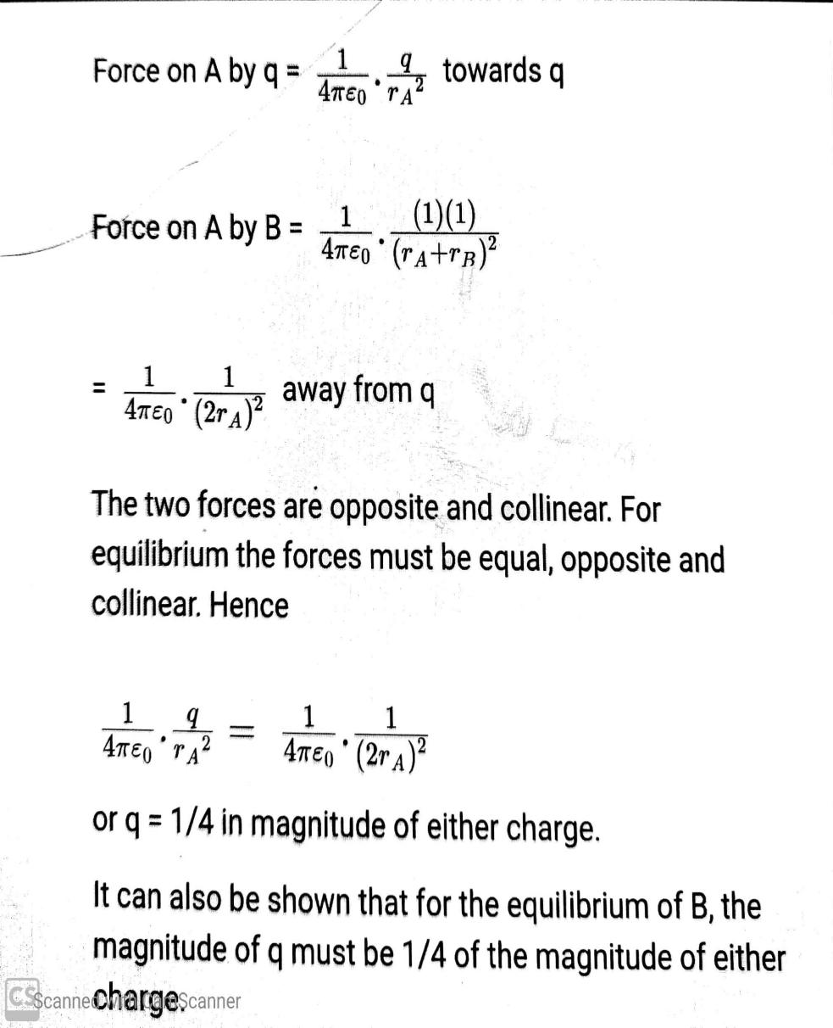

**Q3. Two point charges +q and +4q are placed at distance of L from each other. A third charge Q is placed in between them so that the system is in equilibrium. Find the position, value and sign of charge Q.**

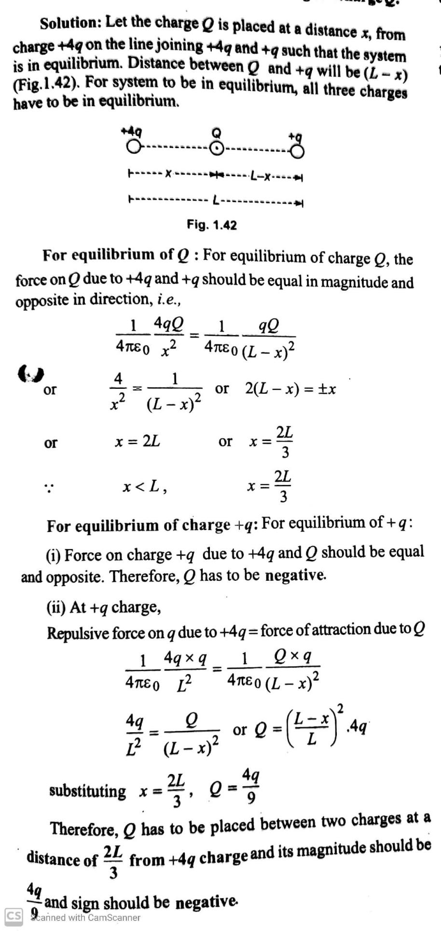

**WORKSHEET 2  
ASSIGNMENT**

**Q1.**Two point charges 9q and q are separated from each other by distance L.Where should we placed third charge Qon the line joining them so that it remains in equilibrium.

**Q2.**Two free point charges +4q and -q are at a distance L from each other .Where should we place a third point charge Q on the line joining two charges so that it remains in equilibrium?

**Q3**.A Charge Q is placed at each of the four corners of a square of side d .What charge should be placed at the centre of the square so that the entire system remains in equilibrium?

* **MCQ Types-**
  1. Coulomb is the unit of which quantity?  
     a) Field strength  
     b) Charge  
     c) Permittivity  
     d) Force
  2. Coulomb law is employed in  
     a) Electrostatics  
     b) Magnetostatics  
     c) Electromagnetics  
     d) Maxwell theory
  3. Find the force between 2C and -1C separated by a distance 1m in air(in newton).  
     a) 18 X 106  
     b) -18 X 106  
     c) 18 X 10-6  
     d) -18 X 10-6
  4. Two charges 1C and -4C exists in air. What is the direction of force?  
     a) Away from 1C  
     b) Away from -4C  
     c) From 1C to -4C  
     d) From -4C to 1C
  5. Find the force of interaction between 60 stat coulomb and 37.5 stat coulomb spaced 7.5cm apart in transformer oil(εr=2.2) in 10-4 N,  
     a) 8.15. b) 1.518 c)1.815d)1.752
  6. Find the force between two charges when they are brought in contact and separated by 4cm apart, charges are 2nC and -1nC, in μN.  
     a) 1.44 b) 2.44 c) 1.404 d) 2.404
  7. The Coulomb law is an implication of which law?  
     a) Ampere law  
     b) Gauss law  
     c) Biot Savart law  
     d) Lenz law
  8. Two small diameter 10gm dielectric balls can slide freely on a vertical channel. Each carry a negative charge of 1μC. Find the separation between the balls if the lower ball is restrained from moving.  
     a) 0.5  
     b) 0.4  
     c) 0.3  
     d) 0.2
  9. A charge of 2 X 10-7 C is acted upon by a force of 0.1N. Determine the distance to the other charge of 4.5 X 10-7 C, both the charges are in vacuum.  
     a) 0.03  
     b) 0.05  
     c) 0.07  
     d) 0.09
  10. For a charge Q1, the effect of charge Q2 on Q1 will be,  
      a) F1 = F2  
      b) F1 = -F2  
      c) F1 = F2 = 0  
      d) F1 and F2 are not equal

Next topic-Relative permittivity continued……..

**Note: Please do all work in your old note book which will be checked when School reopens.**