**18th May 2020 Jesus and Mary School MODULE - 2**

**Class 1**

**Science**

**Topic: Plants Around Us**

In the previous chapter we learn about living things and non-living things. Plants are living things and in this chapter we learn what plants are.

Plants are green in colour they give us fruits, vegetables and flowers. Plants provide us shelter, clean and fresh air.

**Parts of plant:**

The main part of plants are:- roots, stem, branches, leaves, flowers, fruits and buds.

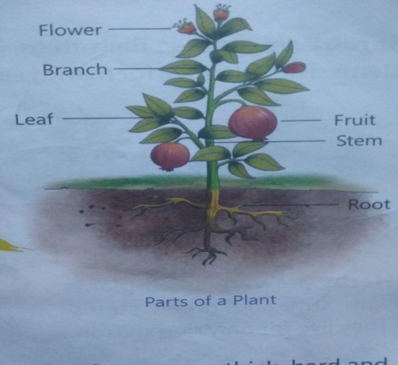

**Types of Plants:**

**Let us learn about big and small plants.**

Trees - are very big tall and strong plants. They have very thick, hard and woody stem known as Trunk. These trees live for many years. For Example:- Neem tree, Peepal tree, Coconut tree and Mango tree.

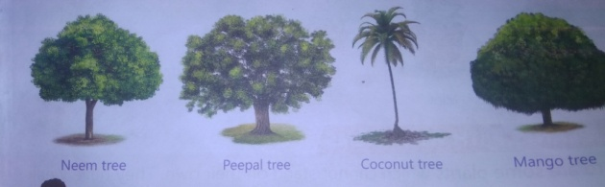

Shrubs - are smaller than trees. They look like bushes with hard woody stems. They also live for many years. For Example:- Jasmine plant, Rose plant and Cotton plant.

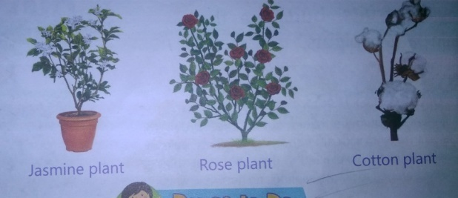

Herbs - are very small plants with soft and green stem. They live only for one season. Like Coriander, Mint and Tulsi.

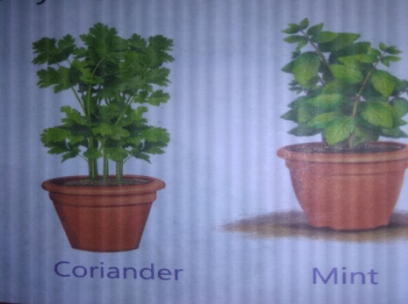

**Plants with weak Stems:**

There are some plants which cannot stand on their own. They have weak stems. They need the support of sticks, walls or other plants to grow upwards. They are known as Climbers. For Example:- Grapevine, Money plant and Pea plant.

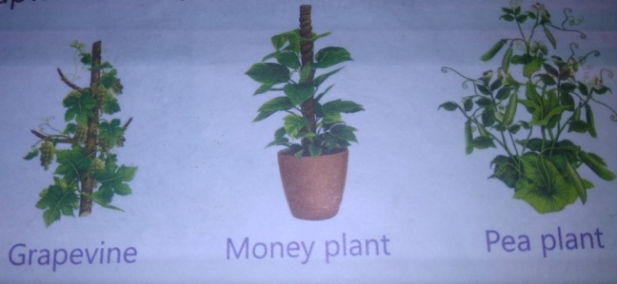

Creepers - are also plants with a weak stem. They creep or grow along the ground. They have very big and heavy fruits. For Example: - Pumpkin plant, Watermelon plant and Bottle ground plant.

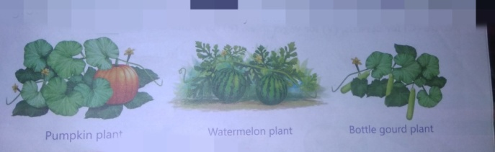

Plants are useful to us. Plants are also called our ‘green friends’ because they give us so many useful things to eat such as fruits, rice, vegetables, coffee, oil, Dry fruits etc. We cannot live without plants we should grow more and more plants.

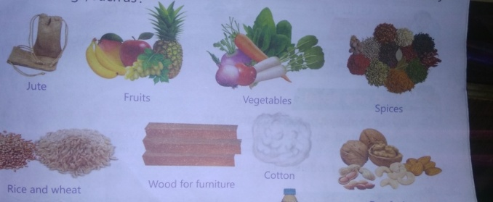

**Worksheet -2**

**Note:- Do all the given exercises in your copy.**

**Exercise 1 Write True or False:**

1. Herbs are very small plants. (True)
2. Trees live for few years. (False)
3. Plants give us food items. (True)
4. We get milk from plants. (False)

**Exercise 2 Fill in the blank.**

1. Creepers are also plants with a weak stem.
2. Plants are also called our green friends.
3. Trees are very big, tall and strong plants.
4. There are five main parts of plants.

**Exercise 3 Jumble words.**

1. DUB --------------------- BUD
2. FAEL --------------------- LEAF
3. REWOLF -------------------- FLOWER
4. TOOR ------------------- ROOT
5. TIURF ------------------- FRUIT

**Exercise 4 Questions and Answers.**

**Q 1. What is a trunk?**

Ans: Trees with very thick, hard and woody stem are known as trunk.

**Q 2. Which plant lives for only one season?**

Ans: Herbs lives only for one season.

**Q 3. Name the different parts of a plant.**

Ans: Roots, Stem, Leaf, Flower and Bud.

**Q 4. Name any four things that we get from plants.**

Ans: Fruits, vegetables, wood and flower.

**Exercise 5** Draw the diagram of a flower in copy.

---------------------------------------------------------------------------------------------------------------------