**18th May 2020 Jesus and Mary School MODULE – 2**

**Class 2**

**Science**

**Topic: Plants are useful.**

In the previous topic we learned about how plants grow. Now we will learn about how plants are useful for us, like how we get food from plants, importance of plants in our life and uses of plant.

Can you imagine our world without plants? Our world will look so dull and colourless. Plants are our green friends. We get lots of useful things from plants. Let us find out how plants are useful in our daily life.

**Food from plants:**

One of the most important uses of plants are that we get our food from them. Plant store food in different parts like in fruits, seeds, stems and roots. We eat fruits of some plants like Mango fruit from Mango tree. We also eat seeds of plants like Wheat and Maize. Most of the leaves that we eat are vegetables like Spinach and Cabbage. Stems of Ginger etc.

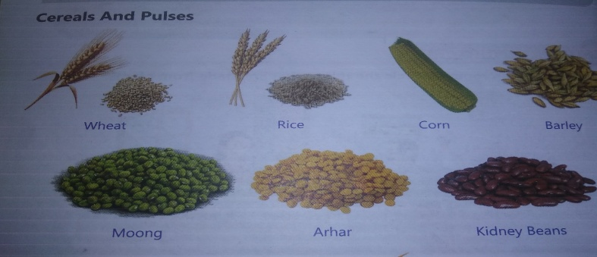

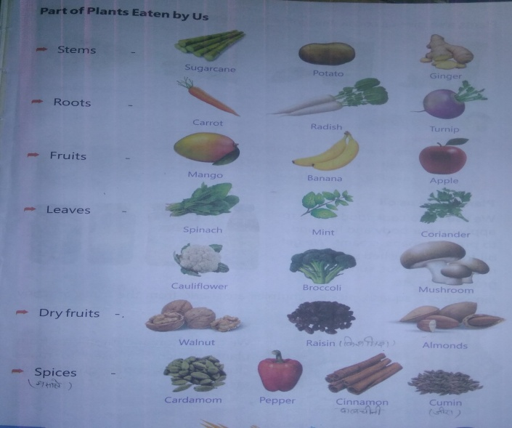

Plants also give us cocoa, tea, coffee and sugar.

**Plants give us oil:**

We use oil to cook food, to apply on our body and hair and to prepare soaps, creams. We get oil from crushed seeds of mustard, coconut, sunflower, groundnuts etc. jams, juices, squash, pickles, chutnies are made from the fruits of many plants.

**Fibres:** We get cotton and jute fibres from plants, which are used to make clothes, mats, ropes, gunny bags etc.

**Wood:** Trees like teak, bamboo, deodar is used to make furniture, boats, carts, bats, hockey sticks, pencils, match sticks etc. woods of some trees are also used as fuel. We get paper, rubber and gum from plants.

**Medicines:**

Plants like Neem, basil (tulsi), Turmeric, Amla and Ginger are used to make medicines.

**Flowers:**

Flowers are the most beautiful part of plants. They are used:

1. To decorate houses and offices.
2. To make garlands and bouquets.

**Manure:**

The dried, dead, fallen plants parts when mixed with soil make manure which is used to make the soil fertile.

**Shelter:**

1. Plants provide shelter to many animals like birds, monkeys, insects, snakes etc.
2. Plants keep the air fresh and clean. They take in carbon dioxide and gives us oxygen.

Plants are the amazing gifts of nature. It is difficult to imagine our life without them. We should always look after them and save them from destruction.

**Worksheet -2**

**Note: do all the given exercises in your note book.**

**Exercise 1. Write true or false:**

1. Pulses are rich in proteins. (true)
2. Mango is the root part of the plant. (false)
3. Neem is a medicinal tree. (true)
4. Bamboo is a spice. (false)

**Exercise 2. Fill in the blank.**

1. Plants are very useful to us.
2. Trees provides shelter to animals.
3. Turmeric is use as medicine.
4. Carrot root is the edible part of the plant.

**Exercise 3. Match the following:**

Column A Column B

1. Medicinal plant -------------------------- Neem
2. Tree give us wood ----------------------- Bamboo
3. Dryfruits --------------------------------- Almond
4. Plants with fibres -------------------------- Jute

**Exercise 3. Question and answers:**

**Question 1. Why do we need oil?**

Answer: We need oil to cook food items and to apply on our body.

**Question 2. List any five food items we get from plants?**

Answer: Mango, Walnut, Mint, Pepper and Sugarcane.

**Question 3. How flowers are useful to us?**

Answer: Flowers are useful to us as they are use to decorate our houses and offices.

**Question 4. What are manure?**

Answer: The dead parts of the plant are mixed with soil to make Manure.

**Exercise 5.** Draw diagram of two fruits and two roots part of the plant that we eat.

------------------------------------------------------------------------------------------------------------