**18th May 2020 JESUS AND MARY SCHOOL MODULE -2**

**CLASS- 4**

**SCIENCE**

**TEETH TO CHEW**

**EXPLANATION**

**Teeth-** Teeth are a very important part of our Personality. It gives a proper shape to our face and helps us to speak properly and clearly. They also help us to chew food nicely so that it gets digested completely.

**Sets of teeth:-**  There are two Sets of teeth which we get in our life time .

**(1) Temporary teeth (2) permanent teeth**

1. **Temporary teeth-** Temporary teeth are 20 in number. It starts to develop from 6 months to 3 years. These are called milk teeth.
2. **Permanent teeth-** Permanent teeth are usually 32 in number. From 6 - 7years milk teeth starts fall and new set of teeth grow in their place these are Called permanent teeth.

**Types of Teeth:-** There are four types of teeth in each Jaw.

* **Incisors-**A human has 4incisors in each jaw which means total eight incisors. They have sharp thin edges to cut and bite food.
* **Canines-**There are also called tearing teeth as they are used for tearing food· They are very sharp and pointed teeth. There are 4 Canines, 2 in each jaw.
* **Premolars-**These are the grinding teeth which are used to chew and grind the food into a paste. There are 8 premolars, 4 in each Jaw.
* 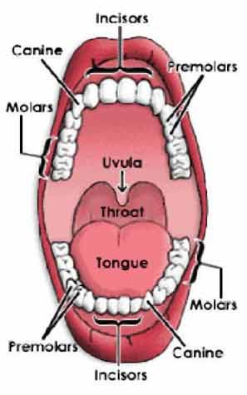**Molars-** These are 12 in number, 6in each jaw .They are bigger, flatter and broad in size. These are used for grinding and swallowing food.

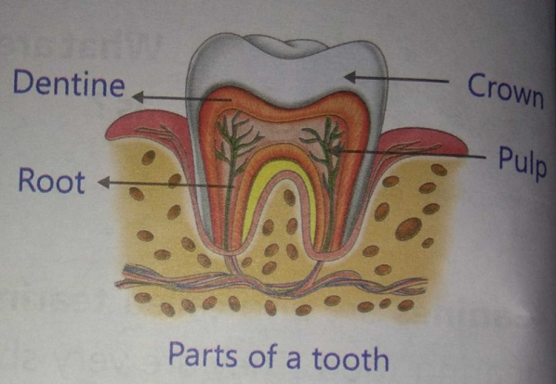

**Part of a tooth-**

1. **Enamel-**This is the outermost white part of the tooth. It is said to be the hardest part of our body.
2. **Dentine-**It is lies below the enamel. It is also very hard.
3. **Pulp-**It is the soft innermost part of teeth. It has blood vessels and nerves. All these parts of a tooth are connected to the gum.
4. **Root-** Teeth are fixed in the gums of our jaw. Some part of the tooth is inside the gum. It is known as the root.

**Dental caries-** Acid is formed when bacteria meets the sugar in food caught between your teeth. This acid damages the enamel and makes tiny holes or cavities called dental caries.

**Caring for teeth-**

* Brush your teeth correctly and regularly twice a day.
* If teeth are not cleaned properly then they get covered with a yellow sticky substance called plaque.
* Avoid eating too hot, too cold and too sweet foods.
* Eat lots of fresh fruits and salad for healthy teeth.
* Visit your dentist every six months for a routine checkup.

**WORK SHEET – 2**

**Note: Do all the following exercises in your copy.**

**Exercises – 1 Fill in the blanks –**

* 1. Canines are also called tearing teeth.
  2. Enamel is the hardest part of a tooth.
  3. There are 6 molars in each jaw.
  4. Doctor who treats people’s teeth is called dentist.

**EXERCISE – 2 unscramble the words to fill in the blanks.**

* 1. The hardest part of our tooth is **enamel . (** leemna **)**
  2. The harmful germs which causes cavities are **bacteria . (** aatrebci **)**
  3. **Plaque** is the yellow substance formed on teeth. **(**aplque **)**
  4. **Pulp** is the soft inner part of teeth. **(** Ppul**)**
  5. **Calcium** keeps the teeth healthy. **(**mclciua **)**

**EXERCISE - 3 Word- Meanings**

1. **Milk teeth**- The 20 temporary teeth a child has.
2. **Permanent teeth-** The 32 teeth which grow after the milk teeth falls off.
3. **Germs-** Bacteria which cause disease.
4. **Virus-** A germ which is smaller than a bacterium and causes disease.
5. **Cavity-** A hole in a tooth which is caused by bacteria.

**EXERCISE – 4 Short Type Question- Answer**

**Q 1. What are milk teeth?**

**Ans-** Milk teeth are the temporary teeth a child has. They are 20 in number.

**Q 2. What are permanent teeth?**

**Ans-** Around the age of six years milk teeth starts falling and new teeth grow in place of them: These new teeth are called permanent teeth.

**Q 3. Why are teeth important for us?**

**Ans-** Teeth are very important for us because they help us in different ways. For e.g. they help to chew the food well and to speak clearly.

**Q4.How are cavities formed?**

**Ans-** If bacteria finds food on the teeth they can grow well and make hole or cavities on the surface of the tooth. They travel through the dentine to the pulp making cavity bigger and bigger.

**Qus5. What do bacteria needs to grow?**

**Ans-** Bacteria need food, warmth, air and moisture to grow.

**Q6. How are bacteria useful?**

**Ans-**  Some Bacteria are useful for us as they can turn milk into curd and breakdown the food we eat. Bacteria also help the dead plant or animal to rot.

**EXERCISE – 5 Long type question- answer**

**Q 1. Describe the structure of a tooth with diagram.**

**Ans.** A tooth is made up of different parts.

**1) Enamel-** It is the hardest thing in the body and covers the toot

**2) Dentine-** It is the layer softer than the enamel and lies just below the enamel.

**3) Pulp-** It is the soft part of the tooth having nerves and blood. It lies under the dentine.

**4) Root-** It is the part of tooth fixed inside the gums.

**Q2. Name four of Permanent teeth? How do they help us? Explain with diagrams.**

**Ans-** There are four kinds of permanent teeth.

**1) Incisors-** Incisors are the front flat teeth and help us to bite the food.

**2) Canines -** Canines are pointed teeth and help us to tear food.

**3) Premolars –** Premolars are broad teeth they help us to crush the food and push the food to molars.

**4 Molars -** Molar are also broad teeth help us to crush and grind the food.

**Q3- Discuss briefly about bacteria, virus and Protozoa.**

**Ans-Bacteria-** Bacteria are very tiny living things having only one cell and can be seen only under a microscope.

**Virus-** A Virus is smaller than bacteria and is found everywhere. They come to life only when they are inside the cell of a living body. Scientists are not sure whether to call them living or non living.

**Protozoa-** Protozoa are bigger than bacteria but still very tiny and cause some disease like malaria, dengue, fever etc.

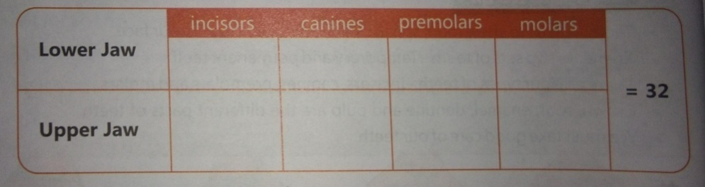**Q4. Complete the given table -**

**Q5. Draw and level the figure of-**

1. Parts of a tooth. 2. Human denture.