**18th May 2020 JESUS AND MARY SCHOOL MODULE – 2**

**CLASS - 5**

**SCIENCE**

**SKELETAL SYSTEM**

**EXPLANATION**

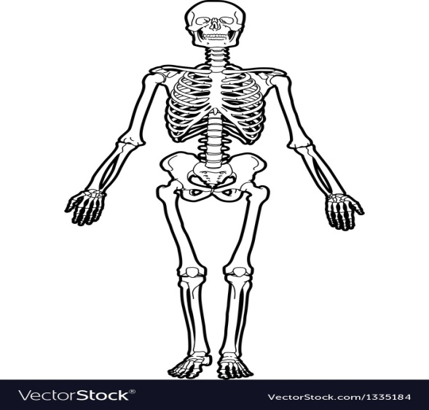The skeleton is the framework of the body, Consisting of bone sand other connective tissues which protects and support the body tissues and internal organs The human skeleton contains 206 bones. Six of which are the tiny bones of the middle ear (three in each)that function in hearing.

**Functions of the skeleton.**

* The skeleton forms a long framework of our body.
* It gives shape and support to the body.
* It helps us to stand upright.
* It protects the delicate internal organs.
* It helps in the movement of body parts along with the muscles.

**Parts of our skeleton-**

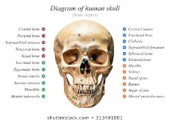**Skull-** The skull is made up of 22 bones which include the bones in the head and the facial region. Eight bones are joining together to give shape to the head remaining Fourteen bones form the face. The skull protects the delicate brain. It has holes for eyes and nose the lower jaw is the only movable bone of the skull.

**Human skull**

**Vertebral column or the backbone**

The backbone or spine is made up of 33 bones called the vertebrae and is Joined to the skull. The vertebrae are placed one over the other forming a vertebral column through which the spinal cord passes. The spine is a flexible part of the body that facilitates the twisting and bending of our back in different directions. The vertebral column offers protection to the delicate spinal cord. It is a bundle of nerves pass through the hollow vertebral column.

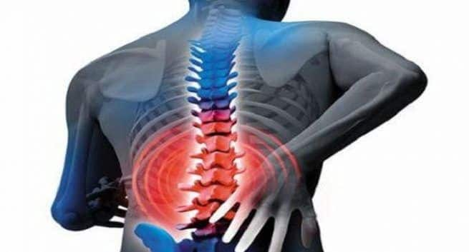**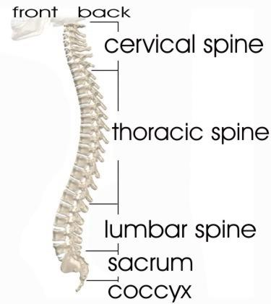Backbone**

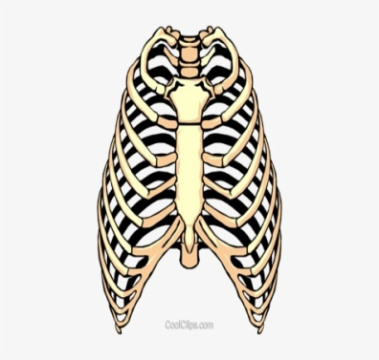**Ribs-** There are 12 pairs of curved bones present in our chest. It form a cone -shaped cage, called **ribcage**. It protects heart and lungs. The ribs are attached to the spine at the back and the breast bone in the front. The last two pairs are not attached to the breast bone . They are called **floating ribs.**

**The Limbs are of two types -**

**Forelimbs** or arms are made of two parts-upper arm and the Lower arm joined together at elbows The upper arms has one Bone Called humerus.

**Hind Limbs** or legs are also made up of two parts. The upper Leg and the lower leg are joined together at the knees. The upper leg or thigh has the Longest bone of our body called femur .

**Joints**- A joint is the meeting paint of two or more bones. The joints are held together by strong elastic tissues called ligaments. Muscles are attached to bones by strong tissues called tendons. There are two types of Joints.

**Immovable joints**- The joints which cannot move. Ex- joints of skull, ribcage.

**Movable joints**- The joints which can move. Ex- joints of arms, legs.

**There are four types of movable joints:**

**Hinge joints:** Hinge joint work much like a hinge of a door or a window. The bones at these joints can move only in one direction. Ex- Elbow, knee, finger.

**Gliding joint:** The gliding joint allows a set of complex movements. Ex- Ankle and wrist..

**Ball and socket joint:** The ball and socket joint moves in all directions in this a ball-like end of one bone fits in a corresponding spherical Cavity of another bone Ex. Hip joint, shoulder joint.

**Pivot joint**:-Pivot joint is located between the skull and the first two Vertebrae of the spine. This joint enables us to move our head upward or downward or sideways.

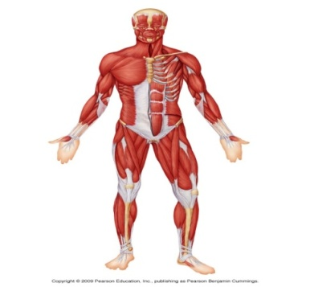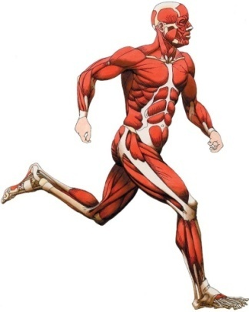**Muscles**: - Muscles are fleshy bundles of thin elastic tissues that help bones and joint to move. They are responsible for every movement of our body. We have more than 650 muscles in our body of different shapes and sizes. There is the two types of muscles.

**Voluntary muscles** - These muscles are under our control. They are also called skeletal muscles, as they are attached to bones. Ex- Muscles of arms and legs.

**Involuntary muscles** - These muscles are not under our control-control. They are also know, as smooth muscles .Ex -muscles of internal organs like lungs, and Intestine.

**Cardiac -** Cardiac Muscles are special types of muscles present in our heart. They work all the time, without getting tired:

**WORK SHEET - 2**

**Note: Do all the given exercises in your copy.**

**Exercises - 1 True/False**

1. Hind limbs or legs are made up of their parts (F)
2. Forelimbs or arms are made of two parts. (T)
3. There are 15 pairs of curved bones present in our chest.(F)
4. Vertebral column has consists of 38 small bones Called vertebrae. (T)
5. Lungs are protected by Limbs. (F)

**EXERCISE – 2 Fill in the blanks-**

1. Lungs are protected by rib cage.
2. There are 12 pairs of curved bones present in our chest.
3. The muscles in our heart are cardiac muscles.
4. Calcium and phosphorus are good for bones.

**EXERCISE – 3 Word- Meanings**

1. **Contract -** to decrease in size.
2. **Posture -** the position in which someone holds his body while standing or sitting.
3. **Pivot -** the central point.
4. **Voluntary -** working automatically.
5. **Involuntary -** working on the instruction of a master or controller.

**EXERCISE – 4 Short type Question/Answer**

**Q1.What should we include in our diet to keep our skeleton system healthy and strong?**

**Ans-** We should include Calcium, phosphorus, vitamins and water in our diet to keep our skeleton system healthy and strong.

**Q2- What do you mean by Rib Cage?**

**Ans-** The rib cage is made up of 12 pairs of thin curved bones. Each bone is called a rib. Ribs are attached to the spine at the back, and to the breast bone in front.

**Q3- What do you mean by floating ribs?**

**Ans-** The last two pairs of ribs are joined only to the backbone and not to the breast Bone. These are called floating ribs.

**Q4-** **What do you mean by Tendons?**

**Ans-**Muscles are attached to the bone with the help of strong fiber tissues is called tendons.

**Q5- How can we take care of our muscles and bones?**

**Ans-** We can take care of our muscles and bones by following ways-

1. Avoid unnecessary stress to your bones, joints and skeleton.
2. Eat foods rich in calcium and proteins to keep bones and muscles healthy.
3. Sunlight helps our body to make vitamin D which is beneficial for our bones.
4. Exercise regularly to keep the muscles fit and strong.

**EXERCISE – 5 Long type question- answer**

**Q1-Write a short note on the-**

**(a) Hinge joint (b) Pivot joint**

**(c) Ball and socket joint (d) sliding joint**

**Ans-(a) Hinge joint**-A Hinge joint allows the bones to move in only one direction. It acts like the hinge of a door. Knees and elbows have hinge joints.

**(b) Pivot joint** - This Joint occurs where the skull meets the first vertebrae of the spine. It allows some amount of circular motion.

**(c)Ball and Socket joint**- In such joint, the round, ball- like end of a bone fits into the socket of the other bone. This joint allows one bone to rotate and make circular movements. The Shoulder and hip girdle are ball and socket joints.

**(d) Sliding Joint**- The bones at these joint slide over each other. Some bones in the waists and ankles have these joints.

**Q2- Define it**

**1-Voluntary muscles**

**2- Involuntary muscles**

**Ans**- **(1) Voluntary muscle-** The muscles which is allow to move, when we want such muscles are Called voluntary muscles. Ex- Muscles of hands neck or legs.

**(2)Involuntary muscle-**These muscles are not allowed to move. They are not under our control. Ex- Muscles of the heart, stomach and kidneys.

**EXERCISE – 6 Draw the figure of –**

* 1. **A Ribcage**
  2. **A Skull**
  3. **A Skeleton**
  4. **Backbone**