## **25thMay, 2020 JESUS AND MARY SCHOOL AND COLLEGE Module 2**

## **CLASS-10**

## **BIOLOGY**

## **GENETICS**

## ***Topics***

1. Introduction
2. Chromosomes and genes
3. Sex determination in humans
4. Sex linked inheritance
5. Mendel’s experiment on inheritance

**Explanation**

All the members of the species inherit the characters into their off springs. The inheritance of parental characters from one generation to next generation is called heredity. Individual characteristics are different in different individuals by which we identify them. These are called variations. Variation is defined as individual of same species contain some differences so that they look different. The branch of biology which deals with heredity and variations is called genetics. The genetics term was first used by William Bateson in 1906. Variations may be somatic, which are not heritable and germinal, which are heritable.

**Chromosomes and Genes**

Chromosomes are darkly stained protoplasmic bodies. These were first observed by Hofmeister and the term chromosomes was given by Waldeyer in 1888. Chromosomes are the vehicles that carry genetic material in the form of DNA. In prokaryotic cells the genetic material is DNA which is without nuclear membrane but in eukaryotic cell the chromosomes are formed of DNA and protein. These are present inside the nucleus.

Structure of chromosome— Each Chromosome consist of two chromatids which are joined at some point along the length. This point is called centromere. The two identical chromatids are called sister chromatids. On the basis of position of centromere, chromosomes are of different types—

* **Metacentric–** In which centromeres is found in the center and two chromatids are equal.
* **Sub-metacentric–** In this the centromere is present slightly away from the center.
* **Acrocentric–** In this the centromere is at the sub terminal position.
* **Telocentric–** In this the centromere is present at the terminal position.

There is another type of chromosome also found called satellite chromosome. Satellite is small spherical part of chromosome distal to secondary constriction. Satellite chromosome are also called SAT chromosome.

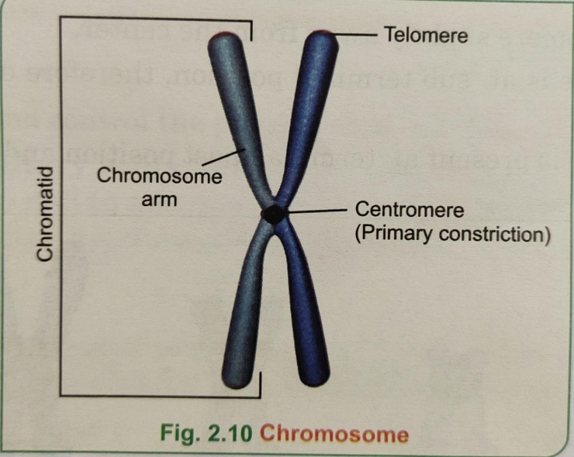A gene is a segment of DNA of a chromosome which determines the appearance of a particular character. In the chromosome the genes are present at a specific position. This position is called locus. A single gene may occur in alternative forms known as alleles.

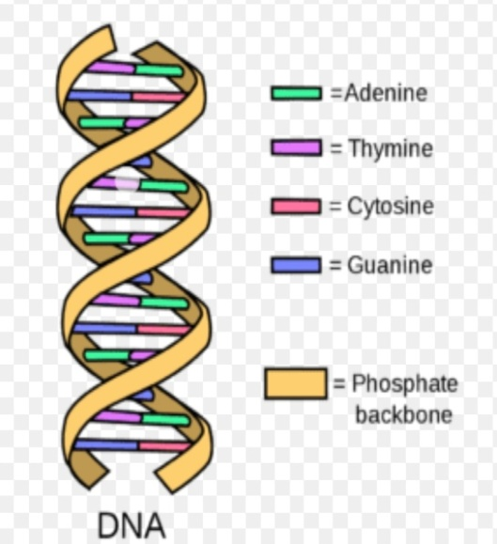Structure of DNA— DNA is discovered by Rosalind Franklin in 1953 and the structure of DNA is given by Watson and Crick. Therefore they were awarded noble prize. Each DNA molecule is made up of two complementary strands which are wound each other in a double helix. DNA is made up of nitrogenous bases, phosphoric acid and deoxyribose sugar. Nitrogenous bases are of two types- Purine and pyrimidine. Purine contains two bases adenine and guanine while pyrimidine has also two bases cytosine and thymine. A single strand of each DNA is made up of repeating nucleotides. The diameter of each DNA is 20 A°(angstrom). Both the strands of DNA together formed a ladder like arrangement with the nitrogenous base forming the rungs of the ladder. One purine is attached to a pyrimidine by hydrogen bond.

**DNA structure given by Watson and Crick**

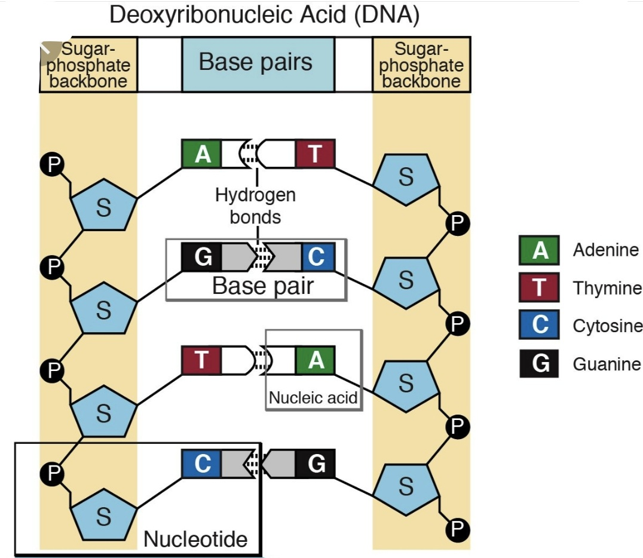

**Sex determination in human beings**

The human cells contain 22 pairs of chromosome which are called autosomes and two sex chromosomes. Males have one ‘X’ chromosome and one ‘Y’ chromosome (44 + XY). In females there are two ‘X’ chromosome (44 + XX). The total chromosomes are 46 in each. If nucleus of a ‘X’ sex chromosomes containing sperm fuses with the nucleus of an ovum having ‘X’ chromosome then female embryo is resulted (44 + XX) while if the nucleus of ‘Y’ sex chromosome containing sperm fuses with the nucleus of an ovum having ‘X’ chromosome then male embryo is resulted (44 + XY). A complete set of chromosome of a species is called karyotype.

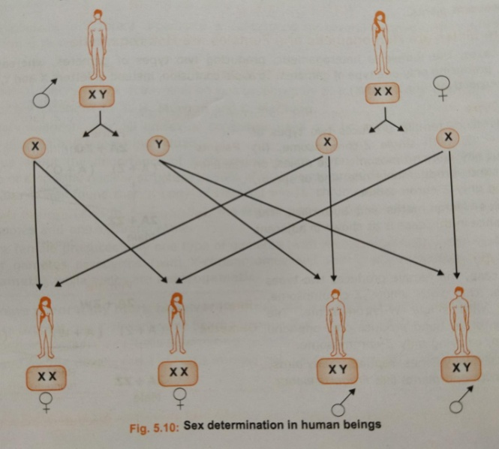

**Sex Linked Inheritance**

Some traits that are autosomal in nature but present on sex chromosomes. These traits are called sex linked characters. If they are present on ‘X’ chromosome , they are called X-linked character and if they are present on ‘Y’ chromosome then they are called Y-linked character. A sex linked allele inherited by a male is expressed even if it is recessive because it is not hidden by another, dominant allele. Male can't be a carrier whereas a female can be a carrier, a diseased and normal. So males are sufferers from these disease. Haemophilia and colour blindness are example of sex linked disease in humans and they have same pattern. Haemophilia is a disease in which the blood fails to clot when any injury takes place and colour blindness is a condition in which individuals fail to identify the primary colours mostly red and green. Both disease are due to recessive gene present on ‘X’ sex chromosome. Example– If a carrier female is married to a normal male then the inheritance of disease takes place in this manner—

* Genotype– Normal daughter 1 , normal son 1 ,carrier daughter 1 and diseased son 1.
* Phenotype– Normal children 3, diseased 1.

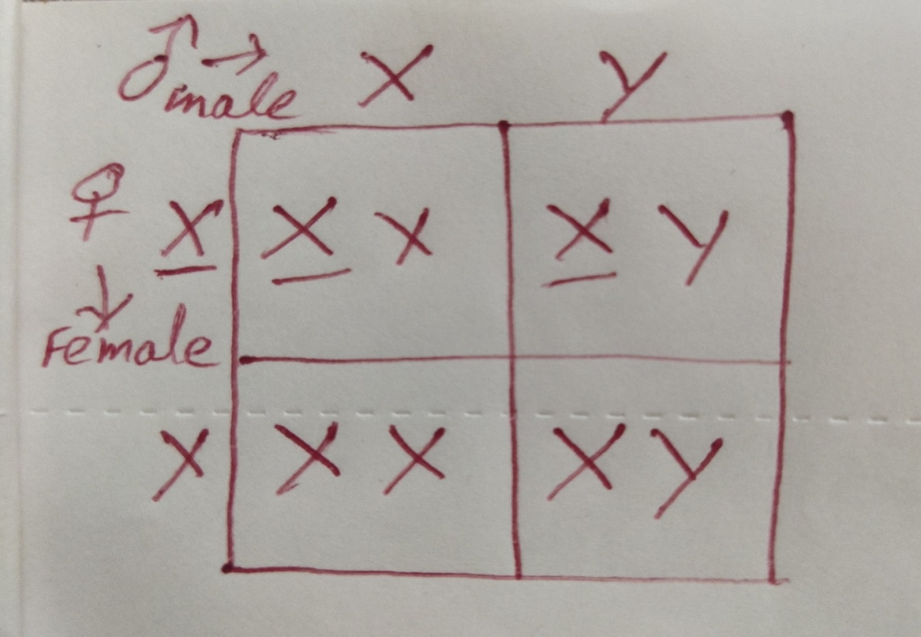The son may get the disease from the mother and daughter gets the disease from the father. This is called criss-cross inheritance.

**Mendel’s experiment on Inheritance**

Gregor Johann Mendel is known as the father of genetics. He carried out his experiments on the common garden pea*(pisum sativum)*. He selected this plant due to these reasons—

1. Peas were available in many pure breeding varieties.
2. Self pollination and cross pollination both can be done.
3. Hybrids resulting from crossing two varieties were perfectly fertile.
4. Presence of more number of contrasting characters.

Mendel studied seven pairs of contrasting traits.

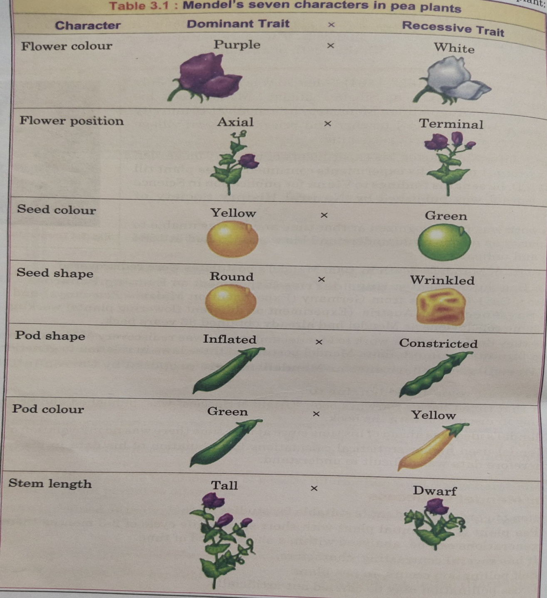

Mendel has given three laws of inheritance on the basis of his experiments on the pea plant.

First and second laws are based on monohybrid cross while third law is based on dihybrid cross.

These are :-

* **Law Of Dominance—** When the cross between two parents with two different homozygous traits is done, only one of the parent expresses itself in the first generation. The allele which expresses itself is called dominant and the other one which fails to express is called recessive allele. Ex– When homozygous red flowered peas are crossed with homozygous white flowered peas, then in F1 generation only red flowers are produced these are all hybrids. In this red colour is dominant and the white colour is hidden (recessive).

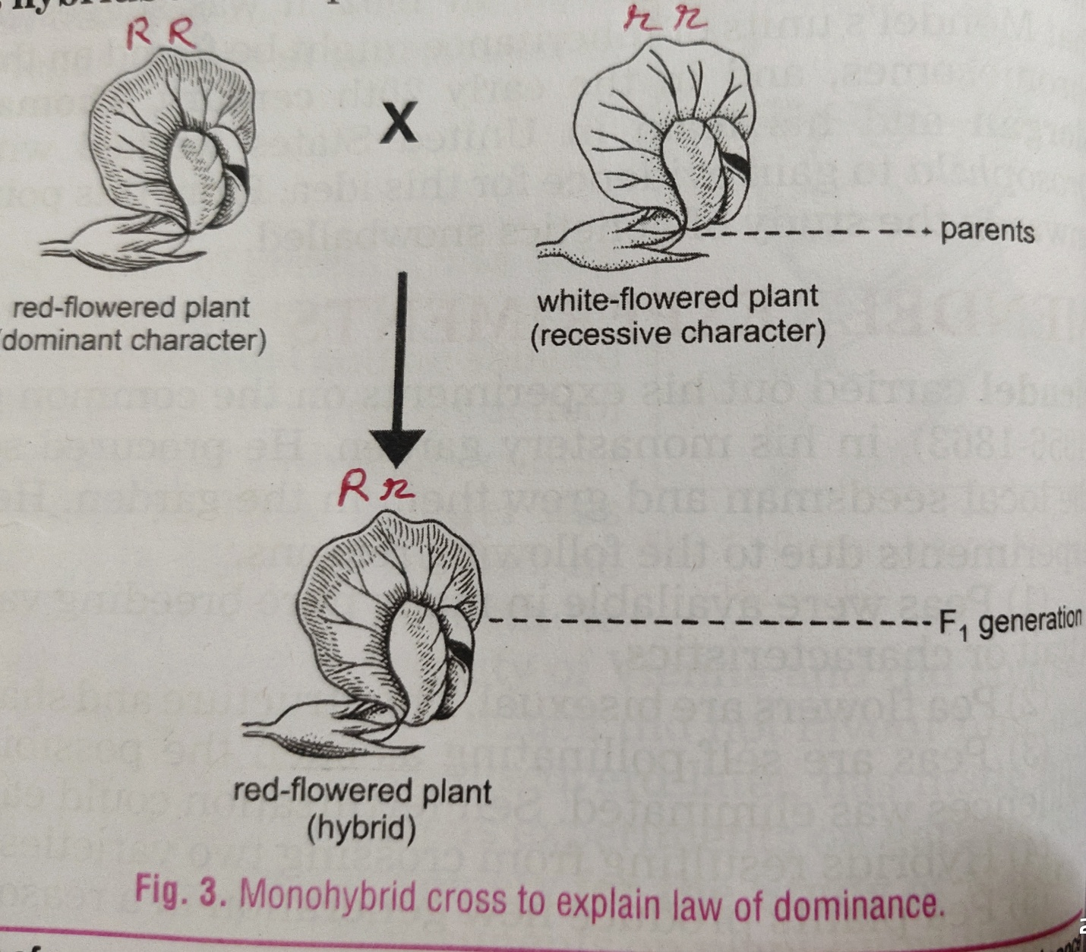

* **Law Of Segregation–** The two factors of a character in a heterozygous condition do not get mixed up. These characters get separated at the time of gamete formation. This is called law of segregation. Gametes are pure therefore this law is also called law of purity of gametes. Ex– When pure breeding red and white flowered varieties were crossed, they formed red flowered individuals only in F1 generation but after self pollination in this generation, the results were segregated like this.

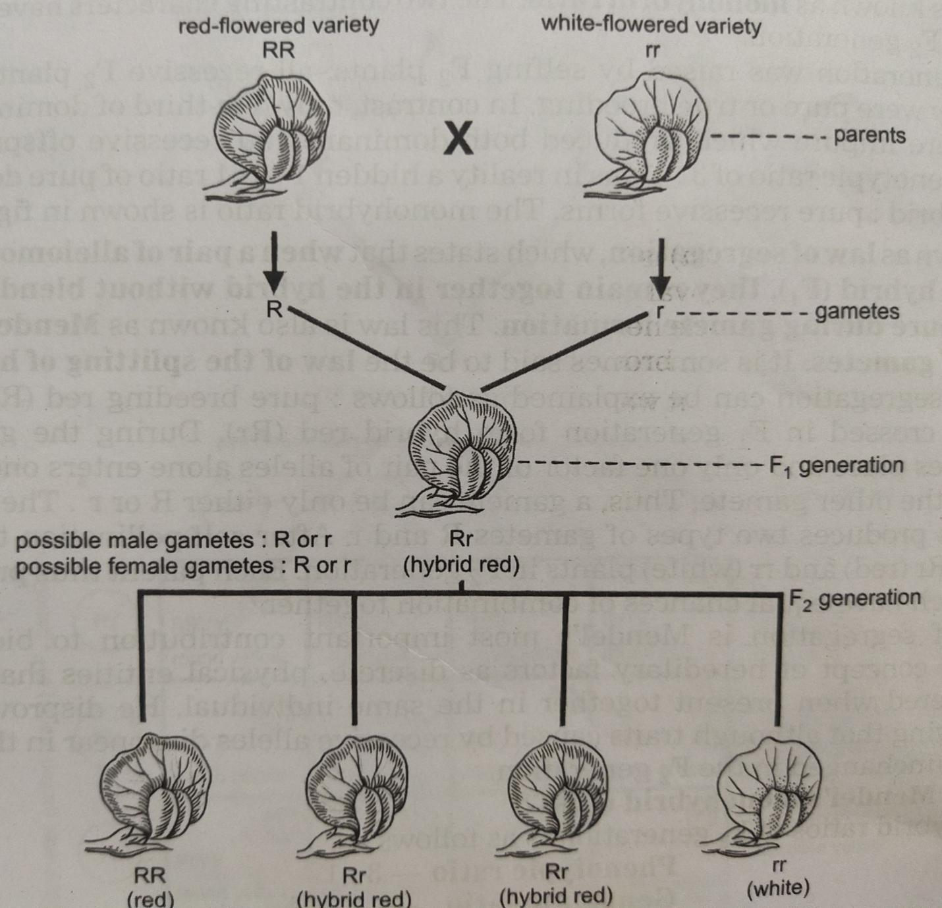

In F2 generation the phenotype ratio is 3:1 and genotype ratio is 1:2:1.

* **Law Of Independent Assortment–** This Law depends upon dihybrid cross it means the cross takes place between two pairs of contrasting characters. When two pairs of independent alleles are brought together in the hybrid F1, they show independent dominant effects. The factors assort themselves independently at random and freely. This is called law of independent assortment. Ex– When the cross takes place between yellow and round seeded plants and green and wrinkled seeded plants then in F1 generation all individuals had yellow round seeds but after self pollination in F1 generation the results are segregated independently at random and freely.

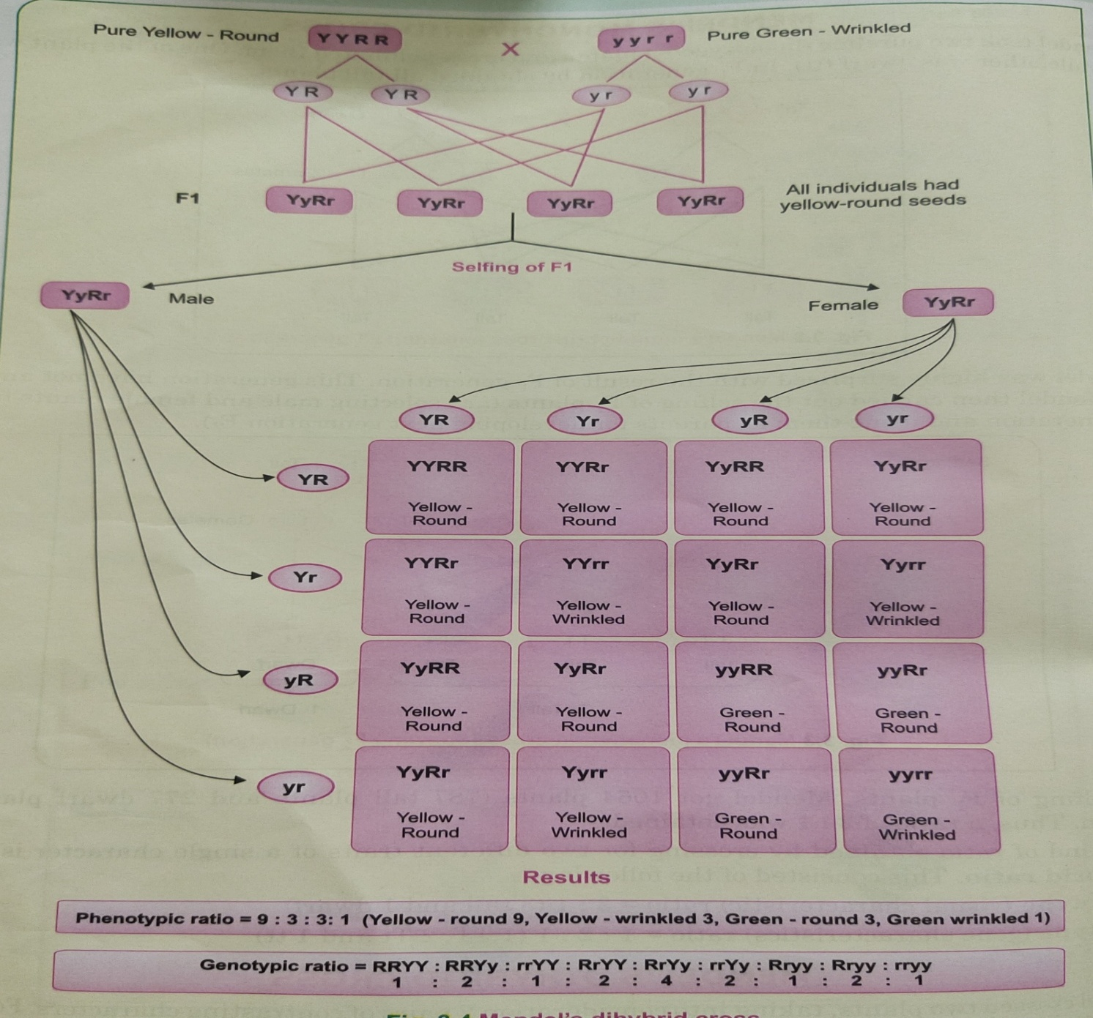

**Mutation**

Sudden change in the genes is called mutation and mutation causing agents are called mutagens.

**EXERCISES**

**Answer the following questions in brief.**

1. Describe Mendel’s Law Of dominance.
2. Describe Mendel’s Law of segregation.
3. Describe Mendel’s Law of independent assortment.
4. When a colour blind male is married to a normal female then what will be the off springs in F1 generation? Explain with punnet square.
5. Why father is responsible for the sex of a child?
6. Describe sex determination in human being.
7. Why Mendel selected pea plant for his experiment?
8. In a certain species of animals black fur ‘B’ is dominant over brown fur ‘b’. Predict a genotype and phenotype of the off springs when both the parents are ‘Bb’ or having heterozygous black fur.
9. What are genes? Where they are located?
10. Draw the structure of DNA given by Watson and Crick.

**Give one one difference between these-**

1. Phenotype and Genotype.
2. Homozygous and Heterozygous.
3. Metacentric and Telocentric chromosome.
4. Cytosine and Adenine base.
5. Monohybrid cross and Dihybrid cross.

**Define the following.**

* Dominant
* Allele
* Genetics
* Heredity
* Karyotype

**Name the following -**

1. Scientific name of pea plant.
2. Genetic constitution of an individual.
3. Dihybrid phenotype ratio.
4. Sudden change in the genotype of an individual.
5. An ‘X’-linked genetic disease.

**NOTE-**

**Please do all this work in your copies which will be checked when school reopens. Please consider this important.**

**\*\*\*\*\*\*\*\*\*\*\*\*\*\*\*\*\*\*\*\*\*\*\*\*\*\*\***