**25th May, 2020 Jesus And Mary School And College Module-2**

## **CLASS- 12**

### **BIOLOGY**

### **Sexual Reproduction in Flowering Plants**

#### **Topics**

1. Sexual Reproduction
2. Events in sexual reproduction
3. Parthenogenesis
4. Flowers (Reproductive organ)
5. Structure and development of anther and male gametophyte
6. Structure and development of ovule and female gametophyte

**Explanation**

Sexual Reproduction involves the formation of male and female gametes, either by the same individual or by different individuals of the opposite sex. The male and female gametes fuse together to form zygote. By the division of this zygote the new organism is formed. This type of reproduction gives the individuals that are not identical to the parents.

All organisms have to reach a certain stage of growth and maturity in their life before they can reproduce sexually. The period of growth is called juvenile phase. At sexual maturity the organism produces its off springs. Reproductive organs develop and mature in animals which is called puberty but in higher plants the flowers are the reproductive organs which show the sexual maturity.

The sexual reproduction is divided into three events-

* Pred-Fertilization
* Fertilization
* Post-Fertilization

**Pre-Fertilization event—** The events before the fusion of gametes are called Pre-Fertilization event. Gametogenesis(formation of gametes) is the main process of this events in sexually reproducing organisms. Gametes are haploid structures. In some organisms the gametes are similar called isogametes.

After the formation of male and female gametes both must be physically brought together for fertilization. Some gametes are motile and some are non-motile. This coming of the gametes close together is called gamete transfer.

**Fertilization—** The fusion of male and female gametes is called fertilization. This is the very important event in sexual reproduction. After this the diploid cell, zygote forms. The fertilization is also called syngamy. When the fertilization takes place inside the body of the organism then it is called internal fertilization like in bryophytes, angiosperms and in higher animals reptiles, birds and mammals etc. When the fertilization takes place outside the body then it is called external fertilization like in many algae, amphibians and some fishes etc.

**Post-Fertilization event—** When the zygote is formed then this event starts. From the zygote the process of development of the embryo takes place. This is called embryogenesis. In this mitosis cell division takes in zygote and number of cells are formed. After this in flowering plants ovary develops into fruit and ovules develop into seeds. Animals who lay eggs are called oviparous while the animals who give young ones are called viviparous.

**Parthenogenesis—** The special mode of sexual reproduction in which development of egg takes place without the sperm cell is called parthenogenesis. This phenomenon naturally takes place among insects, rotifers, some lizards and in platyhelminthes. In honey bee the males are produced parthenogenetically.

**FLOWERS**

Flowers are the reproductive organs. The flower has mostly four sets called whorls. Whorls are arranged on the thalamus by a stalk. The four whorls are calyx, corolla, androecium and gynoecium. The individual part of calyx is called sepal while individual part of corolla is called petal. These are accessory whorls. In some flowers calyx and corolla are not differentiated then it is called perianth. The individual part of perianth is called tepal example- Onion flower. The essential organs are androecium and gynoecium. Androecium is the male part produce pollen grains while gynoecium is the female part and divided into style, stigma and ovary. Ovary contains locules in which ovules are present attached with the placenta. Arrangement of ovule on the placenta is called placentation.

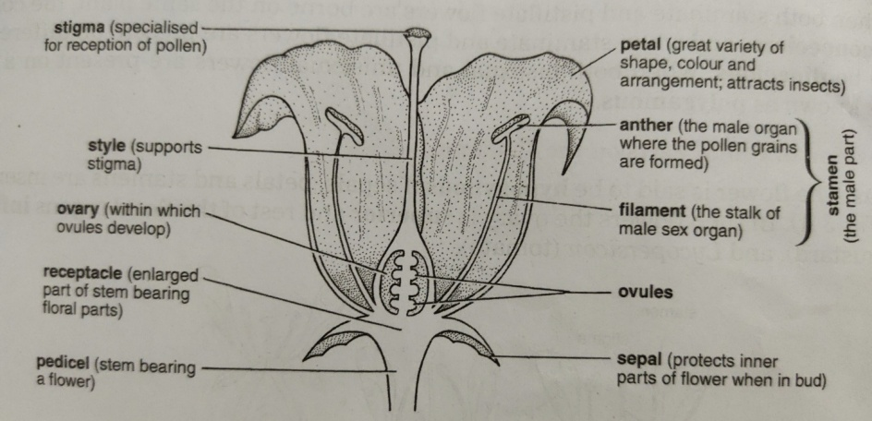

Flowers are complete or incomplete. If all the four whorls present then it is called complete flower and if anyone is absent among four whorls then it is called incomplete flower. According to the position of the floral parts on the thalamus, flowers are of three types-

* **Hypogynousflower—** When ovary is situated above the floral whorls on the thalamus of the flower then it is called hypogynous flower. In this, ovary is superior while other parts are inferior. Eg- tomato flower.
* **Perigynous flower—** When in the thalamus a cup shape structure is formed around the ovary and other floral parts appear to be inserted on the rim of the cup then these are called perigynous flower. Here the ovary is half inferior. Eg- In rose.
* 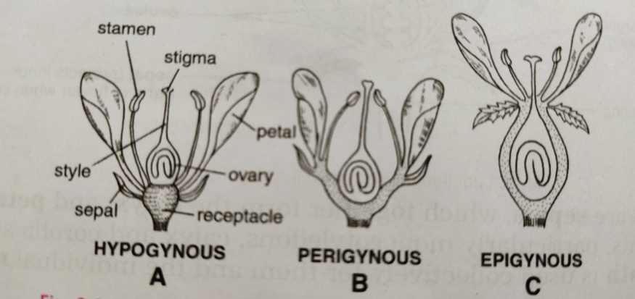**Epigynous flower—** When the thalamus completely enclosesthe ovary and fuses with the ovary wall and other whorls arise above the ovary then it is called epigynous flower. Eg- Cucumber.

**Structure and development of anther and male gametophyte**

Some hypodermal cells become distinct in each lobe of young anther these cells are called archesporial cells, dividepericlinally, forming a primary parietal layer towards the outside and a primary sporogenous layer towards the inside. Now the wall of the anther is made up of epidermis, endothecium, middle layers and a single tapetum. The cells of the middle layers degenerate before the pollen mother cells undergo meiosis. The tapetum has densely cytoplasmic cells serves as a nutritive tissue for pollen mother cells and microspores. The primary sporogenoustissue may either directly or after dividing mitotically act as microspore mother cells. These cells perform meiosis division to form four haploid microspores. This phenomenon is called microsporogenesis. After some changes the spores are dispersed by various agencies of pollination. The four microspores formed from a microspore mother cell are arranged in tetrahedral or isobilateral tetrads. These microspores are also called pollen grains.

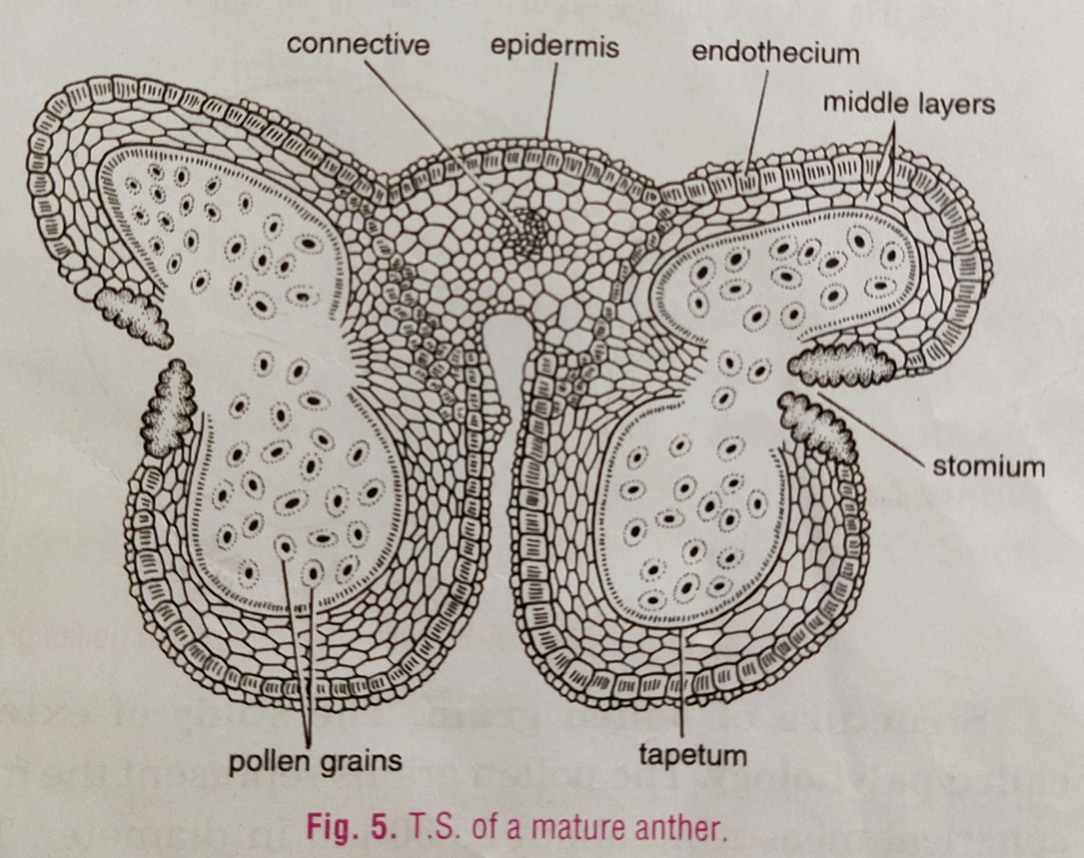

A pollen grain divides into two cells, a generative and a vegetative cell. The generative cell is attached to the inner wall(intine) but the vegetative cell is detached from the pollen wall and

present in the cytoplasm of the vegetative cell. The generative cell divides by mitosis division to form two male gametes.

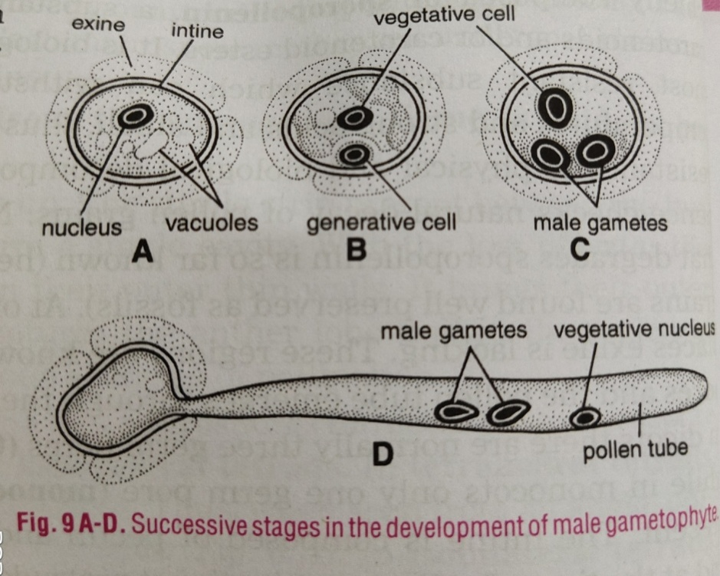

**Structure and development of ovule and female gametophyte**

Ovules are present in the locules of ovary. The ovule has nucellus which is nutritive tissue. The one or two integuments cover the nucellus. The integuments has small opening at one end called micropyle. The ovule is attached to the placenta by a stalk called funicle and the point of attachment of the body of the ovule to the funicle is called hilum. The basal part of the ovule is know as Chalaza.

The ovules are of many types on the basis of relative position of micropyle and chalaza at maturity.

* **Orthotropous ovule—** In this the micropyle chalaza and funicle falling in straight line and ovule is upright. Eg- Cycas.
* **Anatropous ovule—** In this the whole body of the ovule is inverted through 180°. In this micropyle comes close to the base of the funicle. Eg- China rose.
* **Campylotropous ovule—** In has a curved body.The micropyle and chalaza are not in a straight line and the funicle lies at right angles to the chalaza. Eg- Chenopodium.
* **Amphitropous ovule—** In this the curved body is present and the embryo sac bends and becomes horse shoe shaped. Eg- Alisma.
* 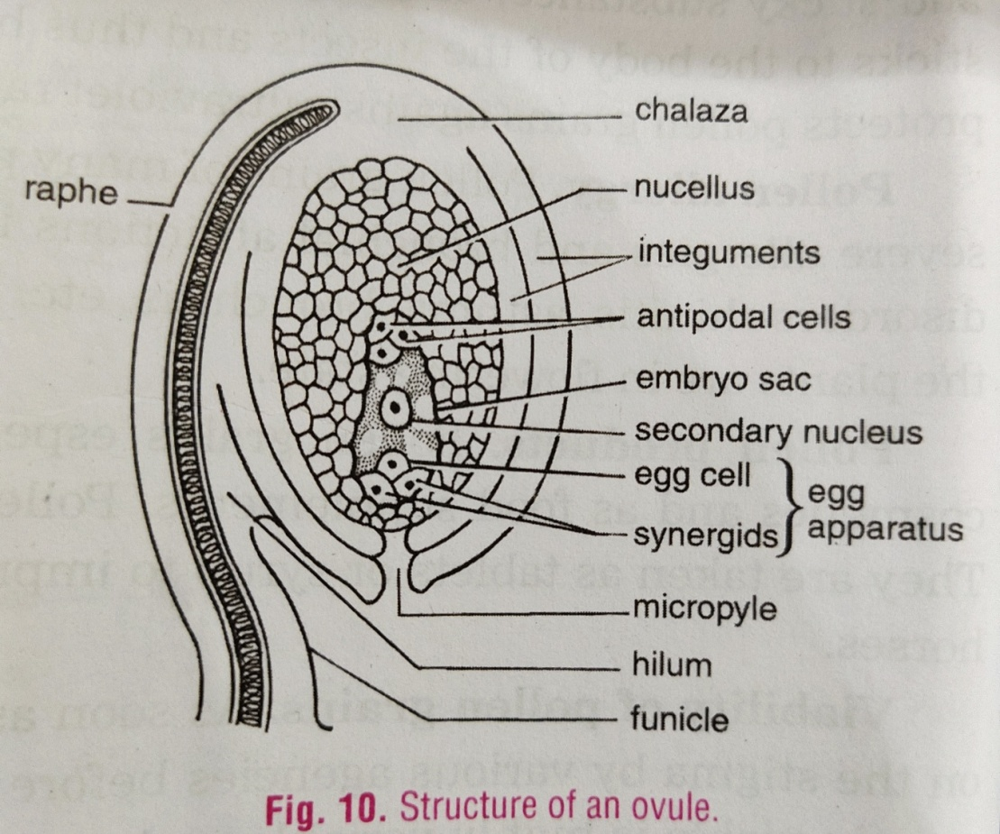**Hemitropous ovule—** In this type the ovule is turned through 90°. The micropyle and chalaza are in a horizontal line and the funicle lies at right angles to it. Eg- Primula.
* **Circinotropous ovule—** In this the funicle is very long and circles the body of the ovule. Eg- Opuntia.

**Development of megaspore-** A hypodermal cell of the nucellusat the micropyler end differentiates as Arche sporial cell. It function as megaspore mother cell. This cell by meiosis division forms four haploid megaspores. In this only one of functional and the other three degenerate.

The megaspore is the mother cell of the female gametophyte. It becomes bigger and forms embryo sac. The haploid nucleus of the megaspore divides by mitosis, forming eight nuclei. Three nuclei at the micropyler end form egg apparatus, three at the chalazal end form antipodal cells and the remaining two, called polar nuclei, come to the center of the sac. The middle one nuclei of egg apparatus is female gamete which is surrounded by synergid cells. It is the most common type of embryo sac in the flowering plants.

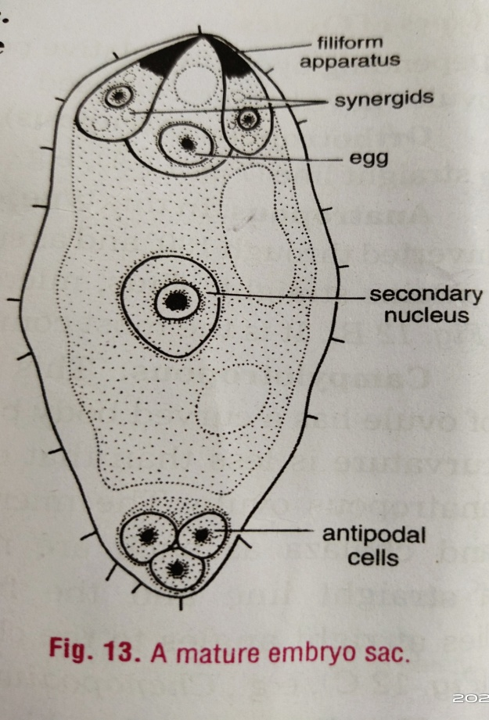

**WORKSHEET**

**Answer the following questions.**

1. Which is a better mode of reproduction, sexual or asexual ? Why ?
2. Explain pre-fertilization and post-fertilization events in the organism?
3. What is parthenogenesis? Explain with one example.
4. Describe the formation of microspores(pollen grains) in the anther lobe.
5. Describe the structure of ovule with diagram.
6. How many type of ovules are found in flowering plants? Describe in brief.
7. What is megasporogenesis?
8. Explain the development of female gametophyte(embryo sac) with diagram.
9. Write down four differences between male and female gametophyte.
10. Explain about hypogynous, perigynous and epigynous flowers.

**Give one one difference between these-**

1. External and Internal fertilization.
2. Petal and Tepal.
3. Orthotropous and Anatropous ovule.
4. Superior and Inferior ovary.
5. Oviparous and Viviparous.

**Define-**

1. Placentation
2. Perianth
3. Micropyle
4. Syngamy
5. Tapetum

**NOTE-**

**Please do all this work in your copies which will be checked when school reopens. Please consider this important.**

**\*\*\*\*\*\*\*\*\*\*\*\*\*\*\*\*\*\*\*\*\*\*\*\*\***