**25th May, 2020 JESUS AND MARY SCHOOL AND COLLEGE MODULE 2**

**CLASS 4**

**COMPUTER SCIENCE**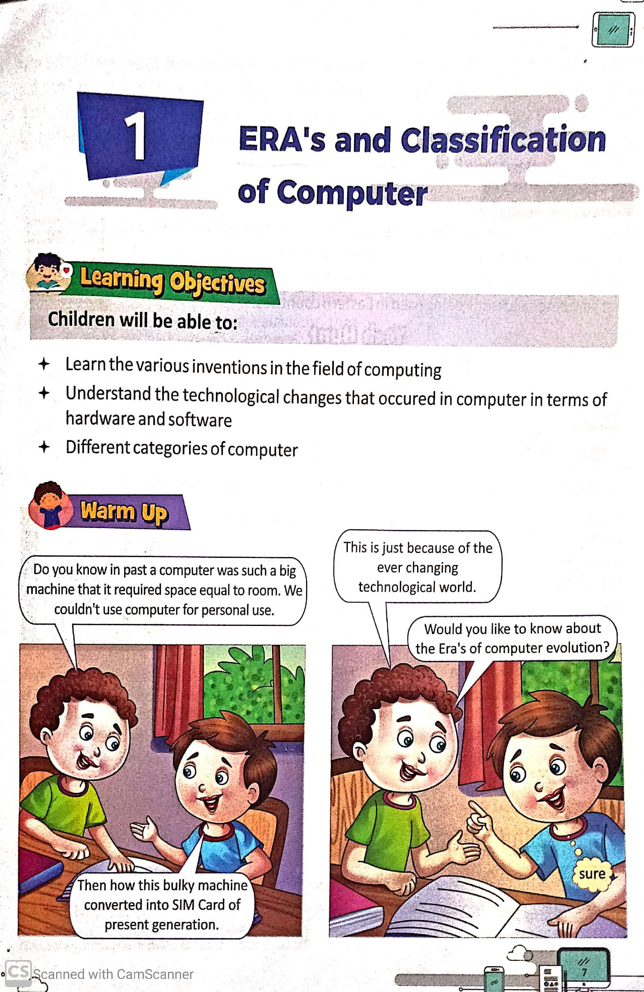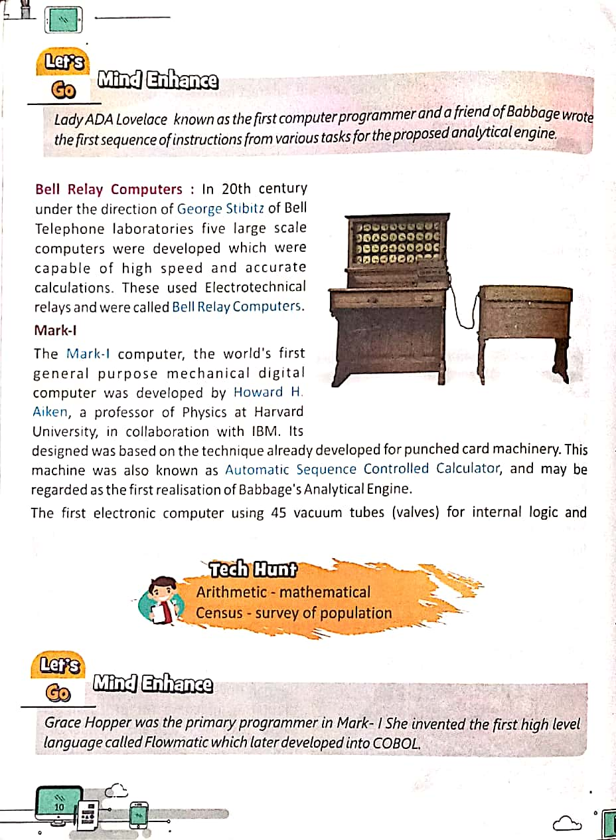

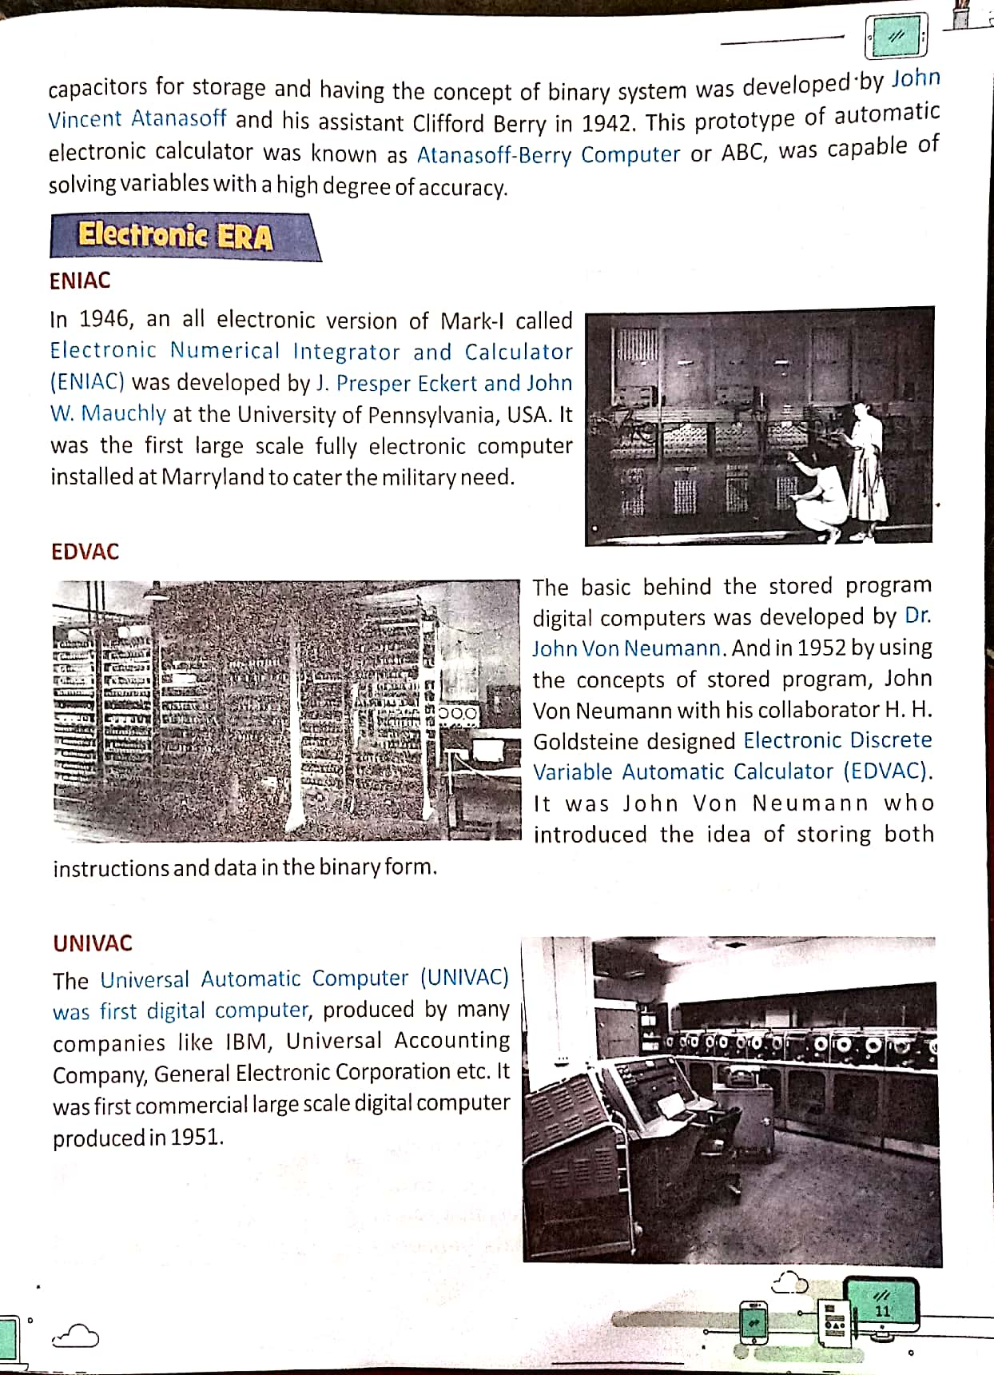

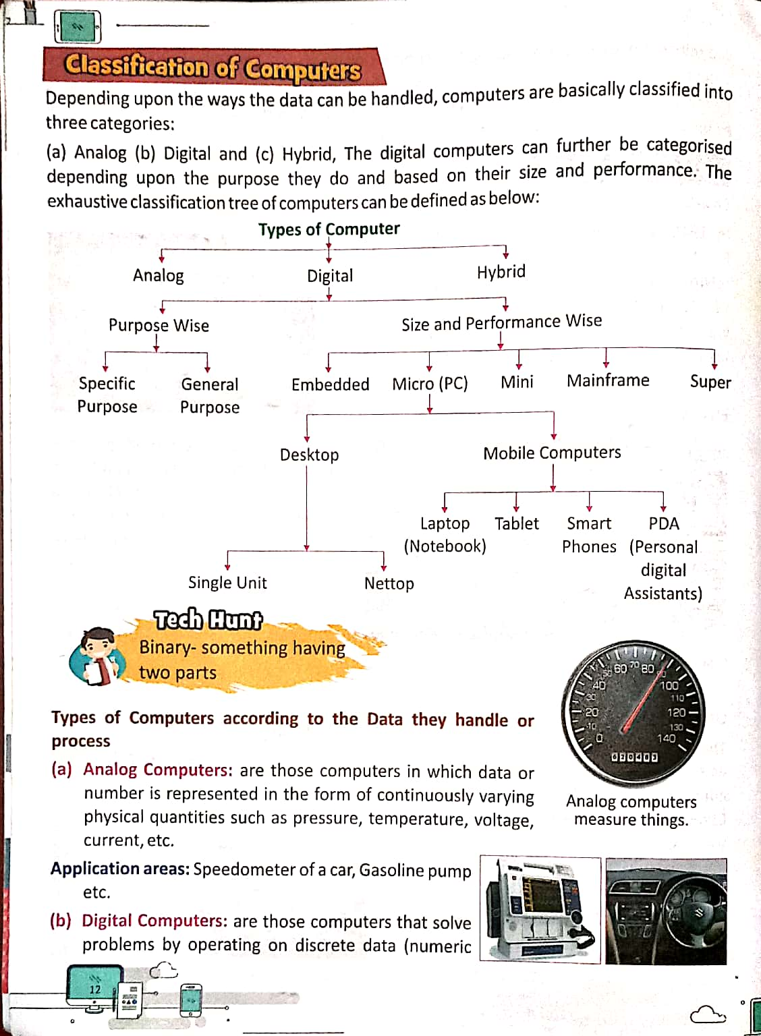

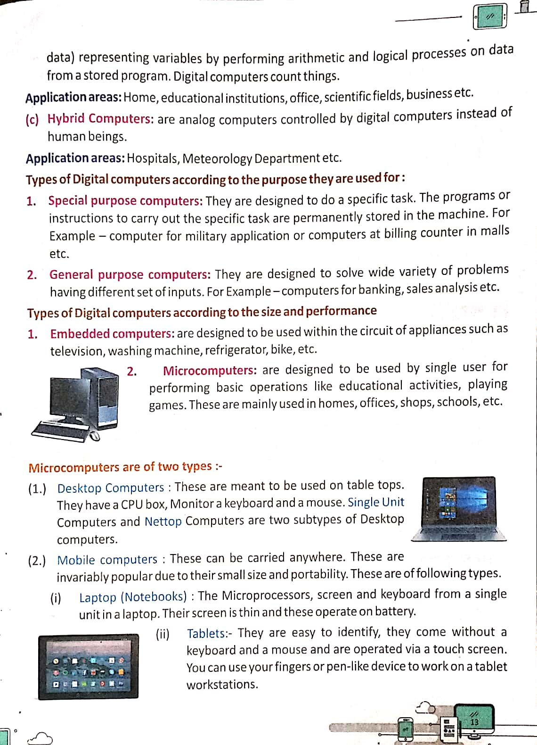

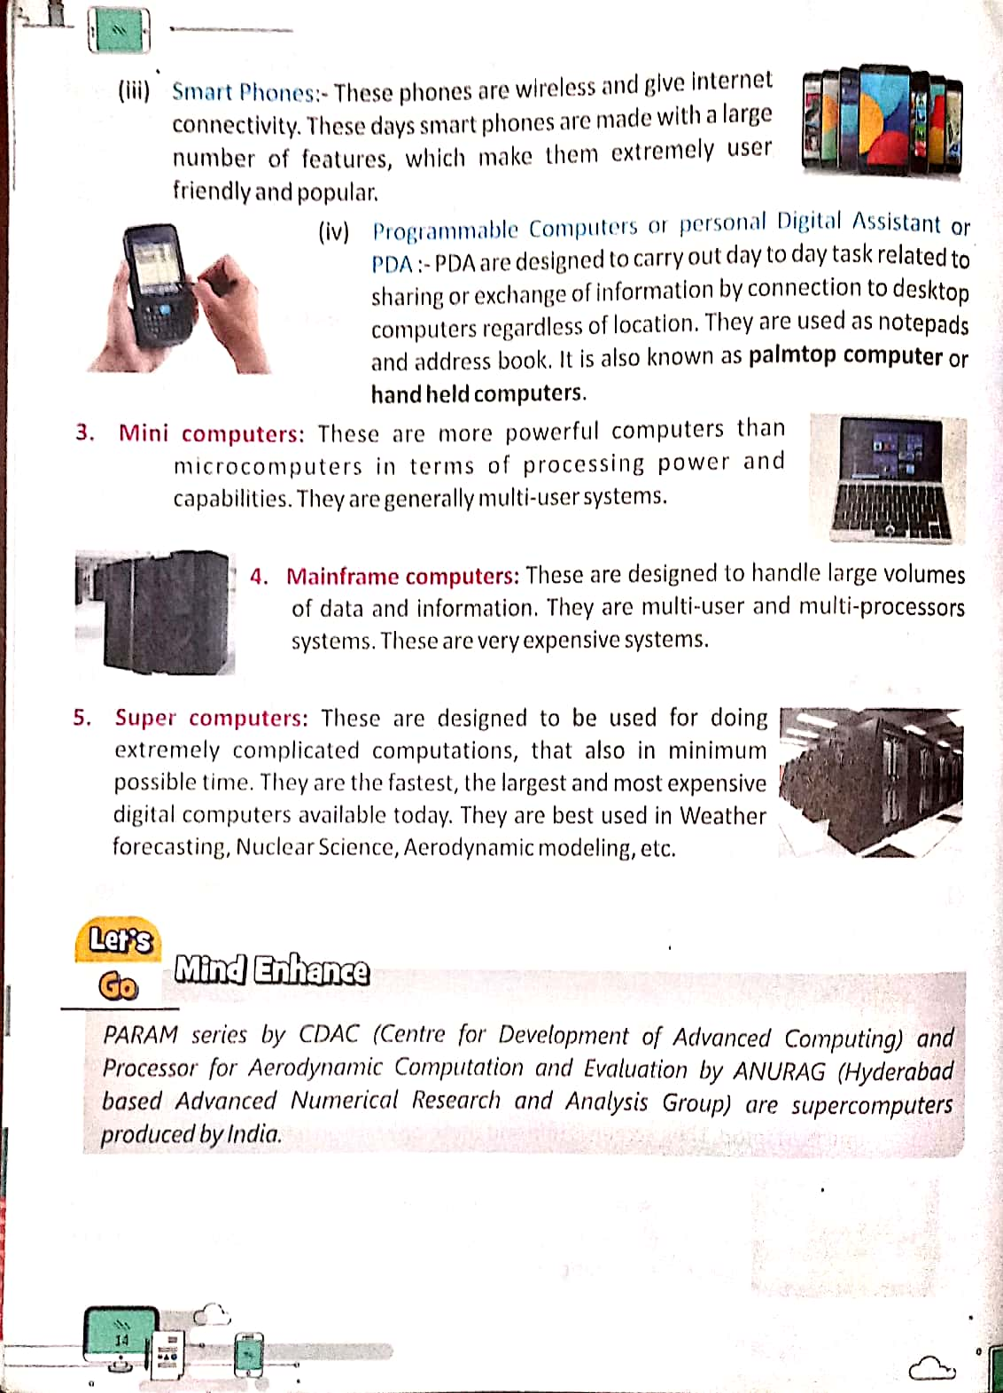

**EXPLANATION**

**Mark-I :**

* In 1937 Howard Aiken of the Harvard University in the USA made a calculating device named Harvard Mark I.
* It worked electro mechanically without any manual efforts.
* It could perform addition, subtraction and multiplication.
* It was the first automatic computer.

**ENIAC**:

* In 1946 Electronic Numerical Integrator and Calculator (ENIAC) came into being.
* It could do the calculation a thousand time faster than any previous machine.
* The size of the ENIAC computer is to big.

**Classification of computers:**

* Computers are categorised into four types based on their size, performance and cost.
* The four main types of computers are micro computer, mini computer, mainframe computer and super computer.
* Analog, Digital and Hybrid are the different categories of computers.
* Digital Computers are further classified into Micro computers, Mini computer, Mainframe computer, Super computers.

**Analog Computer:**

* An analog computer is a type of computer that uses the continuously variable physical quantities such as pressure, temperature, voltage, current etc.

**Digital Computers:**

* A digital electronic computer is a computer machine which is both an electronic computer and a digital computer.

**Hybrid Computer:**

* Hybrid Computer are analog computers controlled by digital computers instead of human beings.

**MICRO COMPUTERS :**

* Micro Computer is a small computer.
* Micro Computer is also called personal computer.
* Micro Computer is a computer in which the CPU is contain on one single chip.
* A Micro Computer is smaller than a mainframe or a mini computer.
* Micro Computers is used in our school, offices and home.

**MINI COMPUTER :**

* Mini Computer is a computer medium power, more than a micro computer but less than mainframe.
* A Mini Computer may also be called a mid-range computer**.**
* Mini computers are used for scientific and engineering computations, business transaction processing, file handling, and database management.
* Mini Computers are at least five times faster than micro computers.

**MAINFRAME COMPUTER :**

* Mainframe Computers are more powerful than the Mini computers, but smaller than the super computers.
* These machines are used in big organizations.
* They have all the input and output devices.

**SUPER COMPUTER :**

* Super computers are the fastest computers.
* They are the biggest type of computers present in the world today.
* Super computers are used for scientific inventions, weather forecasting, space technology and in such important sectors.
* It has all the input and output devices and also a lot of terminals.

**SMART PHONES**

* A smart phone is a cell phone that allows us to do more than make phone calls and send text messages.
* Smart phone can browse the internet and run software programs like a computers.

**WORKSHEET**

* **Question Answer.**

**Q1.** Write down the three categories of computer.

**Ans.** The three categories of computer are-

**Q2.** What are the different types of digital computers?

**Ans.** The different types of digital computers according to the size and performance are- Embedded computers, Micro computers, Mini computers, Mainframe computers, Super computers.

**Q3.** Who invented ENIAC?

**Ans.** ENIAC was invented by John Presper Eckert and John W. Mauchly.

**Q4.** What are Smart phones?

**Ans.** These phones are wireless and give internet connectivity. These days smart phones

are made with a large number of features, which make them extremely user

friendly and popular.

* **Tick the correct option.**

1. John Napier invented a calculating device called …………..
2. Internet **b.** Abacus **c.** ***Napier Bones***
3. Who is known as the father of computer?
4. Gottfried Leibniz **b.**  Blaise Pascal **c.** ***Charles Babbage***
5. John Napier invented Napier’s bones in …………….
6. ***1614*** **b.** 1694 **c.** 1641
7. A special - purpose computer that is part of a machine.
8. Laptop **b.**  ***Embedded*** **c.** Smart phones
9. PDA is a ………………..
10. ***Micro-Computer*** **b.** Mini-Computer **c.** Super Computer

* **True/False:**

1. Mark I was designed by Grace Hopper. ( F )
2. PARAM is a supercomputer manufactured in India. ( T )
3. ENIAC was the first fully electronic digital computer. ( F )
4. Mini computers are multi-user systems. ( T )

* **Write the full forms of the following abbreviations.**

1. PDA - Personal Digital Assistant.
2. ENIAC - Electronic Numerical Integrator and Calculator.
3. EDVAC - Electronic Discrete Variable Automatic Calculator.
4. EDSAC - Electronic Delay Storage Automatic Calculator.
5. UNIVAC - Universal Automatic Computer.
6. CDAC - Centre for Development of Advanced Computing.

**Note- Please do all this work in your “Copies” OR “Notebooks” which will be**

**checked when school reopens. Please consider this important.**

**\*\*\*\*\*\*\*\*\*\*\*\*\*\*\*\*\*\*\*\*\*\*\*\*\*\*\*\*\*\*\*\*\*\*\*\*\*\*\***