**25th May, 2020 JESUS AND MARY SCHOOL AND COLLEGE MODULE 2**

**CLASS 5**

**COMPUTER SCIENCE**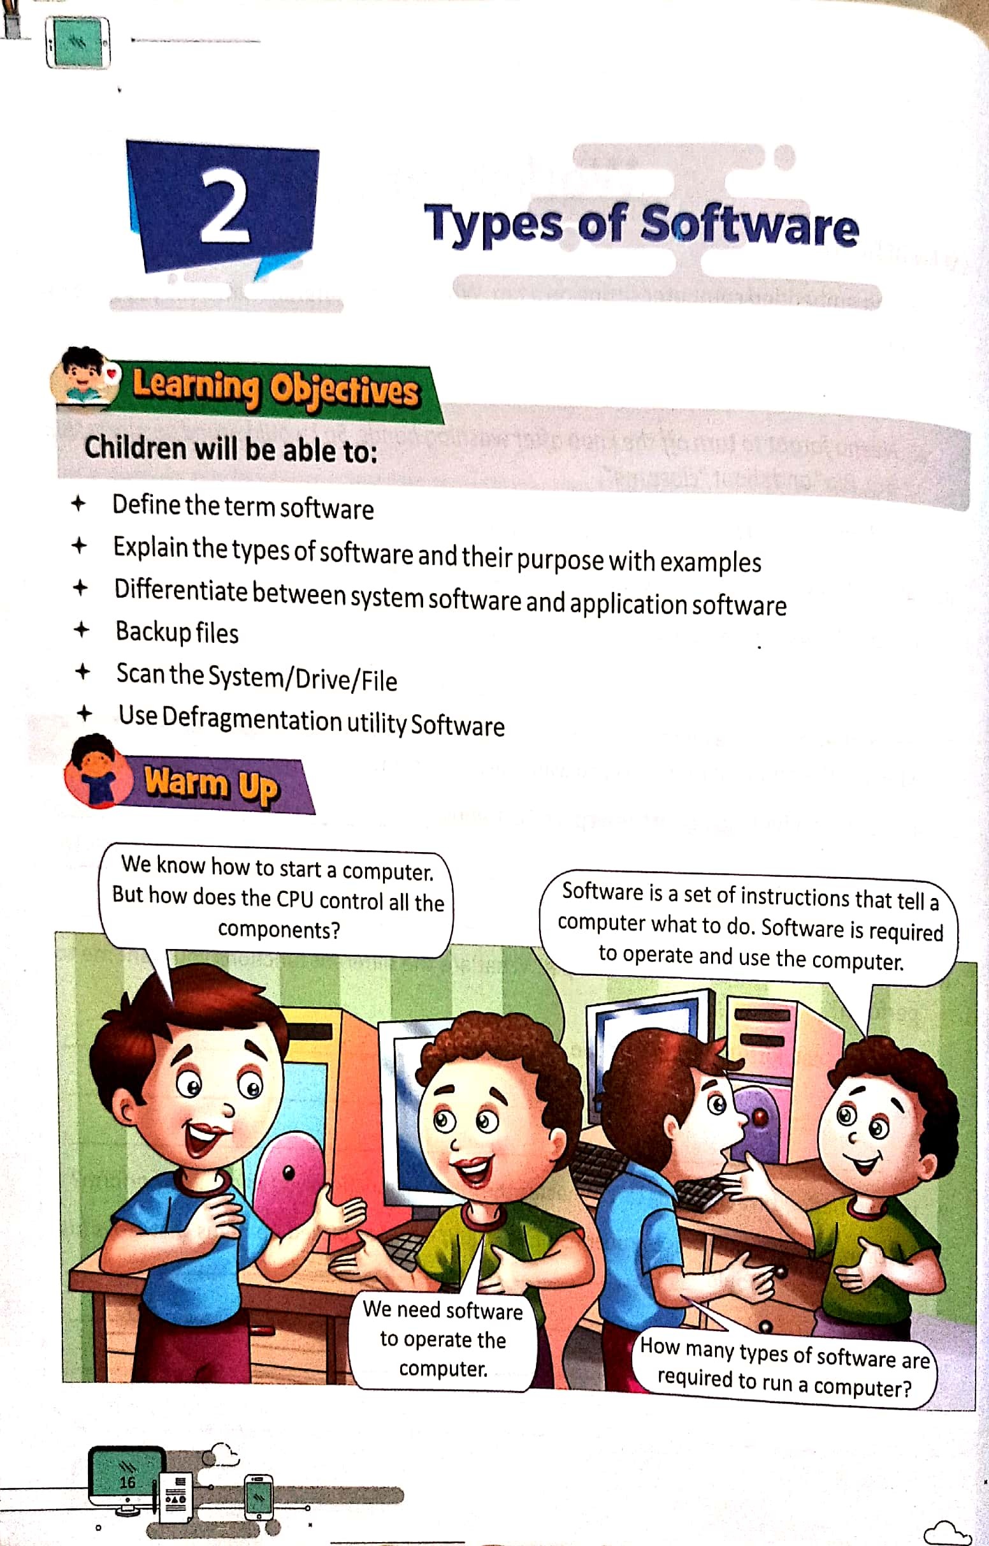

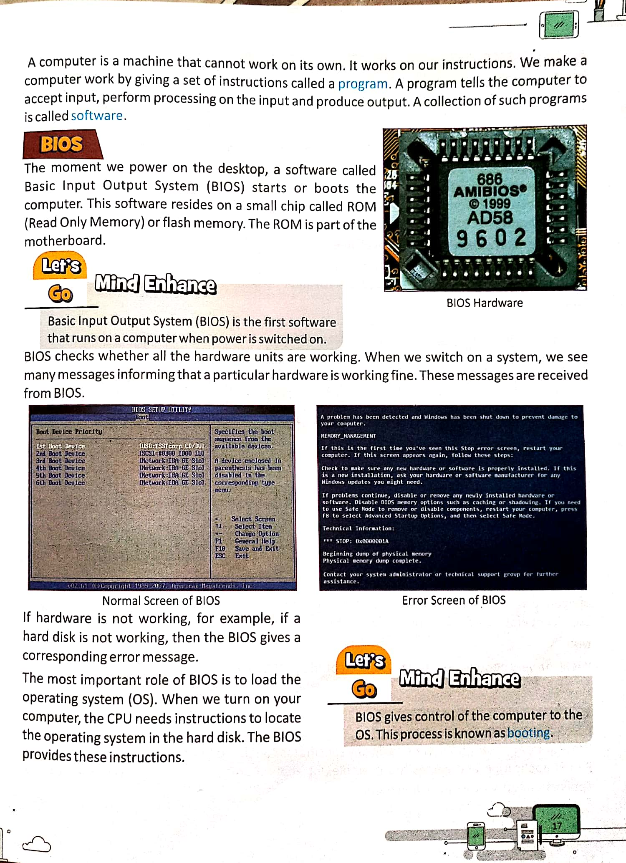

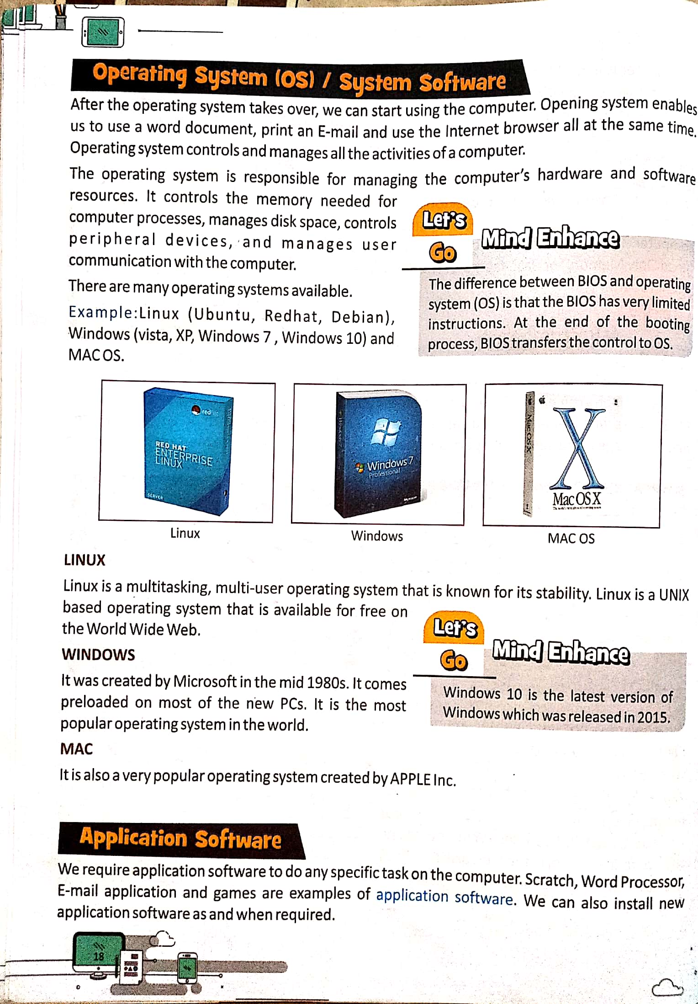

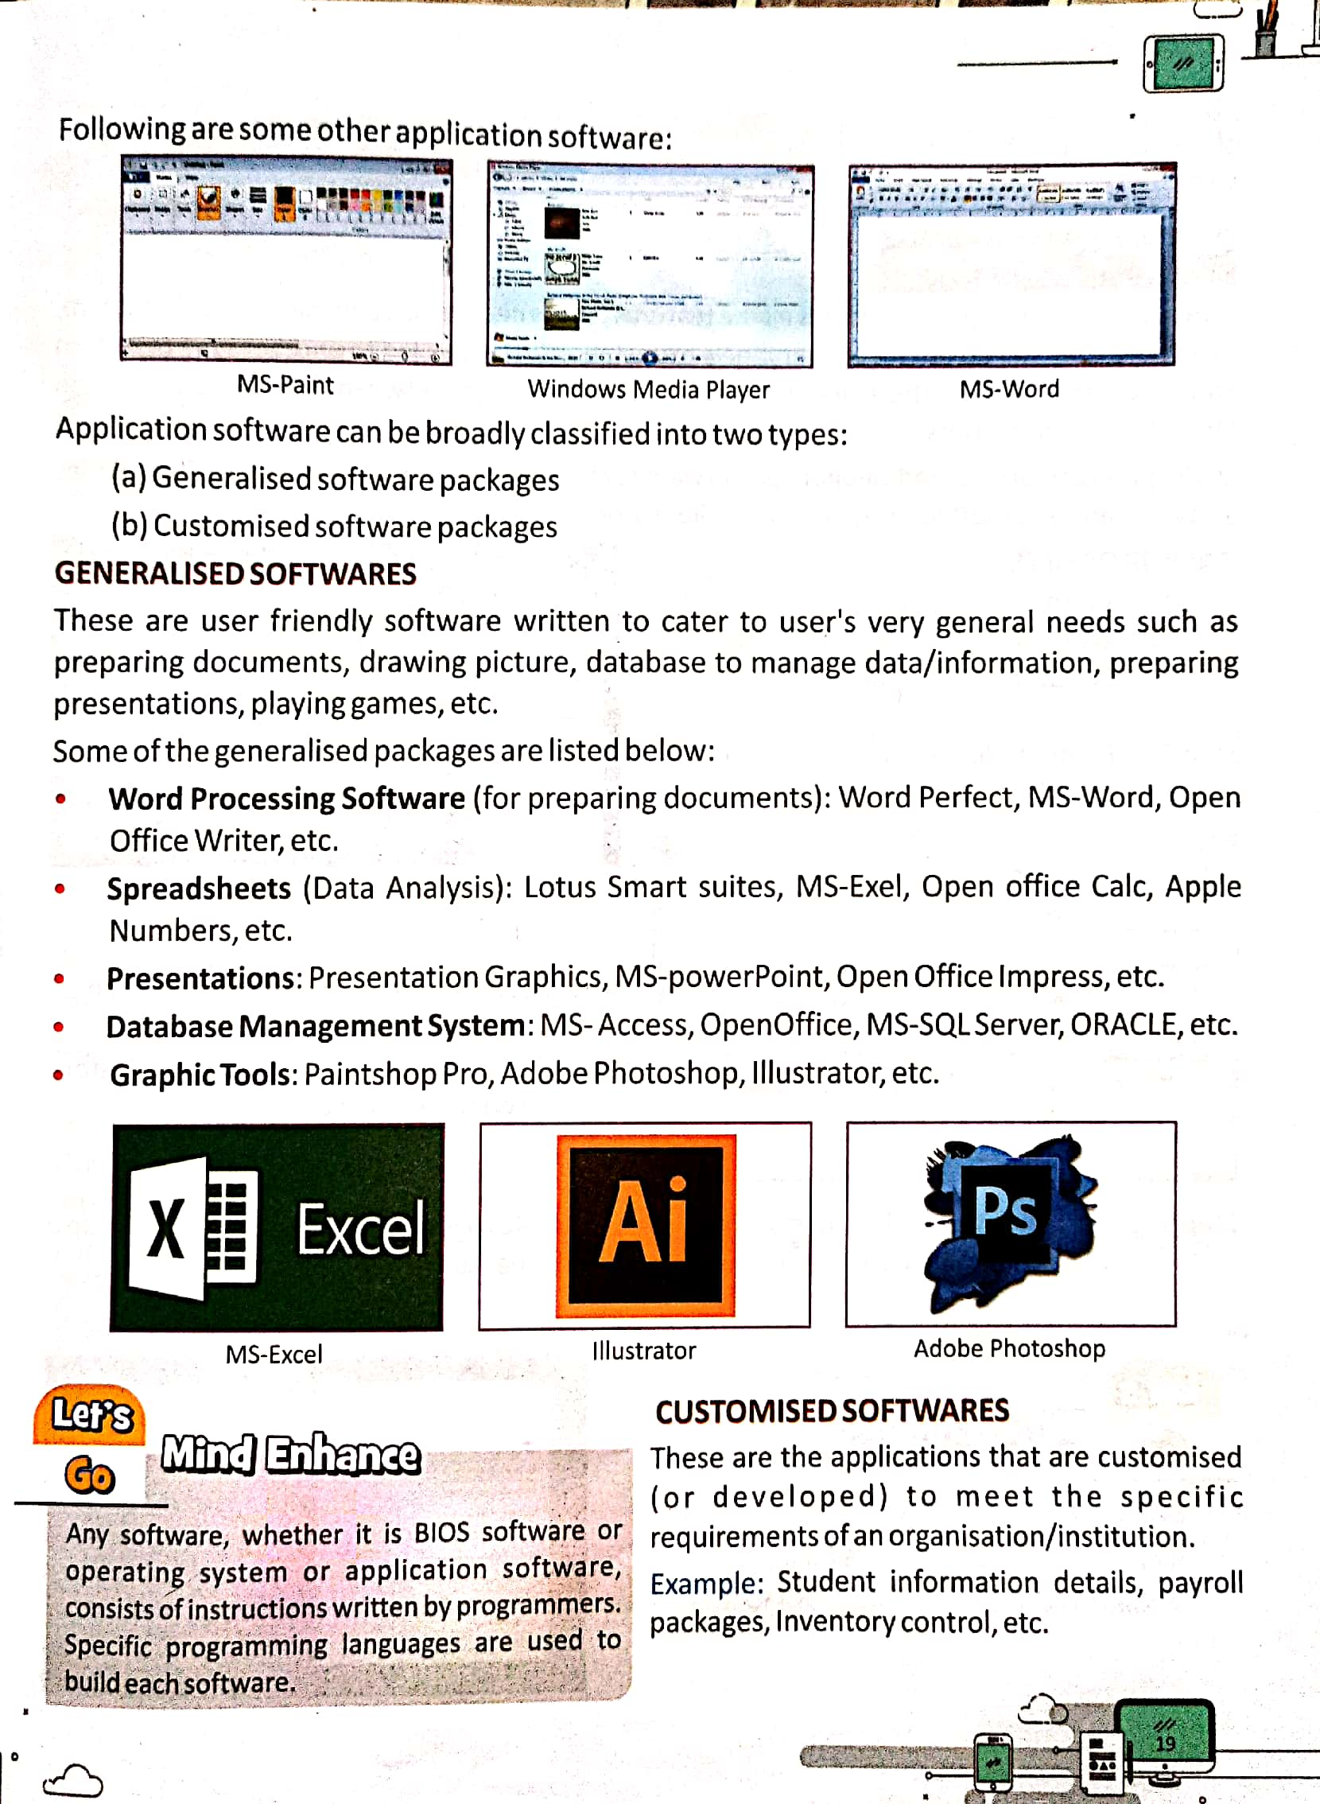

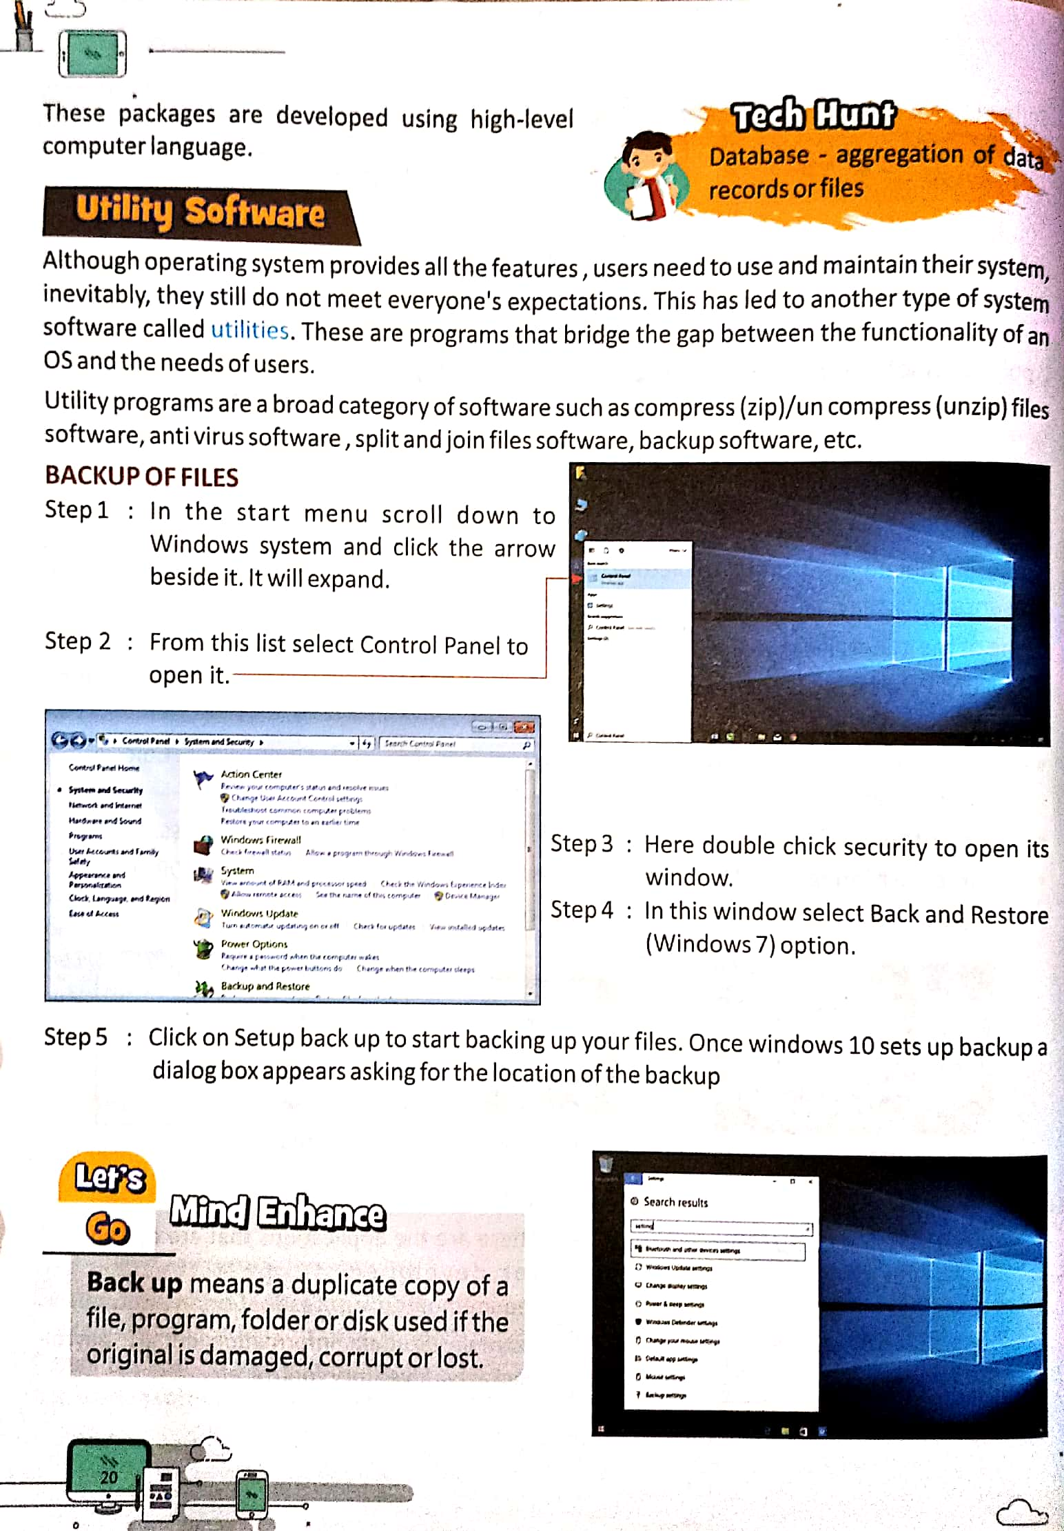

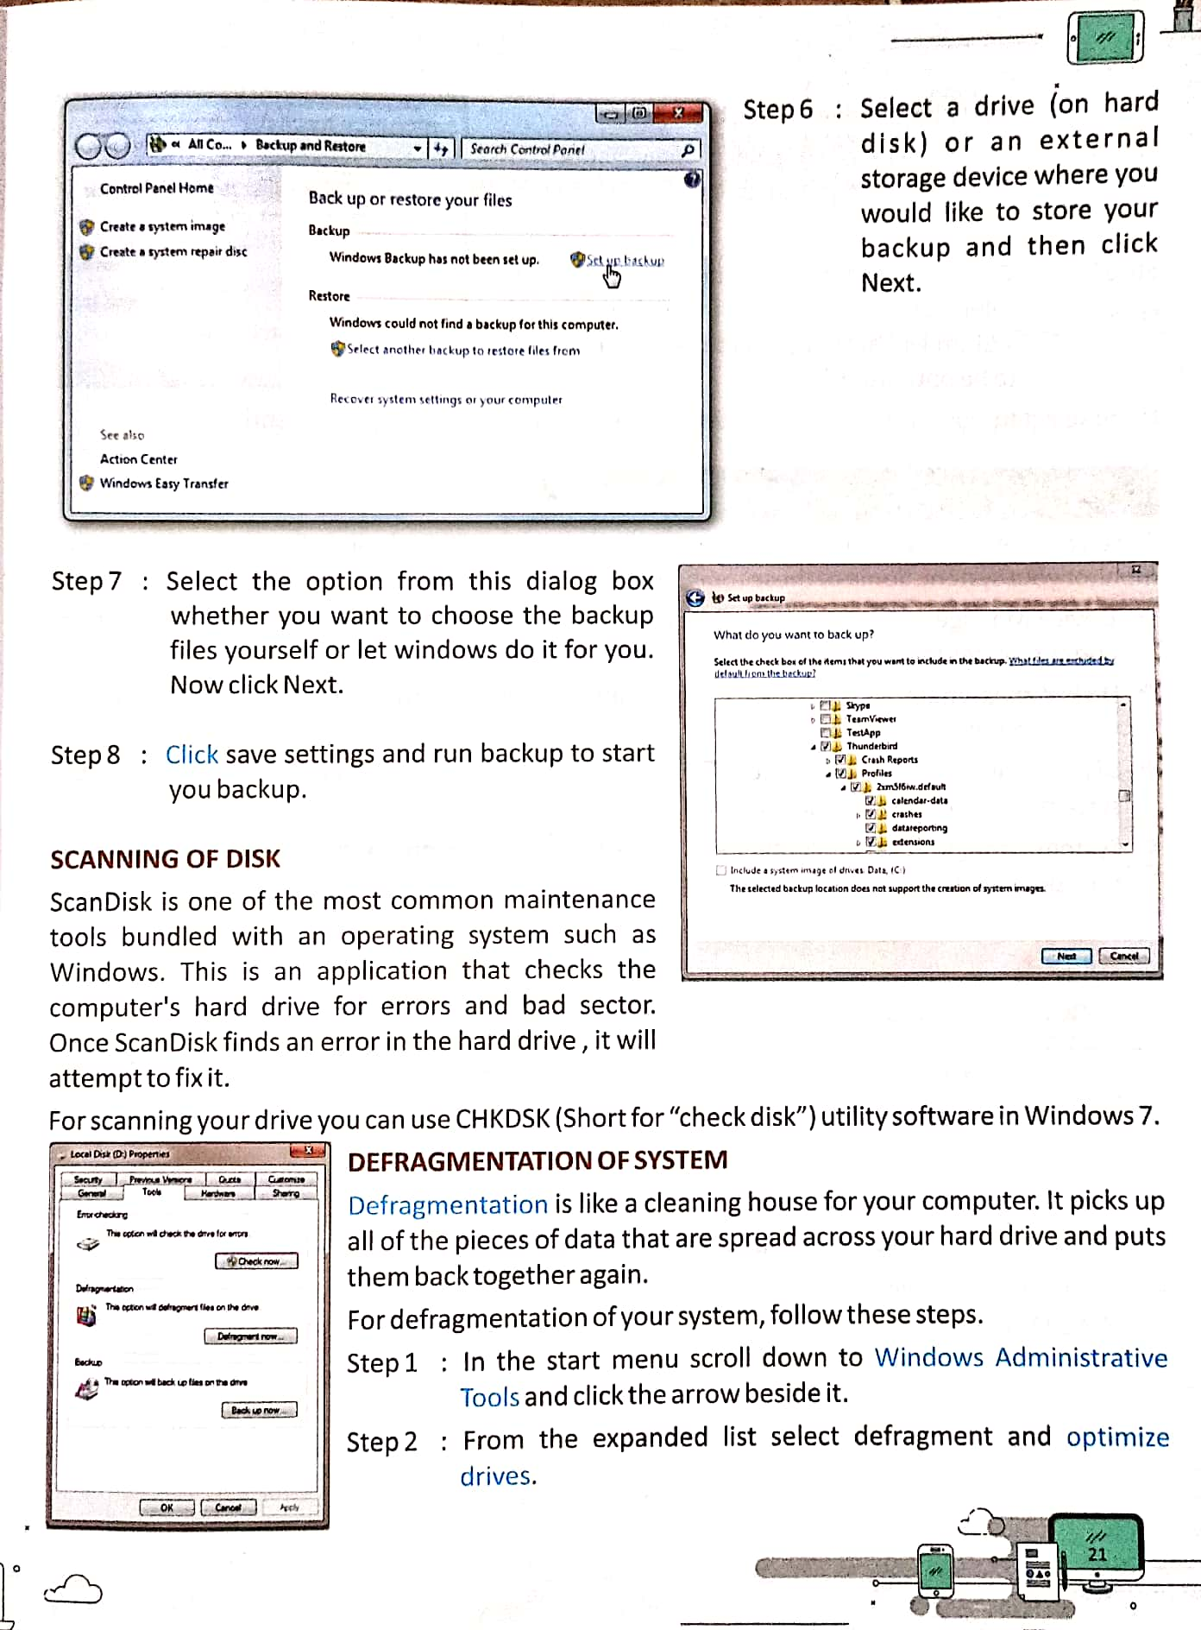

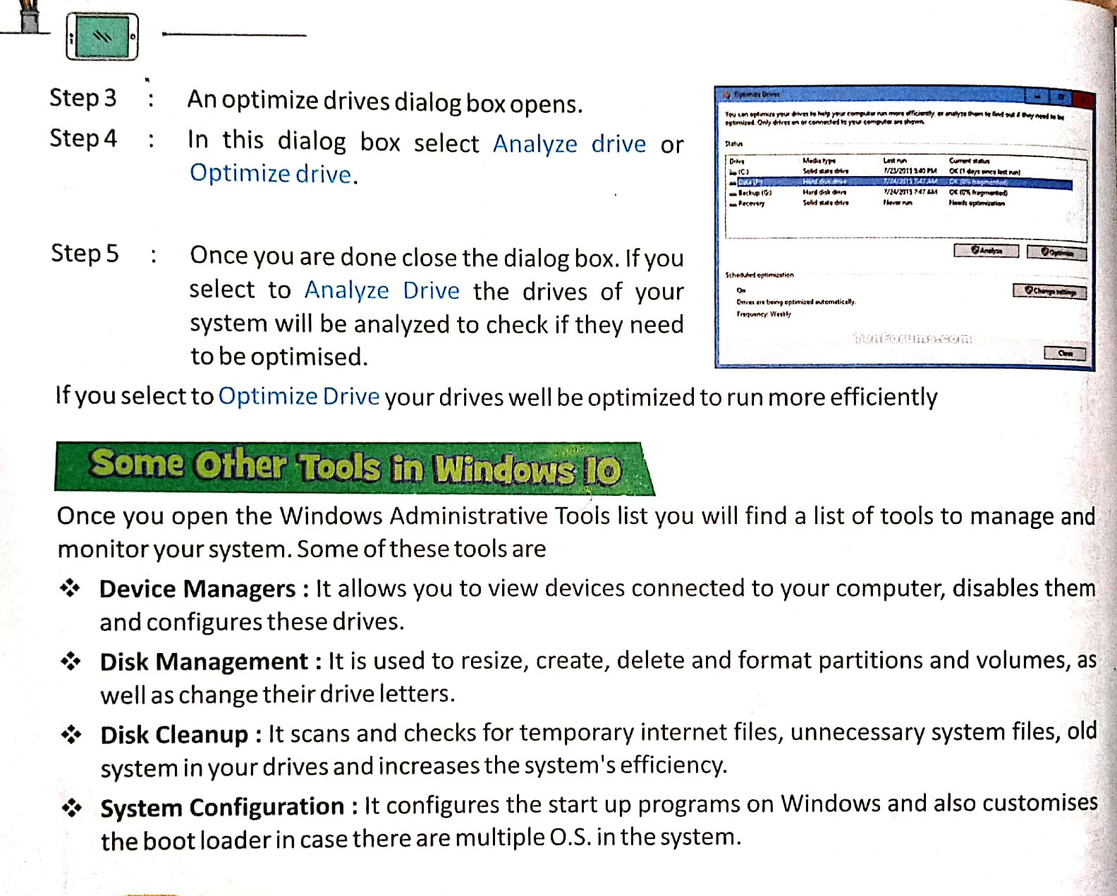**EXPLANATION**

**Program:**

* A computer program is a set of commands or instructions.
* A Program is not written in ordinary human language.
* It is written using programming languages.
* Software is another name given to computer programs.

**Hardware:**

* The physical components of the computer are collectively called computer hardware.
* The term physical means what we can see, touch and feel.
* The input, storage, processing, output and control devices are all hardware as like printer, monitor, CPU, keyboard, mouse etc.

**Software:**

* Computer programs are called software.
* Without software we can not even start a computer.
* Unlike hardware we can not see, touch and feel software.
* There are two types of software- System software and Application software.

**System software:**

* System software is that which performs the operations of the computer system itself.
* Windows, DOS, UNIX, LINUX are examples of system software.
* They are also known as operating system.
* Windows is most commonly used Operating system.

**Application software:**

* In the computer field application means doing a particular activity.
* Application programs are those programs specially designed for particular kind of works as like MS Word, MS Excel, MS Power point, Adobe etc.
* The computer carries out the instructions given by the operator.

**Utility Software:**

* This has let to another types of system software called utilities.
* Utility program are of broad categories of software as like antivirus software, backup software etc.

**BIOS:**

* Basic Input Output System (BIOS) is the first software that runs on a computer when power is switched on.

**Booting:**

* BIOS gives control of the computer to the OS. This process is known as Booting

**Device Managers:**

* It allows us to view devices connected to our computer, disable them and configures these drives.

**Disk Management:**

* It is used to resize, create, delete and format partitions and volumes, as well as change their drive letters

**Disk Cleanup:**

* It scans and checks for temporary internet files, unnecessary system files, old system in our drives and increases the system’s efficiency.

**System configuration:**

* It configures the start up programs on windows and also customises the boot loader in case there are multiple O.S. in the system.

**WORKSHEET**

* **Question/Answer.**

**Q1.** What is a program?

**Ans.** A computer is a machine that cannot work on its own. It works on our instructions. We make a computer work by giving a set of instructions called a program.

**Q2.**  What is software? How many types of software are there?

**Ans.** Software is a collection of computer programs that provide instruction to a computer is known as software. Software are of two types-

1. System Software **(ii)** Application Software.

**Q3.** What is system software? Give Example.

**Ans.** System software is a set of one or more program that control overall functioning of a computer. It acts as an interface between the user and the complex.

Example: MS DOS, Windows, Linux, UNIX.

**Q4.**  What is application software? Give Example.

**Ans.** A set of programs used to solve particular problem of user through computer is called Application software.

Example: MS Word, MS Excel, MS Paint.

**Q5.**  What is BIOS?

**Ans.** Basic Input Output System (BIOS) is the first software that runs on a computer when power is switched on.

**Q6.** What is the difference between BIOS and Operating System (OS)?

**Ans.** The difference between BIOS and Operating System (OS) is that the BIOS has

very limited instructions. At the end of the booting process, BIOS transfers the

control to OS.

* **Tick the correct option.**

1. An operating system is also called:
2. Application software **b.** ***System software***  **c.** Utility software
3. A spreadsheet program helps us to:
4. Perform calculation **b.** Analyse data **c.** ***Both a and b***
5. Which of the following is not a utility program?
6. ***MS-Word*** **b.** Backup software **c.** Disk defragmenter
7. Which of the following is not a system software?
8. Windows **b.** Linux **c.** ***Office***

* **True/False:**

1. Hardware means the physical components of the computer system. (T)
2. An operating system is a must to operate a computer system. (T)
3. Defragmentation is like a cleaning house for computer. (T)
4. Application software is written to perform a specific task or process. (T)
5. BIOS gives control of the computer to the OS. (T)

**Note- Please do all this work in your “Copies” OR “Notebooks” which will be checked when school reopens. Please consider this important.**

**\*\*\*\*\*\*\*\*\*\*\*\*\*\*\*\*\*\*\*\*\*\*\*\*\*\*\*\*\*\*\*\*\*\*\*\*\***