**25th May 2020 JESUS AND MARY SCHOOL MODULE – 2**

**CLASS-V**

**SOCIAL STUDIES**

**Effects of Earth’s Movement**

**Text book**

You have read about the movements of the Earth-rotation and revolution. Rotation is the spinning movement of the Earth on its axis from west to east. The earth completes one rotation on its axis in about 24 hours (23 hours and 56 minutes), making one Earth Day. Revolution is the movement of the Earth around the Sun in a fixed path called orbit. The earth completes one revolution in 365 $\frac{1}{4}$ days (or 365 days, 5 hours and 48 minutes).

This makes one earth year.

**Rotation -** The Earth rotates on its axis. The axis of the Earth is an imaginary line which passes through the centre of the Earth. The upper end of the axis is the North Pole and southern end is the South Pole. The axis of the Earth is tilted at an angle of 66.5° to the plane of the Earth's orbit.

**Effects of Rotation**- Let us read about the effects of rotation.

**Formation of Day and Night**

As the Earth rotates, one half of the Earth that faces the Sun experiences day while the other half that is away from the Sun experiences night. The length of the day depends on the number of hours that a place on Earth faces the Sun.

**Sunrise is Earlier in Countries Lying in the East**- Since Earth rotates from west to east, countries in the east have sunrise earlier than the countries in the west. Japan is the first country to see sunrise because it is located in the extreme east of the eastern hemisphere. Therefore, Japan is called the Land of the Rising Sun'.

**Revolution-** As the Earth is rotating on its axis, it is also revolving around the Sun in its orbit.

The Earth completes one revolution in 365 $\frac{1}{4}$ days (or 365 days, 5 hours and 48 minutes). This makes one earth year.

For convenience, we consider a year consisting of only 365 days and leave out the six hours. These 6 hours are added up to make one day after a period of 4 years(4 x6-24 hours).

This extra day is added to the month of February. Thus, every fourth year, February has 29 days instead of 28. Such a year has 366 days and is called a leap year.

**Effects of Revolution-**

Let us read about the effects of revolution.

Formation of Seasons

The most important effect of revolution is the formation of seasons.

In fact, seasons are caused due to the combined effect of two factors:

1. Revolution of the Earth in its orbit around the Sun

2. Tilting of the Earth's axis at an angle of 66.5° to the plane of its orbit. (Because of the tilted axis of the Earth, when one part of the Earth tilts towards the Sun, the other part tilts away from the Sun. The part of the Earth that leans towards the Sun has summer while the part that leans away from the Sun has winter.)

Remember- As the Earth moves around in its orbit, it tilts in the same direction, that is, it inclines in the same direction. At certain positions in the Earth's orbit, each pole sometimes comes to lean towards the Sun and sometimes, away from the Sun.

Earth experiences four main seasons-summer, winter, and spring. During revolution, there are two important positions of the earth-equinox and solstice. The term equinox is derived from the Latin word equinoxium, Which means equal day and night'. There are two equinox positions-autumn and spring, when the Sun shines vertically over the Equator and day and night are equal throughout the world.

The term solstice is derived from another Latin word solstitium which means 'Sun standing still. The solstice position occurs twice-once when the Sun is at its northernmost highest point (over the Tropic of Cancer) and next when the Sun is at its southernmost/lowest point (Over the Tropic of Capricorn). This is marked by the longest and shortest days respectively.

**June 21st-Summer Solstice-** The North Pole is tilted towards the Sun. The Sun shines directly over the Tropic of Cancer, as a result, the northern hemisphere experiences summer. On 21st June, the northern hemisphere has the longest day and the shortest night of the summer season. This position of the Earth is called the summer solstice. All the places lying beyond the Arctic Circle experience continuous daylight for about six months. At this time in the southern hemisphere, all the conditions are just the opposite. At this position the southern hemisphere experiences winter season. Nights are longer than days. The areas near the South Pole receive less heat as the pole is tilted far away from the Sun.

**September 23rd-Autumn Equinox-**

Neither of the poles is tilted towards the Sun. On September 23rd, the Sun shines directly over the Equator, therefore, the entire Earth experiences equal day and night-time. This position of the Earth is called the autumn equinox. In this position, the northern hemisphere experiences autumn season while the southern hemisphere experiences spring season.

**December 22nd-Winter Solstice**-The North Pole is tilted away from the Sun. Tropic of Cancer receives less heat as it is tilted away from the Sun. As a result, the northern hemisphere experiences winter.

On December 22nd, the northern hemisphere has the shortest day and the longest night of the winter season.

This position of the Earth is called the winter solstice. All the places lying beyond the Arctic Circle experience continuous darkness for about six months.

At this time, in the southern hemisphere all conditions are just the opposite. At this position, it is summer season here. The days are longer than the nights in the southern hemisphere. The areas near the South Pole receive more heat as the rays of the Sun fall on them directly.

**March 21st-Spring Equinox-** Neither of the poles is tilted towards the Sun. On March 21st, direct rays of the Sun fall on the Equator, therefore, the entire Earth experiences equal day and night-time. This position of the Earth is called the spring equinox. Now, the northern hemisphere has spring while the southern hemisphere has autumn. Now you know the effects of the movement of the Earth-rotation causes day and night and revolution (and tilted axis of the Earth) causes a cycle of seasons.

**Explanation-**

**Rotation-** Rotation is the spinning movement of the earth on its axis from west to east. The axis of the earth is an imaginary line which passes through the centre of earth. The earth rotates once in 24 hours with respect to the sun, but once every 23 hours 56 minutes and 4 seconds with respect to other. The earth rotates an imaginary line that passes through the North and South poles of the planet.

**Effects of Rotation and Formation of Day and Night-**

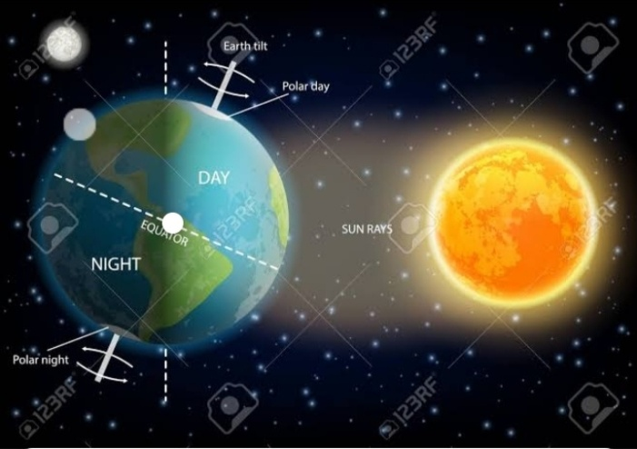

Rotation causes the formation of day and night. As the earth rotates one half of the earth that faces the sun has day while the other half that is away from the sun has night. The length of the day depends on the number of hours that a place on earth faces the sun.

Rotation also affects the direction of winds and ocean current. In the northern hemisphere, wind and current are deflected towards the right (clockwise) and in the southern hemisphere they are deflected to the left anti clockwise.

**Sunrise is earlier in countries lying in the east-** Countries in the east have sunrise earlier than the countries in the west. Japan is the first country to see the sunrise because it is located in the extreme east of the northern hemisphere. Therefore **Japan is called the land of rising sun.**

**Revolution-** Revolution is the movement of the earth around the sun in a fixed path called orbit. The earth complete one revolution in 365 $\frac{1}{4}$ days. Every fourth year is a leap year. The most important effect of revolution is the formation of season.

**Formation of season-**

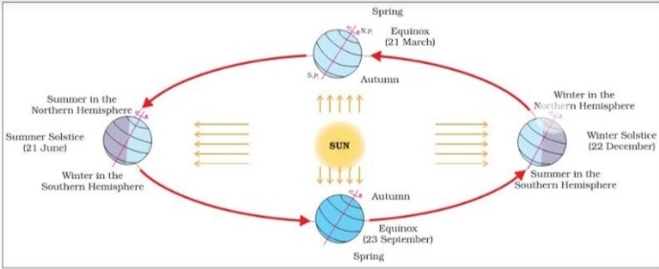

Season are caused due to the combined effect of two factors, such as revolution of the earth in its orbit around the sun and tilting of the earth’s axis at an angle of 66.5° to the plan of its orbit. The part of the earth that leans towards the sun has summer while the part that leans away from the sun has winter. Earth experiences four main seasons- summer, winter autumn and spring. During the revolution there are two important positions of the earth- equinox and solstice.

**Equinox-** The term equinox derived from the Latin word equinoxium which means ‘equal day and night’.

**Autumn equinox-** Neither of the poles is tilted towards the Sun. On September 23rd, the Sun shines directly over the Equator, therefore, the entire Earth experiences equal day and night-time. This position of the Earth is called the autumn equinox. In this position, the northern hemisphere experiences autumn season while the southern hemisphere experiences spring season.

**Spring equinox-** Neither of the poles is tilted towards the Sun. On March 21st, direct rays of the Sun fall on the Equator, therefore, the entire Earth experiences equal day and night-time. This position of the Earth is called the spring equinox.

**Solstice-** The term solstice is derived from another latin word solstitium which means ‘ sun standing still’.

**Summer solstice-** The North Pole is tilted towards the Sun. The Sun shines directly over the Tropic of Cancer, as a result, the northern hemisphere experiences summer. On 21st June, the northern hemisphere has the longest day and the shortest night of the summer season. This position of the Earth is called the summer solstice.

**Winter solstice-** The North Pole is tilted away from the Sun. Tropic of Cancer receives less heat as it is tilted away from the Sun. As a result, the northern hemisphere experiences winter.

On December 22nd, the northern hemisphere has the shortest day and the longest night of the winter season.

**WORKSHEET – 2**

**NOTE: Do the following exercises in your copy**

**Exercise-1 word/meaning**

1. **Movement-** an act of moving
2. **Revolution-**  a single circular movement
3. **Tilt-** bend
4. **Experiences-** skill in particular job or activity
5. **Equinox-** equal day and night
6. **Axis-**  central
7. **Solstice**- sun standing still

**Exercise-2 Short type Ques/Ans**

**Q1. *What is the effect of rotation?***

Ans. The rotation of the earth causes day and night and affect the direction of winds.

**Q2. *How many season does the earth experiences in a year?***

Ans. There are four season that the earth experiences in a year summer, winter, spring, autumn.

**Q3. *What is leap year?***

Ans. After every four year ¼ day is added. It is one extra day to the month of February. This year is known as leap year.

**Q4. *Why are autumn and spring called equinox?***

Ans. Autumn and spring are called equinox because this is when the sun shines vertically over the equator and day and night are equal throughout the world.

**Exercise-3 long type Ques/Ans**

**Q1. *Write the special features of winter and summer solstice.***

Ans. Special features of winter solstice are-

1. The North Pole is tilted away from the sun.
2. Tropic of cancer receives less heat as it is tilted away from the sun.
3. On December 22nd , the northern hemisphere has the shortest day and longest night of the winter season

Special features of summer solstice are-

1. The North pole is tilted towards the sun.
2. The sun shines directly over the tropic of cancer.
3. On 21st June the northern hemisphere has the longest day and the shortest night of the summer season.

**Exercise-4 Fill in the blanks-**

1. The path of the earth around the sun is called orbit.
2. 365 $\frac{1}{4}$ makes one earth year.
3. Countries lying in the east has sunrise earlier.
4. When the sun shines vertically over the tropic of cancer, it is summer.

**Exercise-5 Give one word answer**

1. The Earth rotates on its- axis
2. The Earth’s path around the sun is called- orbit
3. A term for ‘days and nights are equal’- equinox
4. A term for ‘Sun Standing Still’-solstice

**Exercise-6 Write true/false**

1. The earth is tilted at an angle of 66.5° to the plane of its orbit. ( True)
2. Rotation causes seasons. (False)
3. Japan is called the ‘Land of Rising Sun’. (True)
4. A leap year has 365 $\frac{1}{4}$ days. (False)

**Exercise-7 Tick the correct answer**

1. The earth completes one rotation on its axis in

(a) 12 hours (b) 24 hours [√] (c) 36 hours

1. The axis of the earth is always

(a) straight (b) tilted [√] (c) both of these

1. Day and night-time are equal throughout the world on
2. 21st March [√] (b) 21st June (c) 23rd December
3. Days are longer than the nights during
4. autumn equinox (b) summer solstice [√] (c) winter solstice

**Exercise-8 Match the following**

1. Earth’s tilt (a) 66.5°
2. Leap year (b) February has 29 days
3. 21st March and 23rd September (c) equinox
4. 21st June and 22nd December (d) solstice

**Draw and colour the diagram of Revolution and formation of seasons**