25/05/2020 **JESUS AND MARY SCHOOL AND COLLEGE**  Module-2

**CLASS-6 (BIOLOGY)**

**CHAPTER NAME-THE FLOWER**

TOPICS: Structure and Parts of a Flower, Types of Flowers and Functions of a Flower.

**STRUCTURE OF A FLOWER**

A flower is a most attractive part of plant. It develops from the floral bud. Flowers are the reproductive organs of flowering plants and contain male and female structures. Most flowers contain both male and female structures are called ***monoecious***, but some may only contain one structure either male or female are called as ***dioecious****.*

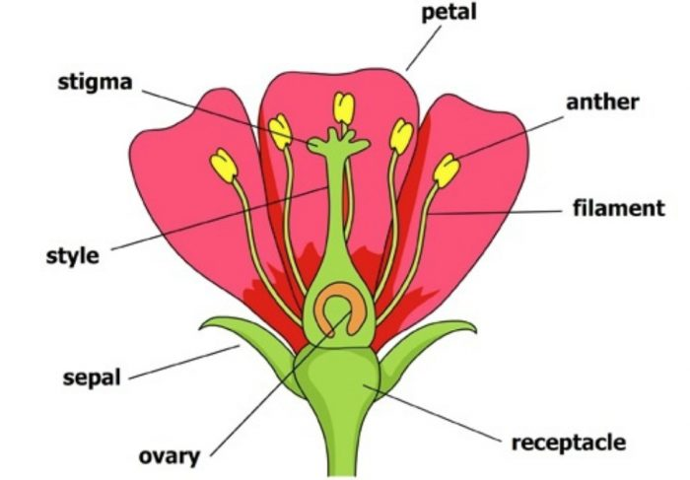

*Figure (a): Structure of a flower*

**PARTS OF A FLOWER**

Flowers have four main parts, namely

1. Calyx
2. Corolla
3. Androecium
4. Gynoecium
5. **Calyx**: It is the outermost part of flower. It is tiny leaf like structures, called ***sepals***. They

protect the inner parts of flower.

1. **Corolla**: Corolla is the second part of flower. It is called as ***petals***. The petals are large and

they are brightly coloured to attract insects for pollination.

1. **Androecium**: An androecium is the third part of most flowers. It is made up of male

reproductive units called ***stamens.***

Each stamen has two parts:

* It has a long thread like structure called a ***filament.***
* The part of a stamen that contains the pollen grains, called ***anthers.***

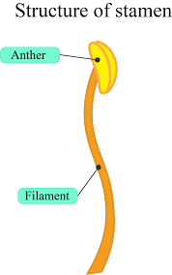

*Figure (b): Structure of a Stamen.*

1. **Gynoecium**: It is the fourth and innermost part of flower. It is composed of single flask-

shaped structure, called pistil or carpel. It is the female reproductive part. A

pistil has three parts: ovary, style and stigma.

**Ovary**: Ovary has ovules. The ovules contain female gametes called eggs or ova.

**Style**: It is the long, thread like, middle part of pistil.

**Stigma**: The stigma is on top of the style. The stigma can be either hairy or sticky, or both to trap

pollen.

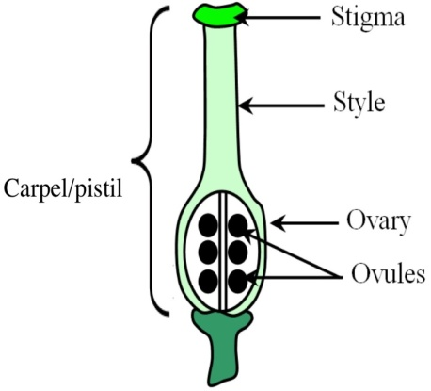

*Figure (c): Structure of a Carpel\Pistil.*

**TYPES OF FLOWERS**

Flowers can be divided into two ways:

1. Based on the presence of male and female reproductive parts, i.e. bisexual or unisexual.

**Bisexual Flowers**: They have both male and female reproductive organs, i.e. stamens and

pistil. These are also called hermaphrodite flowers. Examples: rose and

pea etc.

**Unisexual Flowers**: They have either male reproductive part or female reproductive part.

Examples: cucumber and pumpkin etc.

1. Based on the presence of floral parts, there may be complete or incomplete flowers:

**Complete Flowers**: It has all the four parts, i.e. sepals, petals, androecium and gynoecium.

Examples: mustard and pea etc.

**Incomplete Flowers**: It has one or more parts missing in them. Examples: pumpkin and

papaya etc.

**FUNCTIONS OF A FLOWER**

**Reproduction**: Flowers are reproductive parts of plant. They produce male and female gametes

(eggs).

**Ornamental Value**: It is used for decorations.

**Source of Food**: The ovary of flower develops into fruit and its ovules form seeds. The seeds grow

into new plants.

**Religious Significance**: It is used for worships.

**WORKSHEET-2**

**[A]. Short answers question:**

1. Differentiate between: Monoecious and Dioecious.

2. Name the four parts of a flower.

3. Define corolla.

4. Explain stamen parts.

5. Differentiate between: Androecium and Gynoecium.

6. Define calyx.

7. How many parts of gynoecium are there? Explain it.

8. Explain bisexual flowers.

9. Differentiate between: Complete flowers and Incomplete flowers.

10. Give functions of a flower.

**[B]. Fill in the blanks:**

1. A …………….. is a most attractive part of plant.

2. Most flowers possess both male and female structure is called ………………

3. The part of a stamen that contains the pollen grains, called ………………..

4. The stigma can be either hairy or sticky, or both to trap ……………….

5. ……………… is the outermost part of flower.

**[C]. Write T for true and F for false statement.**

1. Some flowers contain either male or female structures are called monoecious.

2. Calyx is the outermost part of a flower.

3. Stamens have long thread like structure called anthers.

4. A pistil has three parts: ovary, style and stigma.

5. Unisexual flowers have either male reproductive part or female reproductive part.

**Note: Please do all this work in your copies which will be checked when school re-opens.**

**Please consider this important.**

**SOLUTION TO WORKHEET-1**

**(uploaded on 11/05/2020 )**

**[A]. Short answers question.**

1. Leaf is flat, broad and thin part of a plant.

2. The arrangement of veins and veinlets is called venation.

3. Blade or lamina is the wide flat portion of the leaf.

4. Because they perform two main function of photosynthesis and transpiration.

5. A simple leaf is a single leaf that is never divided into smaller leaflet units while Compound leaf is

composed of a number of leaflets on a common stalk.

6. Venation is mainly of two types:

Reticulate venation: Veins get divided and re-divided to form a network. Such type of venation is

called reticulate venation. Example: banyan etc.

Parallel venation: Veins run parallel to each other from the base to the top of the lamina. This type of

arrangement of veins is called parallel venation. Example: wheat etc.

7. The two main functions of leaves are:

* Leaves are called the food factory of a plant. Leaves manufacture food for the plant in the presence

of sunlight and chlorophyll with the help of carbon dioxide and water. This process is called

photosynthesis.

* Leaves have tiny pores on their lower surface called stomata. Stomata help in the exchange of

gases during photosynthesis and respiration.

8. The leaf blade has tiny pores, called stomata.

9. The three types of arrangement of leaves on the stem are:

a) Alternate arrangement of leaves.

b) Opposite arrangement of leaves.

c) Whorled arrangement of leaves.

10. An opposite leaf arrangement, two leaves arise from the stem at the same level (at the same

node), on the opposite sides of the stem. Example: guava, tulsi etc.

**[B]. Fill in the blanks:**

1. Photosynthesis

2. Blade or lamina

3. Stomata

4. Spines

5. Veins and veinlets

**[C]. Write T for true and F for false statement:**

1. True

2. False

3. True

4. True

5. False

**\*\*\*\*\*\*\*\*\*\*\*\*\*\*\*\*\*\*\*\*\***