**25th May, 2020 JESUS AND MARY SCHOOL AND COLLEGE MODULE 2**

**CLASS 6**

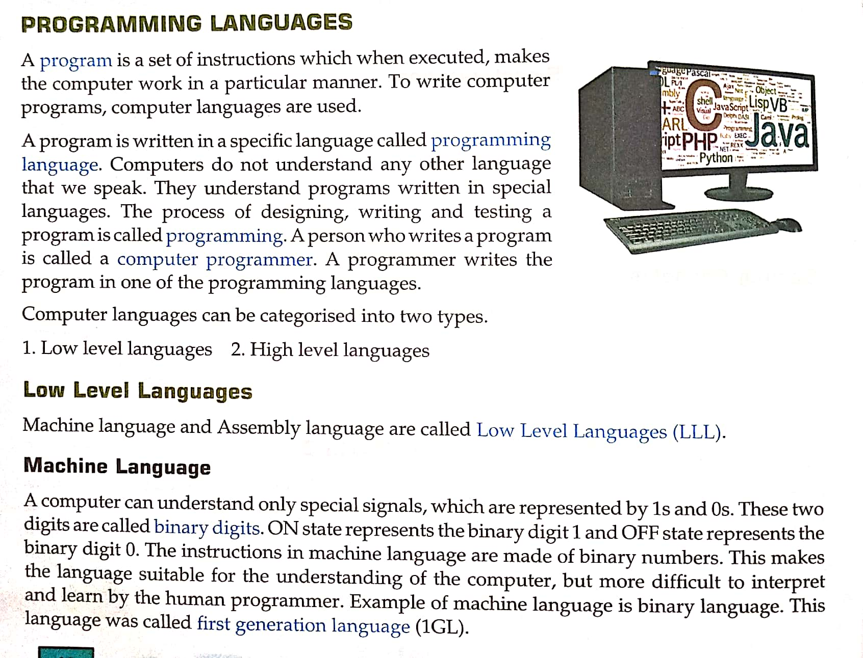**COMPUTER SCIENCE**

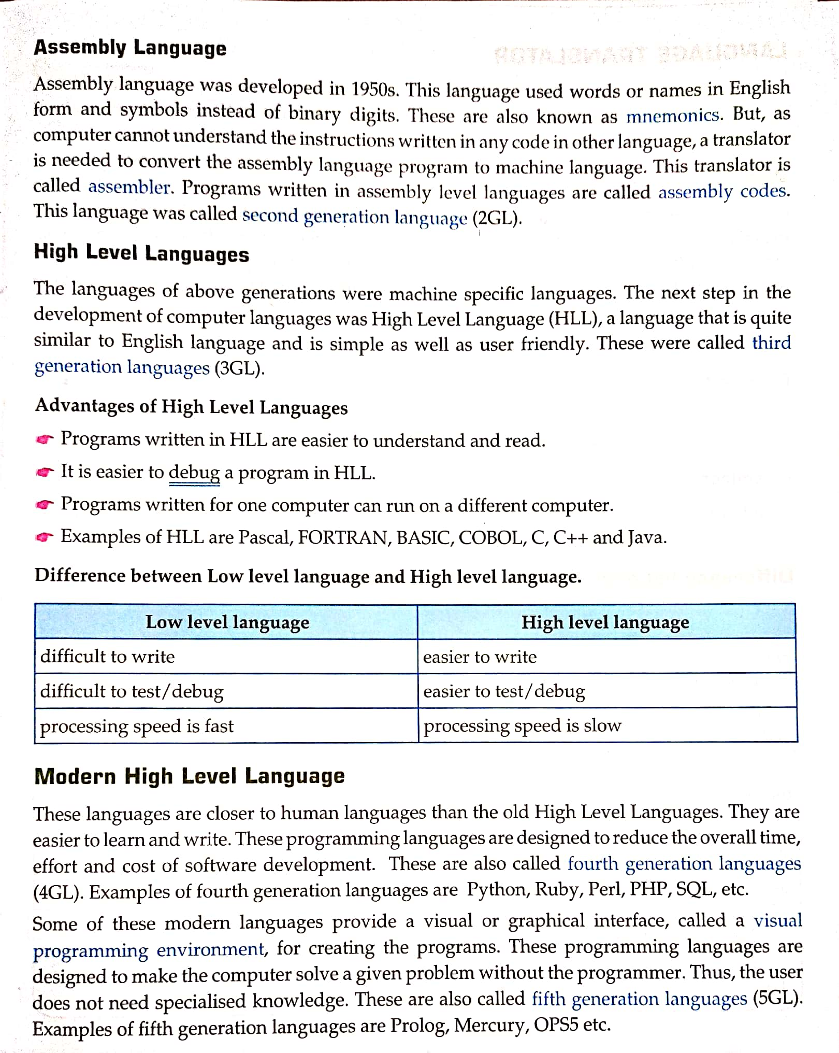

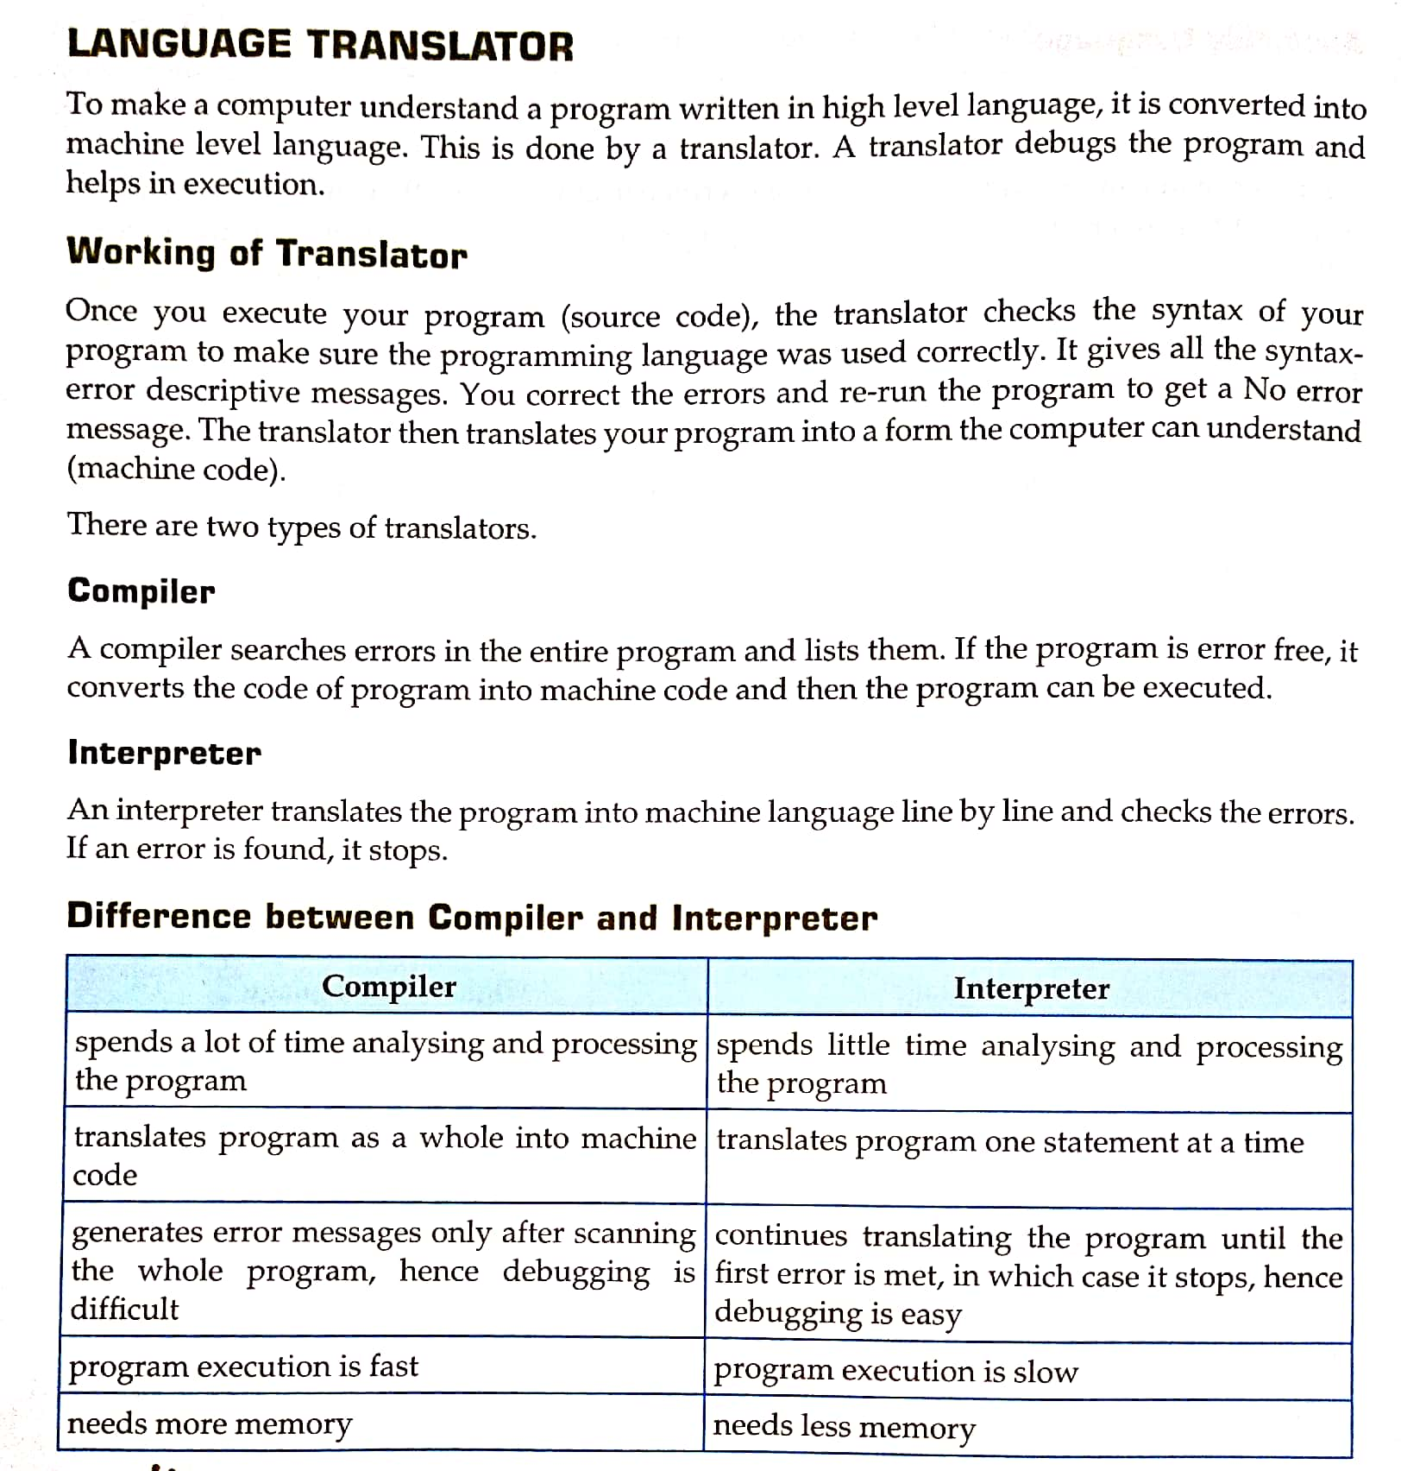**EXPLANATION**

**Programming languages**

* Programming language is a language specially developed to be used for writing computer programs.
* Programming languages are of two types -
* Low level language
* High level language

**Machine language**

* There is only one language that is understood by the computer.
* It is called machine language.
* This language is written in terms of ones and zeros.
* It is very difficult for a person to write programs in machine language.

**Assembly language**

* In assembly language instead of numbers and letters special symbols are used.
* The languages which substitute letters and symbols for the numbers used in the machine program is known as assembly language.
* Symbolic language is another name for assembly language.
* The advantages of assembly languages are
* It is easy to understand and use.
* Easy to locate error and correct them.
* Easy to modify the program.

**High level language**

* High level languages are easy to read and write.
* High level language is translated into the machine code by a compiler or interpreter.
* Some popular high level languages are basic, COBOL, FORTRAN, Pascal, logo and Java.

**Language translator**

* A translator debugs the program and helps in execution.
* To translate the program of high level language to low level language, three processes involve in it. These are:
* Assembler ● Interpreter ● Compiler

**Assembler**

* The program converted from low level language to machine code is called assembler.

**Interpreter**

* The program written in high level language to machine language but it converts programs line by line called interpreter. It is very slow process.

**Compiler**

* The program of high level languages translated into machine code is called compiler. It converts the whole program at a time.

**WORKSHEET 2**

* **Question Answer**

1. What do you understand by computer languages?
2. Name the different categories of computer languages.
3. What is the use of language translators?
4. What are the advantages of high level languages?
5. What is the difference between high level and low level languages?

* **Fill in the blanks.**

1. The process of designing, writing, and testing a program is called …………….. .
2. Machine language and Assembly language are called …………. level languages.
3. A high level language is translated into machine level language by a program called …………….. .
4. An ………………… translates the program into machine language line by line and check the errors.
5. A …….……. searches all the errors of the entire program and then translates it into machine language.

* **True false.**

1. Computers cannot understand the user’s language.
2. Machine language programs are difficult to write.
3. High level language program is directly understood by the computer.
4. Assembler is used to convert high level language program to machine code.
5. Interpreter converts HLL program, line by line into machine code.

**Given below are the answer to Module 1 uploaded on 11/05/2020.**

* **Question Answer**

**Q1.** Name some places where super computers are used.

**Ans.** Super computers are used in forecasting weather, controlling satellites designing aircrafts, studying earthquakes etc.

**Q2.** Name the three types of microcomputers.

**Ans.** The three types of microcomputers are desktops, laptops and tablets.

**Q3.** Where are mainframe computers used?

**Ans.** Mainframe computers are used by large organization where large amount of data needs to stored, such as bank, railway stations etc.

**Q4.** What are handheld devices?

**Ans.** A handheld device is a computer that is held in a hand and can conveniently be stored in a pocket.

**Q5.** Write a short note on embedded computer.

**Ans.** An embedded computer is a small computer fixed inside a machine. It is a computer with specific instructions and requirements used as part of a larger system.

* **Fill in the blanks.**

1. **Super computers** are used for weather forecasting.
2. FORTRAN is an example of **fifth** generation language.
3. IBM-PC is an example for **Micro** computer.
4. PARAM Yuva is a **Super** computer.
5. A **handheld** computer is a computer that is held in a hand and can conveniently be stored in a pocket.

* **True and False.**

1. Computers are four types depending on their memory and size. ( T )
2. Main frame computers have many terminals it can be used by several users.( T )
3. Mini computer is the fastest type of computers. ( F )
4. The main memory of a Super computers is at least 256 megabytes. ( T )
5. An embedded computer is a small computers fixed inside a machine. ( T )

**Note- Please do all this work in your “Copies” / “Notebooks” which will be checked**

**when school reopens. Please consider this important.**

**\*\*\*\*\*\*\*\*\*\*\*\*\*\*\*\*\*\*\*\*\*\*\*\*\*\*\*\*\*\*\*\*\*\*\*\*\*\*\*\*\*\*\***