**25May, 2020 JESUS AND MARY SCHOOL AND COLLEGE MODULE 2**

**SUBJECT - COMPUTER**

**CLASS – 9**

**CHAPTER – INTRODUCTION TO JAVA**

**Note: -** In this chapter, we will learn about basic features of java, types of java programs, basic structure in java programming, java programming with BlueJ, Execution of java program, Modification in java program etc.

**JAVA INTRODUCTION**

Java is an object oriented programming language developed by James Gosling and his colleagues at Sun Micro Systems. The language was initially called Oak.

BASIC FEATURES OF JAVA

* Java programs are both compiled and interpreted.
* It can access data from a local system as well as from net.
* Java programming is written within a class.
* Java doesn’t require any preprocessor (#) or inclusion of header files for creating a Java application program.
* Java is case sensitive. The upper case and lower case letters are distinguished by the language.

**COMPILER AND INTERPRETER**

Software that accepts the whole program in high level language and converts into machine level language is known as **compiler**.

The software which converts the high level instructions line by line into machine level language is known as an **interpreter**.

“Java compiler is a software that converts source code into intermediate binary form called byte code. Further, Java interpreter accept byte code and converts it into machine code suitable to the specific platform.”

OS/2

Java Source code Compiler Byte Code Interpreter UNIX

Windows

**JAVA VIRTUAL MACHINE**

The byte code is the general binary form of the Java source code. This binary form needs to be modulated according to the machine on which it is to be executed (UNIX, Windows, OS/2). Here Java Interpreter plays an important role acting as a machine to produce object code compatible to the specific machine. Although it is a software, Java Interpreter is still referred as the Java Virtual Machine.

**JAVA LIBRARIES IN JDK 1.3**

* Java libraries have many packages.
* Java package is a collection of various classes.
* Each class contains different functions.
* A package can be included in the program by using a keyword ‘import’ (**import java.io.*;**) etc.

**Some packages of Java Development Kit (JDK) are listed below:**

**java.lang** To support classes containing String/character, Math, Integer, Thread, etc.

**java.io** To support classes to deal with input & out put statement.

**java.applet** To support classes to generate applet – specific environment.

**java.txt** For localising text elements such as dates, times and currency, etc.

­­

**Note:**‘Java.lang’ is the default package of the java programming (JDK), i.e. it will automatically be imported in any java program to avail its classes and functions.

**JAVA RESERVED WORDS OR KEYWORDS**

These words are basically used for writing a java statement in the program. Such words cannot be used for naming a variable in the program. Some of reserved words are (case, do, try, catch, for, long) etc.

**TYPES OF JAVA PROGRAMMING**

**[[**

There are two types of java programming.

* **Java Application**

**Java application programming** interface (API) is a list of all classes that are part of the **Java** development kit (JDK). It includes all **Java** packages, classes, and interfaces, along with their methods, fields, and constructors. These prewritten classes provide a tremendous amount of functionality to a programmer.

* **Java Applet**

Applet Programs are small **java** programs developed for internet applications. Applets are embedded in HTML documents. Applet programs can be run using the applet viewer or web browser.

**Basic Structure in Java Programming**

* *Comments in a program.*
* *Declaration of class.*
* *Declaration of main function.*
* *Output statement in java programming.*

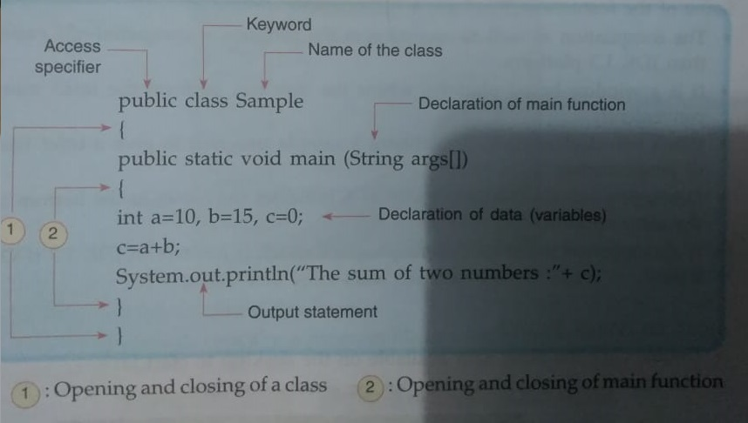

**Note:**

1. Class name must not be a java reserved word.

2. In output statement when a message is to be displayed along with a variable, they are separated with ‘+’ sign.

**JAVA PROGRAMMING WITH BLUEJ**

* BlueJ is a free java environment. It is a window based platform for Java Development Kit (JDK).
* JDK 1.3 or higher version needs to be installed before installing BlueJ. (for JDK visit www.oracle.com ).
* BlueJ can be downloaded from the website [www.bluej.org](http://www.bluej.org) free of cost.

**EXECUTION OF JAVA PROGRAM**

When a class is compiled and shows a message ‘no syntax error’, it means the program is error-free and ready to execution.

**MODIFICATION IN JAVA PROGRAM**

If you want to edit your program, double click the class icon. Program appears on the screen. Edit your program and recompile. If no syntax error it means your program is modified. Close class window and proceed for execution.

**WORKSHEET 2**

**A. Fill in the blank.**

1. Java is a __________ sensitive language.
2. In Java, the package used to find power raised to any base is _______________ .
3. The words which are preserved with the system are called _______________ words, that cannot be used as variable names in java programming.
4. A single line comment is represented by the symbol ______________ in Java programming.
5. BlueJ is a ___________ based platform to operate Java program..

**B. Write T for true or F for false.**

1. Java application is a Java program which is developed by users.. ( )
2. James Gosling developed Java programming language.( )
3. Machine codes are expressed using alphanumeric characters. ( )
4. Byte code is the program in binary form. ( )
5. JVM is a Java Visual Management. ( )

**C. Short answers question.**

1. Name two types of Java programs.
2. Who developed Java? What was it initially called?
3. What is Java Virtual Machine?
4. What is BlueJ?
5. Name three packages of Java Class Library.
6. Name a package that is invoked by default.

**Note:- Please do this work in yourcopies which will be checked when the school reopens . Please consider this important.**

Solutions to worksheet 1 uploaded on 11 may, 2020

**A.Objective Type Question:**

1.Program 2. Object Oriented Programming

3. Procedure Oriented Programming 4.Polymorphism

5.Class

**B.True or False:**

1. **False 2.True 3.True 4.False 5.False**

**C.Fill in the blanks:**

1. Characteristic, behaviour. 2.Inheritance

3. Many, forms 4.Encapsulation

5. Abstraction

**D. Program 1:**

import java.util.Scanner;  
class Multiplication  
{  
public static void main(String args[])  
{

Scanner sc = new Scanner(System.in);   
int p, q, r;  
System.out.println("Enter two integers for multiplication: ");  
p = sc.nextInt();   
q = sc.nextInt();  
r = p * q;  
System.out.println("Multiplication of the integers = "+r);  
}  
}

**Program2:**

import java.util.*;

 class CompundInterest

{

public static void main(String args[])

{

Scanner sc=new Scanner(System.in);

double amount=0,principle,rate,time,ci,t=1;

  System.out.println("enter principle ");

principle=sc.nextDouble();

System.out.println("enter rate");

  rate=sc.nextDouble();

System.out.println("enter time");

time=sc.nextDouble();

rate=(1+rate/100);

            for(int i=0;i<time;i++)

          t*=rate;

amount=principle*t;

  System.out.println("amount="+amount);

  ci=amount-principle;

  System.out.println("compound intrest="+ci);

  }

}

**************************************************************************