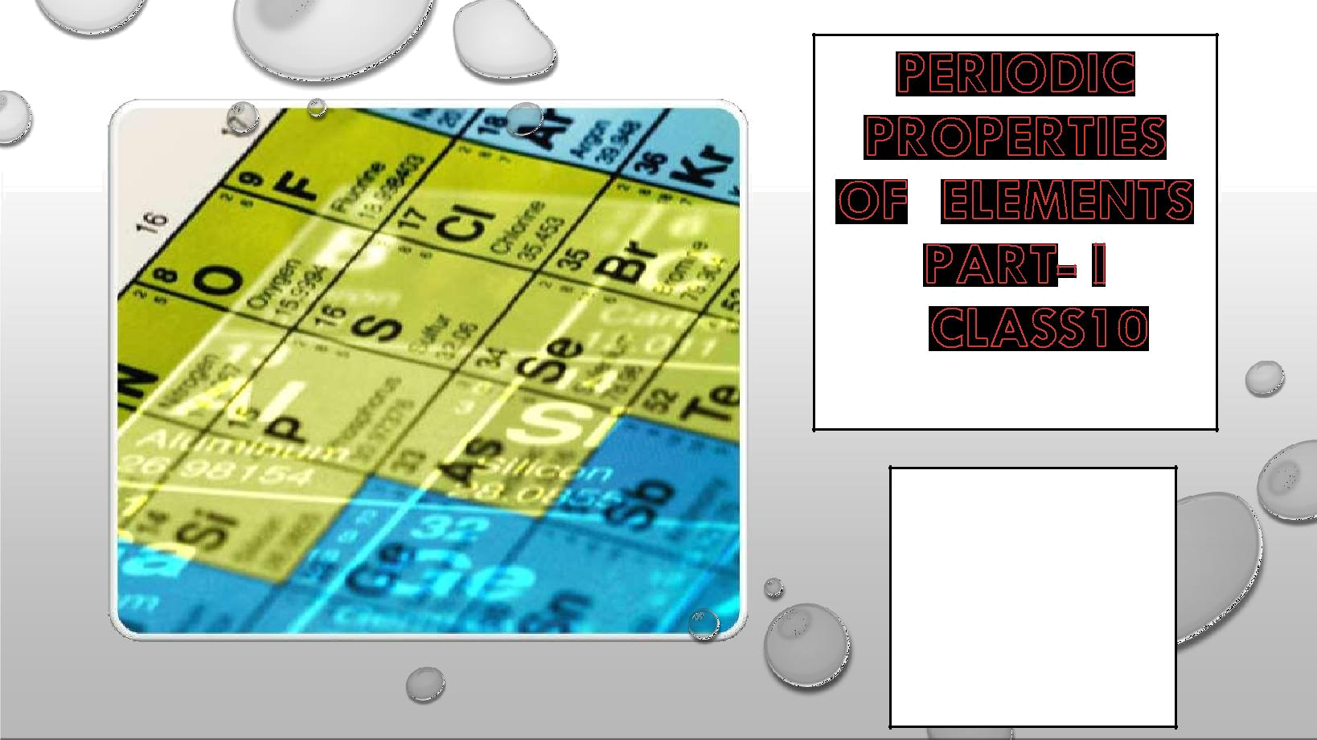

Chemistry by Dr. Satyendra S.

Jesus and Mary

College, Blp.

PREPARED BY

Dr. Satyendra

Singh
PERIODIC TABLE AND CONCEPT MAP

•THE PERIODIC TABLE IS A TABULAR ARRANGEMENT OF THE CHEMICAL ELEMENTS, ORDERED BY THEIR ATOMIC NUMBER, ELECTRONIC CONFIGURATIONS AND RECURRING CHEMICAL PROPERTIES.
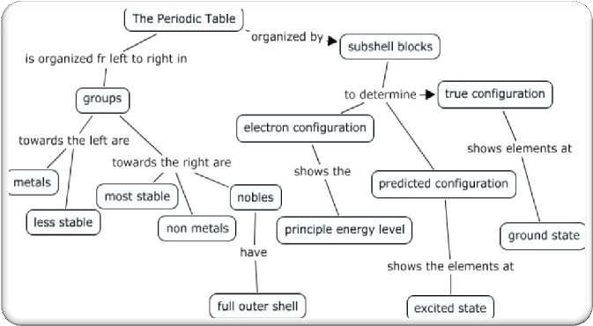
•THIS ORDERING SHOWS PERIODIC TRENDS, SUCH AS ELEMENTS WITH SIMILAR BEHAVIOUR IN THE SAME COLUMN. IT ALSO SHOWS FOUR RECTANGULAR BLOCKS WITH SOME APPROXIMATELY SIMILAR CHEMICAL PROPERTIES. IN GENERAL, WITHIN ONE ROW (PERIOD) THE ELEMENTS ARE METALS ON THE LEFT, AND NON-METALS ON THE RIGHT.

Chemistry by Dr. Satyendra S.

WHY DO WE NEED TO CLASSIFY ELEMENTS

- IN 1800, ONLY 31 ELEMENTS WERE KNOWN. BY 1865, THE NUMBER OF IDENTIFIED ELEMENTS HAD MORE THAN DOUBLED TO 63.

- THERE ARE TOTAL OF 118 ELEMENT6 KNOWN SO FAR AND THE DISCOVERY OF NEW ELEMENTS STILL CONTINUES. EVERY ELEMENT HAS ITS OWN IMPORTANCE, SOME OF THEM ARE USEFUL WHILE OTHERS MAY BE HARMFUL. THE HARMFUL ELEMENTS MAY ALSO BE USEFUL IN OTHER WAY, LIKE RADIOACTIVE ELEMENTS.

- IT IS NECESSARY TO STUDY THE CHEMICAL AND PHYSICAL PROPERTIES OF EACH OF THE ELEMENTS PRESENT AROUND US BECAUSE EVERY ELEMENT IS RELATED TO OUR LIFE IN SOME OR OTHER WAY. WITH SUCH A LARGE NUMBER OF ELEMENTS IT IS VERY DIFFICULT TO STUDY INDIVIDUALLY THE CHEMISTRY OF ALL THESE ELEMENTS AND THEIR INNUMERABLE COMPOUNDS INDIVIDUALLY. TO EASE OUT THIS PROBLEM, SCIENTISTS SEARCHED FOR A SYSTEMATIC WAY TO ORGANISE THEIR KNOWLEDGE BY CLASSIFYING THE ELEMENTS. NOT ONLY THAT IT WOULD RATIONALIZE KNOWN CHEMICAL FACTS ABOUT ELEMENTS, BUT EVEN PREDICT NEW ONES FOR UNDERTAKING FURTHER STUDY.

- PERIODIC TABLE IS THE TOOL WHICH IS USED TO CLASSIFY THE KNOWN ELEMENTS IN GROUPS.

- IT HELPS US TO UNDERTAKE A SYSTEMATIC STUDY OF THE VARIOUS ELEMENTS FOUND IN NATURE WITHOUT WHICH IT WOULD HAVE BEEN IMPOSSIBLE FOR US TO STUDY ALL THE ELEMENTS IN THE TABLE. WITH THE HELP OF PERIODIC TABLE A COMPARATIVE STUDY OF THE ELEMENTS AND THEIR COMPOUNDS CAN BE DONE.

• PERIODIC TABLE ALSO HELPS US TO ANALYSE THE PERIODIC TREND IN VARIOUS PROPERTIES SUCH AS IONISATION POTENTIAL, ELECTRON AFFINITY, ELECTRONEGATIVITY ETC.

Chemistry by Dr. Satyendra S.

DOBEREINER’SLAWOFTRAIDS - 1817

•DOBEREINER WAS THE FIRST SCIENTIST TO CLASSIFY THE ELEMENTS IN SOME GROUPS.

•HE TRIED TO CLASSIFY THE ELEMENTS WITH SIMILAR PROPERTIES IN GROUPS OF THREE ELEMENTS (TRIADS). HE COULD SUCCEED IN MAKING ONLY A FEW TRIADS.

•IN THE TRIADS OF ELEMENTS THE ATOMIC WEIGHT OF THE MIDDLE ELEMENT WILL BE THE ARITHMETIC MEAN OF THE ATOMIC WEIGHTS OF THE OTHER TWO.
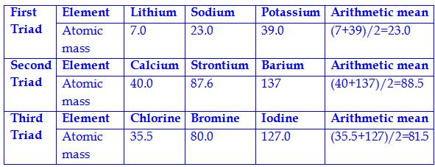

Dobereiner could arrange only a fewelements as triads and there are some such elements present in a triad,whose atomicweights are approximatelyequal, e.g.

Fe Co Ni

Ru Rh Pd

There fore, this hypothesis was not acceptable for all elements.

Chemistry by Dr. Satyendra S.
NEWLANDS LAW OF OCTAVES - 1865

•IN 1865, AN ENGLISH CHEMIST, JOHN NEWLANDS NOTED THAT EVERY EIGHTH ELEMENT SHOWED SIMILAR PHYSICAL AND CHEMICAL PROPERTIES, WHEN THE ELEMENTS ARE PLACED IN

THE INCREASING ORDER OF THEIR ATOMIC MASSES. THIS WAS CALLED AS THELAW NEW OF OCTAVES. THE LAW STATES THAT WHEN ELEMENTS ARE PLACED IN THE INCREASING ORDER

OF THEIR ATOMIC MASSES, THE PROPERTIES OF THE EIGHT ELEMENT WILL REPEAT THE PROPERTY OF FIRST ONE.

•NEWLANDS ARRANGED THE ELEMENTS THEN KNOWN IN THE FOLLOWING MANNER :
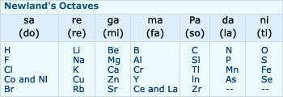

Altough his idea was not widely accepted at that Time, he was later awarded by Davy Medal in 1887 By Royal Society, London.

Chemistry by Dr. Satyendra S.

MENDELEEV’SPERIODICTABLE

- WHILE DOBEREINER INITIATED THE STUDY OF PERIODIC RELATIONSHIP, IT WAS MENDELEEV WHO WAS RESPONSIBLE FOR PUBLISHING THE PERIODIC LAW FOR THE FIRST TIME. IT STATES AS FOLLOWS :

- THE PROPERTIES OF THE ELEMENTS ARE A PERIODIC FUNCTION OF THEIR ATOMIC WEIGHTS.

•MENDELEEV’SPERIODIC LAW (1869) : THE PHYSICAL AND CHEMICAL PROPERTIES OF ELEMENTS ARE A PERIODIC

FUNCTION OF THEIR ATOMIC WEIGHTS.

- IF THE ELEMENTS ARE ARRANGED IN ORDER OF THEIR INCREASING ATOMIC WEIGHTS, AFTER A REGULAR INTERVAL ELEMENTS WITH SIMILAR PROPERTIES ARE REPEATED

•ON THE BASIS OF HIS LAW, MENDELEEF PROPOSED A PERIODIC TABLE FOR CLASSICICATION OF ELEMENTS WHICH IS KNOWN AS MENDELEEV’SPERIODIC TABLE

Chemistry by Dr. Satyendra S.

MENDELEEV’SPERIODICTABLE

•MENDELÉEV'S RESEARCH WAS BASED ON THE 63 ELEMENTS THAT WERE KNOWN AT THAT TIME.

•HE STUDIED THE RELATIONSHIP BETWEEN THE ATOMIC MASSES OF THE ELEMENTS AND THEIR PHYSICAL AND CHEMICAL PROPERTIES.

•HE STUDIED THE FORMATION OF HYDRIDES AND OXIDES OF THE ELEMENTS AND TREATED THIS AS ONE OF THE BASIC PROPERTIES OF AN ELEMENT.

•THE PERIODIC TABLE CONTAINS VERTICAL COLUMNS CALLED ‘GROUPS’ANDHORIZONTAL ROWS CALLED ‘PERIODSHEPLACED ELEMENTS THAT HAD SIMILAR PROPERTIES UNDER VERTICAL COLUMNS, LEAVING BLANK SPACES FOR ELEMENTS NOT YET DISCOVERED.

Chemistry by Dr. Satyendra S.

MENDELEEV’SPERIODICTABLE
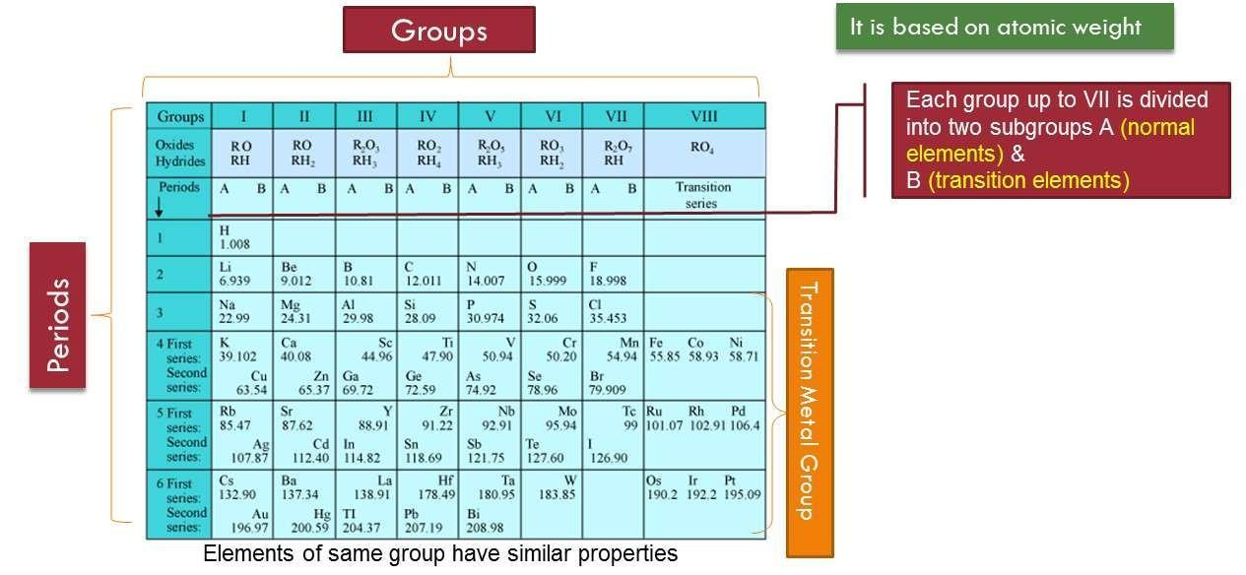

Chemistry by Dr. Satyendra S.

MERITS OR ADVANTAGES OF MENDELEEV’STABLE:PERIO

•STUDY OF ELEMENTS: FIRST TIME ALL KNOWN ELEMENTS WERE CLASSIFIED IN A GROUP ACCORDING TO THEIR SIMILAR PROPERTIES. SO, STUDY OF THE PROPERTIES OF ELEMENTS BECOME EASIER.

•PREDICTING NEW ELEMENTS: IT GAVE ENCOURAGEMENT TO THE DISCOVERY OF NEW ELEMENTS AS SOME GAPS WERE LEFT IN IT. SC, GE, TC WERE THE ELEMENTS FOR WHOM POSITION AND PROPERTIES WERE DEFINED BY MENDELEEV EVEN BEFORE THEIR DISCOVERIES AND HE LEFT THE BLANK SPACES FOR THEM IN HIT TABLE.

BLANK SPACE AT ATOMIC WEIGHT 72 IN SI GROUP WAS CALLED EKA SILICON AND ELEMENT DISCOVERED LATER WAS NAMED GERMANIUM.

- EKA ALUMINIUM: GALLIUM

- EKA BORON: SCANDIUM

- EKA MANGANESE: TECHNETIUM

Chemistry by Dr. Satyendra S.

DEMERITS OF MENDELEEV’S PERIODIC TABLE:

- POSITION OF HYDROGEN: HYDROGEN RESEMBLES BOTH, THE ALKALI METALS (1A) AND HALOGENS(VII A) IN PROPERTIES SO MENDELEEV COULD NOT DECIDE WHERE TO PLACE IT.

- POSITION OF ISOTOPES: AS ATOMIC WEIGHT OF ISOTOPES DIFFER, THEY SHOULD HAVE BEEN PLACED IN DIFFERENT POSITION IN MENDELEEV’SPERIODICTABLE. BUT THERE WERE NO SUCH POSITIONS FOR ISOTOPES IN MENDELEEV’SPERIODICTABLE

•ANOMALOUS PAIRS OF ELEMENTS: THERE WERE SOME PAIR OF ELEMENTS WHICH DID NOT FOLLOW THE INCREASING ORDER OF ATOMIC WEIGHTS. E.G: AR AND CO WERE PLACED BEFORE K AND NI RESPECTIVELY IN THE TABLE BUT HAVING HIGHER ATOMIC WEIGHTS.

- LIKE ELEMENTS WERE PLACED IN DIFFERENT GROUPS: PT AND AG WHICH HAVE SIMILAR PROPERTIES WERE PLACED IN GROUP VIII AND GROUP IB RESPECTIVELY.

- POSITION OF ISOTOPES: AS ATOMIC WEIGHT OF ISOTOPES DIFFER, THEY SHOULD HAVE BEEN PLACED IN DIFFERENT POSITION IN MENDELEEV’SPERIODICTABLE. BUT THERE WERE NO SUCH POSITIONS FOR ISOTOPES IN MENDELEEV’SPERIODICTABLE

•ANOMALOUS PAIRS OF ELEMENTS: THERE WERE SOME PAIR OF ELEMENTS WHICH DID NOT FOLLOW THE INCREASING ORDER OF ATOMIC WEIGHTS. E.G.: AR AND CO WERE PLACED BEFORE K AND NI RESPECTIVELY IN THE TABLE BUT HAVING HIGHER ATOMIC WEIGHTS.

Chemistry by Dr. Satyendra S.

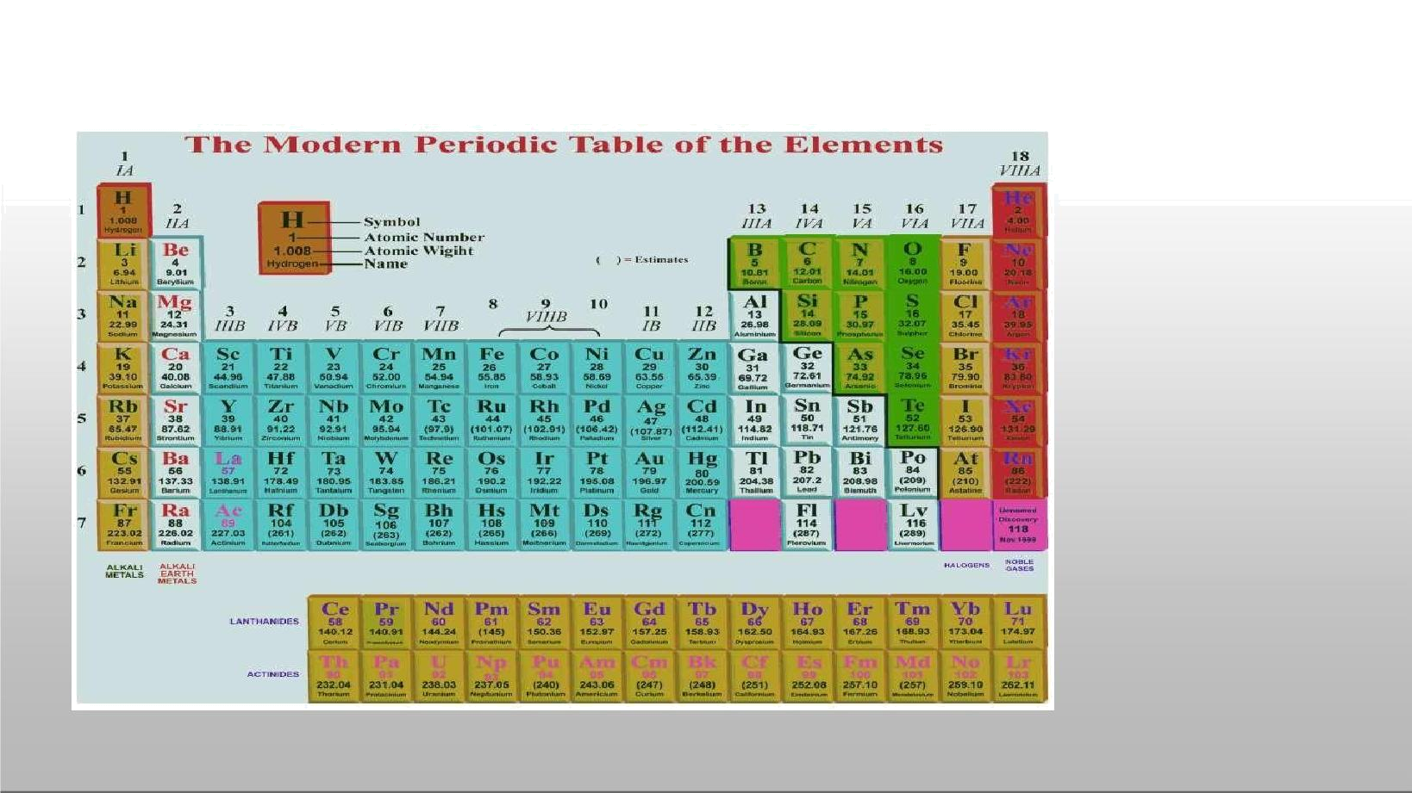

MODERN PERIODIC TABLE

Chemistry by Dr. Satyendra S.

Assignment of I-Worksheet

A. Answer the following questions_
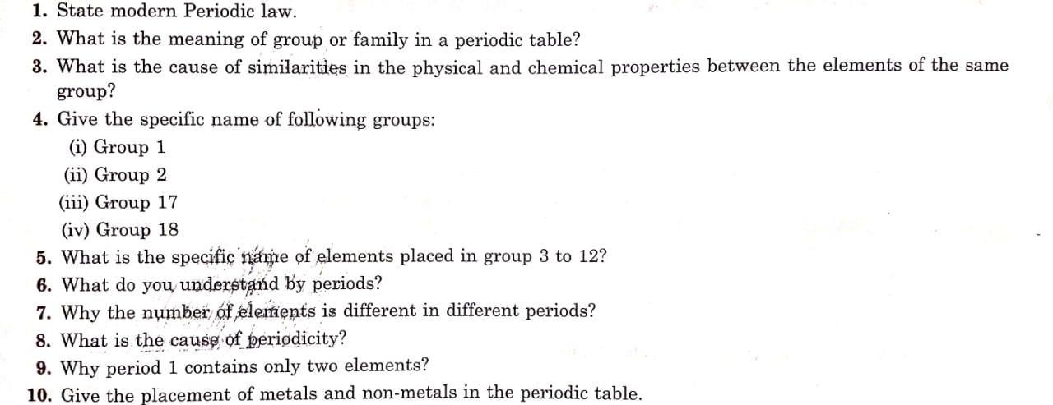

Chemistry by Dr. Satyendra S.

B.Multiple ChoiceQuestions Choiceultiple
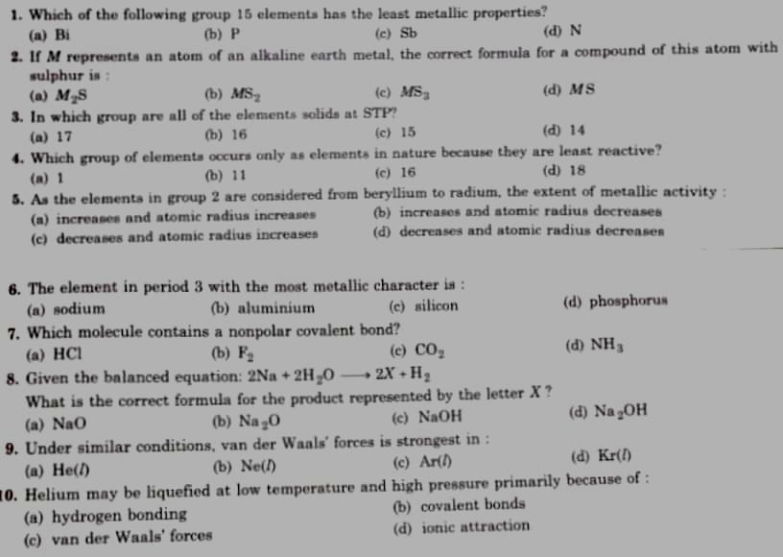

Chemistry by Dr. Satyendra S.

