**JESUS AND MARY SCHOOL AND COLLEGE**

**Class XII**

**CHEMISTRY**

**THE SOLID STATE**

**Solids**

Solids have definite volume, shape, and mass due to the short distance between the fixed position of particles and strong interactions between them.

Characteristics Properties of the Solid State

(i) They have definite mass, volume and shape.

(ii) Intermolecular distances are short.

(iii) Intermolecular forces are strong.

(iv) Their constituent particles (atoms, molecules or ions) have fix4ed positions and can only oscillate about their mean positions.

(v) They are incompressible and rigid.

Amorphous Solids and Crystalline Solids

|  |  |  |
| --- | --- | --- |
| **Sr. No.** | **Amorphous Solids** | **Crystalline Solids** |
| **1.** | Amorphous solids do not have an orderly arrangement of particles and therefore do not possess a definite geometrical shape. | Crystalline solids have definite geometrical shape and orderly arrangement of particles in three dimensional shape. |
| **2.** | They do not have sharp melting points. They first become soft or gradually melt. | Crystalline solids have sharp melting points. |
| **3.** | They do not have crystal symmetry. | They have crystal symmetry. |
| **4.** | Amorphous solids are isotropic *i.e.* they have same values of physical properties such as refractive index, conductivity etc., in all directions. | Crystalline solids are anisotropic *i.e.* they have different values of physical properties such as refractive index, conductivity etc., in all directions. |
| **5.** | When cut with a sharp edged knife amorphous solids break into pieces having irregular edges *e.g.*, charcoal, glass, rubber, etc. | When cut with a sharp edged knife, crystalline solids break into pieces having regular faces, *e.g.*, diamond, NaCl, graphite, Cu crystal, etc. |

Classification of Crystalline Solids

The [classification of crystalline solids](https://byjus.com/chemistry/classification-of-crystalline-solids/) is based on their property. The crystalline property depends on the nature of interactions between the constituent particles, and therefore these solids are divided into four different categories:

* Ionic solids eg.NaCl
* Metallic solids eg. Cu metal
* Covalent or Atomic solids eg. Diamond, graphite
* Molecular solids eg. Ice(polar), Solid CO2(non-polar)

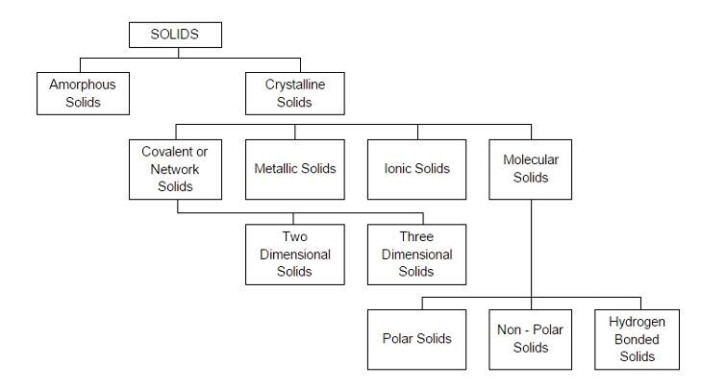

[Crystal Lattices and Unit Cells](https://byjus.com/chemistry/crystal-lattices-and-unit-cells/)

**Unit Cell-**The smallest repeating unit of the crystal lattice is the unit cell, the building block of a crystal.

**Types of Unit Cell**

A lattice can be generated by repeating a small portion called the unit cell. Below are some of the different varieties of the unit cell:

1. Primitive Cubic Unit Cell
2. Body-centered Cubic Unit Cell
3. Face centered cubic unit cell

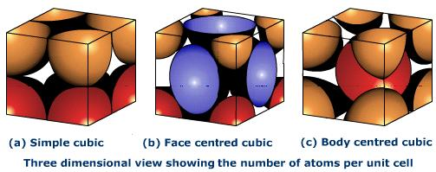

**Crystal Lattices**

A crystal structure is made of atoms. A crystal lattice is made of points. A crystal system is a set of axes. In other words, the structure is an ordered array of atoms, ions or molecules.

Characteristics of Crystal Lattice

(a) Each point in a lattice is called lattice point or lattice site.

(b) Each point in a crystal lattice represents one constituent particle which may be an atom, a molecule (a group of atoms) or an ion.

(c) Lattice points are joined by straight lines to bring out the geometry of the lattice.

**Number of Atoms in a Cubic Unit Cell**

**I.Simple or Primitive Cubic unit Cell (SC)_**

The primitive cubic unit cell has atoms only at its corner. Each atom at a corner is shared between eight adjacent unit cells four unit cells in the same layer and four-unit cells of the upper or lower layer. Therefore, only 1/8th of an atom actually belongs to a particular unit cell.

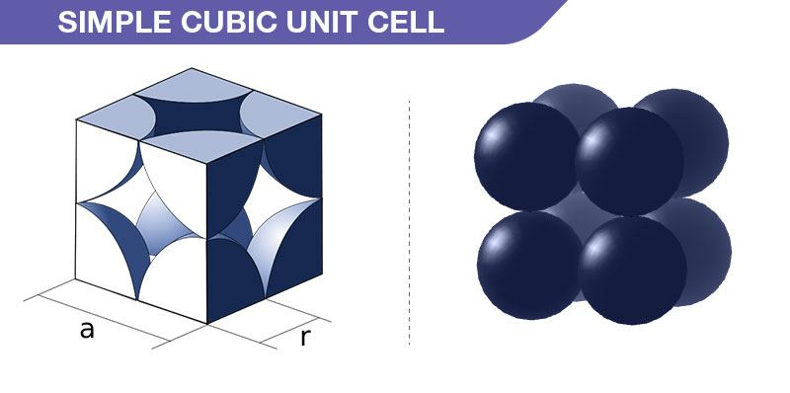

* In a simple cubic system, no. of atoms present in each unit cell

=8 corner atoms * 1/8 atoms per unit cell = **1atom**

**II. Body-Centred Cubic unit Cell (BCC)_**

A body-centred cubic unit cell has an atom at each of its corners and also one atom at its body centre.

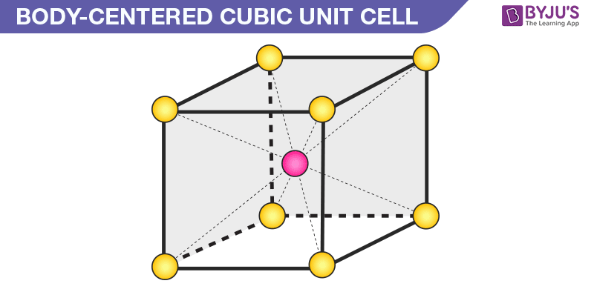

Thus, in a BCC cell, we have:

* Number of atoms present at corners per unit cell=8 corner atoms × 1/8 atom per unit cell = 1 atom
* Number of atoms at body centre = 1 atom

Therefore, the total number of atoms in BCC arrangement=1+1= **2 atoms**

**III. Face-Centred Cubic unit Cell (FCC)_**

A face-centred cubic unit cell contains atoms at all the corners and at the centre of all the faces of the cube. The atom present at the face-centre is shared between 2 adjacent unit cells and only 1/2 of each atom belongs to an individual cell.

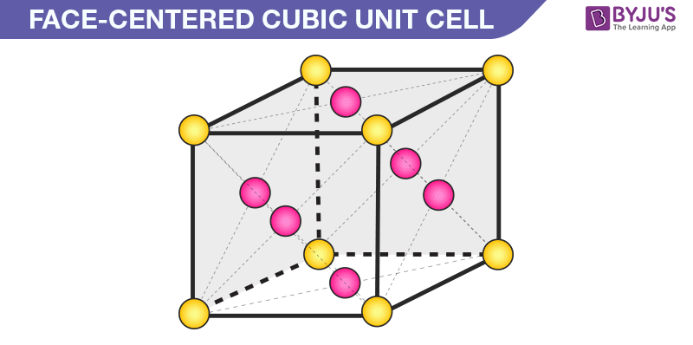

**Fig. Represents the number of Atoms in FCC arrangement**

Thus, in a face-centered cubic unit cell, we have:

* 8 corners × 1/8 per corner atom = 8 × 1/8 = 1 atom
* 6 face-centered atoms × 1/2 atom per unit cell = 3 atoms

Hence the total number of atoms in FCC arrangement =**4 atoms**.

....................................................................................................................................................................

**Worksheet-1**

**I.Short answer type questions_**

1.Ionic solids conduct electricity in molten state but not in solid state,why?

2.Name any one solid in which both Frenkel and Schottky defects are present?

3.How many octahedral sites per sphere are in a cubic close packed(fcc) structure?

4.What is the effect of pressure on NaCl type crystals?

5.How many octahedral voids are there in 1mole of a compound having ccp structure?

6.What is the co-ordination number of an octahedral void?

7.Why is Frenkel defect not found in pure alkali metal halides?

8.Mention two properties which is caused due to presence of F-centre in a solid.

9.Why is potassium chloride violet instead of pure white?

10.What happens when a ferromagnetic substance is subjected to high temperature?

**II. Multiple choice questions:**

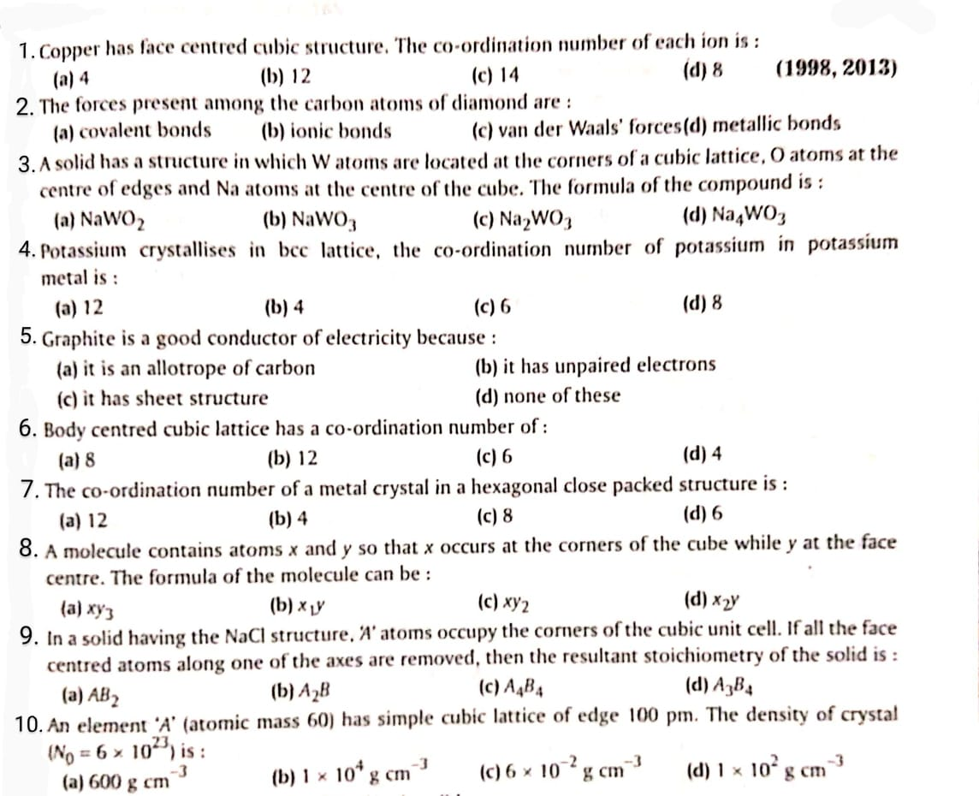

NOTE: All work to be done in your old note books

**\*\*\*\*\*\*\* \*\*\*\***