8TH JUNE 2020 Jesus and Mary school Module no.3

Class.2nd

Moral Education

Chapter - Be punctual.

Summary.

Once there was a cake baking competition held in a jungle .That was a big prize of free trip to Disney land in America . Everyone wanted to go to the Disney land, even hare and tortoise wanted to enter the contest .So everyone were very busy in preparing the cake . The tortoise took a book and choose a delicious recipe of 🍰 cake and bought all the things needed .On the other side the hare spent his time in playing with its friends , suddenly just two days before of contest he thought he had to think of a recipe for a quick and easy 🍰 cake. At last the hare started to bake the cake but it was not fluffy. The hare had forgotten to add sugar in hurry .Now all that the hare can do is to sit and cry .The tortoise won the contest and got the prize .

Moral of the story -Doing work on time always gives us success.

**WORK SHEET – 3**

**NOTE: DO ALL THE EXERCISES IN YOUR COPY.**

Exercise no.1 Tick the correct option.

1................... competition was decided by the animals .

a. cake baking ( ) b. writing ( ) c. cooking ( ) d. none of these ( )

Answer. cake baking

2. The hare spents it's time in ..................... with its friends

a. playing ( ) b. walking ( ) c. running ( ) d. none of these ( )

Answer .playing

3. All animals wanted to go .........................land .

a. fairy ( ) b. dirty ( ) c. Disney ( ) d. none of these ( )

Answer. Disney

4.The hare had forgotten to add ................. in hurry .

a. salt ( ) b. sugar ( ) c. flour ( ) d. 🍰 Cake ( )

Answer .sugar .

5......................... Won the Frist prize for its cake .

a. Tortoise ( ) b.fox ( ) c. hare ( ) d.owl ( ).

Answer. Tortoise.

Exercise no.2 Write true or false statements.

1.The hare won the prize. (False)

2.It was a cake baking competition.(True )

3.The tortoise postponed it's work and could not bake the 🍰 cake .(False)

4.punctuality gives us success. (True)

Exercise no.3.Question and Answer.

Ques1.Which competition decided by the animals ?

Ans1.The 🍰 cake baking competition decided by the animals.

Ques2.Who prepared the 🍰 cake on time ?

Ans2.The tortoise prepared the 🍰 Cake on time.

Ques3.Who won the first prize ?

Ans3.The tortoise won the first prize .

Ques4.When did the tortoise send its cake for the competition?

Ans4.The tortoise send its cake for the competion much more before.

Exercise no.4 Fill in the blanks .

1.Animals decided to have a cake baking competition.

2. Everyone wanted to go to the Disney land.

3.The tortoise 's 🍰 cake won the first prize.

4.Do not postpone your work .

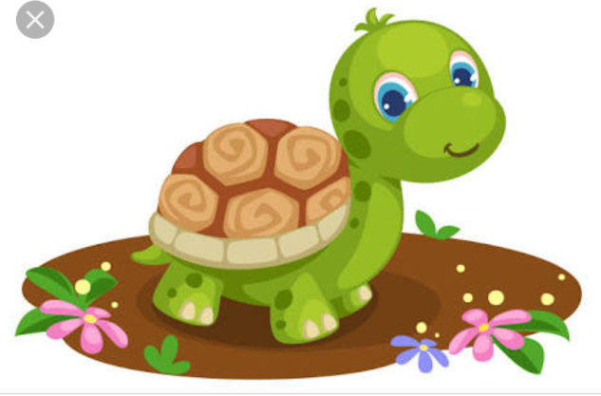

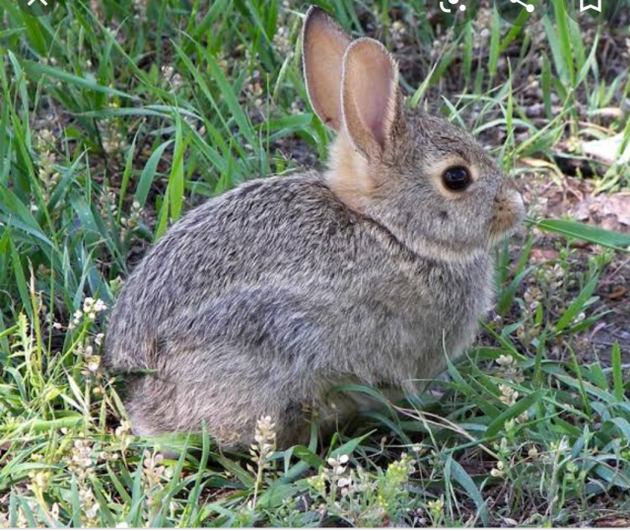

**Picture of tortoise and hare. (Upper one is tortoise and down one is hare.)**