8TH JUNE 2020 Jesus and Mary school MODULE - 3

Class .3

Social studies

Weather , climate and seasons .

Summary .

Weather -Weather is the day to day changes in the atmosphere of any place .Weather is related to changes which happen for a short time .Weather can change everyday .It can change a lot even during the same day . Weather is not same everywhere.

Climate - Climate is a certain type of weather over a large area of anywhere.

Seasons - When the weather remains more less or down the same for a few month in a year ,it is called a season .Seasons are hot or cold ,wet or dry conditions of different places during certain months .Seasons affect our life _the type of 🏠 houses we live in ,the clothes we wear and the food we eat .

Formation of Different Seasons - The earth has two movements - rotation and revolution. Rotation causes day and 🌃 night and revolution causes seasons .During revolution, the Earth travels around the ⛅ sun once every year.

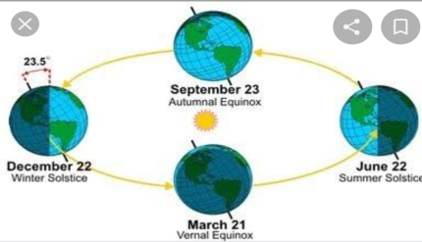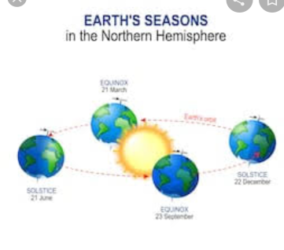

**Revolution Rotation**

Seasons in India - In India there are five seasons _summer, winter, autumn , monsoon, spring,

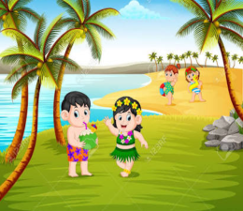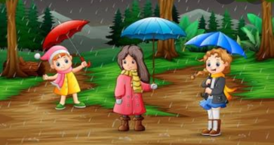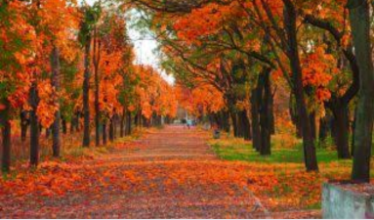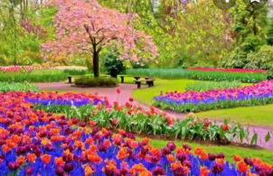

All the seasons are showing there.

Explanation .

1).Weather is related to changes which happen for a short time.

2.)Weather can change in just a few hours ,but climate takes hundreds or even thousands of years to change .

3.) We have seasons because of rotation , revolution and tilted axis of the earth .

4.)Seasons affect our life _the type of 🏠 house we live in ,the clothes we wear ,and the food we eat .

5.)weather is the day to day changes in the atmosphere of any place .

WORKSHEET – 3

NOTE: DO ALL THE FOLLOWING EXERCISES IN YOUR COPY.

Exercise no. 1 Fill in the blanks.

a.)weather is a mix of changes that happen each day in our atmospheric.

b.) Climate is a certain type of weather over a large area for many years.

c.)In India, during of one year, we experience five seasons.

d.)Rivers, wells and ponds fill up with water during monsoon season.

e.)During monsoon, people put on raincoats.

Exercise no.2 Give one word answer for the following.

1.When the Earth is tilted towards the sun ,it is Ans. Summer

2.A short season when leaves turn golden Ans. Autumn

3.The movement when Earth travels around the sun Ans. revolution

4.There can be shortage of food and water when there is no Ans. rain

5.Nights are longer than the days in this season Ans. Summer

Exercise no.3.Question /Answer.

Ques1.)What happen when there is little rainfall?

Ans1.) Very little rainfall dries up crops and there is shortage of food and water.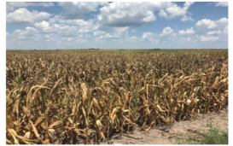

Fields were dried due to shortage of rainfall.

Ques2.) Why do we have seasons?

Ans2.) We have seasons because of rotation and revolution, and tilted axis of the earth.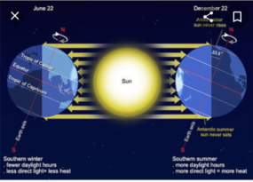

Cause we have seasons.

Ques3.) What type of clothes we wear in summer season?

Ans3.) In summer season we wear cotton clothes to keep ourselves cool.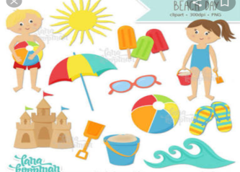

Clothes we wear in summer season.

Long type.

Ques1.) Describe winter season.

Ans1.)Winter is the cold season. During winter the nights are longer than the days. There is snowfall on the high mountains. People wear woolen clothes to keep themselves warm.

Homework.

Draw and colour the diagrams of seasons.