**8th June, 2020 JESUS AND MARY SCHOOL AND COLLEGE MODULE 3**

**CLASS 5**

**COMPUTER SCIENCE**

**Chapter 3 – Computer Memory**

* **TOPIC :**
* Differentiate between the terms data and information
* Explain the purpose of internal and external memory
* Describe different data storage units.
* List the primary and secondary data storage devices

**EXPLANATION**

**Data :**

* Data is a collection of facts, such as, numbers, words, measurements, observation or just description of things.
* Data is processed by the CPU to produce by the CPU to produce new data (output) from secure data (input).

**Information :**

* Information is data that has been processed to be meaningful to the person who receives it.

**Computer Memory :**

* The computer stores all the work done on it.
* The place where information is stored is called the computer.
* There are two main categories of memory :

1. Internal Memory
2. External Memory

**Representation of Memory:**

**Bits and Bytes:**

* A bit is the smallest unit of data that can be stored in a computer. Each bit stores information as either 0 or 1.
* A combination of eight such digits makes a character.
* Thus, a character is represented by 8 bits and is called a byte.

**MEMORY SIZE**

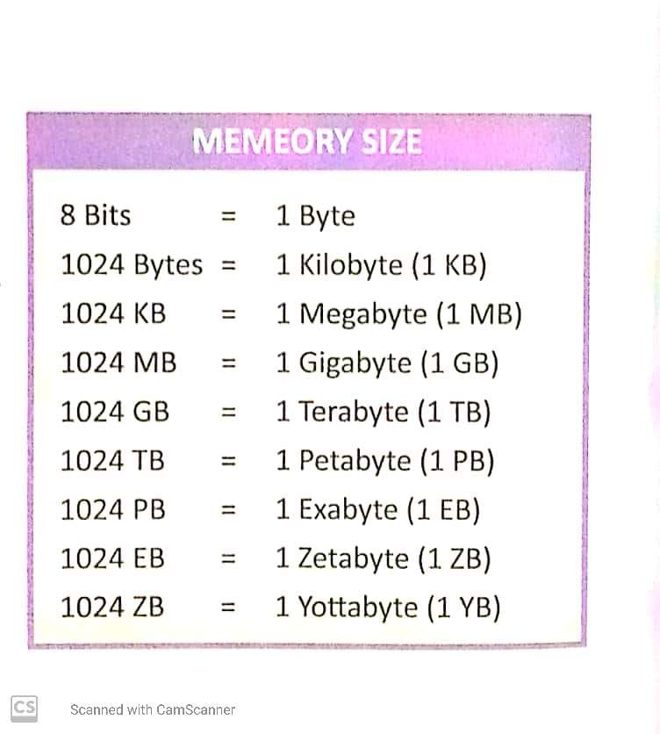

**Types of Memory**

* The internal memory of computer is divided into two types-

1. Primary Memory (RAM, ROM)
2. Secondary Memory (Floppy Disk, CD-ROM, Hard disk)

**Primary Memory:**

* This is known as the main memory of the computer of the computer.
* It is the memory that can be directly accessed by the CPU.
* Primary Memory is also known as internal memory.

**Types of Primary Memory:**

* There are two types of primary memory.

1. RAM (Random Access Memory)
2. ROM (Read Only Memory)

**RAM:**

* RAM stands for Random Access Memory.
* It is a volatile memory.
* The data will be lost when the computer is turned off.
* Data and instruction are temporary in RAM.

**ROM:**

* ROM stand for Read Only Memory.
* It is a non volatile memory.
* Data and instruction are Permanent stored in ROM.

**Secondary Memory:**

* Secondary Memory is called auxiliary memory.
* Secondary memory can store large amount of data permanently.
* It is also known as backup memory.

**Types of Secondary Memory:**

**Magnetic Tape :**

* It is used for storing data backups, particularly in corporate settings.
* The average amount of storage is 5 MB to 140 MB for every standard-length reel, which is 2,400 feet.

**Hard Disk:**

* Hard disk is the most powerful storage device in the computer.
* A Hard disk is made of metal plates and encased in a sealed dust proof case.
* Hard disk can store huge amount of data in its memory.
* Hard disk is a magnetic disk installed inside the computer on which the data is stored.

**CD-ROM:**

* CD-ROM stands for Compact Disk-Read Only Memory.
* Compact disk is the most attractive storage devices these days.
* The diameter of the CD ranges from 10 cm to 30 cm.
* One CD can store 600 MB to 750 MB data on it.

**DVD-ROM:**

* The full form of DVD is Digital Versatile Disk or Digital Video Disk.
* It is smaller to CD but can store much more data, approximately 7 to 21 GB.
* A single DVD can store many cartoon movies.

**USB Drive:**

* A USB (Universal Serial Bus) drive a type of flash memory storage device.
* It is used for transferring data or files from one computer to another.
* It is very small, removable and light weight.
* Flash drives are less expensive than hard drives with the same storage capacity.

**Memory Card:**

* A memory card or flash drive is an electronic flash memory data storage device used in many electronic devices.

**Question/ Answer :**

1. What is computer memory?

**Ans.** The place where information is stored in a computer is called the memory of the computer.

1. What is a bit?

**Ans.** A bit is the smallest unit of data that can be stored in a computer. Each bit stores information either 0 or 1.

1. Differentiate between volatile and non-volatile memory.

**Ans.** Volatile memory loses all content stored in it when the computer is turned OFF while Non-volatile memory does not lose its content when the computer is turned

OFF.

1. What is primary memory? Give types.

**Ans.** Primary memory is the memory that can be accessed directly by the CPU. It is also called internal memory. Computer can read and write on this memory. This memory is fixed inside the CPU box on motherboard. It is the fastest of all other data storage devices. There are two types of primary memory.

1. RAM (Random Access Memory)
2. ROM (Read Only Memory)
3. What are the memory cards?

**Ans.** The memory cards or multimedia cards are designed for portable devices like

mobile phones and digital cameras in the form that can easily be removed.

1. What is a USB drive? What is it used for?

**Ans.** A USB (Universal Serial Bus) drive is a type of flash memory storage device. It is

used for transferring data or files from one computer to another. It is very small,

removable and lightweight. Flash drives are less expensive than hard drives with the

same storage capacity.

**Q7.** What is the differences between RAM and ROM?

**Ans.**

|  |  |
| --- | --- |
| **RAM** | **ROM** |
| RAM stands for Random-Access Memory | ROM stands for Read-Only Memory. |
| RAM is temporary memory. | ROM is permanent memory. |
| Data stored a RAM can be changed. It is also called volatile memory. | Data stored on ROM can be read but cannot be changed. It is also called non-volatile memory. |

1. **Fill in the blanks:**
2. **Bit** is the smallest unit of memory.
3. Internal memory **temporarily** stores data.
4. **Secondary** memory stores the information for long time.
5. The **internal** memory comprises of RAM, ROM.
6. RAM is a **volatile** memory.
7. **True/False :**
8. RAM is temporary memory. **(TRUE)**
9. A character is represented by a bit. **(TRUE)**
10. Computer memories can be divided into four parts. **(FALSE)**
11. Hard disk can be installed inside the computer. **(TRUE)**
12. Flash drive is commonly known as pen drive. **(TRUE)**

**Note- Please do all this work in your “Copies” OR “Notebooks” which will be checked when school reopens. Please consider this important.**

**\*\*\*\*\*\*\*\*\*\*\*\*\*\*\*\*\*\*\*\*\*\*\*\*\*\*\*\*\*\*\*\*\*\*\*\*\***